Yeash Patel

Feb/24/17

Math 131-05D

Homework #4 2a Newton’s method

1. a) $f\left(x\right)=cos\left(x+sqrt\left(2\right)\right)+x*\left(\frac{x}{2}+sqrt\left(2\right)\right)$ interval [-2,1]

b) $f\left(x\right)= exp\left(6*x\right)+3*\left({\left(log\left(2\right)\right)}^{2}\right)*exp\left(2*x\right)-log\left(8\right)*exp\left(4*x\right)-{\left(log\left(2\right)\right)}^{3}$

Interval [-1, 0]

The code uses Newton’s method $[ x_{n+1}=x_{n}-\frac{f\left(x\right)}{f`\left(x\right)}]$ to find roots of a function up to a tolerance of ${10}^{-5}$ within 100 iterations and graph the logarithmic error. For function (a) the code found the root to be at -1.4144 with 29 iterations and an order of convergence of 1.0714. For function (b) the root was found to be -0.18328 this was found with 23 iterations with an order of convergence of 1.0357.

**Matlab Output:**

>> newtonmethod

=======

number of iterations to solve function a:

29

the root for function a is located at:

-1.4144

the order of convergence for function a is:

1.0714

=======

number of iterations to solve function b:

23

the root for function b is located at:

-0.18328

the order of convergence for function b is:

1.0357  
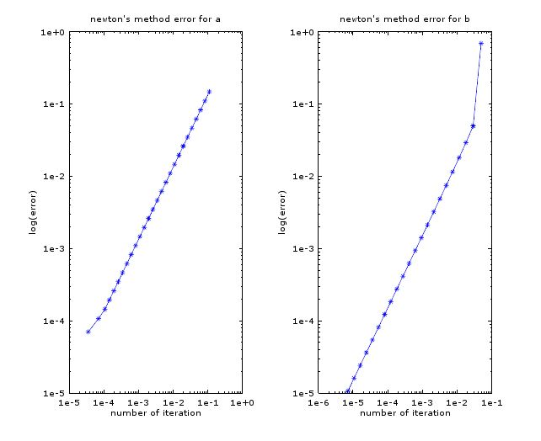

**Matlab code used for this problem:**

%==========================================================

%Name: Yeash Patel

%Class: Math131-Numerical Analysis-05D-SP17

%Title: HW4

%problem 2 newtons method for a and b

%==========================================================

close all

clc

clear all

a=@(x)cos(x+sqrt(2))+x*(x/2+sqrt(2));

da=@(x)x-sin(x+sqrt(2))+sqrt(2);

b=@(z)exp(6*z)+3*((log(2))^2)*exp(2*z)-log(8)*exp(4*z)-(log(2))^3

db=@(z)6*exp(6*z)-4*log(8)*exp(4*z)+6*log(2)^2*exp(2*z)

i=1;

x=-2;

N=100;

TOL=10^-5;

t=1;

z=-1;

err=[];

errb=[];

while(i<=N)

xn(i)=x-(a(x)/da(x))

err(i)=abs(xn(i)-x)

if(err(i)<=TOL||err(i)==0)

disp(i)

disp(x)

break;

end

x=xn(i)

i++

end

while(t<=N)

zn(t)=z-(b(z)/db(z))

errb(t)=abs(zn(t)-z)

if(errb(t)<=TOL||errb(t)==0)

disp(t)

disp(z)

break;

end

z=zn(t)

t++

end

n=length(err)-1

k=length(errb)

aa=log(err(2:n))./log(err(1:n-1))

ab=log(errb(2:k))./log(errb(1:k-1))

disp('=======')

disp('number of iterations to solve function a:')

disp(i)

disp('the root for function a is located at:')

disp(x)

disp('the order of convergence for function a is:')

disp(aa(n-1))

disp('=======')

disp('number of iterations to solve function b:')

disp(t)

disp('the root for function b is located at:')

disp(z)

disp('the order of convergence for function b is:')

disp(ab(k-1))

subplot(1,2,1)

loglog(err(2:n),(err(1:n-1)),'*-')

axis on

title("newton's method error for a")

xlabel('number of iteration')

ylabel('log(error)')

subplot(1,2,2)

loglog(errb(2:k),(errb(1:k-1)),'*-')

axis on

title("newton's method error for b")

xlabel('number of iteration')

ylabel('log(error)')