Yeash Patel

Feb/24/17

Math 131-05D

Homework #4 1b

1. b) $f\left(x\right)=x^{4}-8*x^{3}+24*x^{2}-32*x+16$ on interval [-1,2]

To use fix point iteration method we need to find g(x) such that:

1. it is continuous on the interval
2. it is an element of [-1,2]

$\left|g`\left(x\right)\right|≤k<1$

In my code I used $g\left(x\right)=x-\frac{x^{4}-8*x^{3}+24*x^{2}-32*x+16}{4*x^{3}-24*x^{2}+48*x-32}$ for the numerical portion and for graphing portion of the problem I used $g\left(x\right)=x^{4}-8*x^{3}+24*x^{2}-32*x+16+x$. One might notice that the g(x) used in the numerical portion is similar to Newton’s method this should be okay since one can derive Newton’s method from fixed point. My code takes about 34 iterations to reach a value of 1.9999 and return two graphs which is an accuracy of ${10}^{-6}$. Graph 1 titled “1b functions” is the f(x), g(x), and r(x) (note r(x) = x). The intersection between r(x) and (x) is marked with ‘*’. Graph 2 titled “1b logarithmic errors” and was produced by $|P_{1}-P|$ vs. n.

**Output from Matlab:**

>> oneb

number of iteration:

34

value of function and x value

1.9999

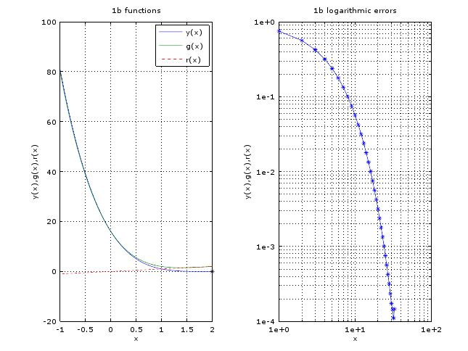

**Matlab code used for this problem:**

%==========================================================

%Name: Yeash Patel

%Class: Math131-Numerical Analysis-05D-SP17

%Title: HW4

%Fixed point method grapghically and anyliticaly

%problem 1 b

%==========================================================

%clear pervious values

close all

clc

clear all

x=linspace((-1),2,100);

y=x.^4-8*x.^3+24*x.^2-32*x+16

g=x.^4-8*x.^3+24*x.^2-32*x+16+x

r=x

i=1

l=-1

tol=10^-6

while (i<=100)

z=l-(l^4-8*l^3+24*l^2-32*l+16)/(4*l^3-24*l^2+48*l-32) %calculate P from Po[ld](note you can derive newtons method from fixed point)

delP=abs(z-l) %find diffrence btween P and Po record it in delp

err(i)=delP

if(delP<tol||delP==0) %check if delp= 0 or is within 0 + or - tolerance

disp('number of iteration:')

disp(i)

disp('value of function and x value')

disp(z) % if so break (done)

break;

else %else continue the loop with Po= P

l=z

i++

end

end

%graph functions

subplot(1,2,1)

plot(x,y,x,g,x,r,'r--')

hold on;

plot(1.9999,0,'k*')

legend('y(x)','g(x)','r(x)')

title('1b functions')

xlabel('x')

ylabel('y(x),g(x),r(x)')

grid on

axis on

%graph errors

subplot(1,2,2)

n=length(err)-1

loglog(1:n,err(1:n),'*-')

title('1b logarithmic errors')

xlabel('x')

ylabel('y(x),g(x),r(x)')

grid on

axis on