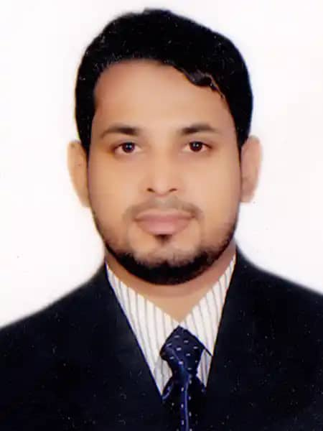

|  |
| --- |
| **MD MAZBA UDDIN** |
| Address: Abdul-Aziz Road, Al-Kharj, Riyadh  Mobile No: 009660573019106  E-mail: nmhtetu@gmail.com  Passport No: A01876724  Iqama No: 2509007874 |

|  |
| --- |
|  |
| **Career Objective:** |
| I am a consistent, hard-working, highly motivated person. I enjoy working with the public. I feel that I am a friendly outgoing and dependable person. I feel it is crucial to demonstrate the importance of my job duties and expectations. |

|  |  |
| --- | --- |
| **Employment History:** | |
| 1. | **Rural Medical Practitioner (February 01, 2016 – July 31, 2021)** |
|  | **Nahid Medical Hall**  Location: Aman Ulla Pur Bazar, Begumganj, Noakhali, Bangladesh. |
| 2. | **Sales Executive (January 15, 2013 – June 30, 2015)** |
|  | **ACME Laboratories Ltd.**  Location: Court de la ACME, Kallayanpur, Dhaka-1207, Bangladesh. |

Academic Qualification:

|  |  |  |  |
| --- | --- | --- | --- |
| **Exam Title** | **Major** | **Institute** | **Pass. Year** |
| H.S.C | Business Studies | Kafile Uddin Degree College | 2013 |
| S.S.C | Business Studies | Janakallan High School | 2011 |

Professional Skills:

Six months of Light Motor Vehicle driving experience.

Career and Application Information:

|  |  |  |  |
| --- | --- | --- | --- |
| Available For | : | Full Time | |
| Preferred Job Category | : | Marketing/Sales, Customer Support, Hospitality, Waiter | |
| Preferred Organization Types | : | Multinational Companies, Hotel, Restaurant, Shopping Mall, Fast Food Shop, Pharmacy, Superstore, Showroom | |
| **Language Proficiency:** | | |
|  | | |
| Spoken Arabic, English, Hindi as well as Bangla to maintain official work and interpersonal relationships. | | |

Personal Details:

|  |  |  |
| --- | --- | --- |
| Father's Name | : | MD Amir Hossain |
| Mother's Name | : | Tahera Begum |
| Gender | : | Male |
| Marital Status | : | Married |
| Spouse's Name | : | Nasima Akther |
| Religion | : | Islam |
| Nationality | : | Bangladeshi |
| Permanent Address | : | Aman Ulla Pur, Joynarayanpur-3829, Begumganj, Noakhali, Bangladesh. |