**Online0**

Due: 11:25 am, 12 July

**Problem**

Write a program that prints your first name and last name with asterisks (*) in console.

For example, if your name has only 2 words you should only print those 2 words in console.   
If your name contains 3 words and it includes md/ mr/ miss (e.g. Md. Abcd Efgh) print the words Abcd Efgh in console. (md should not be counted)  
if your name contains more than 2 words other than md / mr / miss (e.g. Abcd Efgh Ijkl), pick the most convenient two words (e.g. Abcd Efgh) from your name to print in console.

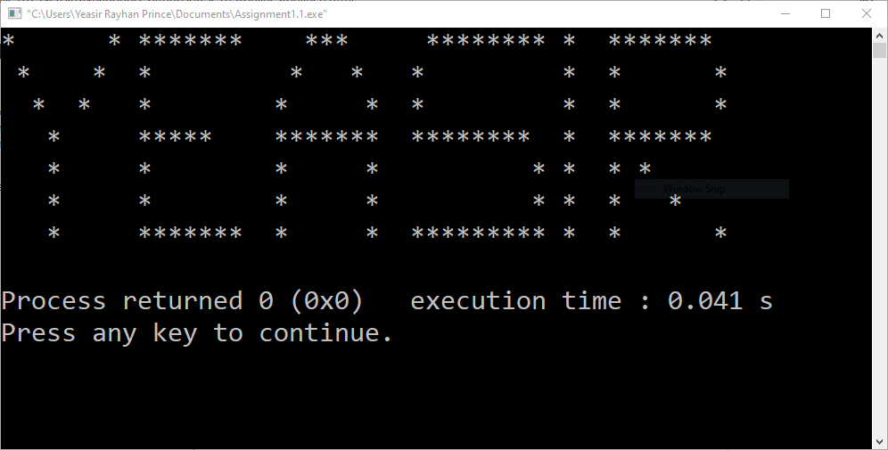I have added an example of how your console might look like once you run your code.

## Instructions

1. You should save your code as Your_10_digit_sudent_id.c, e.g. if a student’s id is 2013-3-60-23 his code should be saved as 2013-3-60-23.c. Remember, 10% of marks is allocated for following the name convention.
2. Submit your code in Google Classroom in proper section labeled as Online0. This [link](https://support.google.com/edu/classroom/answer/6020285?co=GENIE.Platform%3DDesktop&hl=en) might be of help if you are having difficulty to turn in your online.
3. Strictly follow the deadline of the online. Marks will be deducted for a late submission
4. Finally, if you copy your code from any of the students both the copier and provider will be marked -100%