# Practice Problem Set 0

1. Print the message “Hello World!” on one line
2. Print the message “This is a C program.” on one line using one printf.

Print the message "This is a C program." on two lines so that the first line ends with C using one printf.

Print the message "This is a C program." on two lines so that the first line ends with C using two printf.  
Print the message "This is a C program." with each word on a separate line using one printf.

Print the message "This is a C program." with the words separated by tabs.

1. Write a program that prints the following patterns.

1

2 3

4 5 6

7 8 9 10

1

2 3

4 5 6

7 8 9 10

1. Write a Program that prints the following shapes with asterisks.

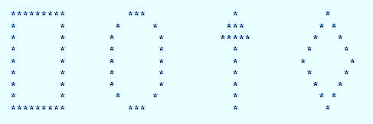

1. Write a Program that prints the following checkerboard shape with asterisks.

