# Practice Problem Set 1.1

1. Write a program that asks the user to enter two fractions in numerator / denominator format and finds the sum of those two fractions in numerator / denominator format.

Hints:

Modern C: Chapter 3, Adding Fraction Program (Page46)

Examples

|  |
| --- |
| Input |
| 3 12 5 13 |
| Output |
| 3 / 12 + 5 / 13 = 99 / 156 |

|  |
| --- |
| Input |
| 5 6 3 4 |
| Output |
| 5 / 6 + 3 / 4 = 38 / 24 |

1. Write a program that asks the user to enter an integer and evaluates the following expressions using math header file.

$$x^{6}, \cos{x}, \sqrt{x}$$

|  |
| --- |
| Input |
| 5 |
| Output |
| 15625  0.9961946981  2.2361 |

1. Write a program that asks the user to enter an integer and displays it in Octal (Base 8).   
   The input should be between 0 and 32767.

The output should be displayed using five digits even if fewer digits are sufficient.

Hints:

Modern C: Chapter 4, Programming Projects 4 (Page71)

|  |
| --- |
| Input |
| 1953 |
| Output |
| 03641 |

1. Write a program that asks the user to enter an integer and displays it in Binary (Base 2).   
   The input should be between 0 and 31.  
   The output should be displayed using five digits even if fewer digits are sufficient.

|  |
| --- |
| Input |
| 24 |
| Output |
| 11000 |

1. Write a program that asks the user to enter three integers and swap them using right-cyclic-shift.

Examples

|  |
| --- |
| Input |
| 10 20 30 |
| Output |
| Before swap: a = 10, b = 20, c = 30  After right cyclic shift: a = 30, b = 10, c = 20 |

1. Write a program that asks the user to enter three integers and swaps them using left-cyclic shift.

Examples

|  |
| --- |
| Input |
| 10 20 30 |
| Output |
| Before swap: a = 10, b = 20, c = 30  After left cyclic shift: a = 20, b = 30, c = 10 |

1. 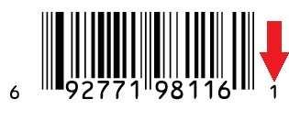For a number of years, manufacturers of goods sold  
   in U.S and Canadian stores have put a bar code on   
   each product. This code, known as a Universal Product Code (UPC), identifies both the manufacturer and the  
   product.  
   Each bar code represents a 12- digit number, which is  
   usually printed underneath the bars.

For example, look at the following bar code

6 92771 98116 1

1st Digit: the type of item

1st group of 5 digits: the manufacturer

2nd group of 5 digits: the product

Final digit: check digit

The purpose of the check digit is to help identify an error in the preceding 11 digits. If the UPC is scanned incorrectly, the first 11 digit will not be consistent with the check digit. (A check digit is calculated from the first 11 digits and if the calculated check digit is not equal to the 12th digit: check digit, an error is shown)

Write a program that calculates the check digit of an arbitrary UPC from the first 11 digits.

Hints:   
Modern C: Chapter 4, Computing a UPC Check Digit (Page56)

Examples

|  |
| --- |
| Input |
| 0 1 3 8 0 0 1 5 1 7 3 5 |
| Output |
| 5 |

|  |
| --- |
| Input |
| 0 5 1 5 0 0 2 4 1 2 8 8 |
| Output |
| 8 |

1. 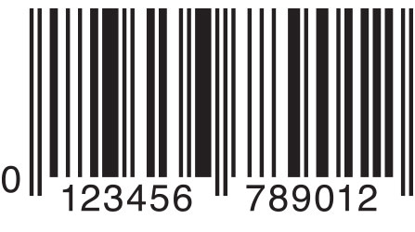European countries use a 13-digit code, known as European Article  
   Number (EAN) instead of the 12-digit Universal Product Code (UPC)  
   found in North America.   
   Each EAN ends with a check digit, just as a UPC does. The technique  
   for calculating the check digit is also similar to UPC.

Write a program that calculates the check digit of an arbitrary EAN from the first 12 digits.

Hints:   
Modern C: Chapter 4, Programming Projects 6 (Page71)

Examples

|  |
| --- |
| Input |
| 8 6 9 1 4 8 4 2 6 0 0 0 8 |
| Output |
| 8 |