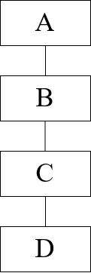 **Assignment 2.1**

1. Does Java allow the class hierarchy shown in Class Diagram – 1?

If yes, write the class definitions for the class hierarchy in class diagram – 1.

You don’t need to implement any method or instance variables.   
Only the class definition will do.

**[Please write your code in intellij IDE then copy-paste the code below,  
Codes written in texts are not allowed]**

Class Diagram - 1

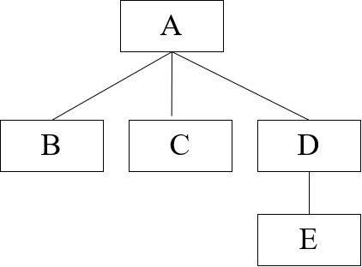

1. Write the class definitions for the class hierarchy in class diagram – 2.

You don’t need to implement any method or instance variables.   
Only the class definitions will do.

**[Please write your code in intellij IDE then copy-paste the code below. Codes written in texts are not allowed]**

Class Diagram - 2

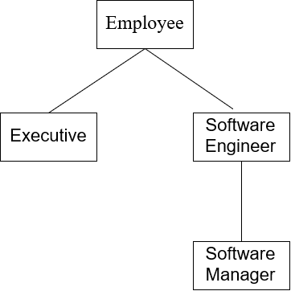

1. Write the class definitions for the class hierarchy in class diagram – 3.

You don’t need to implement any method or instance variables.   
Only the class definitions will do.

**[Please write your code in intellij IDE then copy-paste the code below, Codes written in texts are not allowed]**

Class Diagram -3

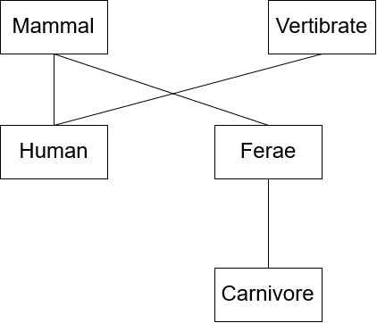

1. Does Java allow the class hierarchy shown in Class Diagram – 4?

If yes, write the class definitions for the class hierarchy in class diagram – 4.

You don’t need to implement any method or instance variables.   
Only the class definition will do.

**[Please write your code in intellij IDE then copy-paste the code below. Codes written in texts are  
   
not allowed]**

Class Diagram -4