Chapter 12 Volatility Models

In our previous discussion of derivatives pricing, little has been said about the volatility in the stochastic model of asset price return. In a simple stochastic model, we assume both drift and volatility as constant factors. The annualized volatility σ can be calibrated through the historical variance of daily logarithmic price returns given by σ²(1/260) = Var(r_{daily}), where there are 260 trading days (52 weeks × 5 days/week) per year. In agreement with market observations, however, it is essential to consider volatility of price return as a dynamical quantity that will change over time and price. In this chapter, we discuss some common volatility models that are useful in derivatives pricing and volatility forecasting.

12.1 ARCH/GARCH Volatility Models

Financial time series of price returns often exhibit a behavior known as volatility clustering. It refers to the observation that there are periods of large returns (high volatility) and periods of small returns (low volatility) as shown, for example, in figure (12.1). This means that "large returns tend to be followed by large returns, and small returns tend to be followed by small returns" as first noted by Mandelbrot. In this sense, volatility is said to suffer from heteroskedasticity for which it will change over time, and the movement must also follow certain autoregressive mechanism. In this respect, it is interesting to examine the autocorrelation coefficients of both excess price returns and squared excess price returns with time lag k. The former evaluates the correlation coefficient of excess price returns (r_{t} − μ) and (r_{t + k} − μ), and the latter evaluates the same coefficient for their squares (r_{t} − μ)² and (r_{t + k} − μ)². For simplicity, mean price return μ is assumed to be constant in our discussion. For instance, we use the historical daily price returns of Dow Jones Index in figure (12.1) to evaluate the above coefficients for time lag k equals 1 to 5. Figure (12.2) shows the Python coding for this work together with the results. It is clear that subsequent daily excess price returns are uncorrelated as the autocorrelation coefficients are shown to be very small for all time lags. On the contrary, there exists strong autocorrelation for daily squared excess price returns as the coefficients are significantly greater than zero. The autoregressive conditional heteroskedasticity (ARCH) model by Engle and the generalized autoregressive conditional heteroskedasticity (GARCH) model by Bollerslev are formulated to describe both the phenomenon of volatility clustering and the autocorrelation among squared excess price returns.
Price Return

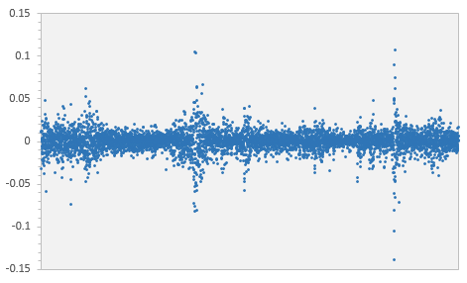
Date

Fig 12.1 : Daily price returns of Dow Jones Industrial Average Index from year 2000 to 2023.

The formulations of these two models begin with the assumption that asset price return is a normal random variable with constant mean and time-dependent volatility as r_{t} = ε(μ, σ_{t}). Also, the running volatility σ_{t} is taken to be a random quantity in the models. In consistent with the results in figure (12.2), subsequent excess price returns (r_{t} − μ) and (r_{s} − μ) are shown to be uncorrelated as

$$\text{E}\left(\text{(}{\text{r}}_{\text{t}} \text{)(}{\text{r}}_{\text{s}} \text{)}\right) \text{E}\left({}_{\text{t}} {}_{\text{s}}\text{'}\right) \text{E}\left({}_{\text{t}}{}_{\text{s}}\right)\text{E}\left(\right)\text{E}\left(\text{'}\right) \text{ 0}$$

where ε and ε' are independent normal random variables. Despite of a random volatility, the expectation of r_{t} remains being the constant mean as E(r_{t}) = μ + E(σ_{t})E(ε) = μ where the volatility is independent of ε. In reality, there is only one realization of r_{t} for which mean μ cannot be estimated accurately through this observed value. Since this is true for every historical price returns in the time series, says {${\text{r}}_{\text{1}}^{\text{obs}}$, ... , ${\text{r}}_{\text{t}}^{\text{obs}}$}, it is efficient to consider the expectation E(r₁ + … + r_{t}) = tμ, and estimate mean μ using the historical mean $\overline{\text{r}}$ as

$\text{E}\left(\frac{{\text{r}}_{\text{1}} {\text{r}}_{\text{t}}}{\text{t}}\right) \overline{\text{r}} \text{error}\text{(1/}\sqrt{\text{t}}\text{)} \text{ , } \overline{\text{r}} \frac{\text{1}}{\text{t}}\sum_{\text{i} \text{1}}^{\text{t}}{{\text{r}}_{\text{i}}^{\text{obs}}}$ (12.1)

Estimation error in the equation refers to the standard deviation of (1/t)(r₁ + … + r_{t}) that is shown to be suppressed by 1/$\sqrt{\text{t}}$ in (A12.2). Hence, mean μ can be estimated accurately through long historical time series. Squared excess price returns at lagged times t and t + k are given by (r_{t} − μ)² = ${}_{\text{t}}^{\text{2}}$ ε² and (r_{t + k} − μ)² = ${}_{\text{t} \text{k}}^{\text{2}}$ ε'², respectively. They are defined based on two independent normal random variables ε and ε'. Hence, the two running volatilities σ_{t} and σ_{t + k} are correlated random quantities as squared excess price return is shown to exhibit strong autocorrelation.
Fig 12.2 : Python codings to evaluate the autocorrelation coefficients of DJI daily returns and their results.

import xlwings
import numpy,statistics
#---------------------------------------------------------------
wb=xlwings.Book("./DJI.xlsx")
ws=wb.sheets['returns']
n,nuse=6000,5000
#
r=[]
for i in range(1,n+1):
r.append(ws.range(i,2).value)
mu=statistics.mean(r)
#
z,z2=[],[]
Time lag | Excess price returns | Squared Excess price returns
1 | −0.07029 | 0.18756
2 | −0.04652 | 0.36818
3 | 0.03839 | 0.21730
4 | −0.00600 | 0.26965
5 | −0.04957 | 0.30907

for i in range(nuse):
z.append(r[i]-mu)
z2.append((r[i]-mu)*(r[i]-mu))
#
for k in range(1,5+1):
zk,zk2=[],[]
for i in range(nuse):
zk.append(r[i+k]-mu)
zk2.append((r[i+k]-mu)*(r[i+k]-mu))
x=numpy.array(z)
y=numpy.array(zk)
x2=numpy.array(z2)
y2=numpy.array(zk2)
print(k,numpy.corrcoef(x,y)[0][1],numpy.corrcoef(x2,y2)[0][1])
#
wb.close()

The ARCH(p) model suggests that the volatility σ_{t} at time t is dependent on the realizations of last p squared excess price returns as

${}_{\text{t}}^{\text{2}} \sum_{\text{i} \text{ 1}}^{\text{p}}{{}_{\text{i}}{\left({\text{r}}_{\text{t} \text{i}} \right)}^{\text{2}}}$ (12.2)

where {ω, α₁, ... , α_{p}} are non-negative parameters to be calibrated from market prices. In this way, volatility of price return is considered to be a random quantity through its past realizations {${\text{r}}_{\text{t} \text{p}}^{\text{obs}}$, ... , ${\text{r}}_{\text{t} \text{1}}^{\text{obs}}$}. Also, it is clear that time-lagged volatilities, say σ_{t} and σ_{t + k}, are autocorrelated as there are overlapping terms on the right side of (12.2). Seeing the market price return ${\text{r}}_{\text{t}}^{\text{obs}}$ at time t, we can predict the volatility σ_{t + 1} at forward time t + 1 using (12.2), and so on. The GARCH(p, q) model extended the autoregressive structure of the volatility by including further last q volatilities as

${}_{\text{t}}^{\text{2}} \sum_{\text{i} \text{ 1}}^{\text{p}}{{}_{\text{i}}{\left({\text{r}}_{\text{t} \text{i}} \right)}^{\text{2}}}\sum_{\text{i} \text{ 1}}^{\text{q}}{{}_{\text{i}}{}_{\text{t} \text{i}}^{\text{2}}}$ (12.3)

with additional non-negative parameters {β₁, ... , β_{q}} that need to be calibrated as well.

For illustration purposes, we consider in this section the GARCH(1, 1) model with p = q = 1 defined as

${}_{\text{t}}^{\text{2}} {\left({\text{r}}_{\text{t} \text{1}} \right)}^{\text{2}} {}_{\text{t} \text{ 1}}^{\text{2}}$ (12.4)

where {ω, α, β} are non-negative parameters to ensure an overall non-negative value on the right hand side of the equation. The model also assumes a stationary dynamical feature for the random volatility for which the probability distribution should remain the same at all time. For instance, the mean values E(${}_{\text{t}}^{\text{2}}$) and E(${}_{\text{t} \text{1}}^{\text{2}}$) must be the same under stationary condition. From (12.4), it can be shown that E(${}_{\text{t}}^{\text{2}}$) = ω + (α + β)E(${}_{\text{t} \text{1}}^{\text{2}}$) and, hence, E(${}_{\text{t}}^{\text{2}}$) = ω/(1 − α − β) from stationarity. Since E(${}_{\text{t}}^{\text{2}}$) is strictly positive as ${}_{\text{t}}^{\text{2}}$ is non-negative, we must have ω > 0 and (α + β) ≤ 1. The fact that E(${}_{\text{t}}^{\text{2}}$) must be finite further requires (α + β) < 1. Suppose that E(${}_{\text{u}}^{\text{2}}$) = V_{L}, namely the long-run variance, at all time under stationary condition. The parameter ω can be replaced by the long-run variance as ω = (1 − α − β)V_{L}, and the GARCH(1, 1) model can now be written as

${}_{\text{t}}^{\text{2}} \text{ (1 } \text{)}{\text{V}}_{\text{L}} {\left({\text{r}}_{\text{t} \text{ 1}} \right)}^{\text{2}} {}_{\text{t} \text{ 1}}^{\text{2}} \text{, }$α ≥ 0 , β ≥ 0, α + β < 1 (12.5)

Seeing the price returns {${\text{r}}_{\text{1}}^{\text{obs}}$, ... , ${\text{r}}_{\text{t}}^{\text{obs}}$}, we can estimate the mean parameter μ using the historical mean $\overline{\text{r}}$ as discussed in (12.1). We consider also the expectation E((r₁ − μ)² + … + (r_{t} − μ)²) = tV_{L} as E((r_{u} − μ)²) = E(${}_{\text{u}}^{\text{2}}$) from footnote. It is efficient to estimate the long-run variance using the historical variance ${\overline{}}^{\text{2}}$ given by

${\text{V}}_{\text{L}} \text{E}\left(\frac{{({\text{r}}_{\text{1}} )}^{\text{2}} {({\text{r}}_{\text{t}} )}^{\text{2}}}{\text{t}}\right) {\overline{}}^{\text{2}} \text{error}\text{(1/}\sqrt{\text{t}}\text{)} \text{ , } {\overline{}}^{\text{2}}\frac{\text{1}}{\text{t}}\sum_{\text{i} \text{1}}^{\text{t}}{{({\text{r}}_{\text{i}}^{\text{obs}} )}^{\text{2}}}$ (12.6)

Estimation error of the long-run variance is also shown to be suppressed by 1/$\sqrt{\text{t}}$ in (A12.5) and, hence, it can be estimated accurately through long historical time series.

The GARCH(1, 1) model as defined in (12.5) refers to a forward iteration process that allows prediction of the forward variance ${}_{\text{t} \text{1}}^{\text{2}}$ given price return ${\text{r}}_{\text{t}}^{\text{obs}}$ as seen at time t together with its variance ${}_{\text{t}}^{\text{2}}$. Recursively, the variance ${}_{\text{t}}^{\text{2}}$ is generated through the observed price return ${\text{r}}_{\text{t} \text{1}}^{\text{obs}}$ together with the variance ${}_{\text{t} \text{1}}^{\text{2}}$, and so on. It seems that the starting variance ${}_{\text{1}}^{\text{2}}$ must be defined properly for the iteration to proceed through the use of the historical price returns. At any time s, we can rewrite the model as

${}_{\text{s} }^{\text{2}} \text{ (1 } \text{)}\left(\frac{\text{1 } {}^{\text{s} \text{1}}}{\text{1 } }\right){\text{V}}_{\text{L}} \sum_{\text{i} \text{ 1}}^{\text{s} \text{1}}{{}^{\text{i }\text{ 1}}{\left({\text{r}}_{\text{s} \text{i}} \right)}^{\text{2}}} {}^{\text{s} \text{ 1}}{}_{\text{1}}^{\text{2}}$ (12.7)

where the dependence on the starting variance can be explicitly seen. As 0 ≤ β < 1, the factor β^{s − 1} on the right side is negligible when s is much greater than 1. Hence, it is sufficient to assign a mean value to the starting variance ${}_{\text{1}}^{\text{2}}$ = V_{L} for which the error will be highly suppressed for the generated variances ${}_{\text{s}}^{\text{2}}$ that are far away from it.

In principle, the parameters α and β in the model are calibrated to market prices based on a notion of correctness. For instance, it might refer to the minimization of the root-mean-squared error (rmse) by comparing the model variances {${}_{\text{t}\text{*}}^{\text{2}}$, ... , ${}_{\text{t}}^{\text{2}}$} with the price return residuals {(${\text{r}}_{\text{t}\text{*}}^{\text{obs}}$− μ)², ... , (${\text{r}}_{\text{t}}^{\text{obs}}$− μ)²} given by

$\text{rmse} \sqrt{\left(\frac{\text{1}}{\text{t } \text{t}\text{* }\text{ 1}}\right)\sum_{\text{i} \text{t}\text{*}}^{\text{t}}{{\left({}_{\text{i}}^{\text{2}} {({\text{r}}_{\text{i}}^{\text{obs}} )}^{\text{2}}\right)}^{\text{2}}}}$ (12.8)

for appropriate t* where β^{t* − 1} is small. In this sense, the best α and β are defined to generate the variances that minimize the rmse in (12.8). Another common notion of correctness refers to the normal random assumption on price return in the model. Using a normal density function, we can evaluate the likelihood, or probability, of seeing the price return r = ε(μ, σ) within a small increment r^{obs} ± ½δ as φ_{μσ}(r^{obs})δ. In this way, the likelihood of seeing historical price returns within, respectively, each of the small increments {${\text{r}}_{\text{t}\text{*}}^{\text{obs}}$± ½δ, ... , ${\text{r}}_{\text{t}}^{\text{obs}}$± ½δ} is given by

$\text{L} \prod_{\text{i} \text{t}\text{*}}^{\text{t}}{\left(\frac{\text{1}}{\sqrt{\text{2}} {}_{\text{i}}}\text{exp}\left(\frac{\text{1}}{\text{2}}{\left({\text{r}}_{\text{i}}^{\text{obs}} \right)}^{\text{2}}\text{/}{}_{\text{i}}^{\text{2}}\right)\right)}$ (12.9)

Hence, the best α and β are now defined to generate the variances that maximize the likelihood of seeing the historical price returns in (12.9). To avoid floating point problem when dealing with a long product, it is convenient to maximize instead the logarithm of likelihood as

$\text{logL} \sum_{\text{i} \text{t}\text{*}}^{\text{t}}{\left( \frac{\text{1}}{\text{2}}\text{log}{}_{\text{i}}^{\text{2}} \frac{\text{1}}{\text{2}}{\left({\text{r}}_{\text{i}}^{\text{obs}} \right)}^{\text{2}}\text{/}{}_{\text{i}}^{\text{2}}\right) \text{t} \text{log}\left(\frac{}{\sqrt{\text{2}}}\right)}$ (12.10)

where the constant term on the right side of the equation is irrelevant to the maximization and it can be ignored in the calculation.

The Python function logLikelihood() as shown below evaluates the logarithm of likelihood in (12.10) taking y = [α, β] as variables together with other passing arguments μ, V_{L}, {${\text{r}}_{\text{1}}^{\text{obs}}$, ... , ${\text{r}}_{\text{t}}^{\text{obs}}$}, t*, and t. For the optimization procedure, we will use the minimizer as provided in the scipy.optimize module. The additional sign factor in the function is taken to be −1 as maximizing logL is essential the same as minimizing its negative value −logL. Taking the values of α and β, the variance sequence {${}_{\text{1}}^{\text{2}}$, ... , ${}_{\text{t}}^{\text{2}}$} can be generated starting from ${}_{\text{1}}^{\text{2}}$ = V_{L}. The logarithm of likelihood in (12.10) is then accumulated using the price returns and variances from t* to t, and its negative value is outputted.

def logLikelihood(y,mu,longVar,priceReturn,tstar,tlast,sign):
from math import log
alpha,beta=y
garchVar=longVar
sum=0
for i in range(2,tlast+1):
garchVar=(1-alpha-beta)*longVar+alpha*(priceReturn[i-1]-mu)**2+beta*garchVar
if(i>=tstar):
sum=sum+(1/2)*log(garchVar)+(1/2)*(priceReturn[i]-mu)**2/garchVar
logL=(-1)*sum
#
return sign*logL

To use the scipy minimizer in this work, trial values of α and β must be defined, presumably very close to the solution, in order to initiate the procedure. This can be done using a preliminary search of the two parameters as implemented by the Python function simpleSearch() below. In the function, we consider m equal increments from 0 to 1, and compare the likelihood values of discrete pairs α_{i} = (i/m) and β_{j} = (j/m) within the region α ≥ 0, β ≥ 0, and α + β < 1. The constraints define a triangular region in which index i is running from 0 to m − 1, while index j is running from 0 to m − i − 1 given i.

def simpleSearch(m,mu,longVar,priceReturn,tstar,tlast):
minlogL=1.e10
for i in range(0,m):
for j in range(0,m-i):
y=[(i/m),(j/m)]
logL=logLikelihood(y,mu,longVar,priceReturn,tstar,tlast,-1)
if logL<=minlogL :
alpha,beta=y
minlogL=logL
return alpha,beta

The main program as shown below (kept in garch11.py) uses the Python function minimize() of scipy for the evaluation of the best α and β with trial values taken from the simpleSearch(). The objective function is defined to be the logLikelihood() with sign = −1 as it is a maximization problem.

import numpy,statistics
from scipy.optimize import minimize
#
priceReturn,totalstep,t,tstar,m,z=readfile('DJI.xlsx','model','returns')
mu=statistics.mean(priceReturn[1:t+1])
longVar=statistics.variance(priceReturn[1:t+1])
ytrial=numpy.array(simpleSearch(m,mu,longVar,priceReturn,tstar,t))
#
sign=-1
cons=({'type':'ineq','fun':lowerLimitAlpha},{'type':'ineq','fun':lowerLimitBeta},{'type':'ineq','fun':LimitAlphaBeta})
alpha,beta=minimize(logLikelihood,ytrial,args=(mu,longVar,priceReturn,tstar,t,sign),constraints=cons).x
#
conf,predVar=backtest(mu,longVar,alpha,beta,priceReturn,t,totalstep,z)
writefile('DJI.xlsx','model')

In conjunction with the objective function, there are constraint functions that impose the conditions α ≥ 0, β ≥ 0, and α + β < 1 during the course of the minimization. They are given by

def lowerLimitAlpha(y):
return y[0]
#
def lowerLimitBeta(y):
return y[1]
#
def limitAlphaBeta(y):
tol=1.e-6
return -y[0]-y[1]+1-tol

It should be noted that the last constraint α + β < 1 has been rewritten as − α − β + 1 − tol ≥ 0 in line with the scipy format, and there is a small tolerance tol = 1 × 10⁻¹⁴ being introduced to avoid α + β = 1. As depicted below, we can develop a user interface using EXCEL worksheet that manages all inputs and outputs of the model together with the historical price returns. Reading and writing between Python and EXCEL can be done very easily through the use of the xlwings module.

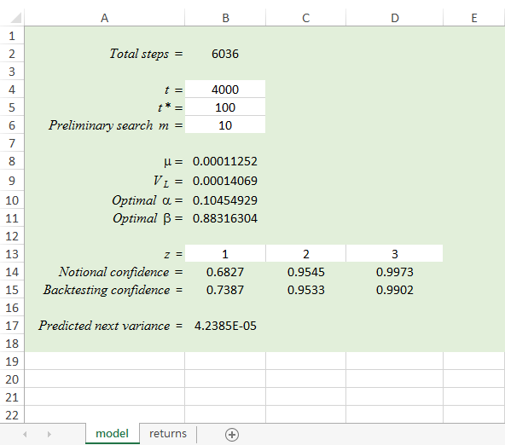

The total number of historical price returns up to current time is totalstep, the GARCH(1, 1) model is aiming at predicting the variance at totalstep + 1. As in-sample data set, the leading t steps will be used to evaluate the model parameters {μ, V_{L}, α, β}. The following steps from t + 1 to totalstep are considered to be out-of-sample set that will be to conduct a back testing procedure immediately before the prediction. According to the normal random assumption, the confidence interval of price return at any time is given by μ − zσ_{s} < r_{s} ≤ μ + zσ_{s} with z defines the confidence level. In this respect, we can back test the validity of the model by checking the percentage that the predicted interval has included the observation for the entire out-of-sample data. This provides useful benchmark values to examine the performance of the model by comparing the realized confidence levels with the notional values. As shown below, the Python function backtest() generates all the variances in the out-of-sample region and counts the total number of observed price returns that stay within the confidence intervals as defined by z = [1, 2 , 3]. At the same time, the predicted variance at totalstep + 1 is generated as the last entry in the variance sequence, while its validity can be verified based on the back testing results.

def backtest(mu,longVar,alpha,beta,priceReturn,tbegin,tlast,z):
from math import sqrt
listofVar=[None]
garchVar=longVar
listofVar.append(garchVar)
for i in range(2,tlast+2):
garchVar=(1-alpha-beta)*longVar+alpha*(priceReturn[i-1]-mu)**2+beta*garchVar
listofVar.append(garchVar)
#
conf=[]
for k in range(len(z)):
n=0
for i in range(tbegin,tlast+1):
if(priceReturn[i]>(mu-z[k]*sqrt(listofVar[i])) and priceReturn[i]<=(mu+z[k]*sqrt(listofVar[i]))):
n=n+1
conf.append(n/(tlast-tbegin+1))
#
return conf,listofVar[tlast+1]

12.2 Implied Volatility Surface

In the Black-Scholes pricing model, asset price return is considered to be a normal random variable with constant volatility. In previous chapter, current pricing of European call and put option contracts are evaluated to be

${\text{c}}_{\text{BS}}\text{(}\text{S}\text{(0), }\text{K}\text{, }\text{, }\text{) } \text{S}\text{(0)}\text{N}\left(\frac{\text{log}\left(\frac{\text{S}\text{(0)}}{\text{K}}\right) \left(\text{r} \frac{\text{1}}{\text{2}}{}^{\text{2}}\right)}{\sqrt{}}\right) \text{K}{\text{e}}^{\text{r}}\text{N}\left(\frac{\text{log}\left(\frac{\text{S}\text{(0)}}{\text{K}}\right) \left(\text{r} \frac{\text{1}}{\text{2}}{}^{\text{2}}\right)}{\sqrt{}}\right)$ (12.11)

${\text{p}}_{\text{BS}}\text{(}\text{S}\text{(0), }\text{K}\text{, }\text{, }\text{) } \text{K}{\text{e}}^{\text{r}}\text{N}\left( \frac{\text{log}\left(\frac{\text{S}\text{(0)}}{\text{K}}\right) \left(\text{r} \frac{\text{1}}{\text{2}}{}^{\text{2}}\right)}{\sqrt{}}\right) \text{S}\text{(0)}\text{N}\left( \frac{\text{log}\left(\frac{\text{S}\text{(0)}}{\text{K}}\right) \left(\text{r} \frac{\text{1}}{\text{2}}{}^{\text{2}}\right)}{\sqrt{}}\right)$ (12.12)

where S(0), K, and τ are contract parameters referring to the current underlying asset price, strike price, and time to expiration, respectively. The factor r is the current risk-free interest rate with the shortest borrowing term, and it is considered to be static. The remaining factor σ in the equations defines the constant volatility of the underlying asset. In a straightforward way, a constant volatility can be estimated from the historical variance of asset price returns. However, the constant assumption itself might not be a good idea by recalling the discussion in last section. In fact, market prices of European call and put options are not exactly consistent with the theoretical prices derived from the Black-Scholes pricing formulae in (12.11) and (12.12). Conversely, we can define the so-called implied volatilities ν(K, τ) that will align the Black-Scholes pricing formulae with the market prices c_{market} and p_{market} of the European call and put options, respectively, with the corresponding strike price K and time to expiration τ. It can be evaluated by solving the root of either one of the following matching functions as

$\text{g}\text{(}\text{) } {\text{c}}_{\text{BS}}\text{(}\text{S}\text{(0), }\text{K}\text{, }\text{, }\text{) } {\text{c}}_{\text{market}}\text{(}\text{K}\text{, }\text{)}$ and $\text{h}\text{(}\text{) } {\text{p}}_{\text{BS}}\text{(}\text{S}\text{(0), }\text{K}\text{, }\text{, }\text{) } {\text{p}}_{\text{market}}\text{(}\text{K}\text{, }\text{)}$ (12.13)

where implied volatilities for call and put options with the same strike price and time to expiration are expected to be the same under the put-call parity condition.

To this end, it is convenient to adopt a powerful root finding procedure, namely the Newton-Raphson method, as described in appendix (12.2). The Python function newtonRaphson_scalar() in the newtonRaphson module implements the Newton-Raphson procedure for function with a single variable. It can be used to estimate the root of the matching function of call price in (12.13) with the callable function given by

from math import erf, sqrt,log,exp
#
def normsdist(x):
normsdist=(1+erf(x/sqrt(2)))/2
return normsdist
#
def matchBSEuropeanCallPrice(sigma,pa):
assetPrice,strike,riskFreeRate,timeExpiration,marketCallPrice=pa
d1=(log(assetPrice/strike)+(riskFreeRate+(1/2)*sigma**2)*timeExpiration)/(sigma*sqrt(timeExpiration))
d2=d1-sigma*sqrt(timeExpiration)
BSEuropeanCallPrice=assetPrice*normsdist(d1)-strike*exp(-riskFreeRate*timeExpiration)*normsdist(d2)
return BSEuropeanCallPrice-marketCallPrice

where sigma is the volatility variable of the function and pa are other passing arguments for the calculation packed as Python tuple. For instance, implied volatility referring to a given market call price and other option parameters (S(0) = $100, K = $95, r = 5% per year, τ = 1 year, c_{market} = $13, prec = 10⁻⁸) can be estimated by calling the Newton-Raphson procedure as

assetPrice,strike,riskFreeRate,timeExpiration,marketCallPrice=100.0,95.0,0.05,1.0,13.0
pa=assetPrice,strike,riskFreeRate,timeExpiration,marketCallPrice
ivtrial=0.17
prec=1.e-8
iv,precMet,dev=newtonRaphson.newtonRaphson_scalar(matchBSEuropeanCallPrice,ivtrial,prec,pa)
print(iv,precMet,dev)

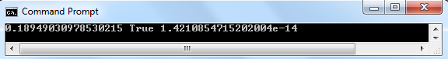

where an effective trial guess ivtrial of the implied volatility must be provided. In principle, the trial guess should be close enough to the solution to ensure convergence toward this value. Here, it makes sense to use the historical volatility of the underlying asset as the trial guess of implied volatility, says ivtrial = 17% per year.

The dependence of implied volatilities ν(K, τ) with respect to strike price K and time to expiration τ are referring to their skew and term structures, respectively. To illustrate the existence of the two structures, we consider the market European call prices of AAPL (Apple Inc.) stock as depicted in file AAPL_Call.xlsx as

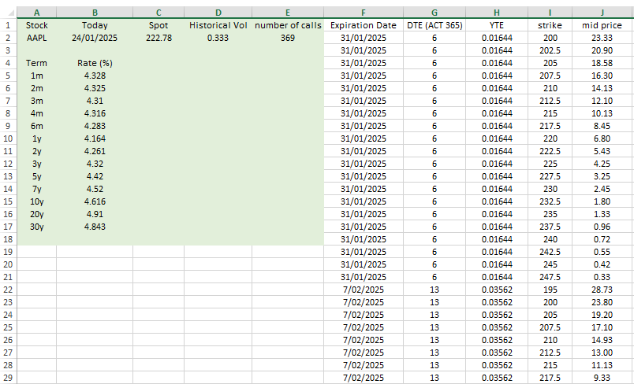

They are quoted as the mid value of bid/ask prices for different strike prices and annualized time to expirations (YTE). In the same file, current asset price is given by $222.78, and the interest rate with the shortest borrowing term of one month is found to be 4.328% per year. Using list of market call price data, the Python function impVol() as shown below generates set of points (yteData, strikeData, ivData) in three dimensions that describe the dependence of implied volatility with respect to strike price and time to expiration. The input market price data are already sorted in order of increasing time to expiration. The array ytebreak defines the point labels of (yteData, strikeData, ivData) that separate out data with different values in yteData including the ending point.

def impVol(assetPrice,riskFreeRate,hisVol,marketCallData,numberOfCall,prec,tol):
#
yteData,strikeData,ivData=[],[],[]
for i in range(numberOfCall):
yte,strike,marketCallPrice=marketCallData[i]
pa=assetPrice,strike,riskFreeRate,yte,marketCallPrice
ivtrial=hisVol
if(marketCallPrice>=assetPrice-strike*exp(-riskFreeRate*yte)):
iv,precMet,dev=newtonRaphson.newtonRaphson_scalar(matchBSEuropeanCallPrice,ivtrial,prec,pa)
if(precMet==True and fabs(dev)<=tol):
yteData.append(yte)
strikeData.append(strike)
ivData.append(iv)
#
ytebreak=[0]
for i in range(len(yteData)-1):
if(yteData[i]!=yteData[i+1]):ytebreak.append(i+1)
ytebreak.append(len(yteData))
#
return yteData,strikeData,ivData,ytebreak

There is an additional tolerance factor tol = 10⁻¹² other than the flag precMet for which both precMet = True and |dev| ≤ tol must be satisfied in order to accept the estimated implied volatility iv from the Newton Raphson procedure. It is also effective to filter out missprice of call option by demanding c_{market} ≥ S(0) − Ke^{−rτ} based on the put-call parity condition. Figure (12.3) displays the plot of three dimensional points (τ, K, ν) generated by the Python coding in volSurface.py. It sketches the so-called implied volatility surface where both the skew and term structures of implied volatility can be seen in the figure.

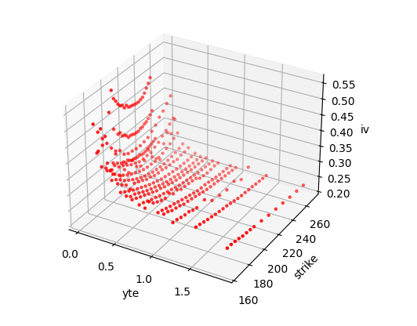
Fig 12.3 : Plot of YTE (τ), strike (K), and implied volatility (ν) for AAPL call options.

The two structures are related to the local volatility of the underlying asset, and the implied volatility surface must first be parameterized for this purpose. In practice, the implied volatility surface is parameterized as

$\text{(}\text{K}\text{, }\text{) } {\text{h}}_{\text{1}}\left(\right) {\text{h}}_{\text{2}}\left(\right){\text{X}}_{} {\text{h}}_{\text{3}}\left(\right){\text{X}}_{}^{\text{2}}\text{ , } {\text{X}}_{} {\text{tan}}^{\text{1}}\left(\text{ln}\left(\frac{\text{K}}{\text{S}{\text{(0)}\text{e}}^{\text{r}}}\right)\right)$ (12.14)

with coefficients h₁(τ), h₂(τ), and h₃(τ) depending on the time to expiration. The term X_{τ} is known as the moneyness of the option in which an arctangent function is used to avoid singularity when strike price K is very small. For each of the expiration term {τ₁, τ₂, ...} in the market data, the volatility skew structures (ν versus K) can be obtained by linear least-square fitting of the coefficients to the implied volatilities in the data. As discussed in appendix (11.1), the truncated set of basis functions are chosen to be {1, X_{τ}(K) ${\text{X}}_{}^{\text{2}}$(K)} with m = 3 in this case. The Python function volSkewCurve() evaluates the coefficients h₁(τ), h₂(τ), and h₃(τ) for the fitted skew curves with different time to expiration. They are shown in figure (12.4). The same figure displays, for example, the fitted volatility skew curves for selected time to expirations as generated by the Python function fittedVolSkewCurve().

def moneyness(assetPrice,riskFreeRate,strike,yte):
from math import log,exp,atan
return atan(log(strike/(assetPrice*exp(riskFreeRate*yte))))
#
def volSkewCoeff(assetPrice,riskFreeRate,yteData,strikeData,ivData,ytebreak):
from linearLeastSquaresFit import bfuncFit
#
skewCoeff=[]
yteList=[]
nCurve=len(ytebreak)-1
for i in range(nCurve):
yte=yteData[ytebreak[i]]
strikes=strikeData[ytebreak[i]:ytebreak[i+1]-1]
ivs=ivData[ytebreak[i]:ytebreak[i+1]-1]
#
phi=[]
nStrike=len(strikes)-1
for j in range(nStrike+1):
x=moneyness(assetPrice,riskFreeRate,strikes[j],yte)
phi.append([0,1.0,x,x**2])
skewCoeff.append(bfuncFit(ivs,phi,nStrike,3))
yteList.append(yte)
#
return yteList,skewCoeff
#
def fittedVolSkewCurve(assetPrice,riskFreeRate,yteList,skewCoeff,strike,i):
x=moneyness(assetPrice,riskFreeRate,strike,yteList[i])
return skewCoeff[i][1]+skewCoeff[i][2]*x+skewCoeff[i][3]*x**2

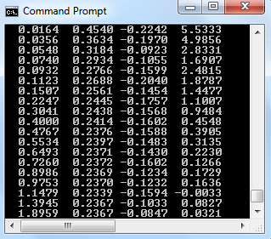
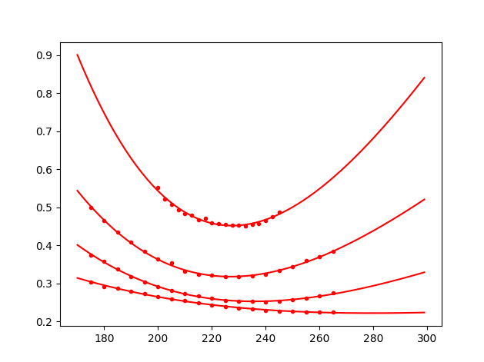
τ = 0.0164
τ = 0.0548
τ = 0.1507
τ = 0.4767
iv
strike

Fig 12.4 : Coefficients of the fitted volatility skew curves (τ, h₁(τ), h₂(τ), h₃(τ)) together with the plots for selected time to expiration in year.

It is effective to define implied volatilty term structure by assuming an exponential convergence for the skew coefficients with suppression rates {α₁, α₂, α₃}, long-run values {a₁, a₂, a₃}, and ranges {b₁, b₂, b₃} as

${\text{h}}_{\text{j}}\left(\right) {\text{a}}_{\text{j}} {\text{b}}_{\text{j}}{\text{e}}^{{}_{\text{j}}\sqrt{}} \text{, } \text{j} \text{ 1, 2, 3}$ (12.15)

As shown below, the Python function fitVolSkewCoeffTerm() estimates these three parameters for the skew coefficients by minimizing the mean-square error from their previously established values. For skew coefficient h_{j}(τ), the mean-square error with given rate, long-run value and range is evaluated as

$\text{mse}\text{(}{}_{\text{j}}\text{,} {\text{a}}_{\text{j}}\text{, }{\text{b}}_{\text{j}}\text{) } \left(\frac{\text{1}}{\text{L}}\right)\sum_{\text{i} \text{ 1}}^{\text{L}}{{\left({\text{a}}_{\text{j}} {\text{b}}_{\text{j}}{\text{e}}^{{}_{\text{j}}\sqrt{{}_{\text{i}}}} {\text{h}}_{\text{j}}\left({}_{\text{i}}\right)\right)}^{\text{2}}}$ (12.16)

The optimal values of α_{j}, a_{j}, and b_{j} can then be estimated by calling the function minimize() in scipy module with the callable function taken to be mse(). Initial values of the optimal search are taken to be α_{j} = 0, a_{j} = h_{j}(τ_{L}), and b_{j} = h_{j}(τ₁) − h_{j}(τ_{L}) where τ₁ and τ_{L} are the shortest and longest time to expiration, respectively, as shown in figure (12.4). The parameters are estimated to be {α₁ = 9.31, a₁ = 0.24, , b₁ = 0.72}, {α₂ = 0.014, a₂ = 3.57, b₂ = −3.76, }, and {α₃ = 5.59, a₃ = 0.11, b₃ = 11.49} with the exponential convergence of the skew coefficients as displayed in figure (12.5).

def fitVolSkewCoeffTerm(yteList,skewCoeff):
from scipy.optimize import minimize
skewCoeffParameters=[0]
L=len(yteList)-1
for j in [1,2,3]:
pa=yteList,skewCoeff,j
xctrial=[0.0,skewCoeff[L][j],skewCoeff[0][j]-skewCoeff[L][j]]
skewCoeffParameters.append(minimize(mse,xctrial,args=(pa)).x)
return skewCoeffParameters
#
def mse(xc,yteList,skewCoeff,j):
from math import exp,sqrt
L=len(yteList)-1
mse=0
for i in range(L+1):
yte=yteList[i]
hfit=xc[1]+exp(-xc[0]*sqrt(yte))*xc[2]
mse+=(skewCoeff[i][j]-hfit)**2
mse=mse/(L+1)
return mse
Fig 12.5 : Exponential covergence of the skew coefficients.

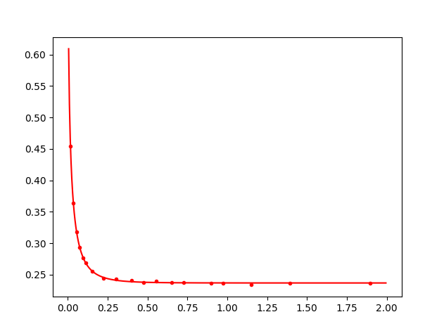
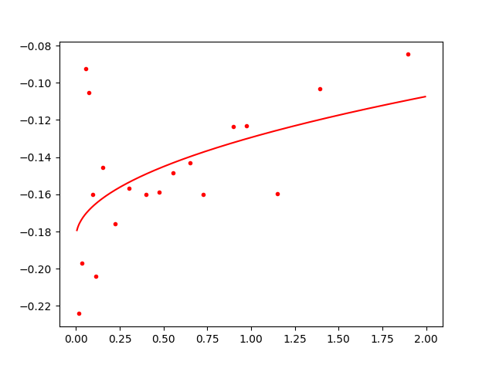
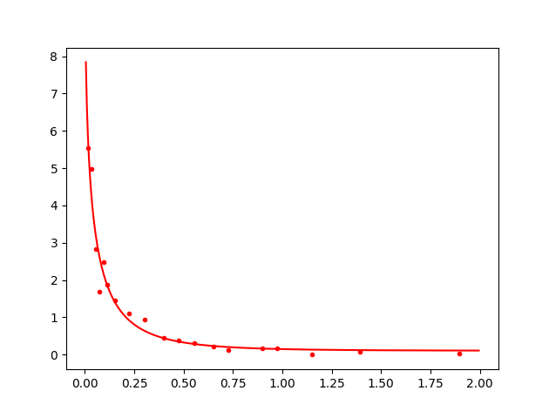
yte
yte
yte
h₁(τ)
h₂(τ)
h₃(τ)

Skew coefficients {h₁(τ), h₂(τ), h₃(τ)} at any time to expiration τ are evaluated from (12.15) through the use of the Python function volSkewCoeffTerm() as shown below. Implied volatility term curve ν(K, τ) can then be constructed using (12.14) with moneyness X_{τ} defined by the strike price. Figure (12.6) sketches the implied volatility surface by plotting the volatility term curves, using the Python function fittedVolTermCurve(), for a set of strike prices. In the Dupire volatility theory, implied volatility surface can be related to the local volatility structure of the underlying asset as it will be discussed in the next section.

def volSkewCoeffTerm(skewCoeffParameters,yte,j):
from math import exp,sqrt
return skewCoeffParameters[j][1]+exp(-skewCoeffParameters[j][0]*sqrt(yte))*skewCoeffParameters[j][2]
#
def fittedVolTermCurve(assetPrice,riskFreeRate,skewCoeffParameters,yte,strike):
x=volSkew.moneyness(assetPrice,riskFreeRate,strike,yte)
h=[None]
for j in [1,2,3]:
h.append(volSkewCoeffTerm(skewCoeffParameters,yte,j))
return h[1]+h[2]*x+h[3]*x**2

Fig 12.6 : Implied volatility surface for AAPL call options.

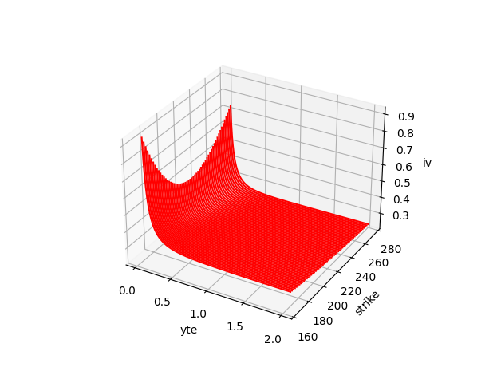

12.3 Dupire Volatility Theory

In derivative pricing, a local volatility model considers the volatility in the stochastic process of asset price return as a function of both asset price and time. Despite the volatility function is not known, it can be calibrated through the implied volatility skew and term structures under the Dupire volatility theory. In this sense, derivative pricing can be done using a volatility structure consistence with the market prices of European style instruments. In the last section, we discussed the construction of the implied volatility surface from market prices of European call option contracts. Here, we will derive the Dupire's formula that enables evaluation of the local volatility given asset price and time using the surface.

In a general formulation, the risk neutral process of a tradable underlying asset can be defined as

$\frac{\text{dQ}\text{(}\text{t}\text{)}}{\text{Q}\text{(}\text{t}\text{)}} \text{rdt} \text{(}\text{Q}\text{(}\text{t}\text{), }\text{t}\text{)}\text{d}{\text{z}}_{\text{t}}$ (12.17)

where σ(Q(t), t) is an unknown local volatility function evaluated with respect to asset price and time. In the risk neutral pricing, the current price of European call option contract c(S(0), K, τ) with asset price S(0), strike price K, and expiration time τ is given by

$$\text{c}\text{(}\text{S}\text{(0), }\text{K}\text{, }\text{) } {\text{e}}^{\text{r}}{\text{E}}_{\text{Q}}\left(\text{max}\text{(}\text{Q}\text{(}\text{) } \text{K}\text{, 0)}\text{|}\text{Q}\text{(0) } \text{S}\text{(0)}\right)$$

${\text{e}}^{\text{r}}\int_{\text{K}}{\text{dy}\text{(}\text{y} \text{K}\text{)}\left(\text{y}\text{, }\text{S}\text{(0), }\right)}$ (12.18)

where ψ(y, S(0), τ) is the probability density function defined with Q(τ) = y at time τ starting from Q(0) = S(0) at current time. Referring to (12.17), the probability density function of the risk neutral process satisfies the forward Kolmogorov equation given by

$\frac{}{}\left(\text{y}\text{, }\text{S}\text{(0), }\right) \frac{}{\text{y}}\left(\text{ry}\left(\text{y}\text{, }\text{S}\text{(0), }\right)\right) \frac{\text{1}}{\text{2}}\frac{{}^{\text{2}}}{{\text{y}}^{\text{2}}}\left({}^{\text{2}}\text{(}\text{y}\text{, }\text{)}{\text{y}}^{\text{2}}\left(\text{y}\text{, }\text{S}\text{(0), }\right)\right)$ (12.19)

It is straightforward to evaluate the partial derivatives of call price in (12.18) with respect to strike price K and expiration time τ as

$\frac{\text{c}\text{(}\text{S}\text{(0), }\text{K}\text{, }\text{)}}{\text{K}} {\text{e}}^{\text{r}}\int_{\text{K}}{\text{dy}\left(\text{y}\text{, }\text{S}\text{(0), }\right)}$ (12.20)

$\frac{{}^{\text{2}}\text{c}\text{(}\text{S}\text{(0), }\text{K}\text{, }\text{)}}{{\text{K}}^{\text{2}}} {\text{e}}^{\text{r}}\left(\text{K}\text{, }\text{S}\text{(0), }\right)$ (12.21)

$\frac{\text{c}\text{(}\text{S}\text{(0), }\text{K}\text{, }\text{) }}{} \text{rc}\text{(}\text{S}\text{(0), }\text{K}\text{, }\text{) } {\text{e}}^{\text{r}}\int_{\text{K}}{\text{dy}\text{(}\text{y} \text{K}\text{)}\frac{}{}\left(\text{y}\text{, }\text{S}\text{(0), }\right)}$ (12.22)

It is instructive to replace the term (∂ψ/∂τ) in (12.22) by the right side of (12.19) and evaluate the integrals using integration by parts to give the Dupire equation as

$\frac{\text{c}\text{(}\text{S}\text{(0), }\text{K}\text{, }\text{)}}{} \text{rK}\frac{\text{c}\text{(}\text{S}\text{(0), }\text{K}\text{, }\text{)}}{\text{K}} \frac{\text{1}}{\text{2}}{}^{\text{2}}\text{(}\text{K}\text{, }\text{)}{\text{K}}^{\text{2}}\frac{{}^{\text{2}}\text{c}\text{(}\text{S}\text{(0), }\text{K}\text{, }\text{)}}{{\text{K}}^{\text{2}}}$ (12.23)

The equation defines the dependence of European call price with respect to the strike price and expiration time. More importantly, it can be rewritten as an expression of the so-called Dupire local volatility function given by

${}^{\text{2}}\text{(}\text{K}\text{, }\text{)} \frac{\frac{\text{c}\text{(}\text{S}\text{(0), }\text{K}\text{, }\text{)}}{} \text{rK}\frac{\text{c}\text{(}\text{S}\text{(0), }\text{K}\text{, }\text{)}}{\text{K}}}{\frac{\text{1}}{\text{2}} {\text{K}}^{\text{2}}\frac{{}^{\text{2}}\text{c}\text{(}\text{S}\text{(0), }\text{K}\text{, }\text{)}}{{\text{K}}^{\text{2}}}}$ (12.24)

At current time with asset price S(0), we see market European call prices for different strike prices and expiration times. Local volatility σ(x, t) with asset price x at forward time t can be calibrated through their skew and term structures in (12.24) with strike price K as x and expiration time τ as t. Using the calibrated local volatility, the risk neutral pricing of European call prices are expected to be the same as the market prices, and the pricings of other derivative contracts are said to be consistent with market European call prices.

On the other hand, we can define the current pricing of the European call option contract c(S(0), K, τ) using the Black-Scholes pricing formula parametrized by the corresponding implied volatility ν(K, τ) as

${\text{c}}_{\text{BS}}\text{(}\text{S}\text{(0), }\text{K}\text{, }\text{, }\text{(}\text{K}\text{, }\text{)}\text{)} \text{S}\text{(0)}\text{N}\left({\text{d}}_{\text{1}}\right) \text{K}{\text{e}}^{\text{r}}\text{N}\left({\text{d}}_{\text{2}}\right)$ , ${\text{d}}_{\text{1}} \frac{\text{log}\left(\frac{\text{S}\text{(0)}}{\text{K}}\right) \left(\text{r} \frac{\text{1}}{\text{2}}{\text{(}\text{K}\text{, }\text{)}}^{\text{2}}\right)}{\text{(}\text{K}\text{, }\text{)}\sqrt{}}$ , ${\text{d}}_{\text{2}} {\text{d}}_{\text{1}} \text{(}\text{K}\text{, }\text{)}\sqrt{}$ (12.25)

The Black-Scholes formula is consistent with the market call price in which we can evaluate the terms (∂c/∂τ), (∂c/∂K), and (∂²c/∂K²) in (12.24), and derive an expression of the local volatility with respect to skew and term structures of implied volatility. This gives

$\frac{\text{c}\text{(}\text{S}\text{(0), }\text{K}\text{, }\text{) }}{} \frac{\text{S}\text{(0)}{}_{\text{01}}\left({\text{d}}_{\text{1}}\right)}{\text{2}\sqrt{}}\left(\text{(}\text{K}\text{, }\text{)} \text{2}\frac{\text{(}\text{K}\text{, }\text{)}}{}\right) \text{r}\text{K}{\text{e}}^{\text{r}}\text{N}\left({\text{d}}_{\text{2}}\right)$ (12.26)

$\frac{\text{c}\text{(}\text{S}\text{(0), }\text{K}\text{, }\text{)}}{\text{K}} \text{S}\text{(0)}{}_{\text{01}}\left({\text{d}}_{\text{1}}\right)\sqrt{}\frac{\text{(}\text{K}\text{, }\text{)}}{\text{K}} {\text{e}}^{\text{r}}\text{N}\left({\text{d}}_{\text{2}}\right)$ (12.27)

$\frac{{}^{\text{2}}\text{c}\text{(}\text{S}\text{(0), }\text{K}\text{, }\text{)}}{{\text{K}}^{\text{2}}} \frac{\text{1}}{{\text{K}}^{\text{2}}}\frac{\text{S}\text{(0)}{}_{\text{01}}\left({\text{d}}_{\text{1}}\right)}{\text{(}\text{K}\text{, }\text{)}\sqrt{}}\left({\left(\text{1 } {\text{d}}_{\text{1}}\sqrt{}\text{K}\frac{\text{(}\text{K}\text{, }\text{)}}{\text{K}}\right)}^{\text{2}} \text{(}\text{K}\text{, }\text{)}\left({\text{K}}^{\text{2}}\frac{{}^{\text{2}}\text{(}\text{K}\text{, }\text{)}}{{\text{K}}^{\text{2}}} {\text{d}}_{\text{1}}\sqrt{}{\left(\text{K}\frac{\text{(}\text{K}\text{, }\text{)}}{\text{K}}\right)}^{\text{2}}\right)\right)$ (12.28)

and the local volatility in (12.24) can be rewritten as

${}^{\text{2}}\text{(}\text{K}\text{, }\text{) } \frac{{\text{(}\text{K}\text{, }\text{)}}^{\text{2}} \text{ 2}\text{(}\text{K}\text{, }\text{)}\left(\frac{\text{(}\text{K}\text{, }\text{)}}{} \text{r}\text{K}\frac{\text{(}\text{K}\text{, }\text{)}}{\text{K}}\right)}{{\left(\text{1 } \text{bK}\frac{\text{(}\text{K}\text{, }\text{)}}{\text{K}}\right)}^{\text{2}} \text{(}\text{K}\text{, }\text{)}\left({\text{K}}^{\text{2}}\frac{{}^{\text{2}}\text{(}\text{K}\text{, }\text{)}}{{\text{K}}^{\text{2}}} \text{b}{\left(\text{K}\frac{\text{(}\text{K}\text{, }\text{)}}{\text{K}}\right)}^{\text{2}}\right)}\text{ , } \text{b} \frac{\text{log}\left(\frac{\text{S}\text{(0)}}{\text{K}}\right) \left(\text{r} \frac{\text{1}}{\text{2}}{\text{(}\text{K}\text{, }\text{)}}^{\text{2}}\right)}{\text{(}\text{K}\text{, }\text{)}}$ (12.29)

In the same sense, local volatility σ(x, t) with asset price x at forward time t can also be calibrated through the implied volatility surface derived from the market call prices. It is convenient to estimate the partial derivatives (∂ν/∂τ), (∂ν/∂K) and (∂²ν/∂K²) in (12.29) using the parametrized volatility skew structure in (12.14) given by

$\text{K}\frac{\text{(}\text{K}\text{, }\text{)}}{\text{K}} \frac{\text{1}}{\text{1 } {\text{y}}^{\text{2}} }\left({\text{h}}_{\text{2}}\left(\right) \text{ 2}{\text{h}}_{\text{3}}\left(\right){\text{X}}_{}\right) \text{, } \text{y} \text{tan}\left({\text{X}}_{}\right)$ (12.30)

${\text{K}}^{\text{2}}\frac{{}^{\text{2}}\text{(}\text{K}\text{, }\text{)}}{{\text{K}}^{\text{2}}} \frac{\text{1}}{{\left(\text{1 } {\text{y}}^{\text{2}}\right)}^{\text{2}}}\left(\text{2}{\text{h}}_{\text{3}}\left(\right)\right) \frac{{\left(\text{1 } \text{y}\right)}^{\text{2}}}{\text{1 } {\text{y}}^{\text{2}} }\left({\text{h}}_{\text{2}}\left(\right) \text{ 2}{\text{h}}_{\text{3}}\left(\right){\text{X}}_{}\right)$ (12.31)

$\left(\frac{\text{(}\text{K}\text{, }\text{)}}{} \text{rK}\frac{\text{(}\text{K}\text{, }\text{)}}{\text{K}}\right) {\text{h}}_{\text{1}}^{'}\left(\right) {\text{h}}_{\text{2}}^{'}\left(\right){\text{X}}_{} {\text{h}}_{\text{3}}^{'}\left(\right){\text{X}}_{}^{\text{2}} \text{,} {\text{h}}_{\text{j}}^{'}\left(\right) \frac{\text{1}}{\text{2}}{\text{b}}_{\text{j}}{\text{e}}^{{}_{\text{j}}\sqrt{}}\left({}_{\text{j}}\sqrt{}\right)$ (12.32)

The Python function localVol() as shown below evaluates the Dupire's local volatility in (12.29) using the partial derivatives in (12.30) to (12.32) given forward asset price (as K) and forward time (as τ):

def localVol(assetPrice,riskFreeRate,skewCoeffParameters,forwardPrice,forwardTime):
from math import log,tan,sqrt
#
strike,yte=forwardPrice,forwardTime
h1=volTerm.volSkewCoeffTerm(skewCoeffParameters,yte,1)
h2=volTerm.volSkewCoeffTerm(skewCoeffParameters,yte,2)
h3=volTerm.volSkewCoeffTerm(skewCoeffParameters,yte,3)
tdh1=volTerm.tdVolSkewCoeffTerm(skewCoeffParameters,yte,1)
tdh2=volTerm.tdVolSkewCoeffTerm(skewCoeffParameters,yte,2)
tdh3=volTerm.tdVolSkewCoeffTerm(skewCoeffParameters,yte,3)
#
X=volSkew.moneyness(assetPrice,riskFreeRate,strike,yte)
y=tan(X)
term1=(h2+2*h3*X)/(1+y**2)
term2=2*h3/(1+y**2)**2-(h2+2*h3*X)*(1+y)**2/(1+y**2)
term3=tdh1+tdh2*X+tdh3*X**2
#
iv=volTerm.fittedVolTermCurve(assetPrice,riskFreeRate,skewCoeffParameters,yte,strike)
b=(log(assetPrice/strike)+(riskFreeRate+(1/2)*iv**2)*yte)/iv
localVolSq=(iv**2+2*iv*term3)/((1+b*term1)**2+iv*yte*(term2-b*term1**2))
#
if(localVolSq<0):localVolSq=0
#
return sqrt(localVolSq)

As shown in figure (12.7), the local volatility structure of the underlying asset (Apple Inc) is constructed by calling the above Python function for forward asset price around its current asset price of S(0) = $222.78. It should be noted that care must be taken when extending the structure into the left and right regions as it would require a far extrapolation of the implied volatility skew structure in (12.14). It would render the volatility skew structure to be inapplicable and possibly lead to a negative value for local volatility squared. As a remedy, the local volatility squared is defined to be zero in this case. The local volatility term structure is shown to be flatten out with forward time as all three skew coefficients h₁(τ), h₂(τ), and h₃(τ) are defined to be exponentially convergent with time to expiration.

Fig 12.7 : Local volatility structure of AAPL.

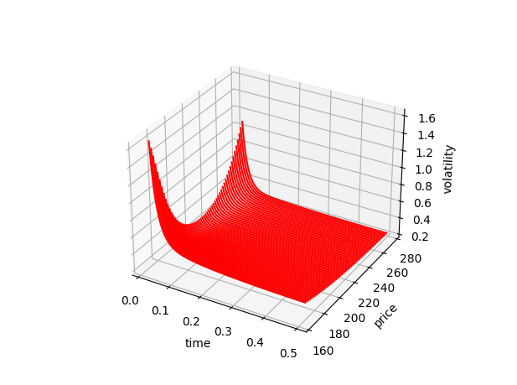

Dupire's volatility model can easily be applied to the Monte Carlo pricing of derivative contract. In Dupire model, local volatility structure is calibrated in the way that the pricings of plain vanilla option contracts are consistent with their market prices. The calibrated structure can then be applied to the pricings of other exotic derivative contracts. In our previous formulation, prices of European call options together with current asset price S(0) and risk-free interest rate r are first extracted from the market. Implied volatility skew coefficients and their term structures are estimated to facilitate calibration of the local volatility function in the stochastic process of asset price. In Monte Carlo pricing, the calibrated volatility function can be used to move forward lognormal asset price starting from S(0) with discrete time increment Δt given by

$\text{Q}\text{(}\text{t} \text{t}\text{)} \text{Q}\text{(}\text{t}\text{)}{\text{e}}^{\left(\text{r} \text{ ½}{\text{(}\text{Q}\text{(}\text{t}\text{), }\text{t}\text{)}}^{\text{2}}\right)\text{t} \text{(}\text{Q}\text{(}\text{t}\text{), }\text{t}\text{)}\sqrt{\text{t}} }$ (12.33)

The Python function mcECallDupire() as shown below implements the Monte Carlo pricing of a European call option contract with strike K and time to expiration τ.

def mcECallDupire(assetPrice,strike,riskFreeRate,skewCoeffParameters,expiration,nstep,nsample):
snn=None
dcfSample=[]
dt=expiration/nstep
for Ls in range(0,nsample):
Qt=assetPrice
for i in range(0,nstep):
sigma=localVol.localVol(assetPrice,riskFreeRate,skewCoeffParameters,Qt,i*dt)
snn=rand.stdnormnum(snn)
Qt=Qt*exp((riskFreeRate-(1/2)*sigma**2)*dt+sigma*sqrt(dt)*snn[0])
dcfSample.append(exp(-riskFreeRate*expiration)*payoff(Qt,strike))
sampleMean=statistics.mean(dcfSample)
stdError=(statistics.stdev(dcfSample))/sqrt(nsample)
return sampleMean,stdError
#
def payoff(assetPrice,strike):
return max(assetPrice-strike,0)
#
#-------------------------------------------------------------------------------------------
assetPrice,riskFreeRate,hisVol,marketCallData,numberOfCall=readfile('AAPL_CALL.xlsx','Call prices')
#
prec,tol=1.e-8,1.e-12
yteData,strikeData,ivData,ytebreak=impVol.impVol(assetPrice,riskFreeRate,hisVol,marketCallData,\
numberOfCall,prec,tol)
yteList,skewCoeff=volSkew.volSkewCoeff(assetPrice,riskFreeRate,yteData,strikeData,ivData,ytebreak)
skewCoeffParameters=volTerm.fitVolSkewCoeffTerm(yteList,skewCoeff)
#
rand.seedinit(5678)
for strike in [180,200,220,240,260]:
expiration,nstep,nsample=0.22466,100,10000
optionPrice,stderr=mcECallDupire(assetPrice,strike,riskFreeRate,skewCoeffParameters,expiration,nstep,\
nsample)
print(strike,optionPrice,stderr)

Figure (12.8) displays, for example, the Monte Carlo pricings of 82-day European call option contracts with different strike prices K and current asset price S(0) = $222.78. Sample size is taken to be 10000 with the use of 100 and 1000 time steps in the simulation. The pricings are shown to be consistent with their market prices, and it requires very frequent update of the local volatility along the simulated path, says 100 times or even 1000 times for improved results. In this sense, the pricing of exotic derivative contract using the same model is said to be consistent with the market prices of European call options.
Fig 12.8 : Monte Carlo pricings of 82-day European call option contracts of AAPL.

Strike prices  K | Monte Carlo pricings  (100 steps, 10000 samples) | Monte Carlo pricings  (1000 steps, 10000 samples) | Market Call prices
180 | $46.06 ± 0.29 | $45.96 ± 0.29 | 45.53
200 | $28.26 ± 0.26 | $27.97 ± 0.26 | 27.60
220 | $13.90 ± 0.21 | $13.45 ± 0.22 | 13.05
240 | $5.31 ± 0.16 | $4.96 ± 0.17 | 4.53
260 | $1.78 ± 0.13 | $1.57 ± 0.14 | 1.36

Appendix 12.1 : Estimation of the mean and long-run variance parameters in GARCH(1,1) model

Suppose we want to estimate the mean parameter in the model using the estimator given by

$\text{E}\left(\frac{{\text{r}}_{\text{1}} {\text{r}}_{\text{t}}}{\text{t}}\right)$ (A12.1)

Variance of the estimand can be evaluated as

$\text{Var}\left(\frac{{\text{r}}_{\text{1}} {\text{r}}_{\text{t}}}{\text{t}}\right) \text{E}\left({\left(\frac{\text{(}{\text{r}}_{\text{1}} \text{) } \text{ (}{\text{r}}_{\text{t}} \text{)}}{\text{t}}\right)}^{\text{2}}\right)$
$\text{E}\left(\frac{{\text{(}{\text{r}}_{\text{1}} \text{)}}^{\text{2}} {\text{ (}{\text{r}}_{\text{t}} \text{)}}^{\text{2}}}{{\text{t}}^{\text{2}}}\right) \text{, } \text{as }\text{E}\left(\text{(}{\text{r}}_{\text{s}} \text{)(}{\text{r}}_{\text{u}} \text{)}\right) \text{ 0}$
$\frac{\text{1}}{{\text{t}}^{\text{2}}}\sum_{\text{i} \text{ 1}}^{\text{t}}{\text{E}\left({}_{\text{i}}^{\text{2}}\right)}$
$\frac{{\text{V}}_{\text{L}}}{\text{t}}$ (A12.2)

where we have used (r_{i} − μ)² = ${}_{\text{i}}^{\text{2}}$ε² that gives E((r_{i} − μ)²) = E(${}_{\text{i}}^{\text{2}}$)E(ε²) = E(${}_{\text{i}}^{\text{2}}$). Stationary condition also requires the expected value$\text{E}\left({}_{\text{u}}^{\text{2}}\right)$ to be the same at all time given by the long-run variance V_{L}.

Similarly, we can estimate the long-run variance parameter in the model using the estimator as

${\text{V}}_{\text{L}} \text{E}\left(\frac{{({\text{r}}_{\text{1}} )}^{\text{2}} {({\text{r}}_{\text{t}} )}^{\text{2}}}{\text{t}}\right)$ (A12.3)

Again, variance of the estimand can be evaluated to be

$\text{Var}\left(\frac{{({\text{r}}_{\text{1}} )}^{\text{2}} {({\text{r}}_{\text{t}} )}^{\text{2}}}{\text{t}}\right) \text{E}\left({\left(\frac{{({\text{r}}_{\text{1}} )}^{\text{2}} {({\text{r}}_{\text{t}} )}^{\text{2}}}{\text{t}}\right)}^{\text{2}}\right) {\text{V}}_{\text{L}}^{\text{2}}$

$\frac{\text{1}}{{\text{t}}^{\text{2}}}\sum_{\text{i} \text{1}}^{\text{t}}{\text{E}\left({\left({\text{r}}_{\text{i}} \right)}^{\text{4}}\right)}\frac{\text{1}}{{\text{t}}^{\text{2}}}\sum_{\text{i} \text{k}}{\text{E}\left({\left({\text{r}}_{\text{i}} \right)}^{\text{2}}{\left({\text{r}}_{\text{k}} \right)}^{\text{2}}\right)} {\text{V}}_{\text{L}}^{\text{2}}$

$\frac{\text{3}}{{\text{t}}^{\text{2}}}\sum_{\text{i} \text{ 1}}^{\text{t}}{\text{E}\left({}_{\text{i}}^{\text{4}}\right)}\frac{\text{1}}{{\text{t}}^{\text{2}}}\sum_{\text{i} \text{k}}{\text{E}\left({}_{\text{i}}^{\text{2}}{}_{\text{k}}^{\text{2}}\right)} {\text{V}}_{\text{L}}^{\text{2}}$

where we have used E((r_{i} − μ)⁴) = E(${}_{\text{i}}^{\text{4}}$)E(ε⁴) = 3E(${}_{\text{i}}^{\text{4}}$) and E((r_{i} − μ)²(r_{k} − μ)²) = E(${}_{\text{i}}^{\text{2}}{}_{\text{k}}^{\text{2}}$)E(ε²)E(ε'²) = E(${}_{\text{i}}^{\text{2}}{}_{\text{k}}^{\text{2}}$).

From (12.5), we have

${}_{\text{t}}^{\text{2}}{}_{\text{t} \text{k}}^{\text{2}} \text{ (1 } \text{)}{\text{V}}_{\text{L}}{}_{\text{t} \text{k}}^{\text{2}} {\left({\text{r}}_{\text{t} \text{ 1}} \right)}^{\text{2}}{}_{\text{t} \text{k}}^{\text{2}} {}_{\text{t} \text{ 1}}^{\text{2}}{}_{\text{t} \text{k}}^{\text{2}}$

and hence,$\text{E}\left({}_{\text{t}}^{\text{2}}{}_{\text{t} \text{k}}^{\text{2}}\right) \text{ (1 } \text{)}{\text{V}}_{\text{L}}^{\text{2}} \text{(} \text{)}\text{E}\left({}_{\text{t} \text{ 1}}^{\text{2}}{}_{\text{t} \text{k}}^{\text{2}}\right)$ which is true for all k. We can apply (12.5) iteratively for the past variances {${}_{\text{t} \text{k}}^{\text{2}}$, ${}_{\text{t} \text{k} \text{ 1}}^{\text{2}}$, ... , ${}_{\text{t} \text{k} \text{m} \text{1}}^{\text{2}}$} on the right side of the expression to give

$\text{E}\left({}_{\text{t}}^{\text{2}}{}_{\text{t} \text{k}}^{\text{2}}\right) \text{ (1 } \text{)}\left(\text{1 } \sum_{\text{i} \text{1}}^{\text{m}}{{\left( \right)}^{\text{i}}}\right){\text{V}}_{\text{L}}^{\text{2}} {\text{(} \text{)}}^{\text{m} \text{1}}\text{E}\left({}_{\text{t} \text{ 1}}^{\text{2}}{}_{\text{t} \text{k} \text{m}}^{\text{2}}\right)$

$$\left(\text{1 } {\text{(} \text{)}}^{\text{m} \text{1}}\right){\text{V}}_{\text{L}}^{\text{2}} {\text{(} \text{)}}^{\text{m} \text{1}}\text{E}\left({}_{\text{t} \text{ 1}}^{\text{2}}{}_{\text{t} \text{k} \text{m}}^{\text{2}}\right)$$

$\text{as} \text{1 } \sum_{\text{i} \text{ 1}}^{\text{m}}{{\left( \right)}^{\text{i}}} \frac{\text{1 } {\text{(} \text{)}}^{\text{m} \text{1}}}{\text{1 } }\text{ , for } \text{ 1}$

${\text{V}}_{\text{L}}^{\text{2}} \text{, when we take }\text{m} \text{ as }\text{it}\text{ is arbitrary}$ (A12.4)

Hence, variance of the estimand in (A12.3) is given by

$\text{Var}\left(\frac{{({\text{r}}_{\text{1}} )}^{\text{2}} {({\text{r}}_{\text{t}} )}^{\text{2}}}{\text{t}}\right) \frac{\text{2}{\text{V}}_{\text{L}}^{\text{2}}}{\text{t}}$ (A12.5)

Appendix 12.2 : Netwon-Raphson Method

In this appendix, we consider a powerful numerical procedure known as Newton-Raphson method capable of solving the root of a smooth function g(x), with continuous derivative, given by g(x_{root}) = 0. The method is initiated by a trial guess of the root x_{trial} (i.e. x_{root} = x_{trial} + e) where the error e involved is presumably small. The Taylor expansion of the function in the neighborhood of x_{trial} can be written as

$\text{g}\text{(}{\text{x}}_{\text{trial}} \text{e}\text{) } \text{g}\text{(}{\text{x}}_{\text{trial}}\text{) } \text{g}\text{(}{\text{x}}_{\text{trial}}\text{)} \text{e} \text{Order}\text{(}{\text{e}}^{\text{2}}\text{)}$ (A12.6)

where there are higher-order terms of at least in quadratic power of e. As g(x_{trial} + e) = g(x_{root}) = 0, it gives an estimation of the error as e ≅ − g(x_{trial})/g'(x_{trial}) for this condition to be true when all higher-order terms on the right side of (A12.6) are negligible. Accordingly, the trial guess can be improved to become

${\text{x}}_{\text{better}} {\text{x}}_{\text{trial}} \text{g}\text{(}{\text{x}}_{\text{trial}}\text{)/}\text{g}\text{(}{\text{x}}_{\text{trial}}\text{)}$ (A12.7)

The error involved in the improved guess is defined as x_{root} = x_{better} + e′, and it can be written in term of the previous error e as

$\text{e} \text{e} \text{g}\text{(}{\text{x}}_{\text{root}} \text{e}\text{)/}\text{g}\text{(}{\text{x}}_{\text{root}} \text{e}\text{)} \frac{\text{1}}{\text{2}}\left(\text{g}\text{(}{\text{x}}_{\text{root}}\text{)/}\text{g}\text{(}{\text{x}}_{\text{root}}\text{)}\right){\text{e}}^{\text{2}}$

For small enough e, the size of e′ is in quadratic power of e. The iteration as described in (A12.7) can be applied recursively for which x_{better} is substituted back to the right side as x_{trial} for further improvement. Hence, the recursive procedure is expected to be quadratic convergent to x_{root}. To proceed, it requires the evaluation of both the function and the derivative at the guess value. Under a defined precision Δx, the derivative can be approximated using the numerical difference given by

$\text{g}\text{(}\text{x}\text{) } \frac{\text{g}\text{(}\text{x} \text{x}\text{)} \text{g}\text{(}\text{x}\text{)} }{\text{x}} \text{Order}\text{(}\text{x}\text{)}$ (A12.8)

The Newton-Raphson procedure should proceed recursively using (A12.7) and stop when the improvement has reached the precision limit or exit criteria of |x_{better} − x_{trial}| ≤ Δx. The Python function newtonRaphson_scalar() as shown below implements the Newton-Raphson procedure taking a user-defined callable function userfunc(x), a trial value of x, a precision limit prec that defines the exit criteria, and other passing arguments pa packed as Python tuple to the function.

def maxIteration():
return 1000
#
def newtonRaphson_scalar(userfunc,x,prec,pa):
from math import fabs
#
for nItr in range(maxIteration()):
xtrial=x
g=userfunc(xtrial,pa)
gshift=userfunc(xtrial+prec,pa)
dgdx=(gshift-g)/prec
x=xtrial-g/dgdx
precMet=(fabs(x-xtrial)<=prec)
if(precMet): break
dev=userfunc(x,pa)
#
return x,precMet,dev

The root of userfunc(x) is outputted together with a flag precMet (True of False) indicating whether the exit criteria has been fulfilled. As a reference, discrepancy of the result dev is defined and outputted by evaluating the function using the exit value of x. It should be noted that the maximum number of iteration maxIteration() of the procedure must be defined to avoid entering into a dead loop.

The method can be generalized to multiple functions {g₁(x), ... , g_{n}(x)} with variables x = (x₁, ... , x_{n}). Here, the problem aims at solving the root vector x_{root} defined through the system of equations as

$\left\{\begin{aligned}{\text{g}}_{\text{1}}\left({\text{x}}_{\text{root}}\right) \text{ 0} \\ \\ {\text{g}}_{\text{n}}\left({\text{x}}_{\text{root}}\right) \text{ 0}\end{aligned}\right.$ (A12.9)

Consider a trial guess x_{trial} of the root vector (i.e. x_{root} = x_{trial} + e) with errors e = (e₁, ... , e_{n}). The Taylor expansions of the multivariable functions in the neighborhood of the trial guess can be written as

${\text{g}}_{\text{i}}\text{(}{\text{x}}_{\text{trial}} \text{e}\text{) } {\text{g}}_{\text{i}}\text{(}{\text{x}}_{\text{trial}}\text{) }\sum_{\text{j} \text{1}}^{\text{n}}{\left(\frac{}{{\text{x}}_{\text{j}}}{\text{g}}_{\text{i}}\text{(}{\text{x}}_{\text{trial}}\text{)}\right)}{\text{e}}_{\text{j}} \text{Order}\text{(all}{ \text{e}}_{\text{i}}{\text{e}}_{\text{j}}\text{) , }\text{i} \text{ 1, ... , }\text{n}$ (A12.10)

All g_{i}(x_{trial} + e) must vanish simultaneously as x_{trial} + e is the solution of the system of equations. Again, we can estimate the errors in the trial solution and improve the guess to be

${\text{x}}_{\text{better}} {\text{x}}_{\text{trial}} {}^{\text{1}}\text{(}{\text{x}}_{\text{trial}}\text{) }\text{g}\text{(}{\text{x}}_{\text{trial}}\text{) }$ (A12.11)

where x_{better}, x_{trial} and g(x_{trial}) are formulated to be n × 1 column vectors in the matrix equation, and Ω(x_{trial}) is a n × n square matrix given by

$\text{(}{\text{x}}_{\text{trial}}\text{) }\left(\begin{matrix}{\text{g}}_{\text{1}}\text{(}{\text{x}}_{\text{trial}}\text{)/}{\text{x}}_{\text{1}} & & {\text{g}}_{\text{1}}\text{(}{\text{x}}_{\text{trial}}\text{)/}{\text{x}}_{\text{n}} \\ & & \\ {\text{g}}_{\text{n}}\text{(}{\text{x}}_{\text{trial}}\text{)/}{\text{x}}_{\text{1}} & & {\text{g}}_{\text{n}}\text{(}{\text{x}}_{\text{trial}}\text{)/}{\text{x}}_{\text{n}}\end{matrix}\right)$ (A12.12)

The partial derivatives in (A12.12) can be approximated using the numerical difference under a defined precision Δx as

$\frac{{\text{g}}_{\text{i}}\text{(}\text{x}\text{)}}{{\text{x}}_{\text{j}}}\frac{{\text{g}}_{\text{i}}\text{(}\text{x} {\text{u}}^{\text{(}\text{j}\text{)}}\text{x}\text{) } {\text{g}}_{\text{i}}\text{(}\text{x}\text{)}}{\text{x}} \text{Order}\text{(}\text{x}\text{)}$ (A12.13)

where u^{(j)} is the unit vector in the jth coordinate with ${\text{u}}_{\text{k}}^{\text{(}\text{j}\text{)}}$= δ_{kj}. Similarly, the Newton-Raphson procedure should proceed recursively using (A12.11) and stop when the improvements for all variables have reached the precision limit or exit criteria of |x_{better,i} − x_{trial,i}| ≤ Δx. The Python function newtonRaphson() as shown below implements the procedure taking a callable list of functions userfuncs(x), a trial vector x, the vector size n, and a precision limit prec.

import mop
#
def kroneckerDelta(i,j):
if(i==j):delta=1
else:delta=0
return delta
#
def newtonRaphson_vector(userfuncs,x,n,prec,pa):
from math import fabs
xtrial=[0 for i in range(n)]
xshift=[0 for i in range(n)]
omega=[[0 for j in range(n)] for i in range(n)]
#
for nItr in range(maxIteration()):
for i in range(n):xtrial[i]=x[i]
g=userfuncs(xtrial,pa)
for j in range(n):
for i in range(n):xshift[i]=xtrial[i]+kroneckerDelta(i,j)*prec
gshift=userfuncs(xshift,pa)
for i in range(n):omega[i][j]=(gshift[i]-g[i])/prec
Dx=mop.solveAxb(omega,g,n,0,0,0)
for i in range(n):x[i]=xtrial[i]-Dx[i]
#
precMet=True
for i in range(n):
precMet=precMet and (fabs(x[i]-xtrial[i])<=prec)
if(precMet):break
#
g=userfuncs(x,pa)
maxDev=0
for i in range(n):
if(fabs(g[i])>maxDev):maxDev=fabs(g[i])
#
return x,precMet,maxDev

The matrix operation as described in (A12.11) can be done using the solveAxb() function in the mop module. As before, the root vector of userfuncs() is outputted together with the flag precMet. The maximum discrepancy at exit maxDev among all equations in the system is also outputted.

From (1.18), it can be shown that μT = E(r) + ½Var(r) and σ²T = Var(r), where r = log(S(T)/S(0)) is the logarithmic price return for time increment T.
R.F. Engle, "Autoregressive conditional heteroskedasticity with estimates of the variance of United Kingdom inflation", Econometrica, 50, No. 4, (1982), 987-1007.
T. Bollerslev, "Generalized autoregressive conditional heteroskedasticity", Journal of Econometrics, 31, No. 3, (April 1986), 307-327. See also Robert Engle, “GARCH 101 : The use of ARCH/GARCH models in applied econometrics”, Journal of Economic Perspectives, 15, No. 4 (2001), 157-168.
From (12.4), the expected value of ${}_{\text{t}}^{\text{2}}$ can be written as $\text{E}\left({}_{\text{t}}^{\text{2}}\right) \text{E}\left({\left({\text{r}}_{\text{t} \text{ 1}} \right)}^{\text{2}}\right) \text{E}\left({}_{\text{t} \text{ 1}}^{\text{2}}\right) \text{ (} \text{)}\text{E}\left({}_{\text{t} \text{ 1}}^{\text{2}}\right)$ where we have used the result$\text{E}\left({\left({\text{r}}_{\text{t} \text{ 1}} \right)}^{\text{2}}\right) \text{E}\left({}_{\text{t} \text{ 1}}^{\text{2}}\right)$ in appendix 12.1.
Variance at time s − 1 is given by ${}_{\text{s} \text{ 1}}^{\text{2}} \text{ (1 } \text{)}{\text{V}}_{\text{L}} {\left({\text{r}}_{\text{s} \text{2}} \right)}^{\text{2}} {}_{\text{s} \text{ 2}}^{\text{2}}$. Substituting back to the right hand side of (12.5) at time s, it gives $${}_{\text{s} }^{\text{2}} \text{ (1 } \text{)(1} \text{)}{\text{V}}_{\text{L}} {\left({\text{r}}_{\text{s} \text{1}} \right)}^{\text{2}} {\left({\text{r}}_{\text{s} \text{2}} \right)}^{\text{2}} {}^{\text{2}}{}_{\text{s} \text{ 2}}^{\text{2}}$$ We can repeatedly iterate backward to s − k and get ${}_{\text{s} }^{\text{2}} \text{ (1 } \text{)}\left(\frac{\text{1 } {}^{\text{k}}}{\text{1 } }\right){\text{V}}_{\text{L}} \sum_{\text{i} \text{ 1}}^{\text{k}}{{}^{\text{i} \text{1}}{\left({\text{r}}_{\text{s} \text{i}} \right)}^{\text{2}}} {}^{\text{k}}{}_{\text{s} \text{k}}^{\text{2}}$ .
See Chapter 9 of W.H. Press, S.A. Teukolsky, W.T. Vetterling, and B.P. Flannery, Numerical Recipes in C : The Art of Scientific Computing, 2nd Edition, Cambridge University Press, 1997.
With the same strike and time to expiration, call price = put price + asset price − present value of strike price.
In appendix (11.1), a linear regression model of $\text{f}\text{(}\text{x}\text{) }\sum_{\text{i} \text{ 1}}^{\text{m}}{{\text{c}}_{\text{i}}}{}_{\text{i}}\text{(}\text{x}\text{)}$ is introduced with data set of {ϕ₁(x_{i}), ... , ϕ_{m}(x_{i})} and f(x_{i}) for points {x₀, ... , x_{n}}.
Bruno Dupire, "Pricing with a smile", RISK, Vol. 7, No. 1, (1994) 126-129.
From integration by parts, $\int_{\text{K}}{\text{dy}\text{(}\text{y} \text{K}\text{)}\frac{}{\text{y}}\left(\text{y}\left(\text{y}\text{, }\text{S}\text{(0), }\right)\right)} \lim_{\text{y } }\left(\text{(}\text{y} \text{K}\text{)}\text{y}\left(\text{y}\text{, }\text{S}\text{(0), }\right)\right)\int_{\text{K}}{\text{dyy}\left(\text{y}\text{, }\text{S}\text{(0), }\right)} \int_{\text{K}}{\text{dyy}\left(\text{y}\text{, }\text{S}\text{(0), }\right)}$ ${\text{e}}^{\text{r}}\left(\text{c}\text{(}\text{S}\text{(0), }\text{K}\text{, }\text{)} \text{ K}\frac{\text{c}\text{(}\text{S}\text{(0), }\text{K}\text{, }\text{)}}{\text{K}}\right)$ , using (12.18) and (12.20). $\int_{\text{K}}{\text{dy}\text{(}\text{y} \text{K}\text{)}\frac{{}^{\text{2}}}{{\text{y}}^{\text{2}}}\left({}^{\text{2}}\text{(}\text{y}\text{, }\text{)}{\text{y}}^{\text{2}}\left(\text{y}\text{, }\text{S}\text{(0), }\right)\right)}$ $\lim_{\text{y} }{\text{(}\text{y} \text{K}\text{)}\frac{}{\text{y}}\left({}^{\text{2}}\text{(}\text{y}\text{, }\text{)}{\text{y}}^{\text{2}}\left(\text{y}\text{, }\text{S}\text{(0), }\right)\right)}\lim_{\text{y } }{{}^{\text{2}}\text{(}\text{y}\text{, }\text{)}{\text{y}}^{\text{2}}\left(\text{y}\text{, }\text{S}\text{(0), }\right)} {}^{\text{2}}\text{(}\text{K}\text{, }\text{)}{\text{K}}^{\text{2}}\left(\text{K}\text{, }\text{S}\text{(0), }\right)$ ${}^{\text{2}}\text{(}\text{K}\text{, }\text{)}{\text{K}}^{\text{2}}\left(\text{K}\text{, }\text{S}\text{(0), }\right)$ ${\text{e}}^{\text{r}}{}^{\text{2}}\text{(}\text{K}\text{, }\text{)}{\text{K}}^{\text{2}}\frac{{}^{\text{2}}\text{c}\text{(}\text{S}\text{(0), }\text{K}\text{, }\text{)}}{{\text{K}}^{\text{2}}}$ , using (12.21). where $\lim_{\text{y} }{{\text{y}}^{\text{n}}\left(\text{y}\text{, }\text{S}\text{(0), }\right)}\text{ 0}$ and $\lim_{\text{y} }{{\text{y}}^{\text{n}}\frac{}{\text{y}}\left(\text{y}\text{, }\text{S}\text{(0), }\right)}\text{ 0}$ for Gaussian density function.
We have used the results $\text{K}{\text{e}}^{\text{r}}{}_{\text{01}}\text{(}{\text{d}}_{\text{2}}\text{) } \text{S}\text{(0)}{}_{\text{01}}\text{(}{\text{d}}_{\text{1}}\text{)}$ , $\frac{{}_{\text{01}}\text{(}{\text{d}}_{\text{1}}\text{)}}{\text{K}} {}_{\text{01}}\text{(}{\text{d}}_{\text{1}}\text{)}{\text{d}}_{\text{1}}\frac{{\text{d}}_{\text{1}}}{\text{K}}$ , and $\frac{{\text{d}}_{\text{1}}}{\text{K}}$ $\sqrt{}\frac{\text{(}\text{K}\text{, }\text{)}}{\text{K}} \frac{\left(\text{1 } {\text{d}}_{\text{1}}\sqrt{}\text{K}\frac{\text{(}\text{K}\text{, }\text{)}}{\text{K}}\right)}{\text{K}\text{(}\text{K}\text{, }\text{)}\sqrt{}}$.

