4.26

# include<iostream>

int main()

{

int num,num1,num2,num3,num4;

using namespace std;

cout<<"Input a five-digit";

cin>>num;

num1=num/10000;num4=num%10;num2=num/1000%10;num3=num/10%10;

if(num1==num4)

{

if (num2==num3)

cout<<"The digit is a palindrome";

else

cout<<"The digit is not a palindrome";

}

else

cout<<"The digit is not a palindrome";

system("pause");

return 0;

}

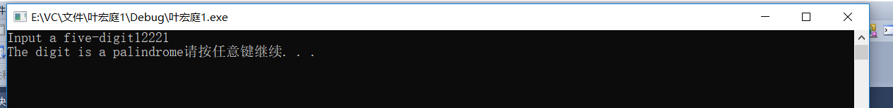

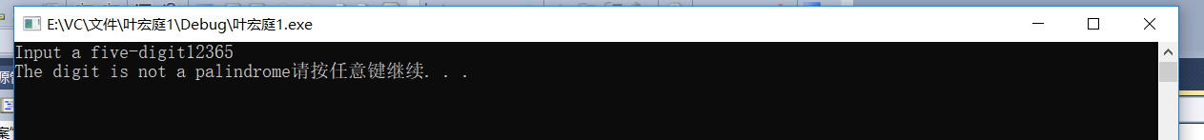

4.26

循环（任意位数）

# include<iostream>

int main()

{

using namespace std;

long long int num;int i=1,wei[100001];

cout<<"Enter a number:"<<endl;

cin>>num;

while(num!=0)

{

wei[i]=num%10;

num/=10;

i++;

}

int a,b;

a=1,b=i-1;

while (b>a)

{

if(wei[a]==wei[b])

a++,b--;

else

{

cout<<"这a不?是º?回?文?数ºy。¡ê"<<endl;

a=b+10;

}

}

if(a==b||b==a-1)

cout<<"这a是º?回?文?数ºy。¡ê"<<endl;

system("pause");

return 0;

}

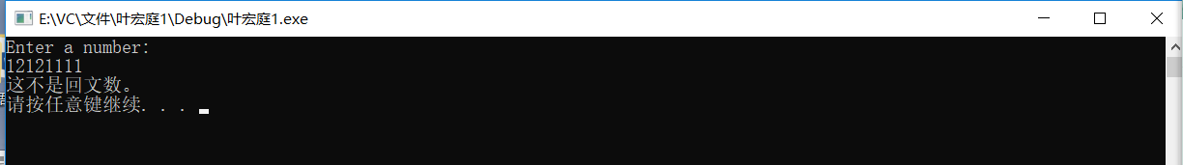

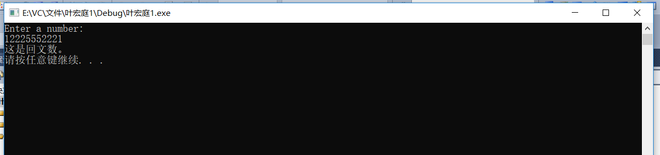

4.27

# include<iostream>

int main ()

{

int num,a,b,m;

a=0;b=1;m=0;

using namespace std;

cout<<"Input a binary numeber:";

cin>>num;

while (num>0)

{ a=num%10;

m+=a*b;

b*=2;

num=num/10;

}

cout<<"The decimal equivalent is"<<m;

system("pause");

return 0;

}

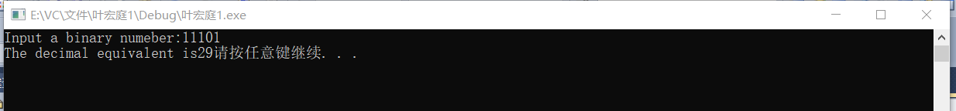



4.34

A）

# include<iostream>

int main()

{

int num,f=1,a;

using namespace std;

cout<<"Input a number:";

cin>>num;

a=num;

if(num==1||num==0)

f=1;

else

while(num>=1)

{

f=f*num;

num=num-1;

}

cout<<a<<"!="<<f;

system("pause");

return 0;

}

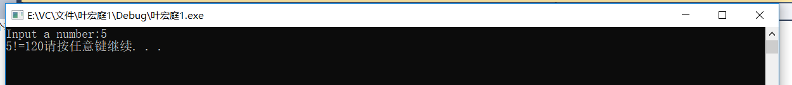

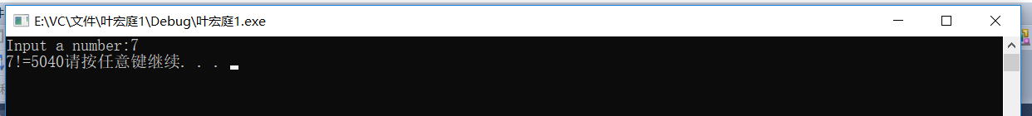

B）

# include<iostream>

int main()

{

int n=1,a,f=1;double e=1.0;

using namespace std;

cout<<"Input an accuracy:";

cin>>a;

while(n<=a)

{

f*=n;

e+=1.0/f;

n++;

}

cout<<"e ="<<e;

system("pause");

return 0;

}

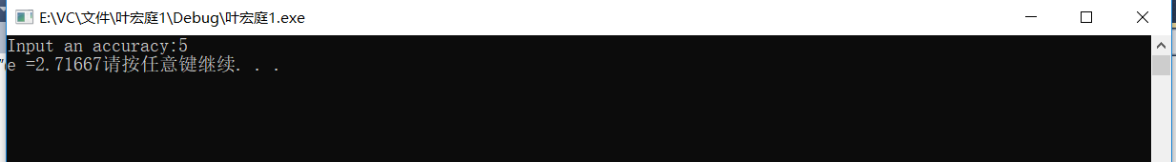

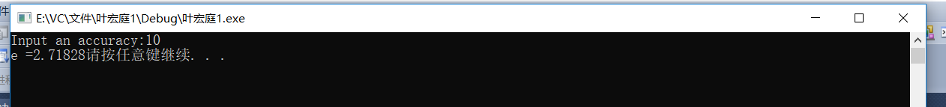

C）

# include<iostream>

int main()

{

int n=1,x,f=1,y;double t=1.0;

using namespace std;

cout<<"Input x:";

cin>>x;

y=x;

while(n<=y)

{

f*=n;

t+=x/f;

n++;

x=x*x;

}

cout<<"e^"<<y<< "="<<t;

system("pause");

return 0;

}

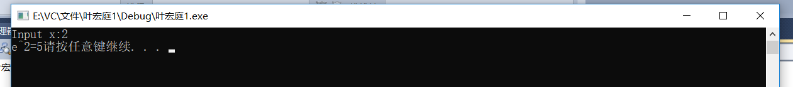

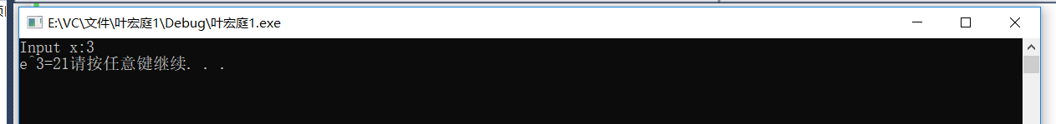

4.16

# include<iostream>

# include<iomanip>

int main()

{

int hours ,hours2;double rate,salary=0;

using namespace std;

cout<<"Enter hours(-1 to end) and hourly rate:"<<endl;

cin>>hours>>rate;

cout<<fixed<<setprecision(2)<<endl;

while(hours!=-1&&hours<=40)

{

salary=hours*rate;

hours=-1;

}

while(hours>40)

{

hours2=hours-40;

salary=40*rate+1.5*rate*hours2;

hours=-1;

}

cout<<"Salary is"<<salary<<endl;

system("pause");

return 0;

}

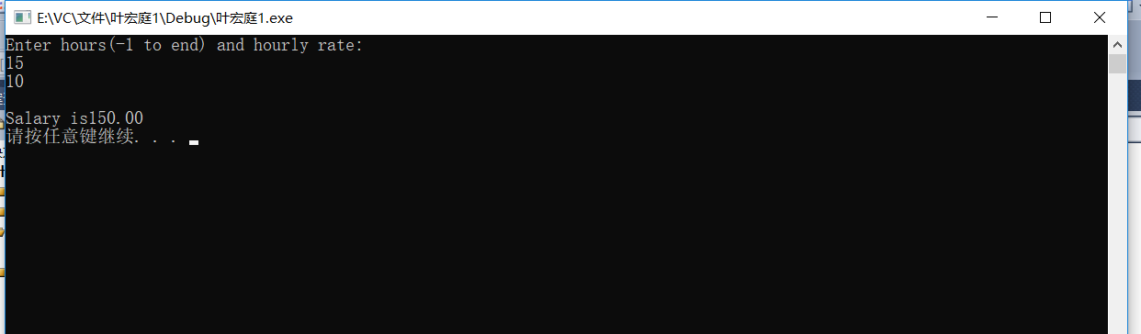

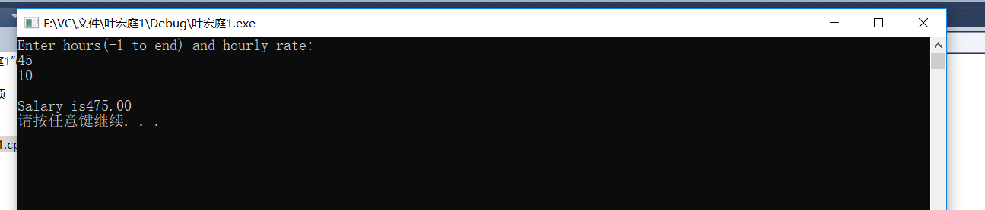

4.25

# include <iostream>

int main ()

{

int num,a=1,i=1,h=2;

using namespace std;

cout<<"Enter sizes";

cin>>num;

while(a<=num)

{

cout<<"*"<<" ";

a++;

}

while (h!=num)

{

cout<<"\n*";

while(i!=num-1)

{

cout<<" ";

i++;

}

if (i==num-1)

cout<<" ";

cout<<"*"<<endl;

h+=1;

i=1;

}

a=1;

while(a<=num)

{

cout<<"*"<<" ";

a++;

}

system("pause");

return 0;

}

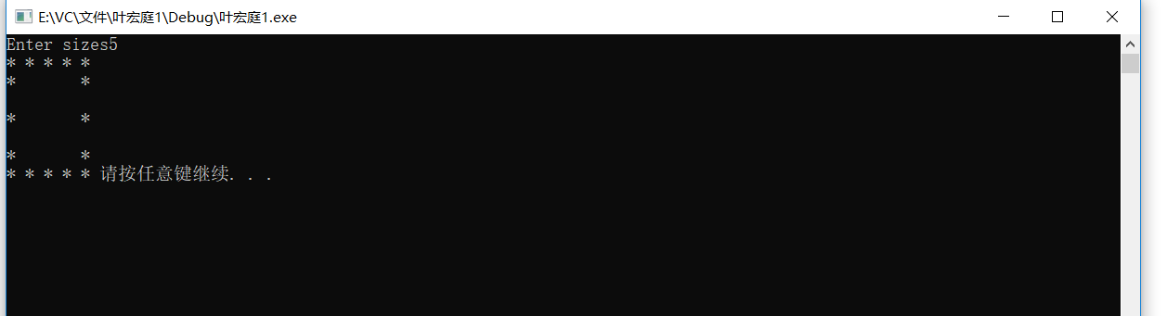

上机

1.

# include <iostream>

# include <iomanip>

int main ()

{

int hours ,hours2;double salary;

using namespace std;

cout<<"Enter hours worked (-1 to end)"<<endl;

cin >>hours;

while (hours!=-1)

{

if (hours<=40)

salary=hours*10;

else

{

hours2=hours-40;

salary=400+hours2*15;

}

cout<<"The salary is"<<fixed<<setprecision(2)<<salary<<endl;

cout<<"Enter the next hours(-1 to end)"<<endl;

cin>>hours;

}

system ("pause");

return 0;

}

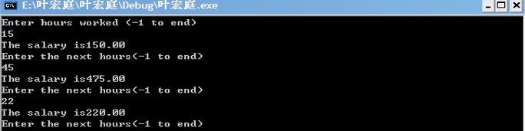

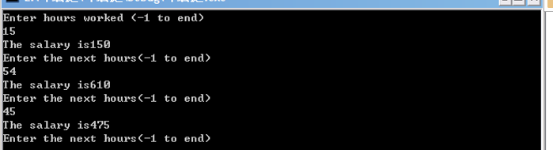

1（2）

# include <iostream>

# include <iomanip>

int main ()

{

int hours,hours2;double salary;

using namespace std;

cout<<fixed<<setprecision(2)<<"Enter worked hours (-1 to end) ";

cin>>hours;

while(hours!=-1)

{

if(hours<=40)

salary=10*hours;

else

{

if(hours!=55)

{

hours2=hours-40;

salary=400+hours2*15;

}

else

salary=10*55+100;

if(hours>=75)

salary=salary+1000;

}

cout<<"\nThe salary is"<<salary;

cout<<"\nEnter the next hours(-1 to end)";

cin>>hours;

}

system("pause");

return 0;

}

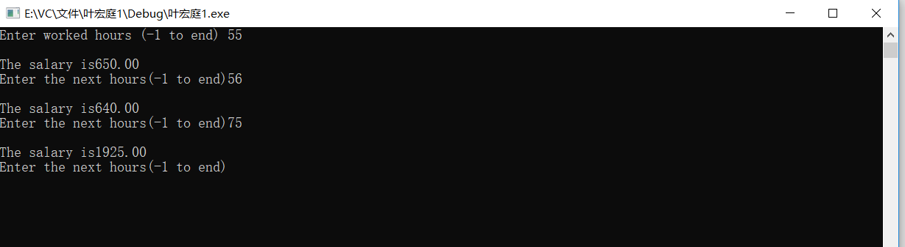

2.

# include <iostream>

int main()

{

int rows,columns;

using namespace std;

cout<<"Enter rows and columns";

cin>>rows>>columns;

int i=1,a=2;

while(i<=columns)

{

cout<<"*";

i++;

}

while(a<rows)

{

cout<<"\n*";

i=2;

while(i<=columns)

{

if(i<columns)

cout<<" ";

else

cout<<"*";

i++;

}

a++;

}

cout<<endl;

i=1;

while(i<=columns)

{

cout<<"*";

i++;

}

system("pause");

return 0;

}

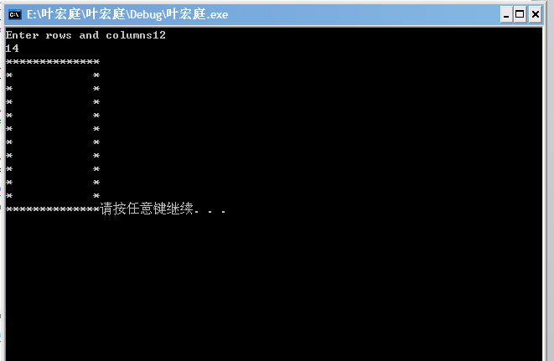

程序改错题

初始代码：

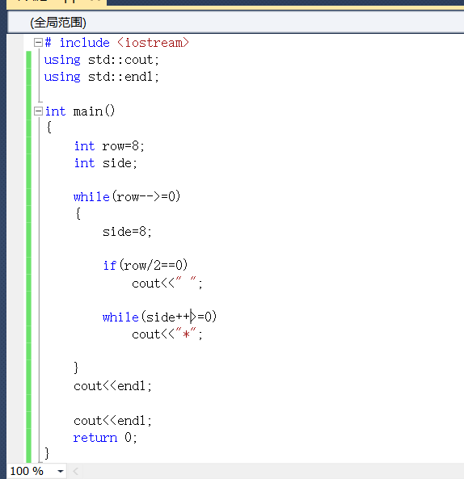

由于side++>=0恒成立，循环无法停止。

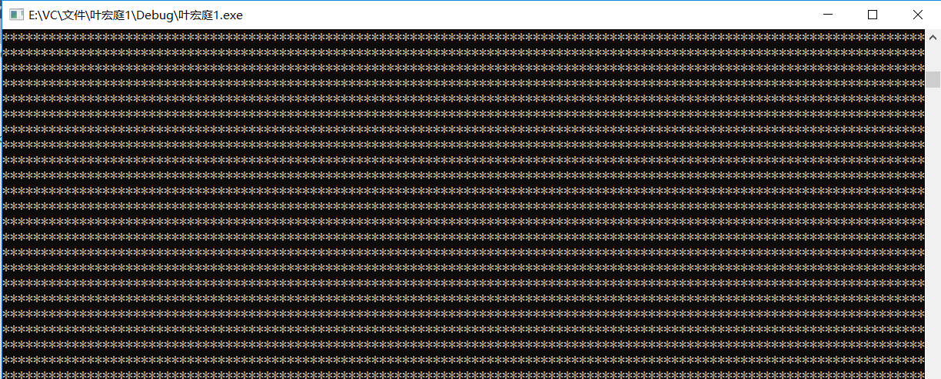

将side++改为side—

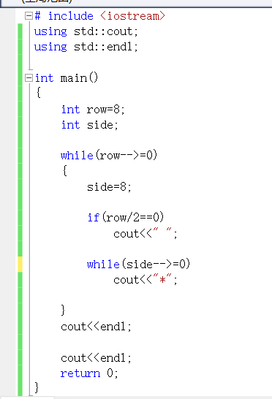

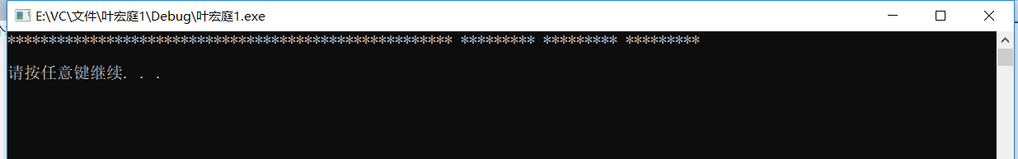

没有换行输出。

在循环内插入cout<<endl；

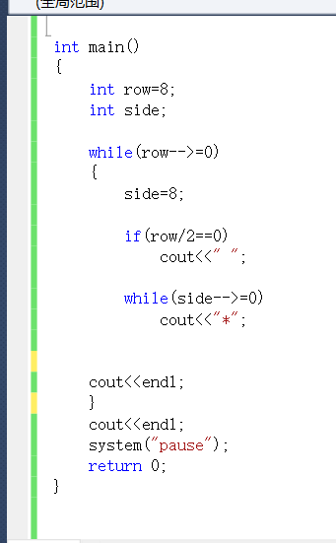

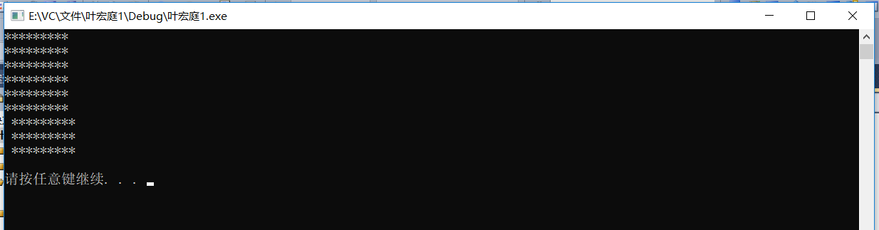

空格位置不对。

除与取余错误。

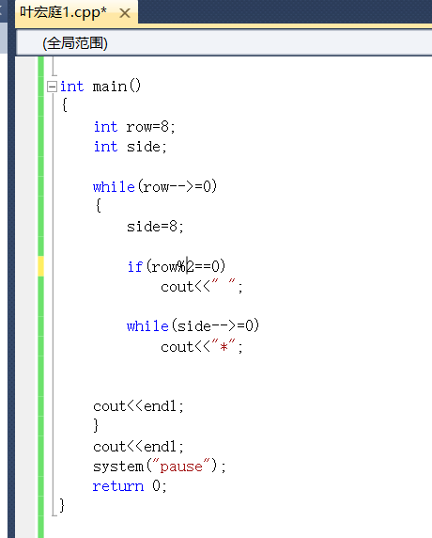

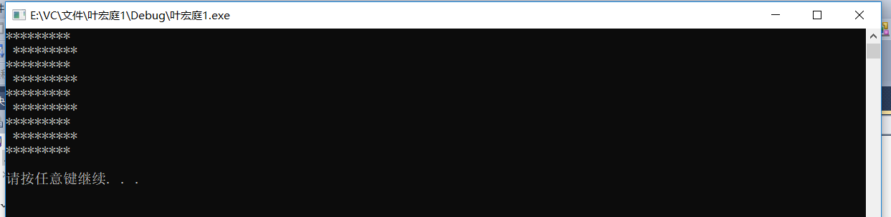

星号之间没有空格。

加入空格输出。

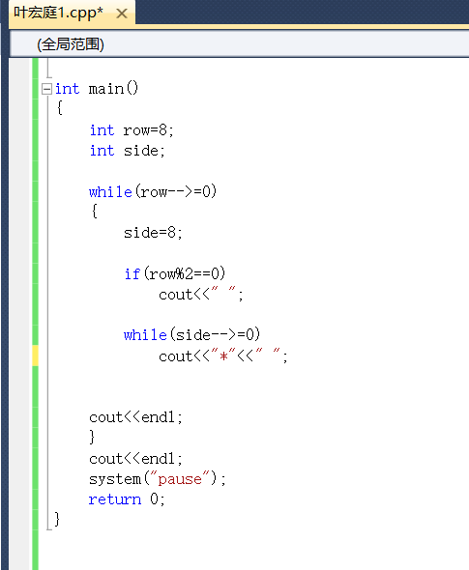

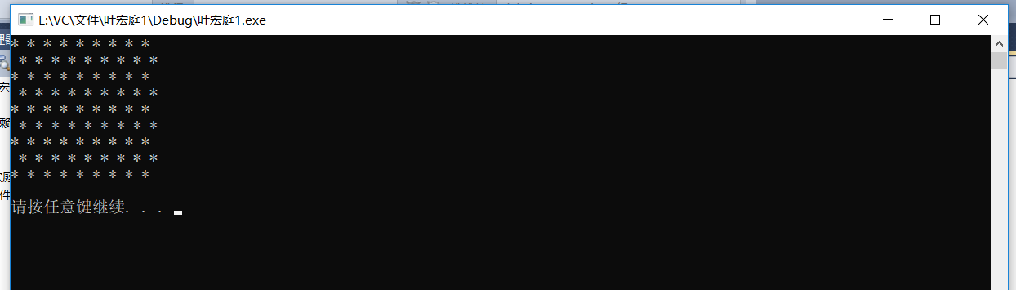

多输出了一行。

将row—改为—row；

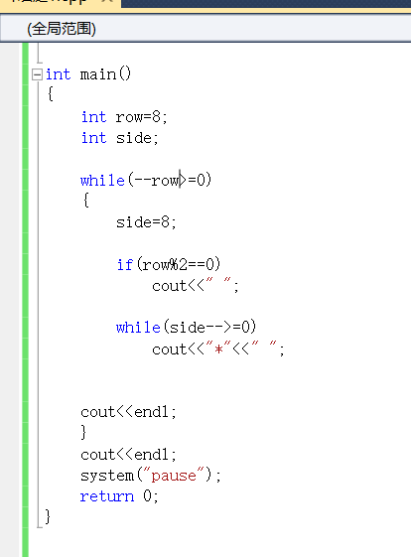

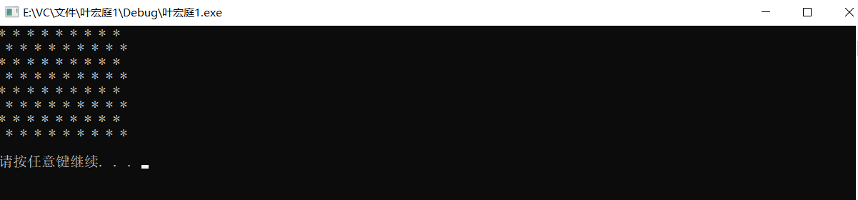

完成要求输出。