5.6

# include <iostream>

int main()

{

int num,i=0,total=0;double average;

using namespace std;

cout<<"Enter an number (9999 to end)"<<endl;

cin>>num;

if (num==9999)

average=0,i=1;

for(;num!=9999;i++)

{

total+=num;

cout<<"Enter the next number (9999 to end)"<<endl;

cin>>num;

}

average=static_cast<double>(total)/i;

cout<<"The average is"<<average;

system("pause");

return 0;

}

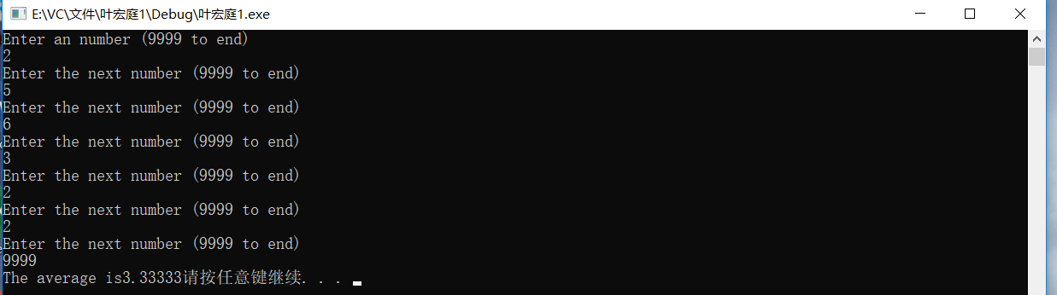

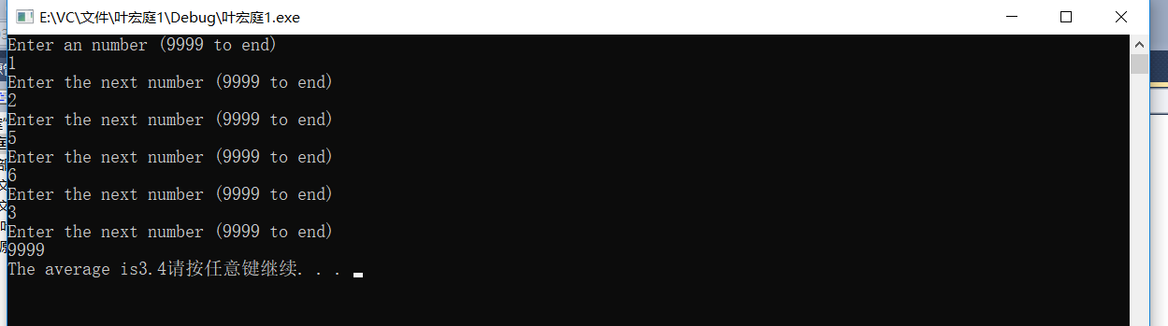

5.12

（a）

# include <iostream>

int main()

{

int num,i=1,a=1;

using namespace std;

cout<<"Enter an num to decide a pattern";

cin>>num;

for(;a<=num;a++)

{

cout<<endl;

i=1;

for(;i<=a;i++)

cout<<"*";

}

system("pause");

return 0;

}

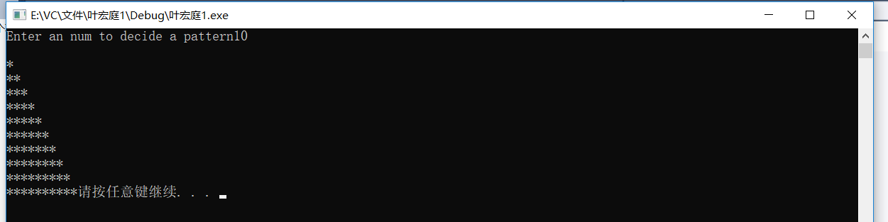

（b）

# include <iostream>

int main()

{

int num,i=1,a;

using namespace std;

cout<<"Enter an num to decide a pattern";

cin>>num;

a=num;

for(;a>=1;a--)

{

cout<<endl;

i=1;

for(;i<=a;i++)

cout<<"*";

}

system("pause");

return 0;

}

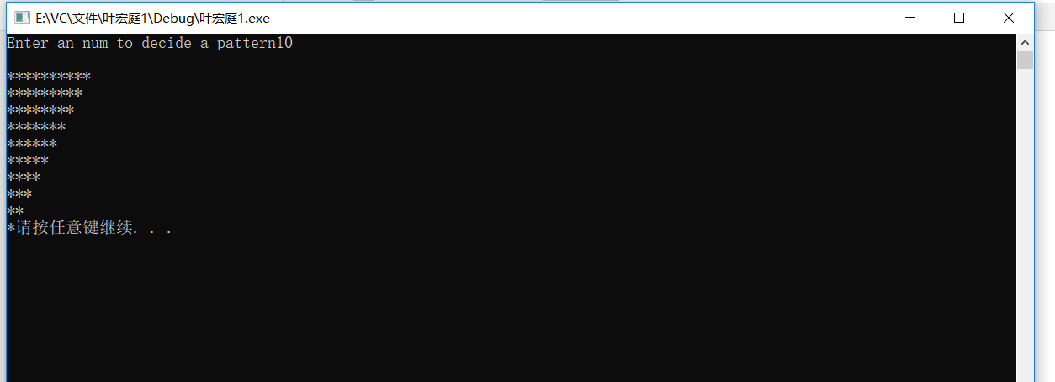

（c）

# include <iostream>

int main()

{

int num,i=1,a,b;

using namespace std;

cout<<"Enter an num to decide a pattern";

cin>>num;

a=num;

for(;a>=1;a--)

{

cout<<endl;

i=1;b=num;

for(;b>a;b--)

cout<<" ";

for(;i<=a;i++)

cout<<"*";

}

system("pause");

return 0;

}

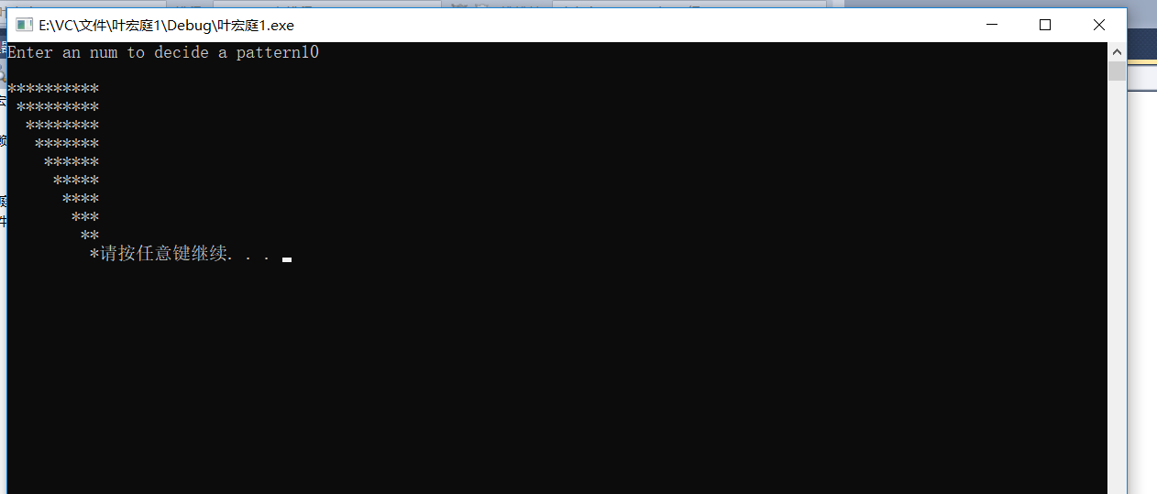

（d）

# include <iostream>

int main()

{

int num,i=1,a,b;

using namespace std;

cout<<"Enter an num to decide a pattern";

cin>>num;

a=num;

for(;a>=1;a--)

{

cout<<endl;

i=num;b=1;

for(;b<=a;b++)

cout<<" ";

for(;i>=a;i--)

cout<<"*";

}

system("pause");

return 0;

}

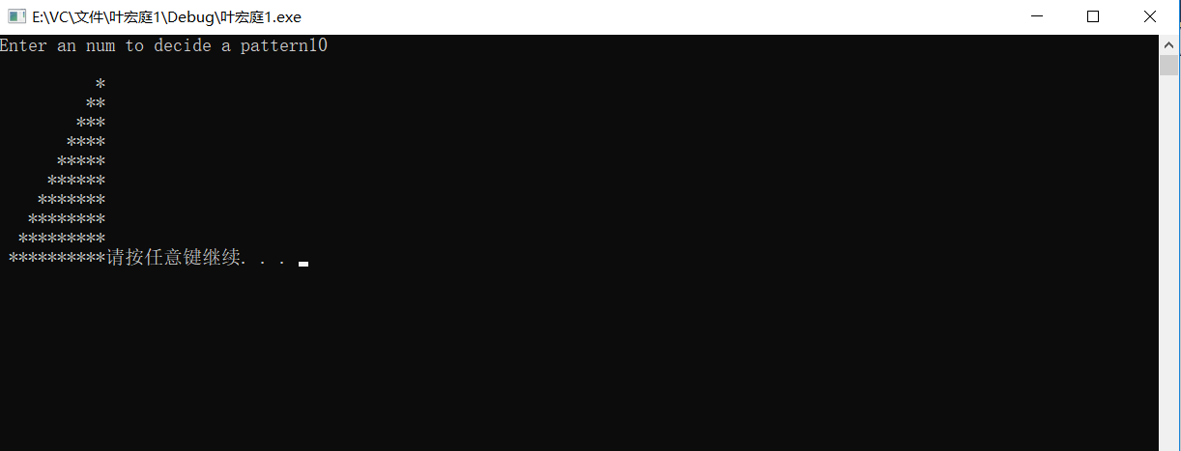

5.20

# include <iostream>

int main()

{

using namespace std;

int side1,side2,hypo=5;

for(side1=3;side1<=500;side1++)

{

for(side2=4;side2<=500;side2++)

{

hypo=side2+1;

for(;hypo<=500;hypo++)

{

if(side1*side1+side2*side2==hypo*hypo)

{

cout<<"side1="<<side1<<"\nside2="<<side2<<"\nhypotenuse"<<hypo<<"\n"<<endl;

break;

}

if(side1*side1+side2*side2<hypo*hypo)

break;

}

}

}

system("pause");

return 0;

}

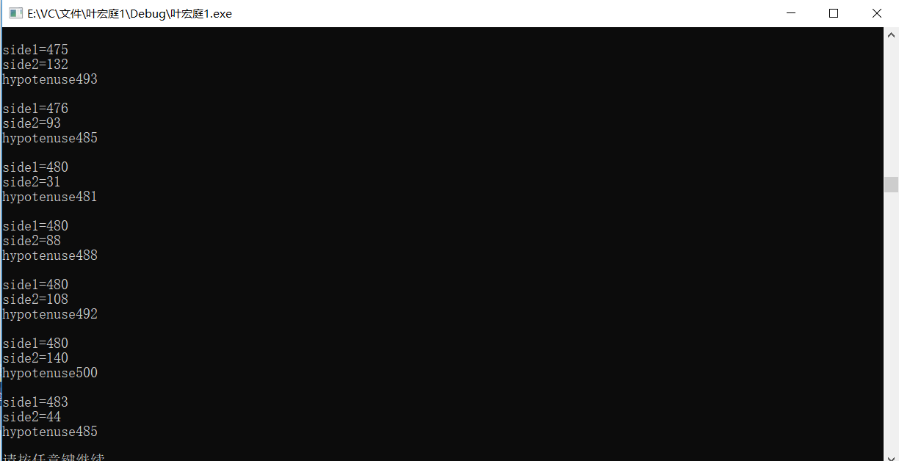

5.9

# include <iostream>

int main()

{

using namespace std;

int num=1,product=1;

for(;num<=15;num+=2)

product*=num;

cout<<"The product is "<<product;

system("pause");

return 0;

}

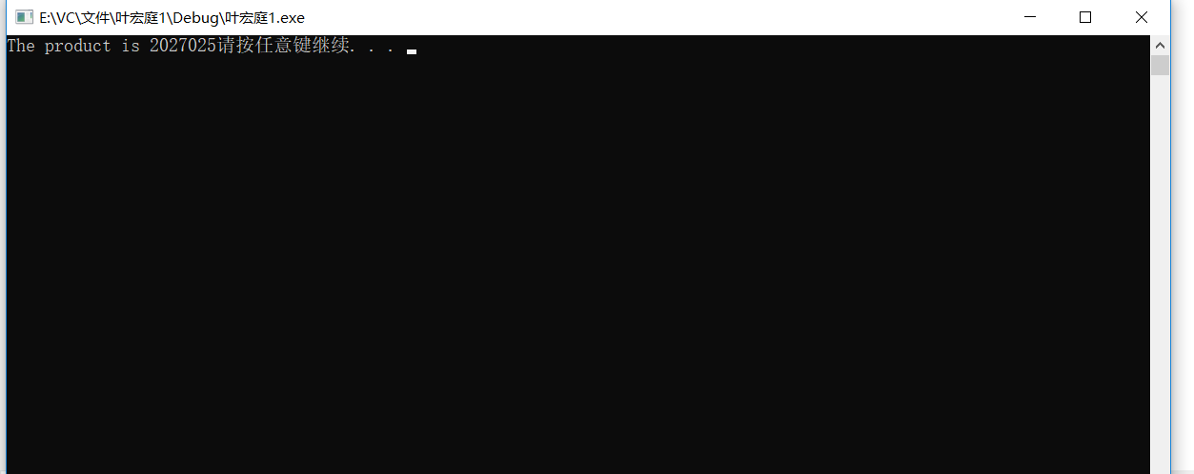

5.14

# include <iostream>

# include <iomanip>

int main()

{

double total=0;int product,quantity;

using namespace std;

cout<<"Enter the product number(0 to end):"<<endl;

cin >>product;

cout<<"Enter the quantity sold:"<<endl;

cin>>quantity;

for(;product!=0;)

{

if (product>5)

cout<<"Please enter a right product number!"<<endl;

switch(product)

{

case 1:

total+=2.98*quantity;

break;

case 2:

total+=4.50*quantity;

break;

case 3:

total+=9.98*quantity;

break;

case 4:

total+=4.49*quantity;

break;

case 5:

total+=6.87*quantity;

break;

}

cout<<"Enter the product number(0 to end):"<<endl;

cin>>product;

cout<<"Enter the quantity sold:"<<endl;

cin>>quantity;

}

cout<<"The total is:"<<total;

system("pause");

return 0;

}

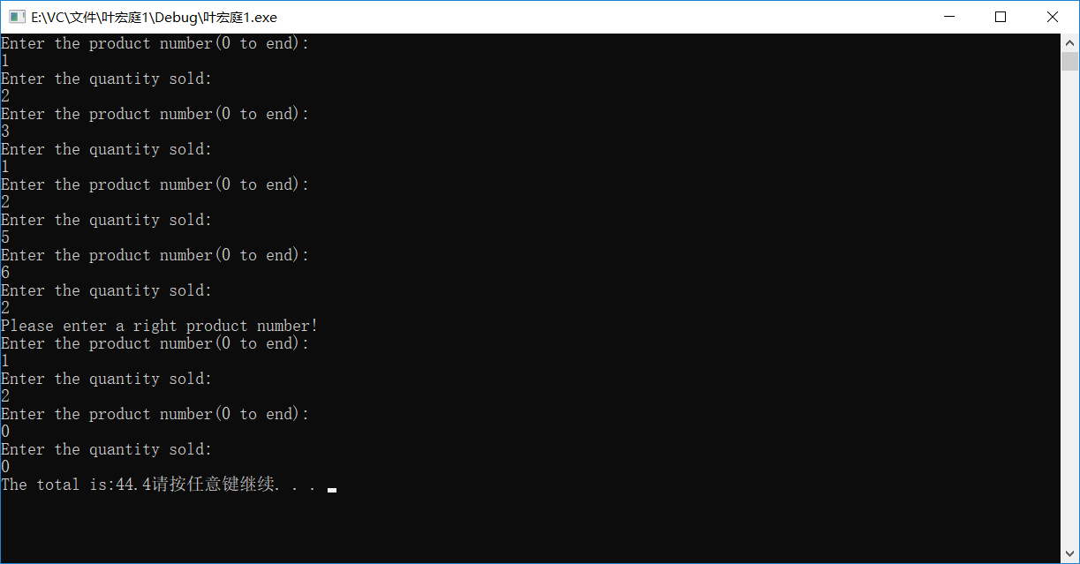

5.19

# include <iostream>

int main()

{

double a=1,b;int n; long double πD=0.0;

using namespace std;

cout<<"Enter a big number to calculate the value of πD:"<<endl;

cin >>n;

for(;a<=n;a+=4)

{

b=a+2;

πD+=(4/a-4/b);

}

cout<<"The value of πD is"<<πD;

system("pause");

return 0;

}

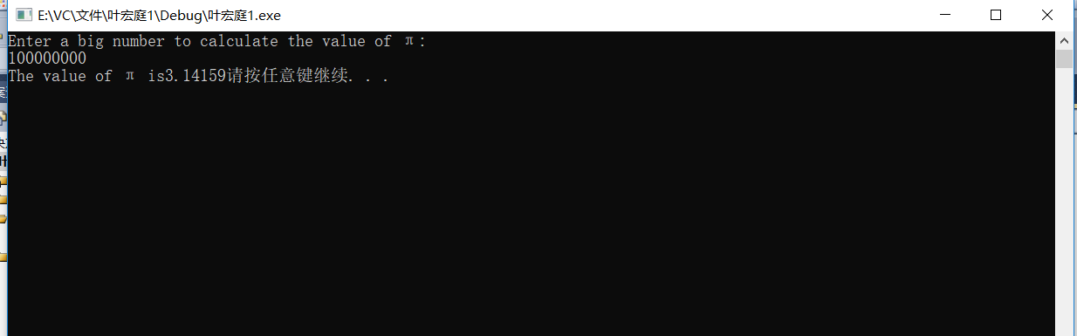

5.23

# include <iostream>

int main()

{

int row,i=1,a,b,c=1;

using namespace std;

cout<<"Enter the row number:"<<endl;

cin >>row;

for(;i<=row;i++)

{

for(a=1;a<=row-i;a++)

cout<<" ";

for(b=1;b<=2*i-1;b++)

cout<<"*";

cout<<endl;

}

for(i=row-1;i>=1;i--)

{

for(a=1;a<=row-i;a++)

cout<<" ";

for(b=2*i-1;b>=1;b--)

cout<<"*";

cout<<endl;

}

system("pause");

return 0;

}

