6.21

# include <iostream>

int main()

{

int a;bool b;

bool even (int);

using namespace std;

cout<<"Enter a number to determine is or not a even:";

cin>>a;

b=even(a);

cout<<b;

system("pause");

return 0;

}

bool even (int x)

{

bool i;

if(x%2==0)

i=true;

else

i=false;

return i;

}

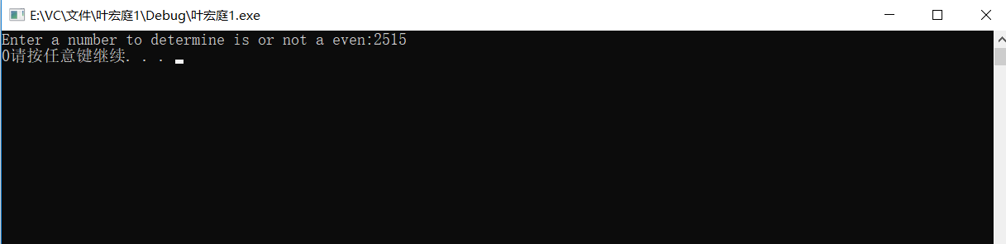

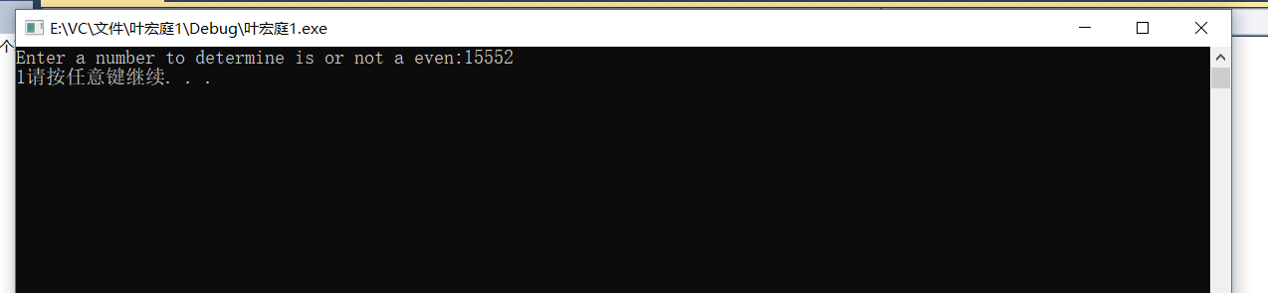

6.34

# include <iostream>

# include <cstdlib>

int main()

{

using namespace std;

using std::rand;

int a,b;

a=1+rand()%1000;

cout<<"I have a number between 1 and 1000"<<"\nCan you guess my number?"<<"\nPlease type your first guess:";

cin>>b;

while(b!=a)

{

if(b<a)

cout<<"Too low try again.";

else

cout<<"Too high try again.";

cin>>b;

}

cout<<"Excellent! You guess the number!";

system("pause");

return 0;

}

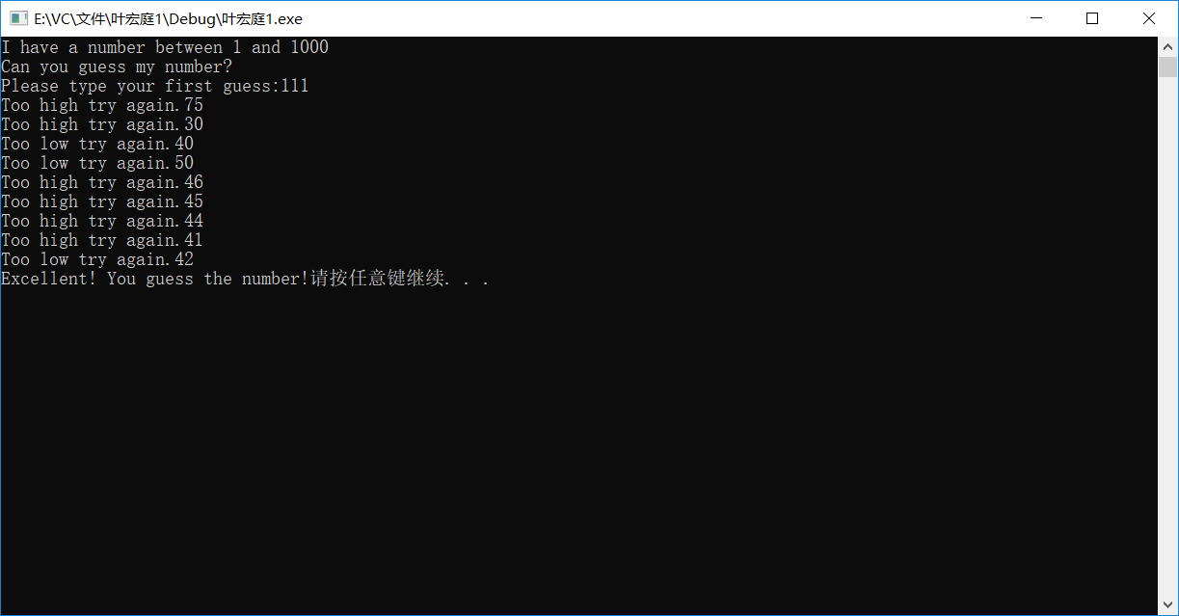

6.35

# include <iostream>

# include <cstdlib>

int main()

{

using namespace std;

using std::rand;

int a,b,c=0;

a=1+rand()%1000;

cout<<"I have a number between 1 and 1000"<<"\nCan you guess my number?"<<"\nPlease type your first guess:";

cin>>b;

while(b!=a)

{

if(b<a)

cout<<"Too low try again.";

else

cout<<"Too high try again.";

cin>>b;

c+=1;

}

if(c<10)

cout<<"Either you know the secret or you got lucky!";

else

if(c==10)

cout<<"Ahah! You know the secret!";

else

cout<<"You should be able to do better!";

system("pause");

return 0;

}

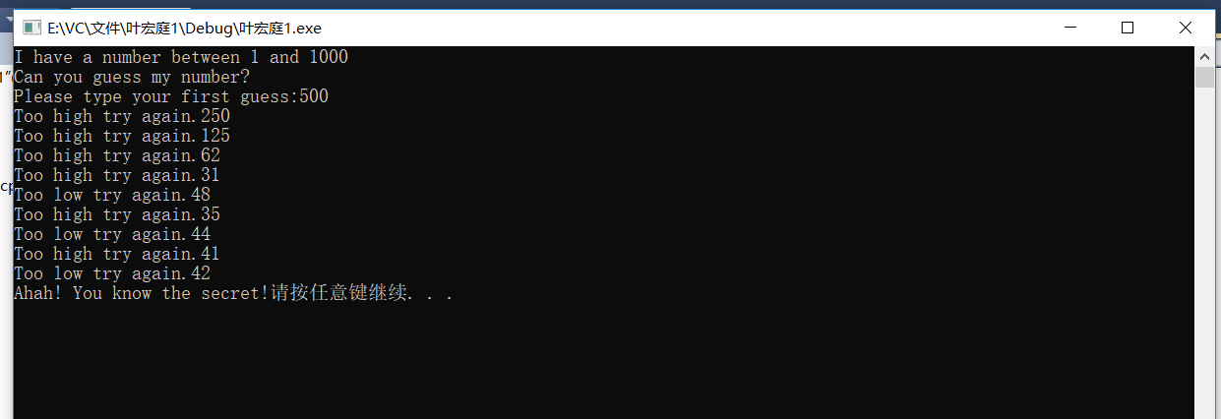

6.37

# include <iostream>

using namespace std;

int main()

{

int fibonacci(int);

int number;

cout<<"Enter a number to determine how much fibonaci to print:";

cin>>number;

cout<<endl;

fibonacci(number);

system("pause");

return 0;

}

int fibonacci(int number)

{

int num1=0,num2=1,num3;

if(number==1)

cout<<0<<" ";

else

{

if(number==2)

cout<<0<<" "<<1<<" ";

else

{

cout<<0<<" "<<1<<" ";

for(int i=3;i<=number;i++)

{

if(i&2!=0)

{

num1+=num2;

cout<<num1<<" ";

}

else

{

num2+=num1;

cout<<num2<<" ";

}

}

}

}

return 0;

}

Part a .

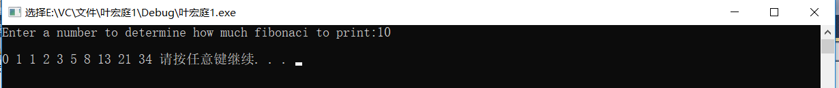

Part b.

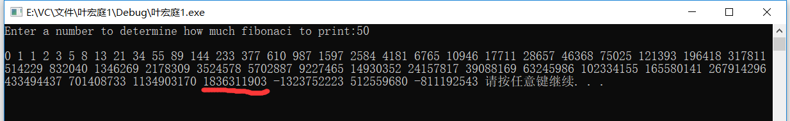

# include <iostream>

using namespace std;

int main()

{

double fibonacci(double);

double number;

cout<<"Enter a number to determine how much fibonaci to print:";

cin>>number;

cout<<endl;

fibonacci(number);

system("pause");

return 0;

}

double fibonacci(double number)

{

double num1=0,num2=1,num3;

if(number==1)

cout<<0<<" ";

else

{

if(number==2)

cout<<0<<" "<<1<<" ";

else

{

cout<<0<<" "<<1<<" ";

for(int i=3;i<=number;i++)

{

if(i&2!=0)

{

num1+=num2;

cout<<num1<<" ";

}

else

{

num2+=num1;

cout<<num2<<" ";

}

}

}

}

return 0;

}

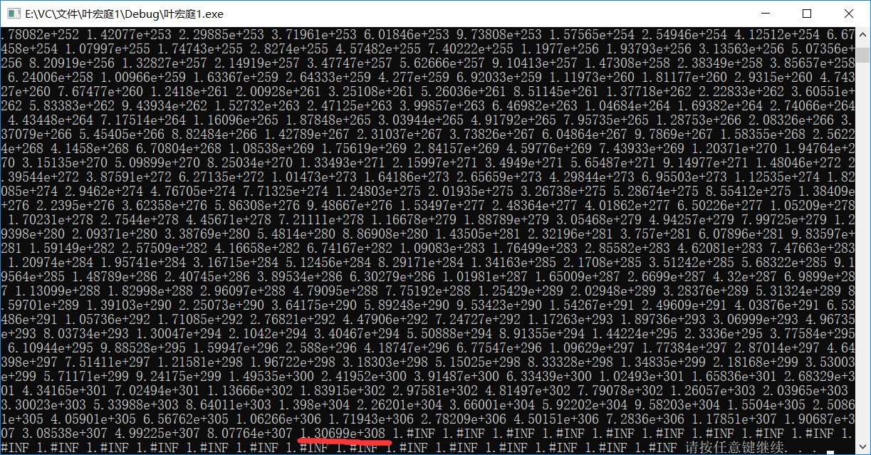

递归堆栈

# include <iostream>

using namespace std;

int main()

{

int fibonacci(int);

int number;

cout<<"Enter a number to print fibonacci series:";

cin>>number;

cout<<fibonacci(number);

system("pause");

return 0;

}

int fibonacci(int number)

{

if(number-1==0||number-1==1)

return number-1;

else

return fibonacci(number-1)+fibonacci(number-2);

}



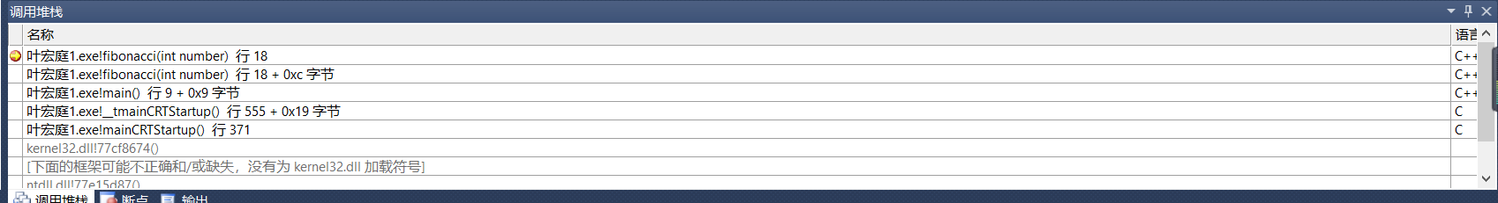

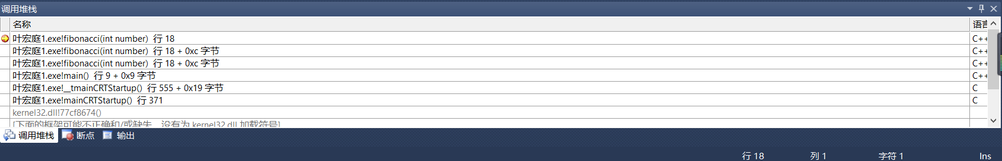

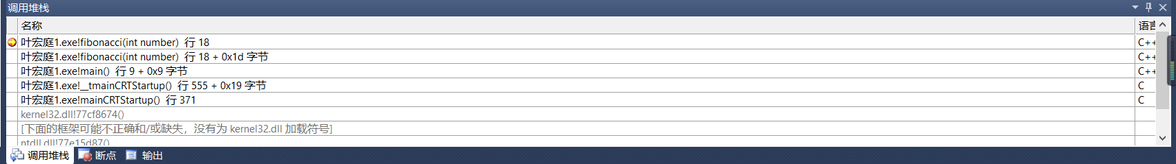

6.41

# include <iostream>

using namespace std;

int main()

{

int gcd(int,int);

cout<<"Enter two number to find their greatest common divisor(num1 must bigger than num2:";

int num1,num2;

cin>>num1>>num2;

cout<<gcd(num1,num2);

system("pause");

return 0;

}

int gcd(int x, int y)

{

if(y==0)

return x;

else

return gcd(y,x%y);

}





6.46

# include <iostream>

using namespace std;

int mystery(int,int);

int main()

{

int x,y;

cout<<"Enter two integers:";

cin>>x>>y;

cout<<"The result is "<<mystery(x,y)<<endl;

system("pause");

return 0;

}

int mystery(int a,int b)

{

if(b>0)

{

if(b==1)

return a;

else

return a+mystery(a,b-1);

}

else

if(b==0)

return 0;

else

if(b==-1)

return -a;

else

return -a+mystery(a,b+1);

}

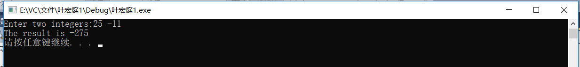

6.51

# include <iostream>

using namespace std;

int tripleByValue(int);

void tripleByReference(int &);

int main()

{

int count=5;

int &Ref=count;

cout<<"The result of tripleByValue is:"<<tripleByValue(count)<<endl;

tripleByReference(Ref);

cout<<"The result of triplrByReference is:"<<count<<endl;

system("pause");

return 0;

}

int tripleByValue(int number)

{

return number*number*number;

}

void tripleByReference(int &number)

{

number=number*number*number;

}

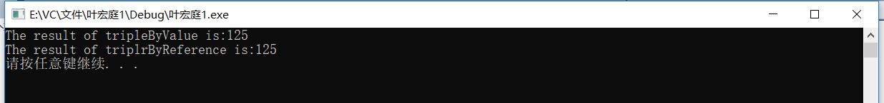

6.53

# include <iostream>

using namespace std;

template <class A> A minimum (A ,A);

int main()

{

cout<<"Enter two arguments to compare:"<<endl;

int a,b;

cin>>a>>b;

cout<<"The minimum is:"<<minimum(a,b)<<endl;

char c,d;

cin>>c>>d;

cout<<"The minimum is:"<<minimum(c,d)<<endl;

double e,f;

cin>>e>>f;

cout<<"The minimum is:"<<minimum(e,f)<<endl;

system("pause");

return 0;

}

template <class A> A minimum(A num1,A num2)

{

if(num1-num2<0)

return num1;

else

return num2;

}

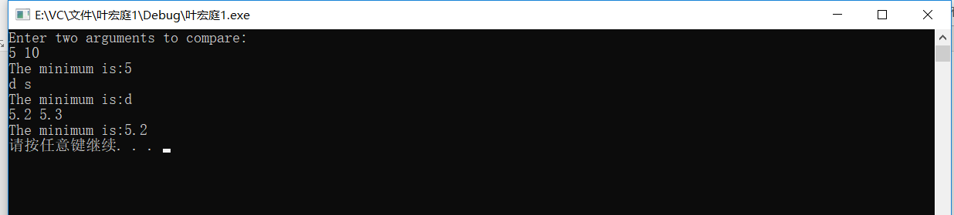

5.20

# include <iostream>

using namespace std;

int main()

{

int count=0,loopcount=0;

cout<<"Side1"<<" "<<"Side2"<<" "<<"Side3"<<endl;

for(int side1=1;side1<=500;side1++)

for(int side2=side1;side2<=500;side2++)

for(int side3=side2;side3<=500;side3++)

if(side1*side1+side2*side2==side3*side3)

{

cout<<side1<<" "<<side2<<" "<<side3<<endl;

count+=1;

}

cout<<"a total of "<<count<<" "<<"triplrs were found."<<endl;

system("pause");

return 0;

}

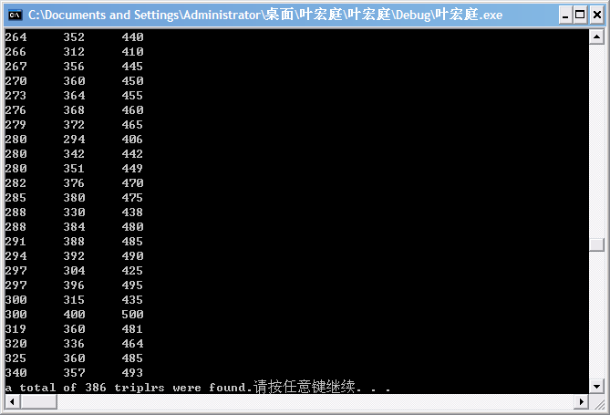

练习1：

# include <iostream>

using namespace std;

int main()

{

int count=0,loopcount=0;

cout<<"Side1"<<" "<<"Side2"<<" "<<"Side3"<<endl;

for(int side1=3;side1<=500;side1++)

for(int side2=side1;side2<=500;side2++)

for(int side3=side2;side3<=500;side3++)

{

if(side1*side1+side2*side2==side3*side3)

{

cout<<side1<<" "<<side2<<" "<<side3<<endl;

count+=1;

}

loopcount+=1;

}

cout<<"a total of "<<count<<" "<<"triplrs were found."<<endl;

cout<<"Loopcount="<<loopcount;

system("pause");

return 0;

}

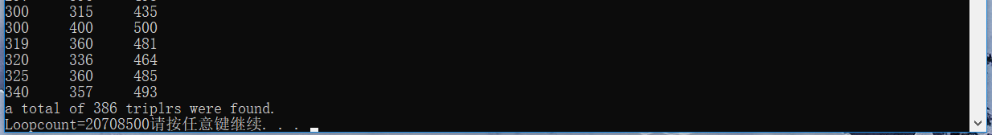

练习2

# include <iostream>

using namespace std;

int main()

{

int count=0,loopcount=0;

cout<<"Side1"<<" "<<"Side2"<<" "<<"Side3"<<endl;

for(int side1=1;side1<=500;side1++)

for(int side2=side1;side2<=500;side2++)

for(int side3=side2;side3<=500;side3++)

{

if(count==20)

break;

if(side1*side1+side2*side2==side3*side3)

{

cout<<side1<<" "<<side2<<" "<<side3<<endl;

count+=1;

}

loopcount+=1;

}

cout<<"a total of "<<count<<" "<<"triplrs were found."<<endl;

cout<<"Loopcount="<<loopcount;

system("pause");

return 0;

}

Innermost：



Middle loop：



Outmost：



练习3

# include <iostream>

using namespace std;

int main()

{

int count=0,loopcount=0;

cout<<"Side1"<<" "<<"Side2"<<" "<<"Side3"<<endl;

for(int side1=1;side1<=500;side1++)

{

if(side1==8)

continue;

for(int side2=side1;side2<=500;side2++)

for(int side3=side2;side3<=500;side3++)

{

if(side1*side1+side2*side2==side3*side3)

{

cout<<side1<<" "<<side2<<" "<<side3<<endl;

count+=1;

}

loopcount+=1;

}

}

cout<<"a total of "<<count<<" "<<"triplrs were found."<<endl;

cout<<"Loopcount="<<loopcount;

system("pause");

return 0;

}



练习4

# include <iostream>

using namespace std;

int main()

{

int count=0,loopcount=0;

cout<<"Side1"<<" "<<"Side2"<<" "<<"Side3"<<endl;

for(int side1=1;side1<=500;side1++)

for(int side2=1;side2<=500;side2++)

for(int side3=1;side3<=500;side3++)

{

if(side1*side1+side2*side2==side3*side3)

{

cout<<side1<<" "<<side2<<" "<<side3<<endl;

count+=1;

}

loopcount+=1;

}

cout<<"a total of "<<count<<" "<<"triplrs were found."<<endl;

cout<<"Loopcount="<<loopcount;

system("pause");

return 0;

}



6.21

# include <iostream>

using namespace std;

int isEven(int);

int main()

{

int number;

cout<<"Enter number to be determined(0 to end):";

cin>>number;

for(;number!=0;)

{

if(isEven(number))

cout<<"True"<<endl;

else

cout<<"False"<<endl;

cout<<"Enter the next number(EOF to end):";

cin>>number;

}

system("pause");

return 0;

}

int isEven(int number)

{

if(number%2==0)

return true;

else

return false;

}

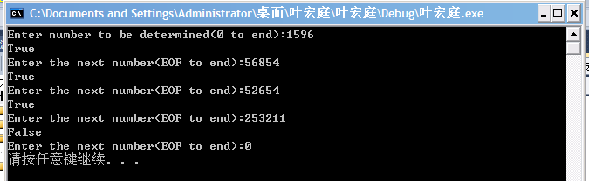

6.34

# include <iostream>

using namespace std;

int main()

{

int number,count=0,a;

number=1+rand()%1000;

cout<<"I have a number between 1 and 1000."<<"\nCan you guess my number?"<<"\nPlease type your first guess."<<endl;

cin>>a;

for(;;)

{

if(a==number)

{

cout<<"Excellent! You guessed the number!"<<"\nWould you like to play again(y or n)?"<<endl;

count+=1;

break;

}

if(a<number)

cout<<"Too low.Try again."<<endl;

else

cout<<"Too high.Try again."<<endl;

count+=1;

cout<<"Type your next guess."<<endl;

cin>>a;

}

if(count<10)

cout<<"Either you know the secret or you got lucky!";

if(count==10)

cout<<"Ahah!You know the secret!";

if(count>10)

cout<<"You should be able to do better!";

system("pause");

return 0;

}

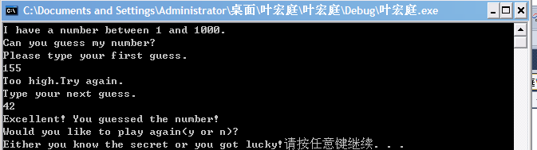

6.30

1.

# include <iostream>

using namespace std;

int Res(int);

int main()

{

int number;

cout<<"Enter a number to be reversed:";

cin>>number;

cout<<"The first result is:"<<Res(number)<<endl;

cout<<"The second result is:"<<Res(Res(number))<<endl;

system("pause");

return 0;

}

int Res(int number)

{

int a,num2=0;

for(;number!=0;)

{

a=number%10;

num2=num2*10+a;

number/=10;

}

return num2;

}

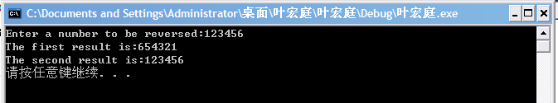

2.

# include <iostream>

using namespace std;

void Res(int &);

int main()

{

int number;

int &Ref=number;

cout<<"Enter a number to be reversed:";

cin>>number;

Res(Ref);

cout<<"The result is:"<<number;

system("pause");

return 0;

}

void Res(int &number)

{

int a,num2=0;

for(;number!=0;)

{

a=number%10;

num2=num2*10+a;

number/=10;

}

number=num2;

}

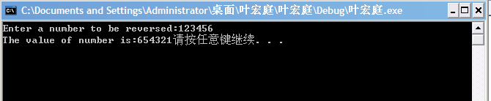

6.31

# include <iostream>

using namespace std;

int gcd(int,int);

int main()

{

int num1,num2;

cout<<"Enter two numbers to find greatest divisor(num1 bigger than num2:";

cin>>num1>>num2;

cout<<"The greatest divisor is:"<<gcd(num1,num2);

system("pause");

return 0;

}

int gcd(int num1,int num2)

{

int divisor;

for(int a=1;a<=num2;a++)

{

if(num1%a==0&&num2%a==0)

divisor=a;

}

return divisor;

}

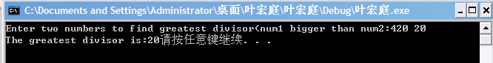

6.38

# include <iostream>

using namespace std;

void towers(int disks,int start,int end,int temp);

int i=0;

int main()

{

int disks,start,end,temp;

cout<<"Enter disks and start,end,temp number"<<endl;

cin>>disks>>start>>end>>temp;

towers(disks,start,end,temp);

system("pause");

return 0;

}

void towers(int disks,int start,int end,int temp)

{

if(disks==1)

cout<<++i<<":"<<start<<"-->"<<end<<endl;

else

{

towers(disks-1,start,temp,end);

cout<<++i<<":"<<start<<"-->"<<end<<endl;

towers(disks-1,temp,end,start);

}

}

