7.10

# include <iostream>

# include <iomanip>

using namespace std;

int main()

{

const int sizecounter=9;

int counter[sizecounter]={0};

cout<<"Enter gross sales(-1 to end)"<<endl;

int sales;

cin>>sales;

while(sales!=-1)

{

int salaries=200+0.09*sales;

counter[salaries/100-2]++;

cin>>sales;

}

for(int i=0;i<sizecounter;i++)

{

if(i!=sizecounter-1)

cout<<"$"<<(i+2)*100<<"-"<<(i+2)*100+99<<setw(5)<<counter[i]<<endl;

else

cout<<"$1000 and over"<<setw(5)<<counter[i]<<endl;

}

system("pause");

return 0;

}

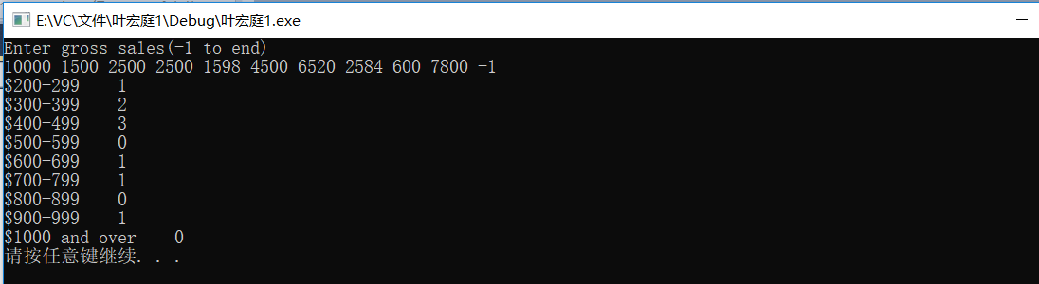

7.11

# include <iostream>

using namespace std;

int main()

{

const int sizeofarray=10;

int swap;

int bubble[sizeofarray]={13,22,32,42,12,31,23,1,3,56};

for(int i=0;i<sizeofarray-1;i++)

for(int j=0;j<sizeofarray-1;j++)

{

if(bubble[j]<=bubble[j+1]);

else

{

swap=bubble[j];

bubble[j]=bubble[j+1];

bubble[j+1]=swap;

}

}

for(int i=0;i<sizeofarray;i++)

cout<<bubble[i]<<endl;

system("pause");

return 0;

}

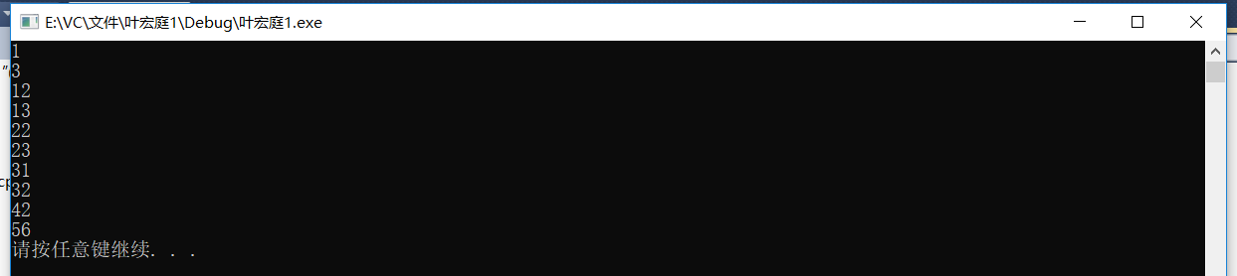

7.12

A）

# include <iostream>

using namespace std;

int main()

{

const int sizeofarray=10;

int swap;

int bubble[sizeofarray]={13,22,32,420,12,31,23,1,3,56};

for(int i=0;i<sizeofarray-1;i++)

for(int j=0;j<sizeofarray-1-i;j++)

{

if(bubble[j]<=bubble[j+1]);

else

{

swap=bubble[j];

bubble[j]=bubble[j+1];

bubble[j+1]=swap;

}

}

for(int i=0;i<sizeofarray;i++)

cout<<bubble[i]<<" ";

system("pause");

return 0;

}



B）

# include <iostream>

using namespace std;

int main()

{

const int sizeofarray=10;

int swap;

int bubble[sizeofarray]={13,22,32,420,12,31,23,1,3,56};

for(int i=0;i<sizeofarray-1;i++)

{

bool k=1;

for(int j=0;j<sizeofarray-1-i;j++)

{

if(bubble[j]<=bubble[j+1]);

else

{

swap=bubble[j];

bubble[j]=bubble[j+1];

bubble[j+1]=swap;

k=0;

}

}

if(k)

break;

}

for(int i=0;i<sizeofarray;i++)

cout<<bubble[i]<<" ";

system("pause");

return 0;

}



7.15

# include <iostream>

using namespace std;

int main()

{

const int size=20;

int a[size];

int number;

int k=0;

for(int i=0;i<size;i++)

{

cin>>number;

bool n=1;

if(number>=10&&number<=100)

{

for(int j=0;j<i;j++)

if(number==a[j])

{

n=0;

break;

}

if(n)

{

a[k]=number;

k++;

}

}

}

for(int i=0;i<k;i++)

cout<<a[i]<<" ";

system("pause");

return 0;

}



7.17

# include <iostream>

# include <ctime>

# include <stdlib.h>

# include <iomanip>

using namespace std;

int main()

{

const int size=13;

const int counter=36000;

int frequency[size]={0};

srand(time(0));

for(long i=0;i<counter;i++)

frequency[(1+rand()%6)+(1+rand()%6)]++;

cout<<setw(5)<<"SUM"<<setw(10)<<"Count"<<setw(12)<<"Expected"<<endl;

for(int i=2;i<size;i++)

cout<<setw(5)<<i<<setw(10)<<frequency[i]<<setw(12)<<(6000-abs(7-i)*1000)<<endl;

system("pause");

return 0;

}

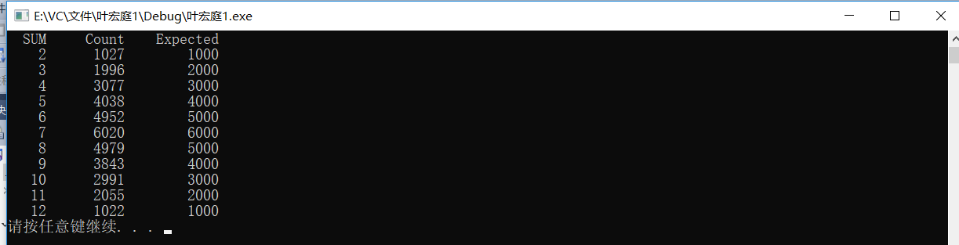

7.20

# include <iostream>

# include <iomanip>

using namespace std;

int main()

{

const int size=11;

int seat[size]={0};

int type;

int answear;

cout<<"Enter 1 for first class, 2 for economy section:";

cin>>type;

for(;type!=0;)

{

if(type==0)

break;

if(type==1)

for(int i=1;i<=5;i++)

{

if(!seat[i])

{

seat[i]=true;

cout<<setw(20)<<"Section"<<setw(8)<<"Seat"<<endl;

cout<<setw(20)<<"First class"<<setw(8)<<i<<endl;

break;

}

if(i==5)

{

cout<<"First class is full, if it's acceptable for economy section (1 for yes, 2 for no)";

cin>>answear;

if(answear==1)

{

type=2;

break;

}

else

cout<<"Next flight leaves in 3 hours.";

}

}

if(type==2)

for(int i=6;i<size;i++)

{

if(!seat[i])

{

seat[i]=true;

cout<<setw(20)<<"Section"<<setw(8)<<"Seat"<<endl;

cout<<setw(20)<<"Economy section"<<setw(8)<<i<<endl;

break;

}

if(i==size-1)

cout<<"Sorry, all seat is full."<<endl;

}

cout<<"Enter the next passenger:";

cin>>type;

}

system("pause");

return 0;

}

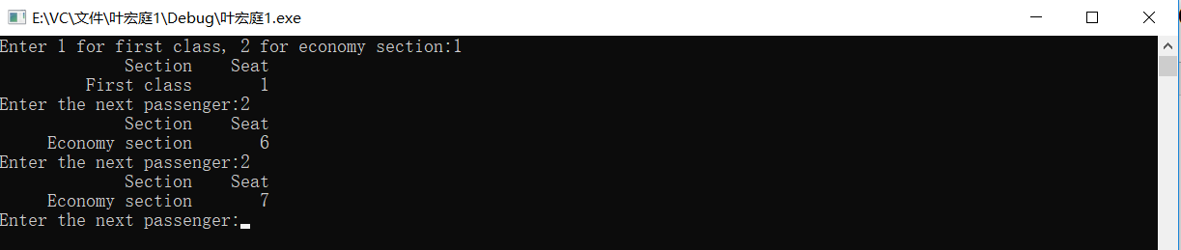

7.32

# include <iostream>

# include <iomanip>

# include <string.h>

using namespace std;

bool testpalindrome(char [],int);

int main()

{

char str1[]="abcd666777666dcba";

int size=0;

for(int i=0;str1[i];i++)

size++;

if(testpalindrome(str1,size))

cout<<"It's a palindrome.";

else

cout<<"It's not a palindrome.";

system("pause");

return 0;

}

bool testpalindrome(char str1[],int size)

{

if(size==1||size==0)

return true;

else

{

if(str1[0]==str1[size-1])

{

size-=2;

for(int i=0;i<size;i++)

str1[i]=str1[i+1];

return testpalindrome(str1,size);

}

else

return false;

}

}



7.36

# include <iostream>

using namespace std;

void stringReverse(char [],int );

int main()

{

char str1[]="abcdefg";

stringReverse(str1,0);

system("pause");

return 0;

}

void stringReverse(char str1[],int start)

{

if(str1[start]=='\0');

else

{

stringReverse(str1,start+1);

cout<<str1[start];

}

}



7.37

# include <iostream>

using namespace std;

int recursiveMinimum(int [],int starts,int ends);

int main()

{

int a[]={10,453,522,57,2143,75,23,53,354,25456};

cout<<"The minimum value is"<<recursiveMinimum(a,0,9)<<endl;

system("pause");

return 0;

}

int recursiveMinimum(int a[],int starts,int ends)

{

if(starts==ends)

return a[starts];

else

if(a[starts]<recursiveMinimum(a,starts+1,ends))

return a[starts];

else

return recursiveMinimum(a,starts+1,ends);

}



7.40

# include <iostream>

# include <vector>

using namespace std;

int recursiveMinimum(vector <int>& ,int start,int ends);

int main()

{

const int size=10;

vector <int> a(size);

for(size_t i=0;i<a.size();i++)

cin>>a[i];

for(size_t i=0;i<a.size();i++)

cout<<a[i]<<" ";

cout<<"\nThe smallest is "<<recursiveMinimum(a,0,size-1);

system("pause");

return 0;

}

int recursiveMinimum(vector <int>& array,int start,int ends)

{

int static smallest=array[start];

if(start==ends)

return array[ends];

else

if(array[start]<recursiveMinimum(array,start+1,ends))

return array[start];

else

return recursiveMinimum(array,start+1,ends);

}

