**Student Class**

源代码：

//源.cpp

# include <iostream>

# include "Student.h"

# include <fstream>

# include <string>

using namespace std;

void main()

{

fstream index("output.txt", ios::out);

int idnum = 1;

char name1[]="";

char name2[]="";

cin >> idnum >> name1 >> name2;

do

{

Student student1(idnum, name1, name2);

student1.print(index);

cin >> idnum >> name1 >> name2;

} while (idnum);

return;

}

//Student.h

# ifndef STUDENT_H

# define STUDENT_H

using namespace std;

# include <string>

# include <fstream>

class Student {

public:

Student(int, char*, char*);

~Student();

void set(int, char*, char*);

void print(fstream &);

private:

int IDnumber;

char* FirstName;

char* LastName;

};

# endif

//Student.cpp

# include <iostream>

# include "Student.h"

# include <string>

# include <iomanip>

# include <fstream>

Student::Student(int a, char* b, char* c)

{

set(a, b, c);

}

Student::~Student()

{

delete[]FirstName;

delete[]LastName;

}

void Student::set(int a, char* b, char* c)

{

IDnumber = a;

FirstName = new char[strlen(b) + 1];

for (int i = 0; i <= strlen(b); i++)

FirstName[i] = b[i];

LastName = new char[strlen(c) + 1];

for (int i = 0; i <= strlen(c); i++)

LastName[i] = c[i];

}

void Student::print(fstream &index)

{

index << setw(10) << IDnumber << setw(10) << FirstName << setw(15) << LastName << endl;

}

运行结果：

运行前：

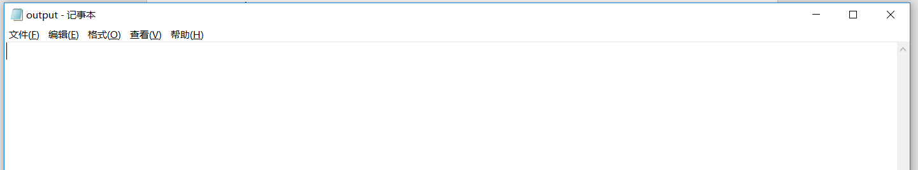

运行过程：



运行后：

