**Assignment1 Report**

71118415叶宏庭

1. **作业要求**

* 熟悉 MS Access工具
* 建立一个university.accdb数据库
* 将文本文档的数据导入到university.accdb中去
* 将5000多个随即元组插入到Students表中

1. **使用平台和工具**
   * Windows 10
   * MS Access 2019
   * Conda 开源软件包管理系统
   * Visual Studio Code 中Python编程
2. **实现方案**
   * **建立一个数据库**

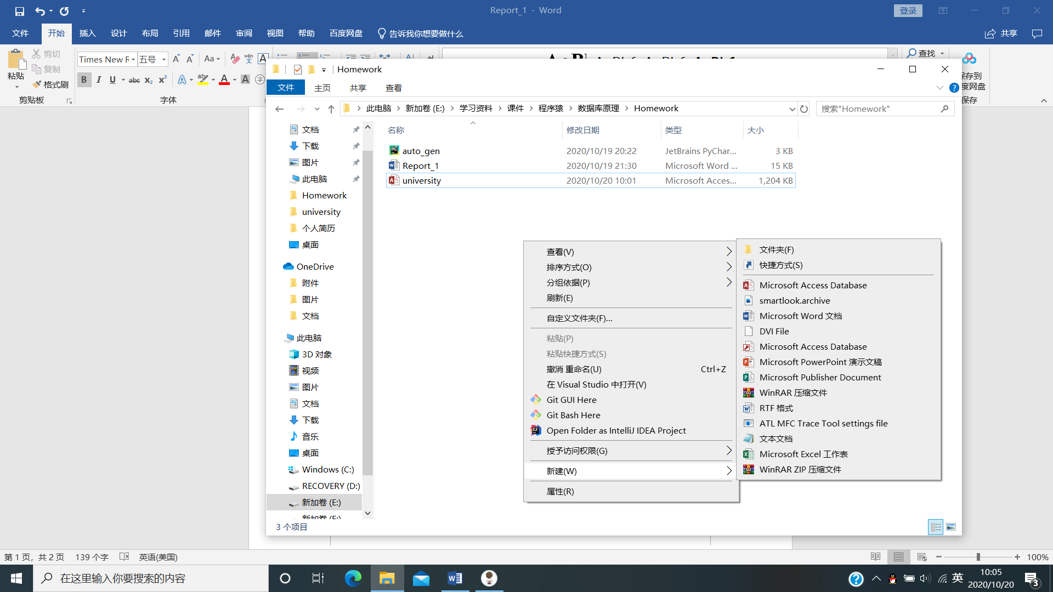

* + 1. **右击文件夹空白处，选择新建Microsoft Access Database文件**
    2. **输入文件名university.accdb**
    3. **完成数据库建立，打开数据库**
  + **导入文本文件**

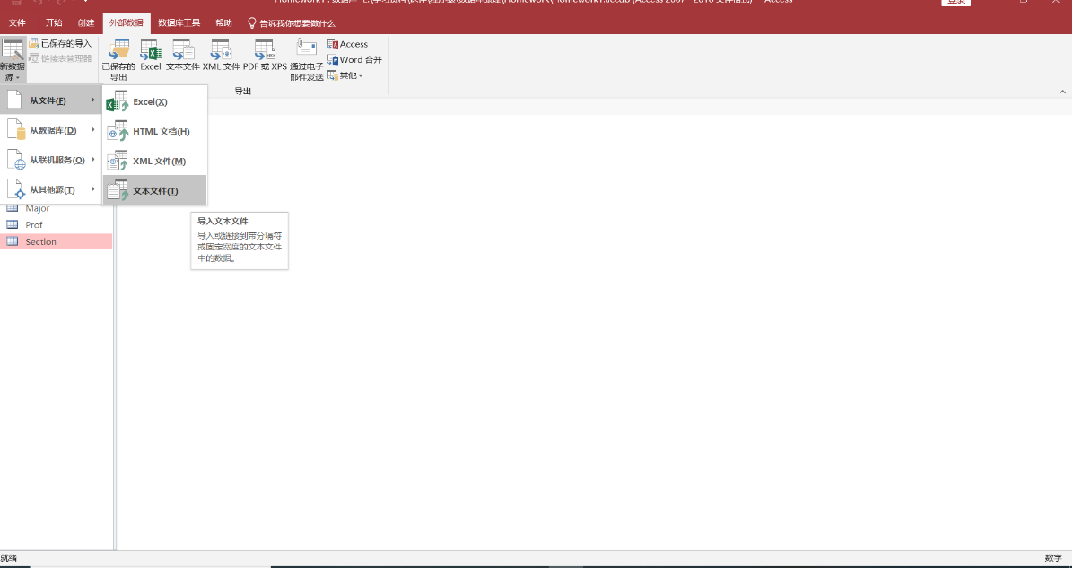

* + 1. **选择外部数据→新数据源→从文件→文本文件**

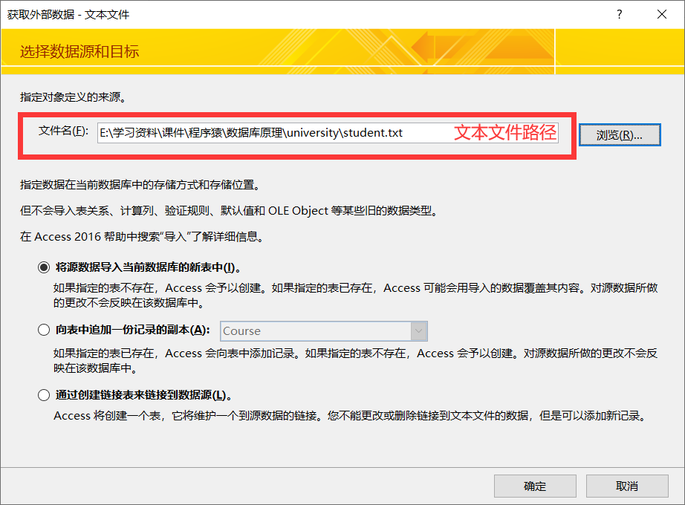

* + 1. **指定文本文件路径**

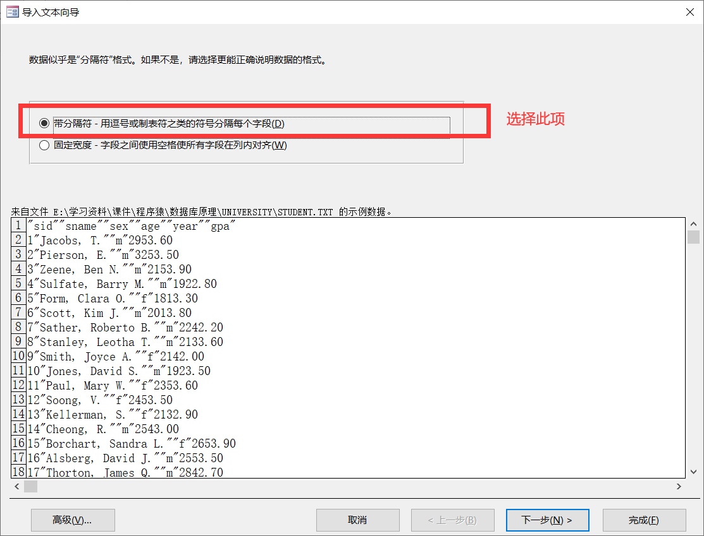

* + 1. **指定数据为分隔符格式**

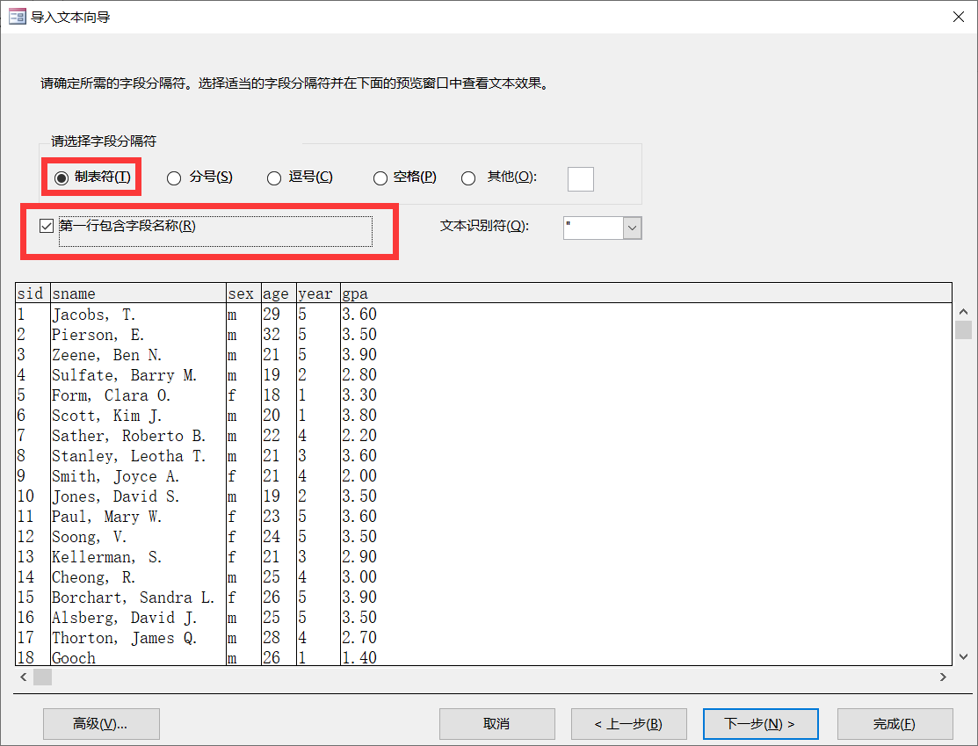

* + 1. **勾选制表符，第一行包含字段名**

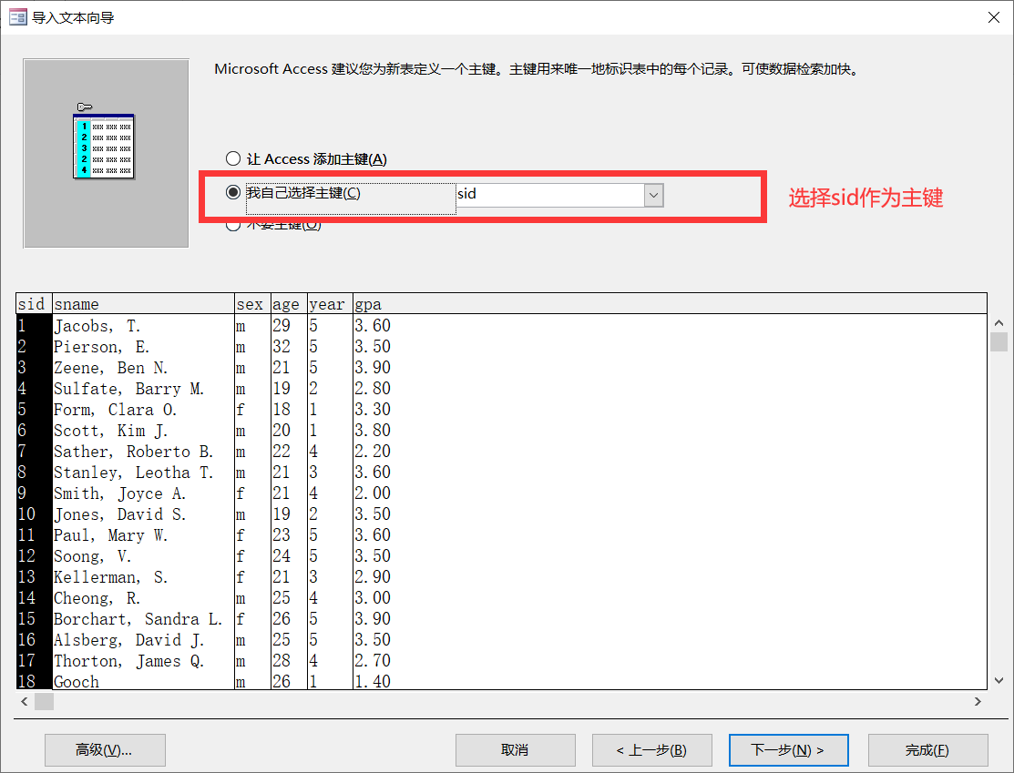

* + 1. **选择sid作为自定义主键，完成创建**

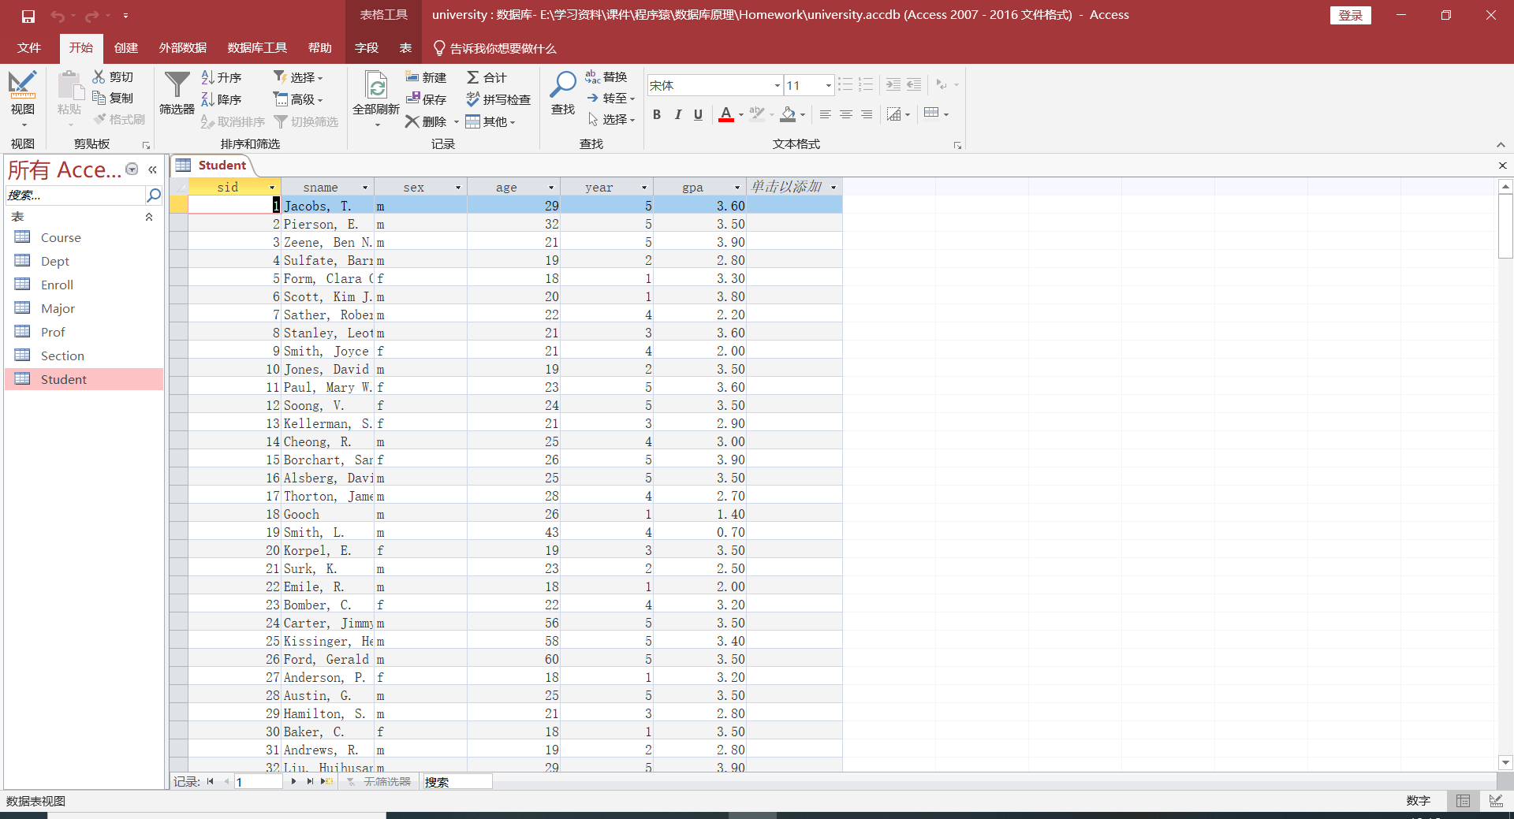

* + 1. **依次完成所有文本文件导入，得到最终数据库university.accdb**
  + **编写Python程序（附录提供源码auto_gen.py）**

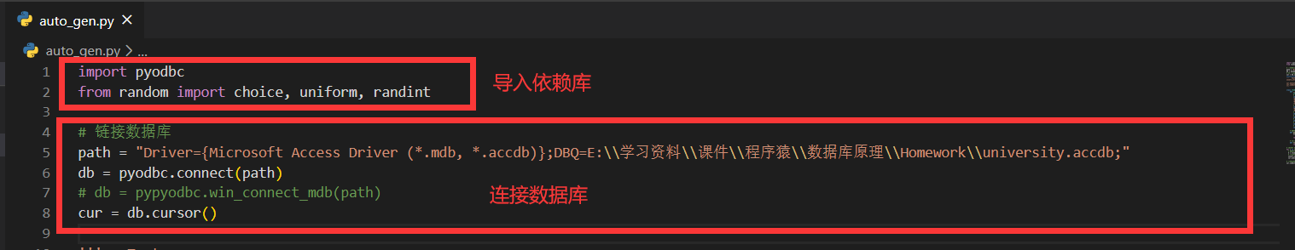

* + 1. **导入依赖库，完成数据库连接**

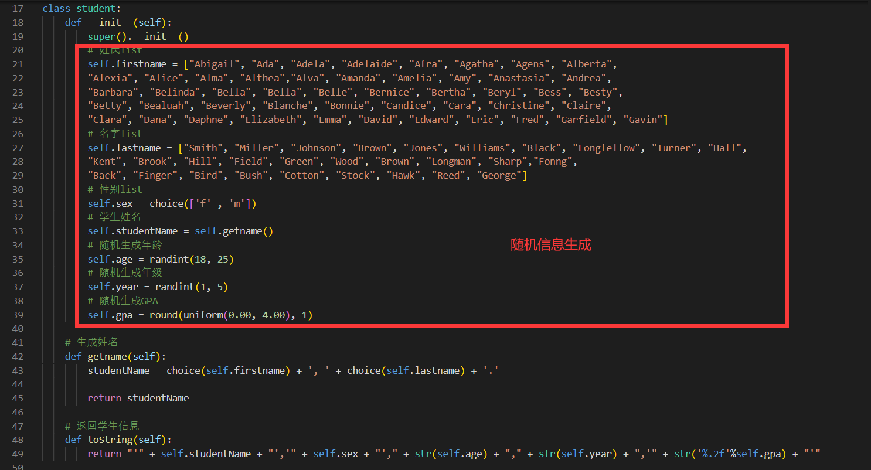

* + 1. **创建student类，完成类的定义(包括各字段信息的随机生成信息)**

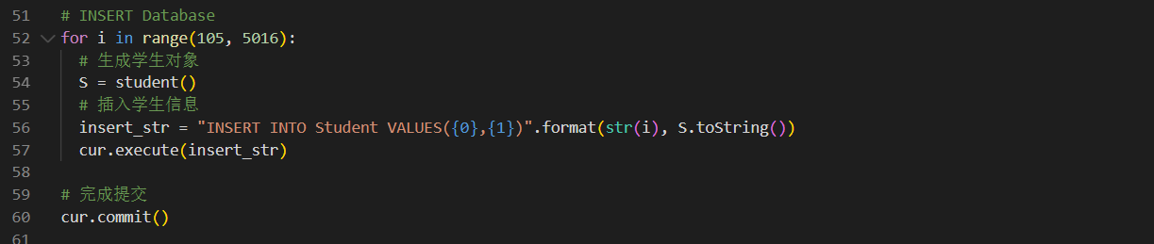

* + 1. **循环随机生成学生对象，插入数据库**
  + **运行Python程序，完成5000条随机学生信息插入**

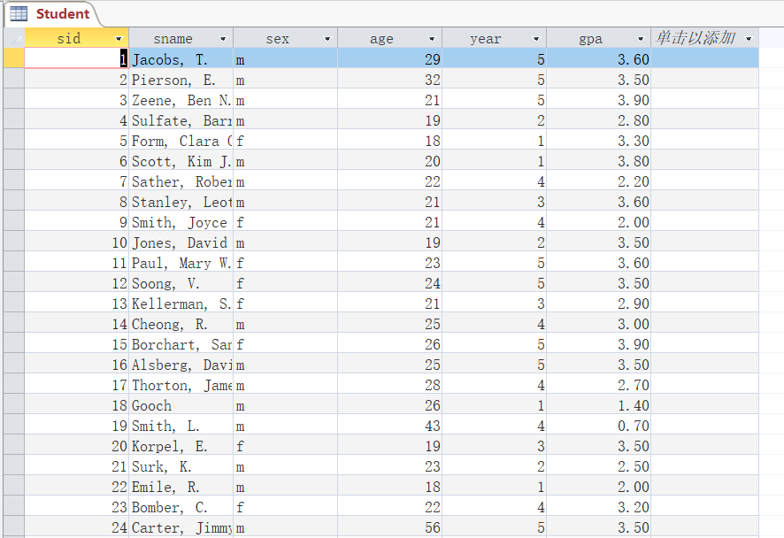

**附录**

// 随机学生信息插入代码 auto_gen.py

import pyodbc

from random import choice, uniform, randint

# 链接数据库

path = "Driver={Microsoft Access Driver (*.mdb, *.accdb)};DBQ=E:\\学习资料\\课件\\程序猿\\数据库原理\\Homework\\university.accdb;"

db = pyodbc.connect(path)

# db = pypyodbc.win_connect_mdb(path)

cur = db.cursor()

''' Test

insert_str = "INSERT INTO Student VALUES(1,'叶宏庭','男',22,3,3.7)"

cur.execute(insert_str)

cur.commit()

'''

class student:

def __init__(self):

super().__init__()

# 姓氏list

self.firstname = ["Abigail", "Ada", "Adela", "Adelaide", "Afra", "Agatha", "Agens", "Alberta",

"Alexia", "Alice", "Alma", "Althea","Alva", "Amanda", "Amelia", "Amy", "Anastasia", "Andrea",

"Barbara", "Belinda", "Bella", "Bella", "Belle", "Bernice", "Bertha", "Beryl", "Bess", "Besty",

"Betty", "Bealuah", "Beverly", "Blanche", "Bonnie", "Candice", "Cara", "Christine", "Claire",

"Clara", "Dana", "Daphne", "Elizabeth", "Emma", "David", "Edward", "Eric", "Fred", "Garfield", "Gavin"]

# 名字list

self.lastname = ["Smith", "Miller", "Johnson", "Brown", "Jones", "Williams", "Black", "Longfellow", "Turner", "Hall",

"Kent", "Brook", "Hill", "Field", "Green", "Wood", "Brown", "Longman", "Sharp","Fonng",

"Back", "Finger", "Bird", "Bush", "Cotton", "Stock", "Hawk", "Reed", "George"]

# 性别list

self.sex = choice(['f' , 'm'])

# 学生姓名

self.studentName = self.getname()

# 随机生成年龄

self.age = randint(18, 25)

# 随机生成年级

self.year = randint(1, 5)

# 随机生成GPA

self.gpa = round(uniform(0.00, 4.00), 1)

# 生成姓名

def getname(self):

studentName = choice(self.firstname) + ', ' + choice(self.lastname) + '.'

return studentName

# 返回学生信息

def toString(self):

return "'" + self.studentName + "','" + self.sex + "'," + str(self.age) + "," + str(self.year) + ",'" + str('%.2f'%self.gpa) + "'"

# INSERT Database

for i in range(105, 5016):

# 生成学生对象

S = student()

# 插入学生信息

insert_str = "INSERT INTO Student VALUES({0},{1})".format(str(i), S.toString())

cur.execute(insert_str)

# 完成提交

cur.commit()