**Assignment 2 Report**

71118415叶宏庭

1. **作业要求**

* 熟悉 SQL 查询语句
* 使用SQL 查询语句完成指定的12个查询

1. **使用平台和工具**
   * Windows 10
   * MS Access 2019
2. **实现方案**
3. **作业内容**

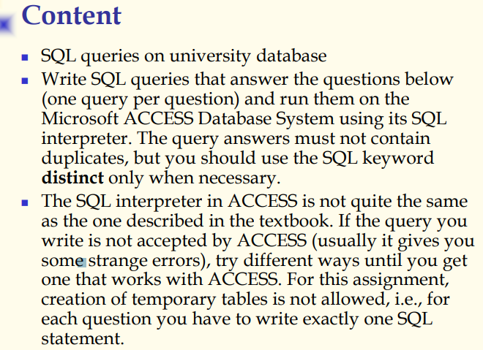

下方为12条指定的查询：

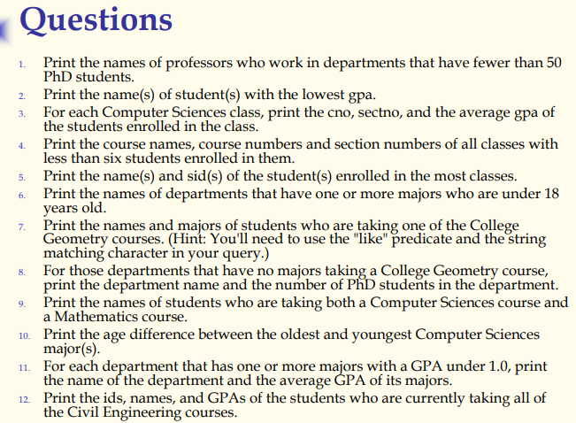

1. **作业要求**

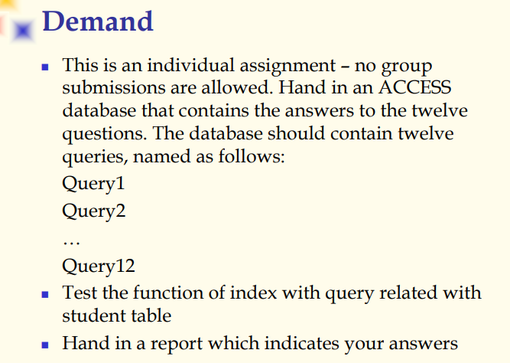

1. **作业具体实现**

本部分将会具体给出12条查询的内容，结果。

* + 1. 
       1. **SQL语句**

SELECT p.pname

FROM Prof AS p, Dept AS d

WHERE p.dname = d.dname AND d.numphds < 50;

* + - 1. **运行结果**

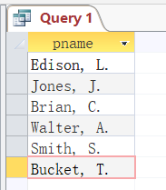

* + 1. 
       1. **SQL语句**

SELECT sname

FROM Student

WHERE gpa = (SELECT MIN(gpa)

FROM Student);

* + - 1. **运行结果（结果元组数量多，此处截图只包含部分，具体请查看university_A2.accdb）**

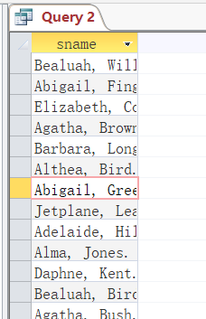

* + 1. 
       1. **SQL语句**

SELECT e.cno, e.sectno, AVG(s.gpa) AS AvgGPA

FROM Enroll AS e, Student AS s

WHERE e.sid = s.sid AND e.cno IN (SELECT cno

FROM Course

WHERE dname = "Computer Sciences")

GROUP BY e.cno, e.sectno;

* + - 1. **运行结果**

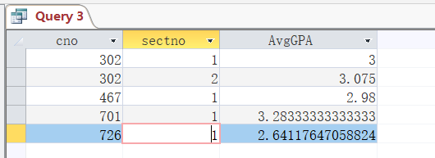

* + 1. 
       1. **SQL语句**

SELECT c.cname, c.cno, Temp.sectno

FROM Course AS c, (SELECT cno, sectno

FROM Enroll

GROUP BY cno, sectno

HAVING COUNT(*) < 6) AS Temp

WHERE c.cno = Temp.cno;

* + - 1. **运行结果（该查询结果为空）**

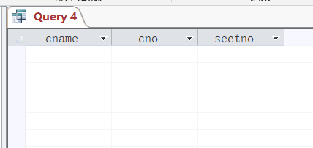

* + 1. 
       1. **SQL语句（本处给出同一SQL语句两种排版）**

I

SELECT sname, sid FROM Student WHERE sid IN (SELECT sid FROM (SELECT sid, COUNT(sid) AS myc FROM Enroll GROUP BY sid) WHERE myc = (SELECT MAX(mycount) FROM (SELECT sid, COUNT(sid) AS mycount FROM Enroll GROUP BY sid)) GROUP BY sid);

II

SELECT sname, sid

FROM Student

WHERE sid IN (SELECT sid

FROM (SELECT sid, COUNT(sid) AS myc

FROM Enroll

GROUP BY sid)

WHERE myc = (SELECT MAX(mycount)

FROM (SELECT sid, COUNT(sid) AS mycount

FROM Enroll

GROUP BY sid))

GROUP BY sid);

* + - 1. **运行结果**

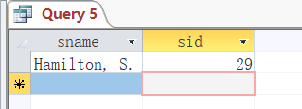

* + 1. 
       1. **SQL语句**

SELECT DISTINCT m.dname

FROM Major AS m, Student AS s

WHERE m.sid = s.sid AND s.age < 18;

* + - 1. **运行结果**

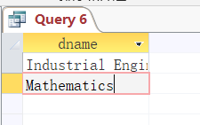

* + 1. 
       1. **SQL语句**

SELECT s.sname, m.dname

FROM Student AS s, Major AS m

WHERE s.sid = m.sid AND s.sid IN (SELECT sid

FROM Enroll

WHERE cno IN (SELECT cno

FROM Course WHERE cname LIKE '*Geometry*'));

* + - 1. **运行结果**

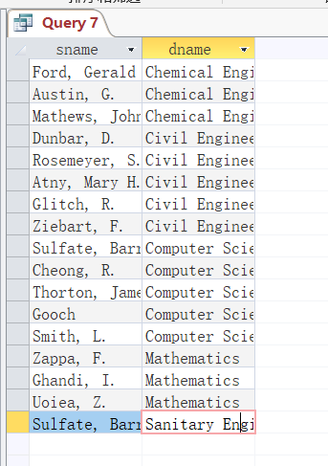

* + 1. 
       1. **SQL语句**

SELECT DISTINCT m.dname, d.numphds

FROM Major AS m, Dept AS d

WHERE m.dname = d.dname AND m.dname IN(SELECT DISTINCT m.dname

FROM Major m

WHERE m.dname NOT IN (SELECT DISTINCT m.dname

FROM Major m

WHERE m.sid IN (SELECT sid FROM Enroll WHERE cno IN (SELECT cno FROM Course WHERE cname LIKE '*Geometry*'))));

* + - 1. **运行结果**

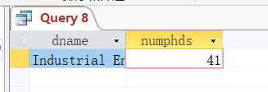

* + 1. 
       1. **SQL语句**

SELECT s.sname

FROM Student AS s

WHERE s.sid IN (SELECT T1.sid FROM (SELECT sid FROM Enroll e WHERE e.dname = "Computer Sciences") AS T1, (SELECT sid FROM Enroll e WHERE e.dname = "Mathematics") AS T2 WHERE T1.sid = T2.sid);

* + - 1. **运行结果**

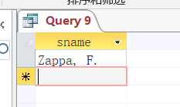

* + 1. 
       1. **SQL语句**

SELECT (MAX(age) - MIN(age)) AS ageDiff

FROM Student AS s

WHERE sid IN (SELECT sid FROM Major WHERE dname = "Computer Sciences");

* + - 1. **运行结果**

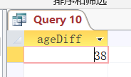

* + 1. 
       1. **SQL语句**

SELECT m.dname, AVG(s.gpa) AS AvgGPA

FROM Student AS s, Major AS m

WHERE s.sid = m.sid

GROUP BY m.dname

HAVING 0 < (SELECT COUNT(*) FROM Student WHERE sid IN (SELECT sid FROM Major WHERE dname = m.dname) AND gpa < 1.0);

* + - 1. **运行结果**

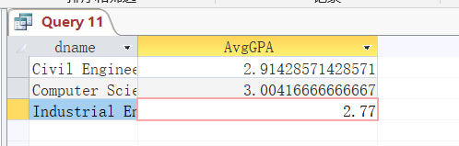

* + 1. 
       1. **SQL语句**

SELECT s.sid, s.sname, s.gpa

FROM Student AS s

WHERE s.sid IN (SELECT sid FROM Enroll WHERE cno IN (SELECT cno FROM Course WHERE dname = "Civil Engineering"));

* + - 1. **运行结果**

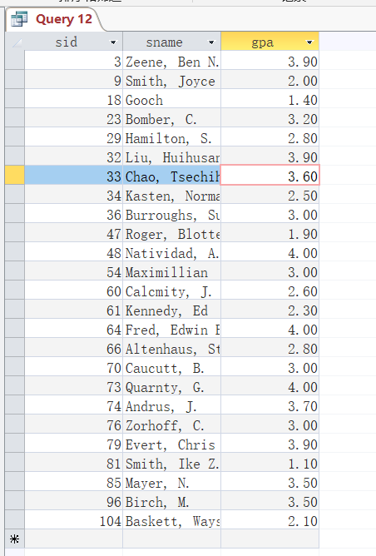

1. **总结**

通过两周的SQL语句学习，掌握了SQL语句使用的理论基础，再通过本次作业的练习，加深了对于SQL语句的理解，能够较好的使用SQL语句对数据库进行查询操作，希望以后能够更好掌握SQL语句，更好使用SQL，完成更强大的功能。