题165-1

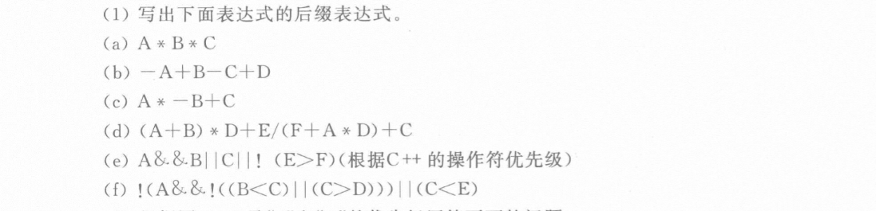

(a)：AB\*C\*

(b)：A-B+C-D+

(c)：AB-\*C+

(d)：AB+D\*EFAD\*+/+C+

(e)：AB&&C||EF>!||

(f)：ABC<CD>||!&&!CE<||