**Lab Exercises Report**

**Assignment 1**

**71118415 叶宏庭**

**1 The Network Diagram**

**How many bits should I use to divide IP address in Internal Network.**

**2^14 = 16384 > 15000**

**2^8 = 256 > 200**

**Mask for the two Internal Networks:**

**Subnet1:**

**Mask：255.255.192.0**

**Subnet2:**

**Mask：255.255.255.0**

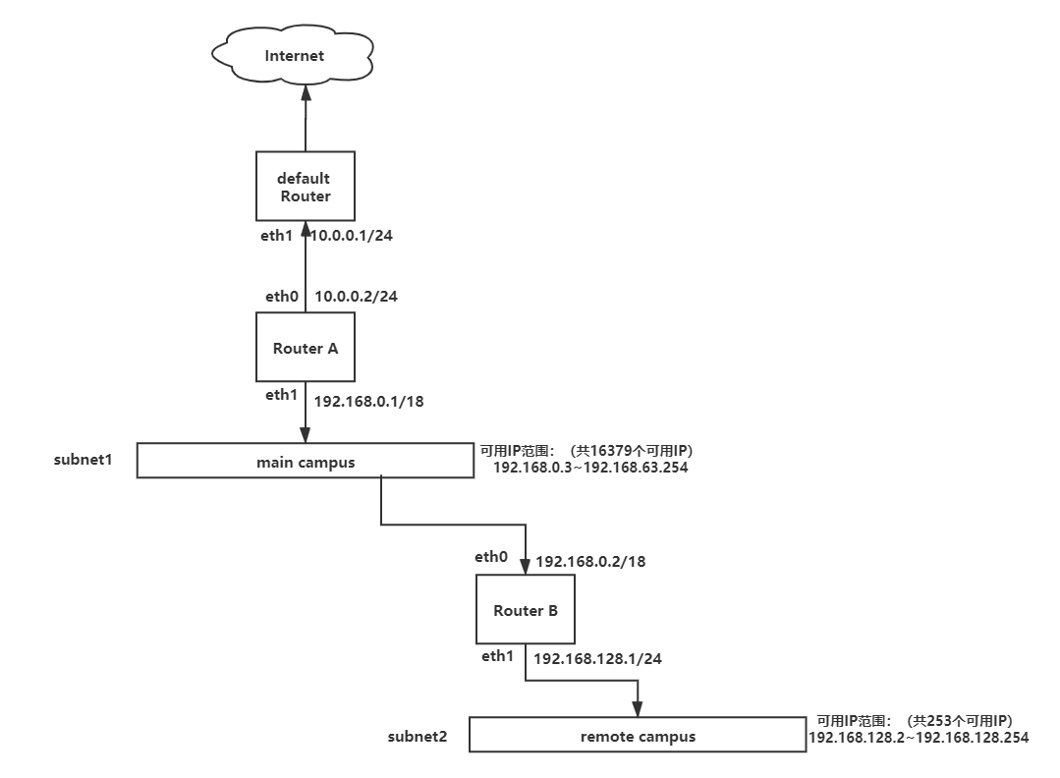

|  |  |  |  |  |
| --- | --- | --- | --- | --- |
| **Destination** | **Gateway** | **Genmask** | **Flags** | **Iface** |
| Default（0.0.0.0） | 10.0.0.1 | 0.0.0.0 | UG | eth0 |
| 192.168.128.0 | 192.168.0.2 | 255.255.255.0 | UG | eth1 |
| 192.168.0.0 | 0.0.0.0 | 255.255.192.0 | U | eth1 |
| 10.0.0.0 | 0.0.0.0 | 255.255.255.0 | U | eth0 |