**Lab Exercises Report**

**Assignment 2**

**71118415 叶宏庭**

**213182964@seu.edu.cn**

1. **Network configuration**
2. **Output from the command ip address.**

**Router:**

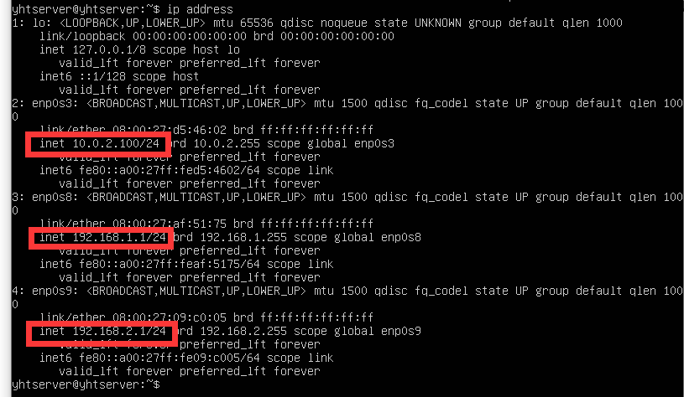

**Web:**

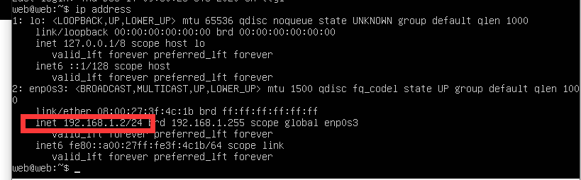

**Files:**

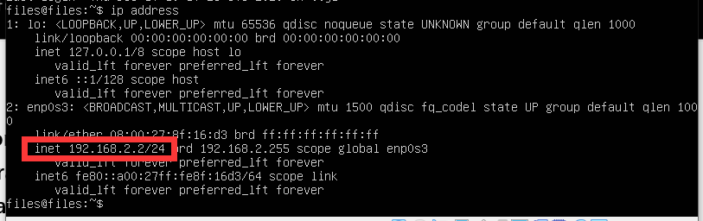

**Desktop:**

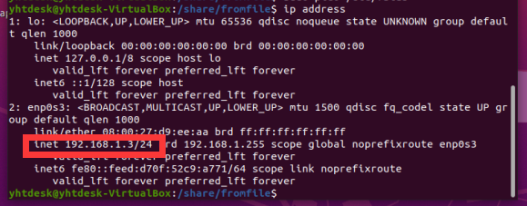

1. **Routing configuration**
2. **cat /etc/iptables/rules.v4 on the router machine.**

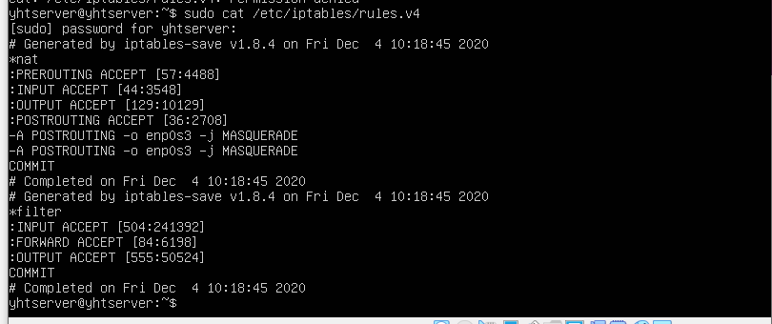

1. **ping 192.168.1.2 on files machine and ping 192.168.2.2 on the web machine.**

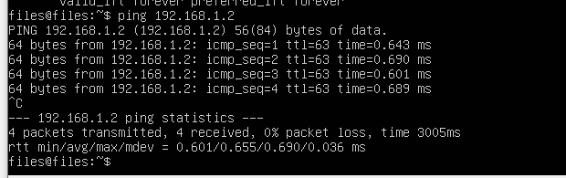

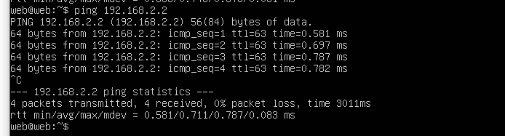

1. **DNS service configuration**
2. **Content of file /etc/bind/named.conf.local and all forward and reverse zone files.**

**/etc/bind/named.conf.local:**

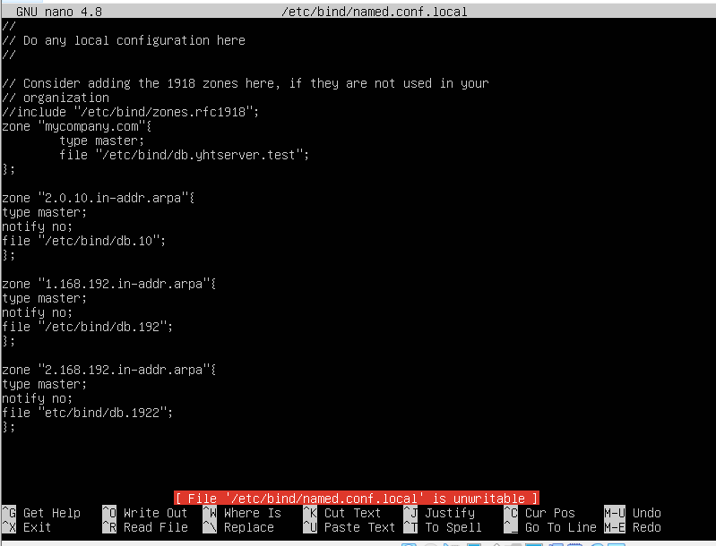

**/etc/bind/db.mycompany.com**

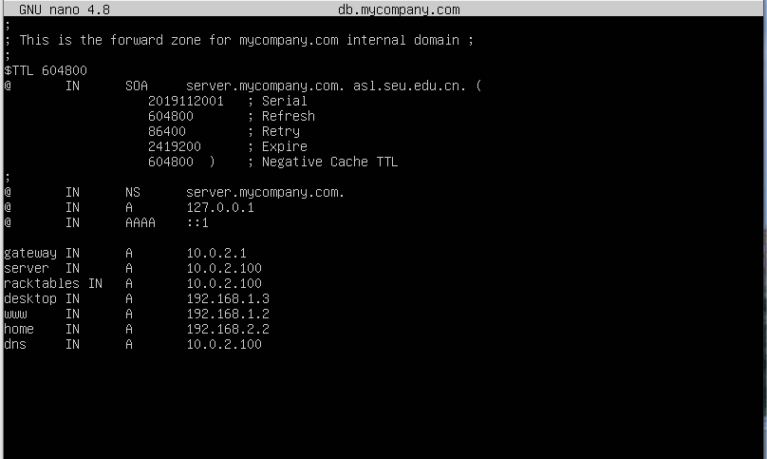

**/etc/bind/db.10:**

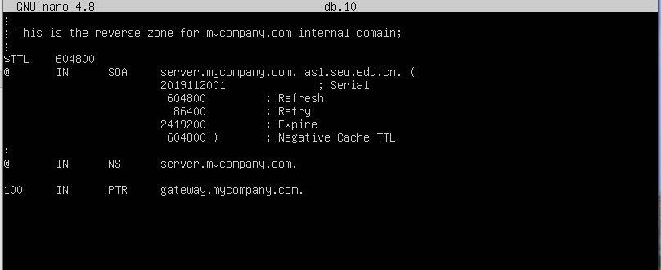

**/etc/bind/db.192:**

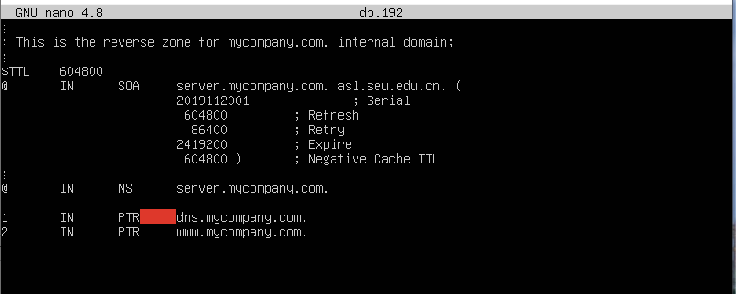

**/etc/bind/db.1922:**

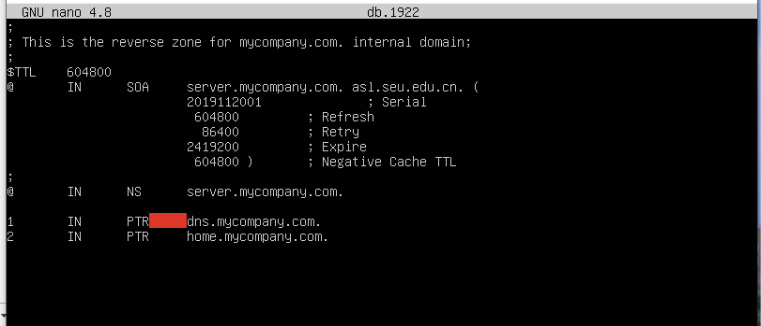

1. **dig** [**home.mycompany.com**](http://home.mycompany.com) **on the web machine and dig** [**www.mycompany.com**](http://www.mycompany.com) **on the files machine.**

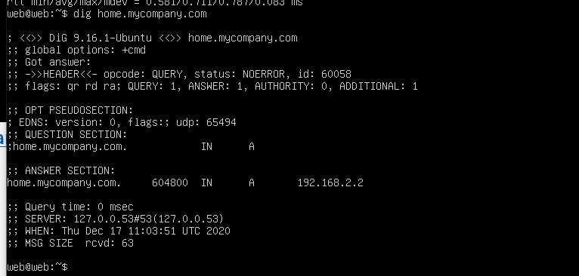

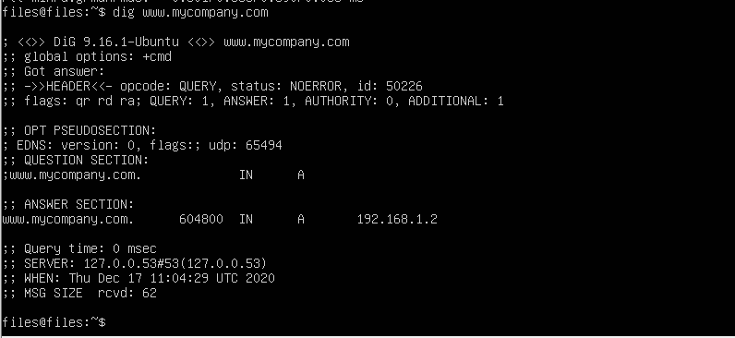

1. **dig -x 192.168.2.2 @dns.mycompany.com on the web machine.**

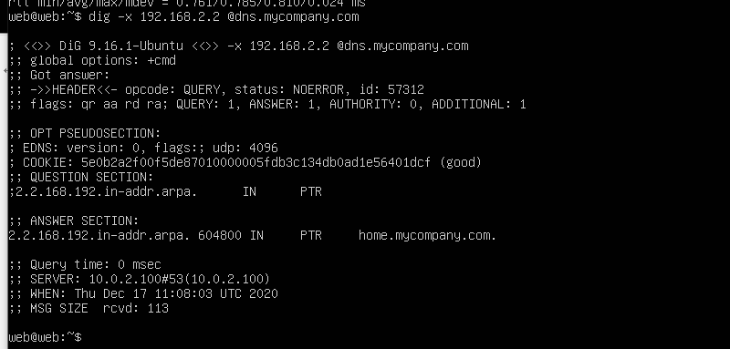

1. **File system configuration**
2. **Zpool status on the web and files machines.**

**Web:**

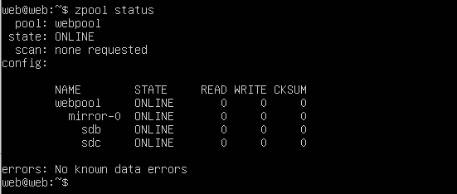

**Files:**

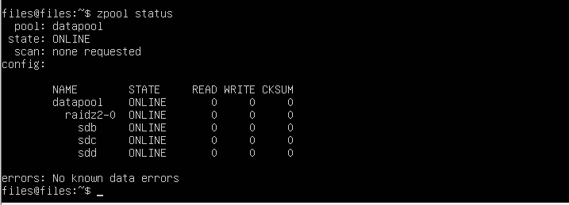

1. **Zfs list on the web and files.**

**Web:**

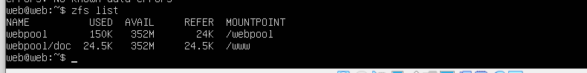

**Files:**

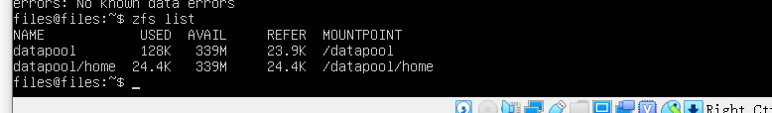

1. **Showmount -e** [**home.mycompany.com**](http://home.mycompany.com) **on the desktop machine.**

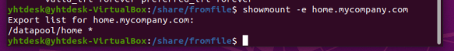

1. **Cat /etc/fstab on the desktop machine.**

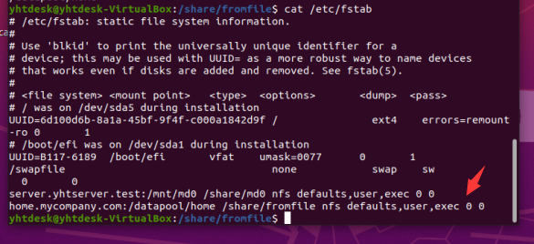

1. **Web service configuration**
2. **Cat /etc/apache2/sites-available/000-default.conf on the web machine.**

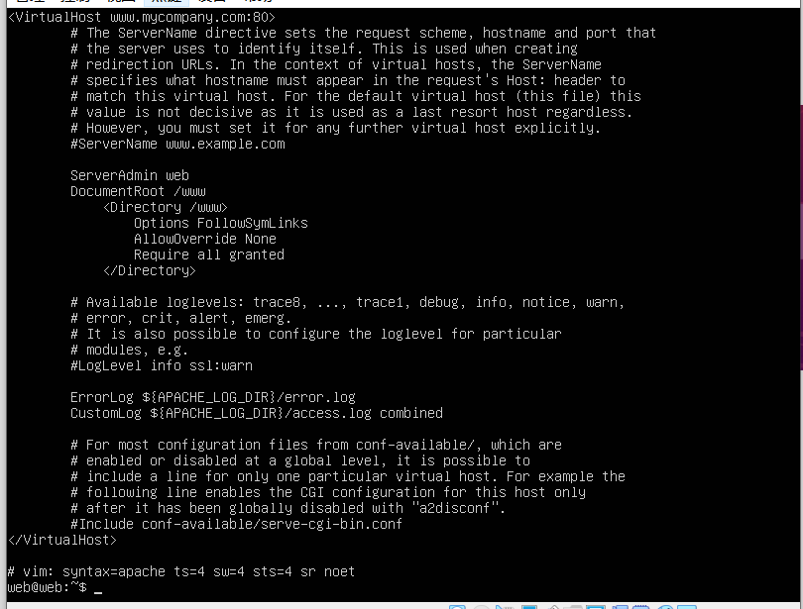

1. **On browser pointing to** [**www.mycompany.com**](http://www.mycompany.com) **on desktop machine.**

