**Lab Exercises Report**

**Lab 3**

**71118415 叶宏庭**

**Q1: /etc/timezone file on the server**

**Asia/Shanghai**

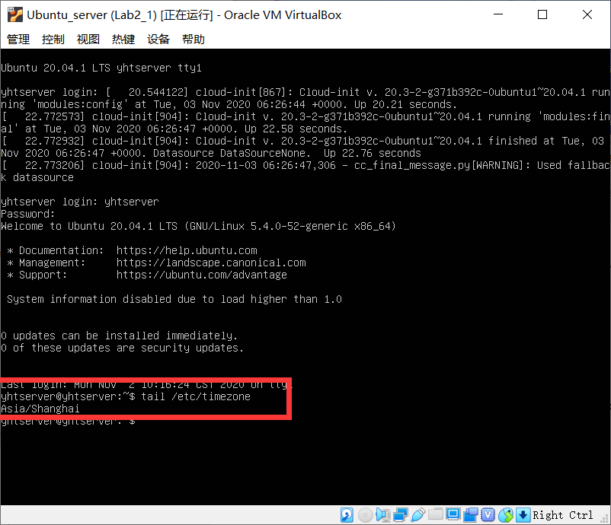

**Q2: the server’s MAC address from the packet captured by tcpdump on the server**

**MAC address：08:00:27:d5:46:02**

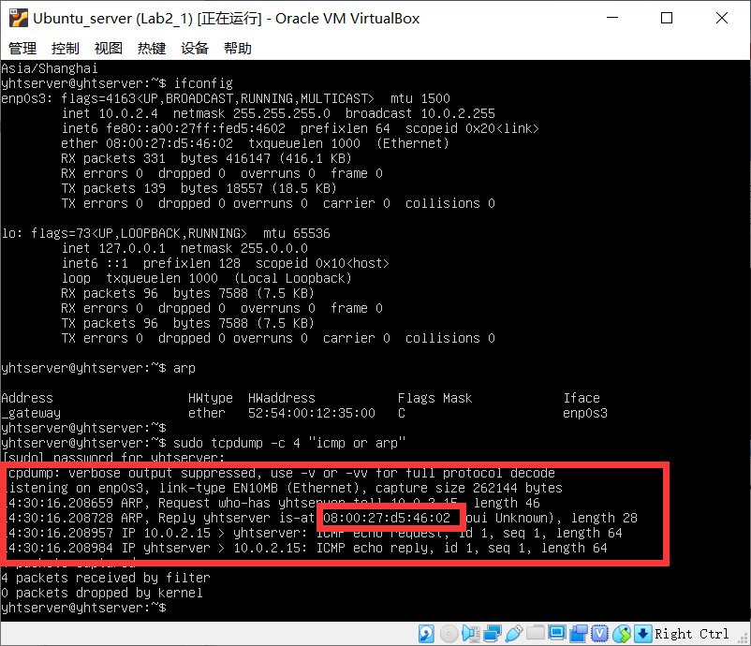

**Q3: MAC address of the source and destination, response time of ping from packets with Wireshark**

**Destination MAC address：08:00:27:d9:ee:aa**

**Source MAC address：08:00:27:d5:46:02**

**Response time of ping：0.024ms**

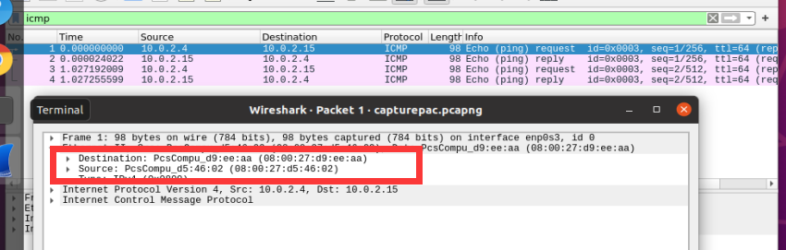

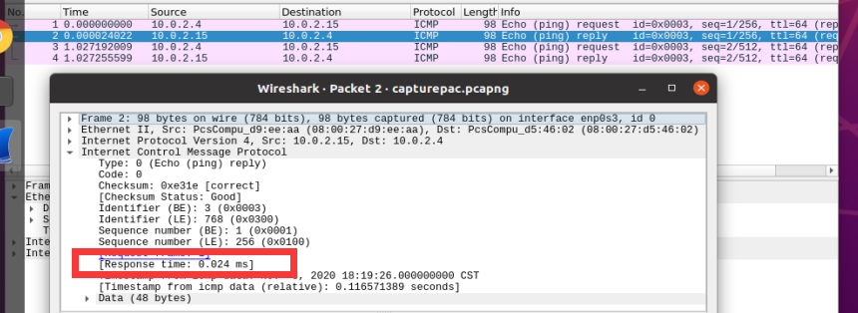

**Q4: IP address of** [**www.baidu.com**](http://www.baidu.com) **from packet with Wireshark**

**IP address of** [**www.baidu.com**](http://www.baidu.com)**：36.152.44.96**

