**Lab Exercises Report**

**Lab 4**

**71118415 叶宏庭**

**Q1: Finding out the count of GET /dokuwiki requests from 10.0.2.200**

**The number of GET requests: 8**



**Q2: Finding out NTP servers for your server VM has found**

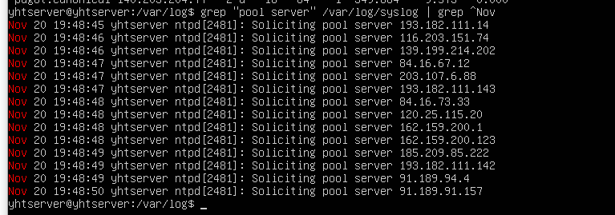

**Q3: Your command and the sorted username entries starting with [aeiou]**

**Command: grep ^[aeiou].*: /etc/passwd | awk -F: ‘{print $1, $3}’ | sort -u**

**Username entries: irc 39; uucp 10; uuidd 107;**

**(Note: Don’t have abc123，because my username in VM is yhtserver)**

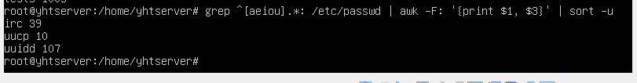

**Q4: Finding out which accounts are in the odds group**

**Accounts in odds group: test1, test3, test5**

