**Lab Exercises Report**

**Lab 5**

**71118415 叶宏庭**

**Q1: Demonstrating the cache/forwarder nameserver working.**

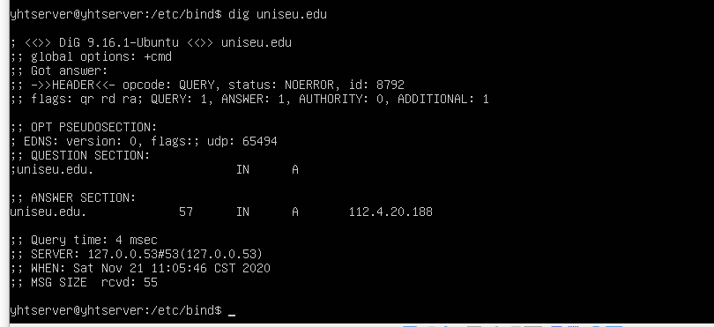

**Q2: Demonstrating forward lookups working.**

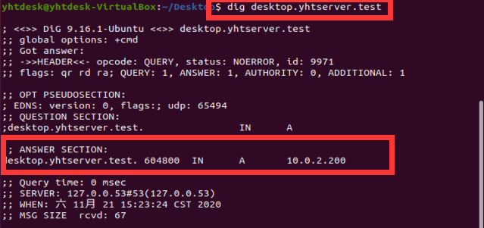

**Q3: Demonstrating reverse lookups working.**

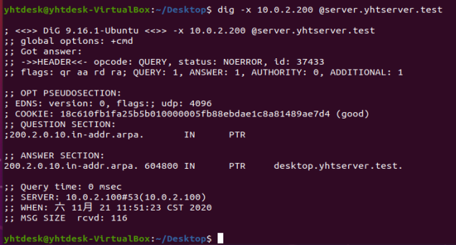

**Q4: Accessing my Dokuwiki using the server’s hostname.**

