**Lab Exercises Report**

**Lab 6**

**71118415 叶宏庭**

**Q1: Showing the content of /etc/mdadm/mdadm.conf on the server VM.**

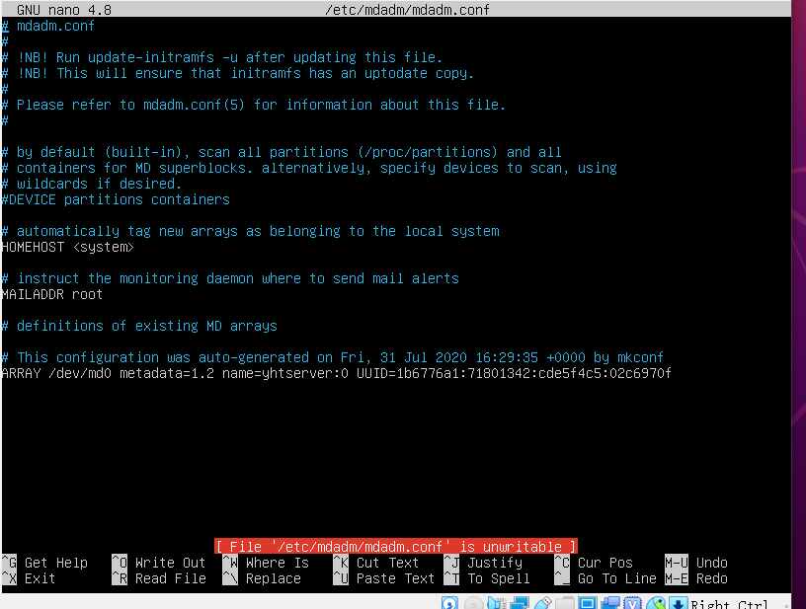

**Q2: Showing the content of /etc/fstab on the server VM.**

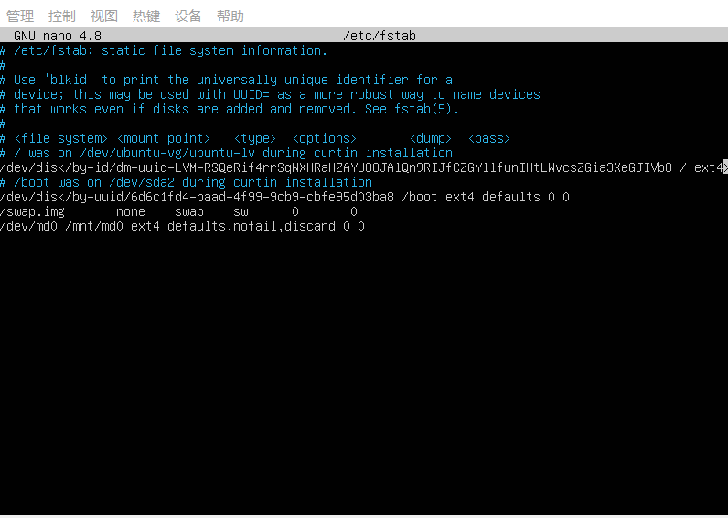

**Q3: Listing the files in the directory /share/md0 on the desktop VM.**

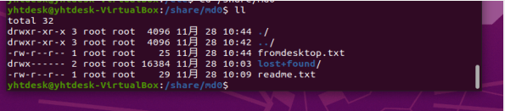

**Q4: Showing the new disk called myDisk4.vdi for the server VM in the VirtualBox manager.**

