**Lab Exercises Report**

**Lab 7**

**71118415 叶宏庭**

**Q1: Showing datasets on the pool.**

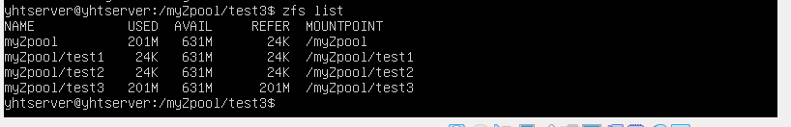

**Q2: Showing the compression ratio of all datasets.**

**(Note: I hava this screenshot after I create the snapshot1, so there is one more line for snapshot1. )**

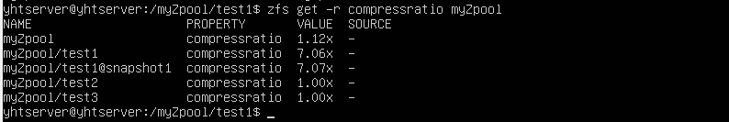

**Q3: Showing the snapshot.**

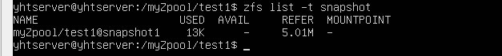

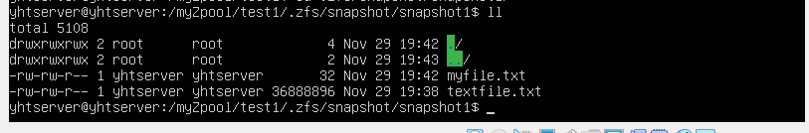

**Q4: Showing the pool with two mirrored VDEVS.**

