**Lab Exercises Report**

**Lab 8**

**71118415 叶宏庭**

**Q1: Demonstrating that the internal network is working by ping each other VMs using their IP addresses.**

**Server 🡪 Desktop**

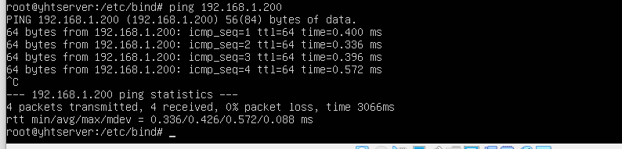

**Desktop 🡪 Server**

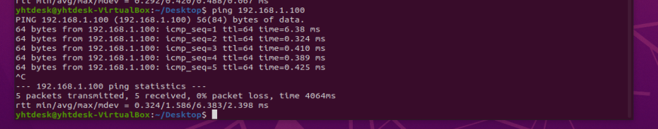

**Q2: Demonstrating that the NAT router is working by ping** [**www.baidu.com**](http://www.baidu.com) **from the desktop VM.**

**Desktop 🡪 www.baidu.com**

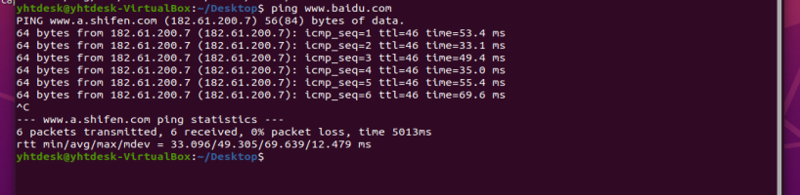

**Q3: Demonstrating that the DNS is working by ping each other VMs using their host names.**

**Server 🡪 Desktop**

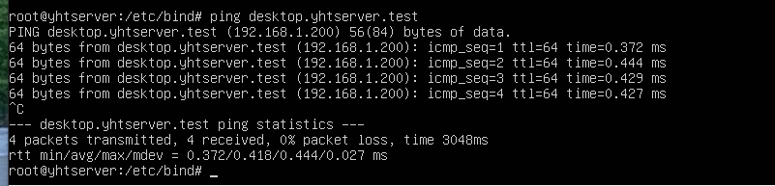

**Desktop 🡪 Server**

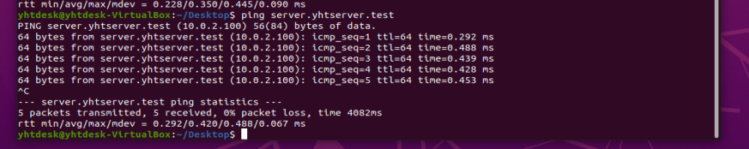

**Q4: Demonstrating that the port forwarding is working by accessing the Dokuwiki from the host machine.**

**Host machine(my Windows) 🡪 Server Dokuwiki**

