**Lab Exercises Report**

**Lab 9**

**71118415 叶宏庭**

**Q1: Showing the installer page in your browser.**

**The screenshot for Step2-Step7 are omitted.**

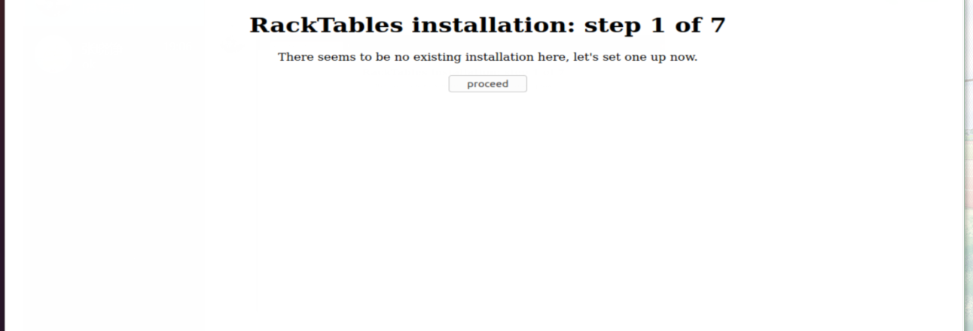

**Q2: Demonstrating that your RackTables instance is running by showing the main page in your browser.**

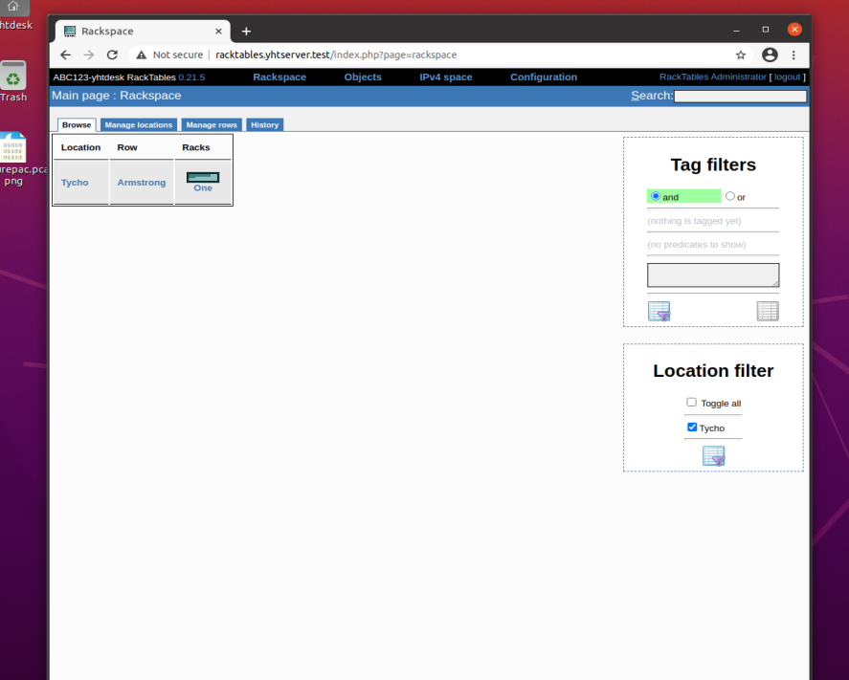

**Q3: Showing somae hardware in the Tycho: Armstrong: One rack.**

