**组合数学作业**

**Chapters2**

71118415-叶宏庭

**Part.1**

**Basic principles or basic permutation and combination: 2,3,4,10,12,39,58**

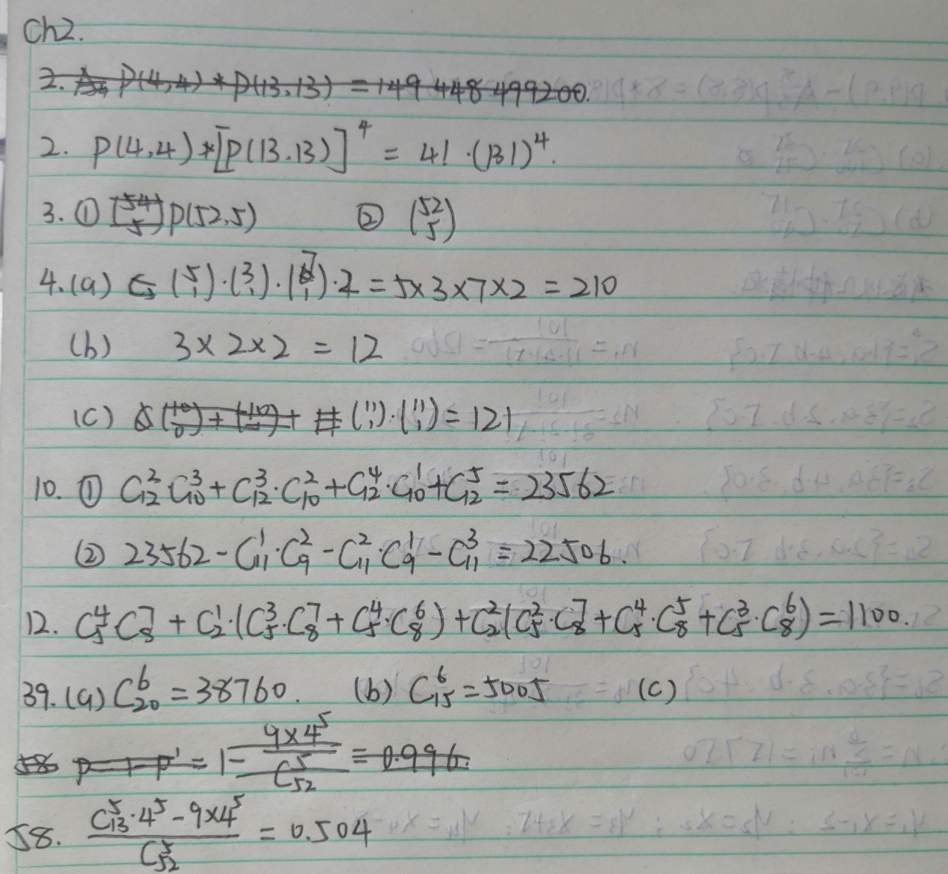

**Part.2**

**Circular permutation: 7,9,20**

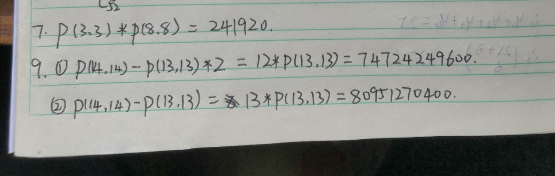

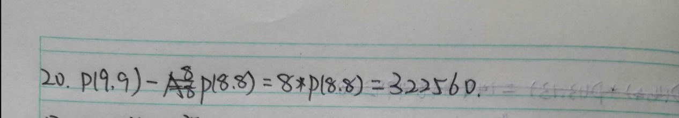

**Part.3**

**Permutation or combination of multisets: 13,33,38**

