**高级数据结构作业**

71118415 叶宏庭

**题1**

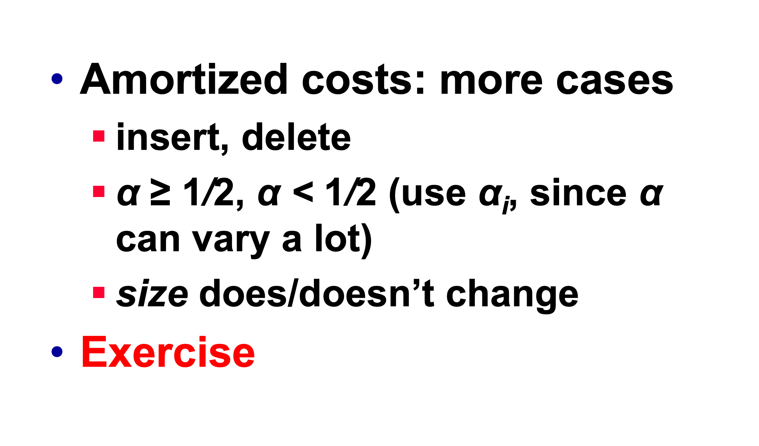

**α>=1/2时，F(T)=2num[T]-size[T]**

**α<1/2时，F(T)=size[T]/2-num[T]**

**Case1：insert，α≥1/2，size doesn’t change**

size(i)=size(i-1)

num(i)=num(i-1)+1

c(i)=1;

Amortized cost

=c(i)+ ΔF=c(i)+F(i)-F(i-1)

=1+(2*num(i)-size(i))-(2*num(i-1)-size(i-1))

=3

**Case2：insert，α≥1/2，size change**

size(i)=2*size(i-1)

size(i-1)=num(i-1)=num(i)-1

c(i)=num(i-1)+1=num(i)

Amortized cost

=c(i)+ ΔF=c(i)+F(i)-F(i-1)

=num(i)+(2*num(i)-size(i))-(2*num(i-1)-size(i-1))

=3

**Case3：insert，α＜1/2，size doesn’t change**

size(i)=size(i-1)

num(i)=num(i-1)+1

c(i)=1

Amortized cost

=c(i)+ ΔF=c(i)+F(i)-F(i-1)

=1+(size(i)/2-num(i))-(size(i-1)/2-num(i-1))

=0

**Case4：insert，α＜1/2，size change**

不存在这种情况；

**Case5：delete，α≥1/2，size doesn’t change**

size(i)=size(i-1)

num(i)=num(i-1)-1

c(i)=1

Amortized cost

=c(i)+ ΔF=c(i)+F(i)-F(i-1)

=1+(2*num(i)-size(i))-(2*num(i-1)-size(i-1))

=-1

**Case6：delete，α≥1/2，size change**

α≥1/2>1/4，所以不存在该情况；

**Case7：delete，α＜1/2，size doesn’t change**

size(i)=size(i-1)

num(i)=num(i-1)-1

c(i)=1

Amortized cost

=c(i)+ ΔF=c(i)+F(i)-F(i-1)

=1+(size(i)/2-num(i))-(size(i-1)/2-num(i-1))

=2

**Case8：delete，α＜1/2，size change**

size(i)=size(i-1)/2

size(i-1)=2*num(i-1)=2*(num(i)+1)

num(i)=num(i-1)-1

c(i)=num(i-1)

Amortized cost

=c(i)+ ΔF=c(i)+F(i)-F(i-1)

=num(i-1)+ (size(i)/2-num(i))-(size(i-1)/2-num(i-1))

=1

**题2**

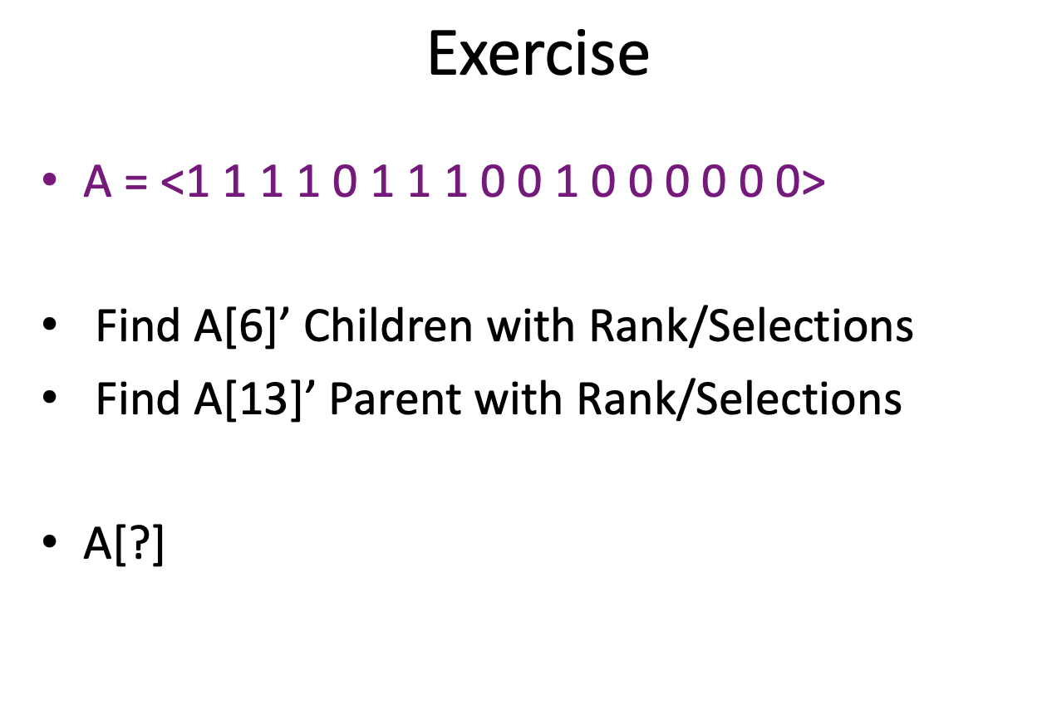

1. 过程：A[rank(6)*2] A[rank(6)*2+1]

结果：A[10] A[11]

1. 过程：A[selections([13/2])]

结果：A[7]