For this Calculation: Permeability is taken as equal to 1.

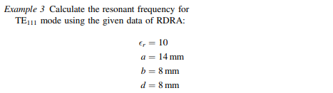

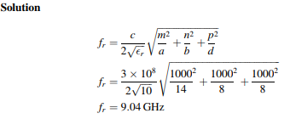

Calculation Results using RDRA Frequency Calculator Application:

Input in order of Permittivity, Permeability, Length, Width, Height

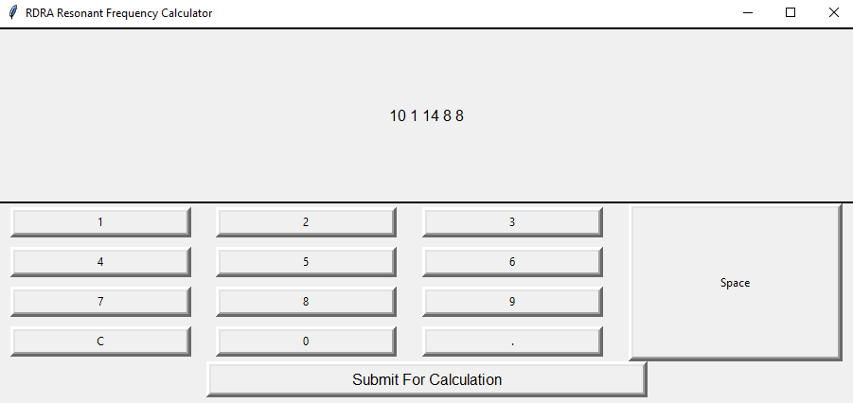

Output

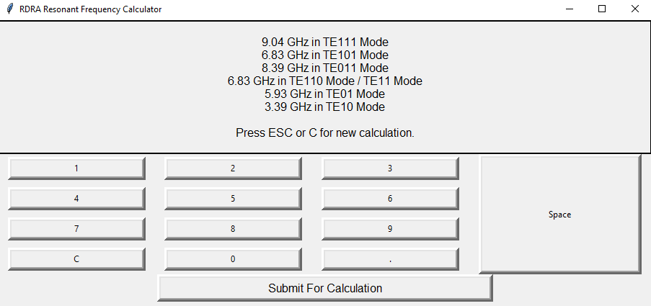

In TE111 Mode of RDRA:

Manual Calculation Result, Fr = 9.04 GHz

Result from Application, Fr= 9.04 GHz