PROJECT ANNOUNCEMENT
Fall 2026

Title: Simulation, Kinematic Modeling, and Trajectory Optimization of an Autonomous Mobile Robot Platform with Caster Wheel Dynamic Interactions

Position Ref: AUTOMR

Type: Group
Status: Ongoing
Seats: 2 students

Industry Partner / Context: Integration with Physical AI Campus Guide Project (Yeditepe University & Arche Robotics)

Project Description:
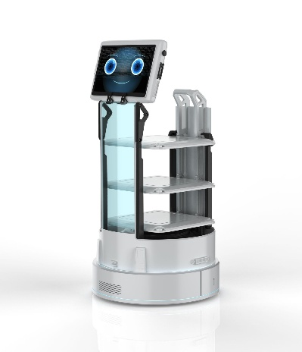
Unmanned Ground Vehicles (UGVs) and Differential Drive Autonomous Mobile Robots (AMRs) heavily rely on passive omnidirectional support wheels—commonly known as caster wheels—for mechanical balance and load distribution. While differential drive wheels govern primary propulsion, passive caster wheels introduce complex dynamic phenomena, including swivel friction, orientation lag, transient scrubbing forces, and parasitic yaw torques. On irregular or multi-surface indoor/outdoor campus environments (e.g., polished marble, carpet, pavers, and sloped ramps), these caster interactions cause wheel slip, path deviations, and degraded odometry estimation.
This ME 492 project focuses on building a high-fidelity physics-based digital twin (simulation environment) of a commercial mobile robot platform to model, analyze, and optimize caster wheel mechanics and path planning algorithms. The project will leverage advanced simulation frameworks (ROS 2, Gazebo, or NVIDIA Isaac Sim) to investigate how different caster wheel parameters—such as offset distance (trail), wheel diameter, tread material/durometer, and swivel damping—affect path tracking accuracy and smooth trajectory generation.
The developed models and path optimization strategies will directly feed into the physical campus guide mobile robot developed in collaboration with Arche Robotics.

Work Description:
- 3D & Kinematic Modeling: Build 3D CAD models and mathematical equations of the robot's driving wheels and swivel caster wheels.
- Physics Simulation: Set up a ROS 2 simulation (Gazebo or Isaac Sim) to model how different campus surfaces (carpet, marble, pavers) affect caster wheel wobble and sliding.
- Caster Wheel Selection: Test different caster wheel sizes, offset lengths, and materials in simulation to find the design that turns most smoothly with the least friction.
- Path & Motion Control: Test smart path-following algorithms with smooth acceleration curves to prevent sudden jerky movements and keep the robot on track.

Required Qualifications and Skills:
- Engineering Core: Solid background in Kinematics and Dynamics of Machinery, Vibration/Mechanical Controls, and CAD modeling (SolidWorks / Fusion 360).
- Software & Simulation: Basic familiarity with Python and/or C++; interest in ROS 2 (Robot Operating System) and physics simulation engines (Gazebo, Isaac Sim, or Webots).
- Control & Optimization: Familiarity with basic control theory (PID, trajectory generation, path planning algorithms).
- Soft Skills: Technical report writing in English, team collaboration, and problem-solving initiative.

Related UN Sustainable Development Goals:
- SDG 9: Industry, Innovation, and Infrastructure

Difficulty: high (X) medium ( ) low ( )
Time commitment: high (X) medium ( ) low ( )

Estimated expense: 0 TL

