PROJECT ANNOUNCEMENT
Fall 2026

Title: Optimization of a Novel Biped Foot Design
Position Ref: BIFO

Type: Individual
Status: New
Seats: 1

Project Description:
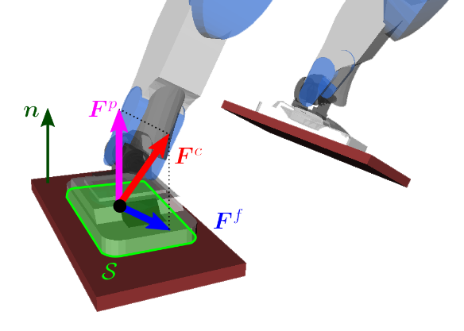
This project focuses on the simulation-based optimization and performance evaluation of a novel bio-inspired foot design for bipedal robots. The study will investigate how foot geometry, stiffness distribution, and compliant material properties influence locomotion performance, including joint torque requirements, ground reaction forces, and Zero Moment Point (ZMP) behavior. The student will work with existing MATLAB/Simulink-based models and experimentally informed material parameters to evaluate and improve the mechanical performance of the proposed foot design.
The work will involve reviewing the existing foot models, verifying simulation parameters, implementing selected optimization and sensitivity analyses, and comparing the performance of alternative foot configurations under prescribed gait conditions. Depending on the progress and quality of the results, the student may contribute to the preparation of a research manuscript, including data analysis, figure preparation, and selected sections of the Methods, Results, or Discussion. The project is intended to provide practical experience in computational robotics, mechanical optimization, and research-oriented engineering analysis.

Work Description:
- Review the existing biped foot design, MATLAB/Simulink models, and relevant literature on compliant and bio-inspired robotic feet.
- Verify model parameters, material properties, optimization settings, and simulation assumptions; identify and correct inconsistencies where applicable.
- Perform selected simulation-based optimization, sensitivity analyses, and comparative evaluations of the flat-foot and multi-segment (TBS) foot designs.
- Process simulation outputs, including joint torques, ground reaction forces, and ZMP trajectories; prepare tables, plots, and summaries of the results.
- Contribute to the preparation of research documentation and, subject to the quality and scope of the completed work, participate in writing or revising a research paper based on the project findings.

Required Qualifications and Skills:
- Basic experience with MATLAB and Simulink; familiarity with numerical simulation and optimization is desirable.
- Interest in robotics, bipedal robots, humanoid locomotion, and biomechanical or bio-inspired mechanical design.
- Basic knowledge of mechanical systems, dynamics, and engineering analysis.
- Ability to interpret simulation results, prepare technical reports, and work independently or collaboratively.
- Willingness to learn research methods, scientific writing, and data visualization.

Related UN Sustainable Development Goals:
- SDG 9 – Industry, Innovation and Infrastructure: Development and evaluation of innovative robotic foot designs and computational engineering methods.

Difficulty: high (X) medium ( ) low ( )

Time commitment: high (X) medium ( ) low ( )

Estimated expense: 0 TL

