INTERACTIVE LINUX AUTOMATION SHELL
A Project Based Learning Report Submitted in partial fulfilment of the requirements for the award of the degree

of

Bachelor of Technology
in The Department of CSE
OPERATING SYSTEMS AND SYSTEMS PROGRAMMING | 25CS2104E
Submitted by
2510030004: SRIHITHA . M
2510030007: AKSHAYA . Y
2510030170: VARSHA .T

Under the guidance of
Dr.Kalpana



Department of Electronics and Communication Engineering
Koneru Lakshmaiah Education Foundation, Aziz Nagar
Aziz Nagar – 500075
OCTOBER - 2026.
Abstract

The Interactive Linux Automation Shell is an Operating Systems project designed to simplify routine Linux operations through an interactive command-line interface. Linux provides several commands for file management, process control, system monitoring, and task automation. However, repeatedly entering commands manually can be time-consuming and difficult for beginners.
The proposed system provides a custom shell interface that accepts user commands and executes supported operations. It aims to simplify common tasks such as navigating directories, managing files, executing commands, and retrieving system information. The application demonstrates important Operating Systems concepts, including process management, command interpretation, system calls, file handling, and interaction between user applications and the Linux operating system.
The shell is designed to provide a modular and extensible environment in which additional commands and automation features can be incorporated. Input validation and error handling help users identify incorrect commands and unsuccessful operations. The project provides practical experience in Linux programming and demonstrates how automation can improve the efficiency of repetitive system operations.
The development of the Interactive Linux Automation Shell also emphasizes modularity, reliability, and ease of use. By organizing command processing and execution into separate components, the system can be maintained and extended with additional functionalities. The application is designed to provide meaningful output and error messages, helping users understand the results of their commands and recover from common input errors. Testing the implemented commands helps evaluate the correctness of operations and the overall behavior of the application.
Furthermore, this project provides practical knowledge of Linux system programming and the internal working of command-line applications. It helps demonstrate how user input is processed, how commands are executed, and how an application interacts with operating-system resources. The project can serve as a foundation for future enhancements, including command history, batch execution, configurable shortcuts, improved system monitoring, and advanced automation capabilities. These improvements could make routine Linux tasks more convenient while strengthening the application's flexibility and usefulness.
The Interactive Linux Automation Shell also focuses on providing a consistent and organized approach to executing system commands. By grouping related operations into a single interface, the application can reduce the need to remember lengthy command sequences for frequently performed tasks. Its command-processing mechanism helps organize user requests, while modular execution makes it easier to maintain the code and introduce new functionalities. This approach is particularly useful in educational environments, where students can explore Linux commands and understand how software interacts with operating-system services.
In addition, the project encourages practical learning through implementation, testing, and debugging of system-level operations. It provides an opportunity to study command execution, file-system interaction, process management, and error handling in a Linux environment. The design can be extended in the future with features such as command history, automated task scheduling, configurable shortcuts, and enhanced system monitoring. Overall, the project aims to combine the fundamental concepts of Operating Systems with a practical automation tool that improves convenience, supports learning, and provides a foundation for further development.

List of Figures
Figure 1: Welcome Interface of MyShell ........................................................ 10
Figure 2: Main Menu and Lesson Selection .....................................................… 9
Figure 3: Quiz Evaluation and Score Display ........................................................ 12
Figure 4: Linux Command Practice and Validation ........................................................ 12

List of Tables

Table 1: Main Modules of the Interactive Linux Automation Shell 9
Table 2: Functional Test Scenarios and Observed Results 11

Table of Contents

INTRODUCTION 6

METHODOLOGY 7

EXPERIMENTS 11

RESULTS 13
CONCLUSION AND FUTURE WORK 14
REFERENCES 15

INTERACTIVE LINUX AUTOMATION SHELL

Introduction

1.1 Background
An operating system manages computer hardware and provides services to application programs. Linux is widely used in software development, server administration, networking, cloud computing, and embedded systems. One of its important features is the command-line interface, which allows users to interact directly with the operating system.
A shell is a command interpreter that accepts user input and executes the requested commands. Common Linux shells include Bash and Zsh. Users can perform operations such as creating files, navigating directories, managing processes, checking system resources, and executing scripts through the shell.
Although Linux provides many powerful utilities, users often need to remember different command names, arguments, and options. Repetitive operations may require several commands to be executed in sequence. This can increase the time required to complete routine tasks and create difficulties for beginners who are unfamiliar with Linux command syntax.
The Interactive Linux Automation Shell addresses this problem by providing a custom command-line application for executing selected Linux operations through a consistent interface. The system accepts user commands, processes the input, identifies the requested operation, and executes the corresponding functionality.
The project also provides practical exposure to Operating Systems concepts. Developing an interactive shell involves input processing, command parsing, process execution, error handling, and interaction with operating-system services. These concepts help bridge the gap between theoretical knowledge and practical system programming.

1.2 Motivation
The main motivation for developing the Interactive Linux Automation Shell is to reduce the effort required to perform repetitive Linux operations. Users frequently perform tasks such as checking system information, organizing files, navigating directories, and executing system utilities.
A custom shell can simplify these activities by providing convenient commands and automation functions. It can also help beginners learn Linux by offering a structured interface and clear feedback.
From an academic perspective, the project provides an opportunity to understand how command interpreters work and how user applications interact with the operating system. It encourages practical learning of process creation, command execution, file handling, and system-level programming.

1.3 Problem Statement
Performing routine Linux operations often requires users to remember command syntax and execute multiple commands manually. Incorrect arguments, invalid file paths, and unfamiliar commands can result in errors and unnecessary delays.
The objective of this project is to develop an interactive Linux automation shell that simplifies selected system operations through a custom command interface. The application should accept user input, identify supported commands, execute the requested operations, display results, and handle invalid input appropriately.
The proposed solution focuses on improving convenience, reducing repetitive manual work, and demonstrating fundamental Operating Systems concepts through practical implementation.

1.4 Objectives
1.To develop an interactive command-line interface for Linux operations.
2.To implement command parsing and command execution.
.To simplify selected file and directory management operations.
4.To provide shortcuts for repetitive system tasks.
5.To support system information retrieval and process-related operations where implemented.
6.To handle invalid commands and incorrect arguments.
7.To demonstrate Operating Systems concepts through practical programming.
8.To develop a modular structure that supports future enhancements.
9.To test the functionality and reliability of the implemented commands.
10.To improve the usability of routine Linux operations.

1.5 Scope of the Project
The project focuses on developing a custom interactive shell for selected Linux commands and automation tasks. Its scope includes accepting user input, interpreting commands, executing supported operations, and displaying results.
Depending on the implemented functionality, the system may support file management, directory navigation, external command execution, process inspection, and system monitoring. The modular design allows additional commands to be introduced in future versions.
The project is intended primarily for educational purposes and routine operations in a Linux environment. It does not aim to replace complete shells such as Bash, which provide advanced scripting, pipelines, redirection, and job-control features.

METHODOLOGY

2.1 System Design
The Interactive Linux Automation Shell follows a modular design. The application starts by displaying a command prompt and waiting for user input. Once a command is entered, the application processes the input and identifies the requested operation.
The command dispatcher selects the appropriate handler based on the command name. The handler executes the operation, either directly through implemented functionality or by invoking an external Linux utility. The resulting output or error message is displayed to the user.
After the operation finishes, the shell returns to the prompt and waits for the next command. This process continues until the user enters the configured exit command.

2.2 System Architecture
The system consists of the following logical components:

User Interface: Accepts commands and displays results.

Command Parser: Separates the command name and its arguments.

Command Dispatcher: Identifies the requested operation.

Built-in Command Handler: Executes commands implemented within the application.

External Command Executor: Runs supported Linux utilities.

System Operation Modules: Perform the implemented file, process, or monitoring tasks.

Error Handler: Reports invalid input and execution failures.
The architecture separates input processing from command execution, making the system easier to maintain and extend.

2.3 Module Description

Interactive Interface
The interface displays a command prompt, accepts user input, and maintains the interactive execution loop. It also recognizes the exit command and terminates the application when requested.
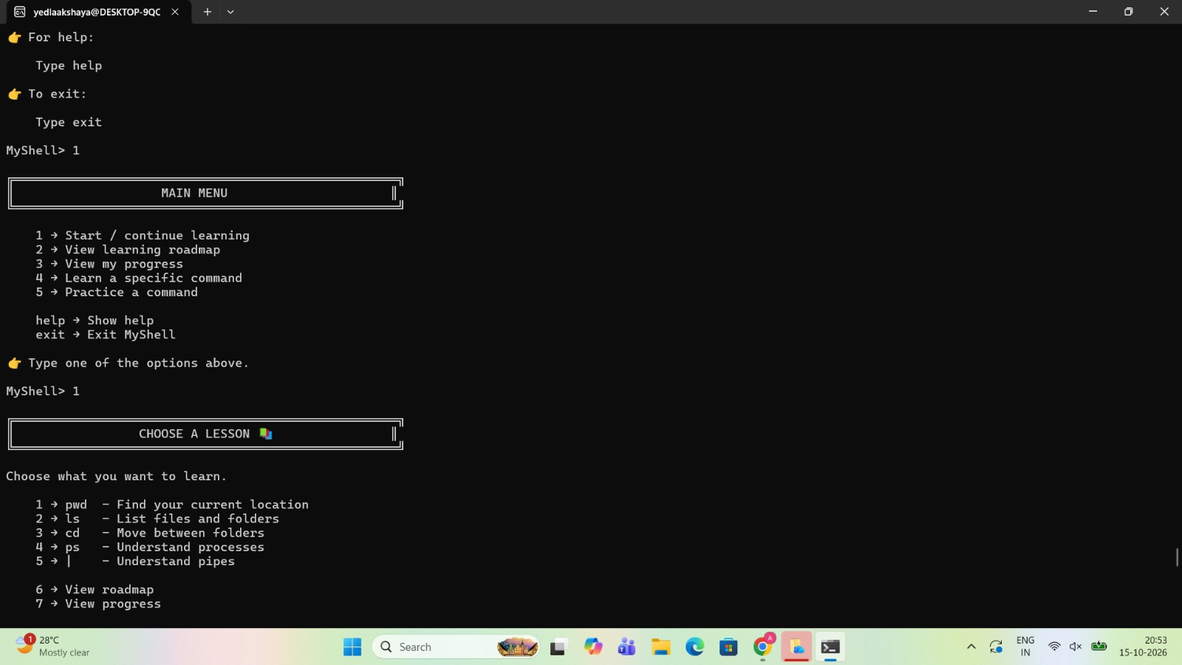
Figure 2: Main Menu and Lesson Selection

Command Parser
The parser processes the input string and identifies the command and its arguments. It helps the application distinguish valid commands from unsupported input.

Command Execution
This module invokes the appropriate command handler or external Linux utility. It is responsible for executing the requested operation and collecting its result.

File Management
This module provides the file and directory operations supported by the implementation, such as listing files, displaying the current directory, or creating and managing files.

Process Management
If implemented, this module supports selected process-related operations, such as displaying running processes or retrieving process information.

System Monitoring
If implemented, this module displays selected system information, such as memory usage, CPU information, disk utilization, or uptime.

Error Handling
Table 1: Main Modules of the Interactive Linux Automation Shell
Module | Purpose
Interactive Interface | Accepts user input, displays results, and maintains the command loop.
Command Parser | Separates command names from arguments and checks supported input.
Command Dispatcher | Routes each valid command to the appropriate handler.
Command Execution | Runs built-in operations or supported external Linux utilities.
Error Handler | Reports invalid input and execution failures.
The error-handling module identifies invalid commands, missing arguments, inaccessible paths, and failed operations. It displays appropriate messages and allows the application to continue when the error is recoverable.

2.4 Algorithms and Data Structures
The main algorithm of the application is based on an interactive command-processing loop.
1.Initialize the shell.
2.Display the command prompt.
3.Read the user's input.
4.Check whether the input is empty.
5.Parse the command and its arguments.
6.Verify whether the command is supported.
7.Validate the required arguments.
8.Execute the selected operation.
9.Display the result or error message.
10.Return to the prompt.
11.Terminate the application when the exit command is entered.

A list, array, or mapping can be used to associate command names with their corresponding handlers. Command arguments can be stored as strings in an array or list. The exact data structures depend on the implementation language.

2.5 Implementation Details
The project is designed to run in a Linux environment. The implementation language and development tools should be documented according to the actual project code.
If implemented in C, the application can use standard input/output functions for terminal interaction and Linux system interfaces for process execution and file operations. Functions such as fork(), exec(), and waitpid() may be used when the implementation directly manages external processes.
The development process involves implementing the interactive interface, adding command parsing, developing the command handlers, handling errors, and testing the application.
The application should validate user input and use appropriate process-execution methods. Operations involving files or processes should respect Linux permissions and avoid unintended modifications.
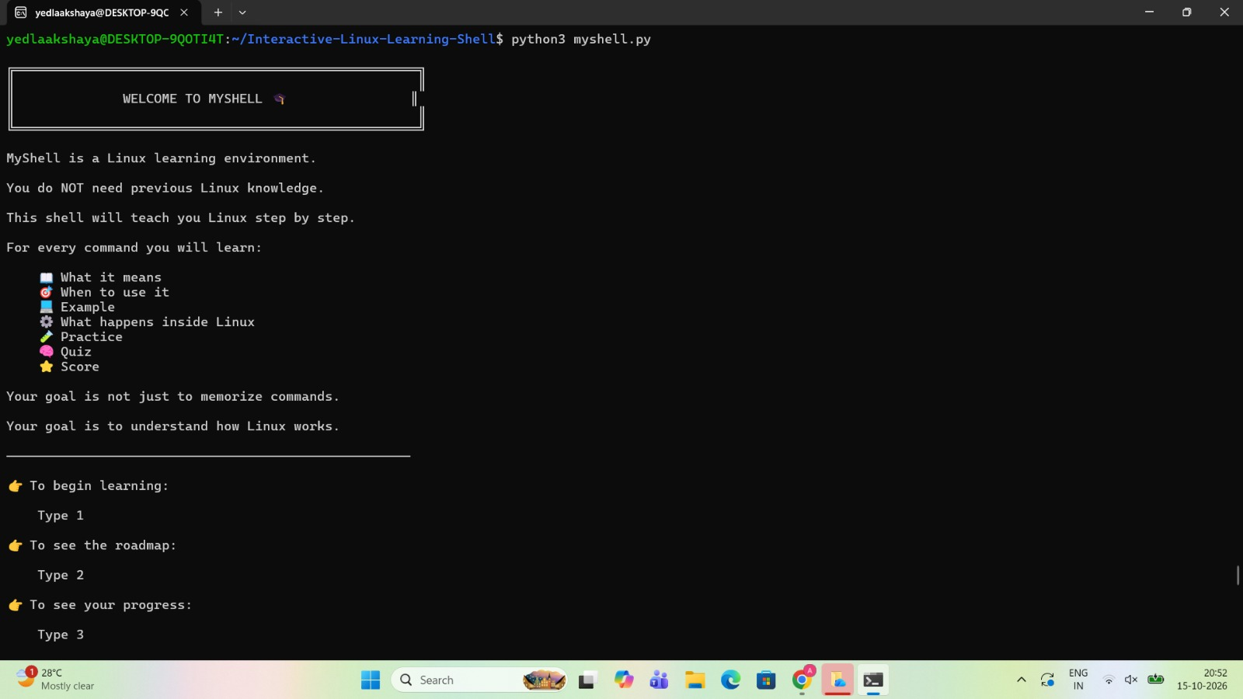
Figure 1: Welcome Interface of MyShell

EXPERIMENTS

3.1 Experimental Environment
The application should be tested in a Linux environment using the actual programming language, compiler or interpreter, and development tools used during implementation.
The testing environment should record the Linux distribution, system configuration, development environment, and execution method. These details help ensure that the test results can be reproduced.

3.2 Testing Methodology
The application is evaluated by entering supported commands and comparing the observed behavior with the expected results. Testing includes normal operations, invalid commands, missing arguments, and operations involving inaccessible files or directories.
Each command should be checked for correct execution and appropriate output. Where file operations are involved, the resulting file-system state should also be verified.
The testing process should establish whether the application executes valid commands correctly, handles errors appropriately, and continues operating after recoverable failures.

3.3 Test Scenarios
The following scenarios can be used to evaluate the system:

1.Launching the shell and displaying the prompt.
2.Executing a supported command.
3.Entering an unknown command.
4.Providing incorrect or missing arguments.
5.Performing a supported file or directory operation.
6.Executing an external Linux command, if supported.
7.Retrieving system information, if implemented.
8.Handling an invalid file path.
9.Returning to the prompt after command execution.
10.Exiting the application safely.
The final report should include only tests that were actually performed.
Table 2: Functional Test Scenarios and Observed Results
Test Case | Expected Result | Evidence
Launch application | Welcome screen or main menu is displayed. | Screenshot 1 or 2
Select a lesson | Lesson options are displayed. | Screenshot 2
Practice pwd command | Correct feedback and current directory are displayed. | Screenshot 4
Answer quiz question | Feedback and score are displayed. | Screenshot 3

3.4 Evaluation Criteria
The system is evaluated based on functional correctness, error handling, reliability, usability, and performance.
Functional correctness measures whether supported commands perform their intended operations. Error handling examines how the application responds to invalid commands and execution failures. Reliability evaluates whether the application continues operating after recoverable errors. Usability considers the clarity of the interface and output. Performance evaluates command-processing overhead and execution time where measurements are available.

4.RESULTS

4.1 Functional Verification
Functional testing is used to verify that the shell accepts commands, identifies supported operations, executes them, and displays the corresponding results.
Each implemented command should be tested independently. For example, a file-management operation should be verified by checking whether the expected change occurred in the file system. Similarly, process-related operations should be checked against the actual process information.
The final results should summarize the number of test cases executed, the number passed, and the number failed. Any failures should be documented with their observed behavior.
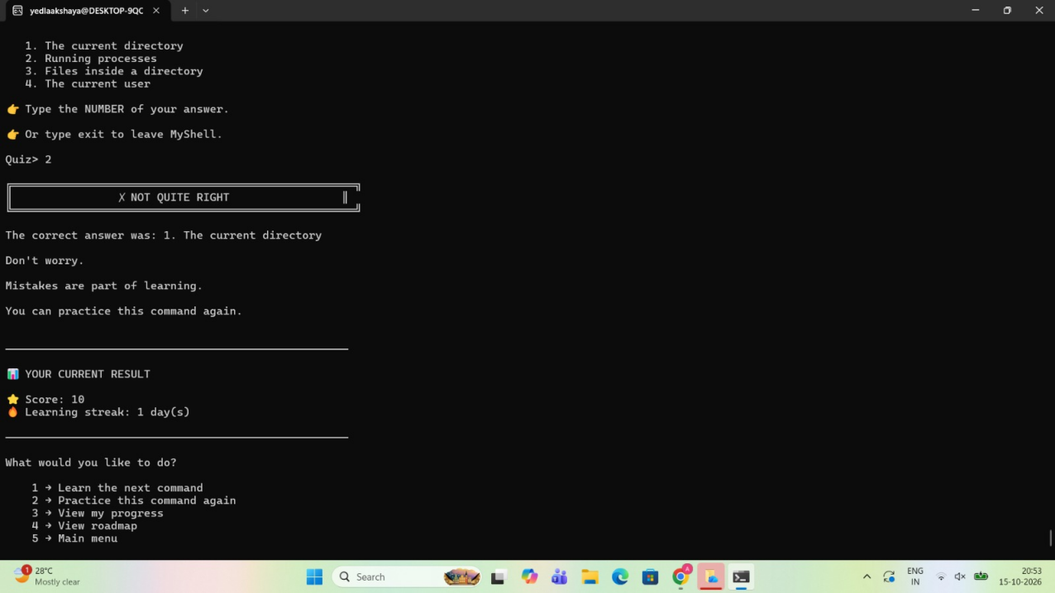
Figure 3: Quiz Evaluation and Score Display
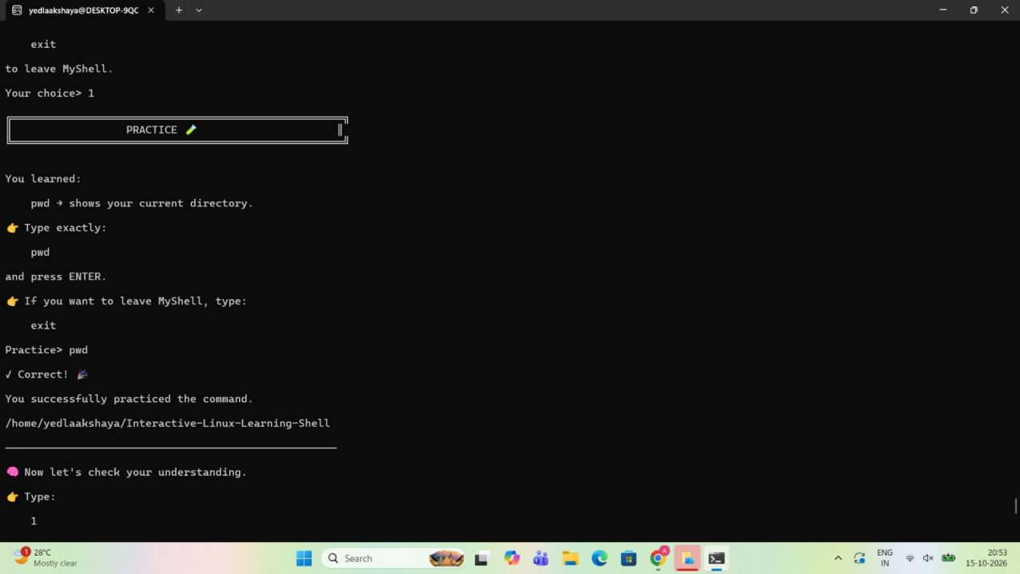
Figure 4: Linux Command Practice and Validation

4.2 Error Handling
Error handling improves the reliability of the Interactive Linux Automation Shell. The application should identify unknown commands, incorrect arguments, and failed operations and display meaningful messages.
Testing should verify that recoverable errors do not unnecessarily terminate the application. The shell should return to the prompt and allow the user to continue entering commands when appropriate.

4.3 Performance and Usability
The system aims to reduce the effort required to execute selected repetitive Linux operations. A consistent command interface and readable output can improve usability, especially for beginners.
Performance depends on the operation being executed. Simple built-in commands may complete quickly, while file operations and external programs depend on the work performed by the underlying operating system.
Any performance figures included in the final report should be based on actual measurements rather than estimates.

4.4 Comparison with the Standard Linux Shell
The standard Linux shell provides extensive command execution, scripting, pipelines, redirection, and other advanced capabilities. The Interactive Linux Automation Shell focuses on a selected set of commands and automation operations.
The main advantage of the proposed application is its ability to group frequently used tasks behind a consistent interface. However, its functionality is limited to the commands and features implemented in the project.
The application should therefore be viewed as a focused automation tool and an educational demonstration of command interpretation rather than a complete replacement for an established Linux shell.

5.CONCLUSION and FUTURE WORK
The Interactive Linux Automation Shell demonstrates how a custom command-line application can simplify selected Linux operations through an interactive interface. The project combines command parsing, operation dispatch, execution, and error handling to provide a structured approach to routine system tasks.
The project also provides practical exposure to important Operating Systems concepts, including process management, system calls, file operations, and interaction between user programs and the operating system.
Future improvements may include command history, configurable aliases, batch execution, logging, additional system-monitoring features, and support for more advanced shell functionality. Improved input parsing and security validation can also make the application more reliable.
In conclusion, the Interactive Linux Automation Shell provides a foundation for learning Linux system programming and developing practical automation utilities. Its effectiveness depends on the correctness of its implemented commands, the quality of error handling, and the results obtained during functional testing.

6.References

1) GNU Project, Bash Reference Manual. https://www.gnu.org/software/bash/manual/
2) GNU Project, GNU Coreutils Manual. https://www.gnu.org/software/coreutils/manual/
3) Linux man-pages Project, Linux Manual Pages. https://man7.org/linux/man-pages/
4) The Open Group, POSIX Specifications. https://pubs.opengroup.org/onlinepubs/9699919799/
5) Linux Kernel Documentation. https://docs.kernel.org/

