Yedige Mussabayev
Figure 1. Azure VM overview. Shows that the proof run was executed on the Azure virtual machine `cc-firewall-debian-test`, with Debian 13 selected as the operating system, the VM running in West Europe, and the public IP used for SSH access.
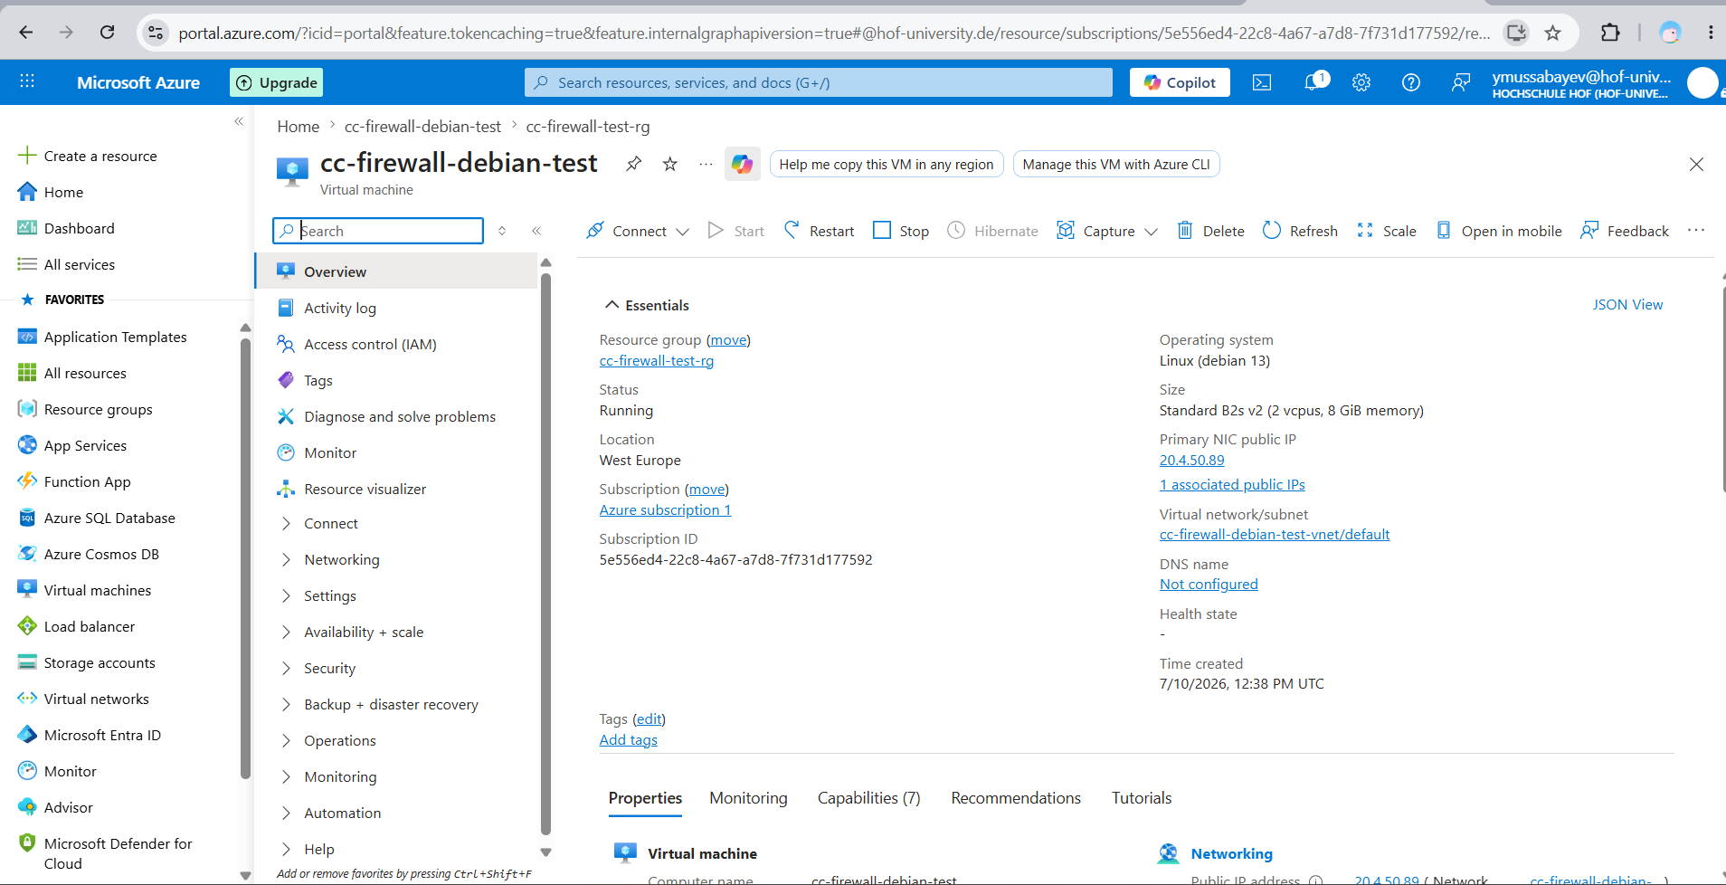

Figure 2. Azure VM platform properties. Confirms the target platform required for the final verification: Linux Debian 13, x64 architecture, VM generation V2, and a Standard B2s v2 size with 2 vCPUs and 8 GiB RAM.
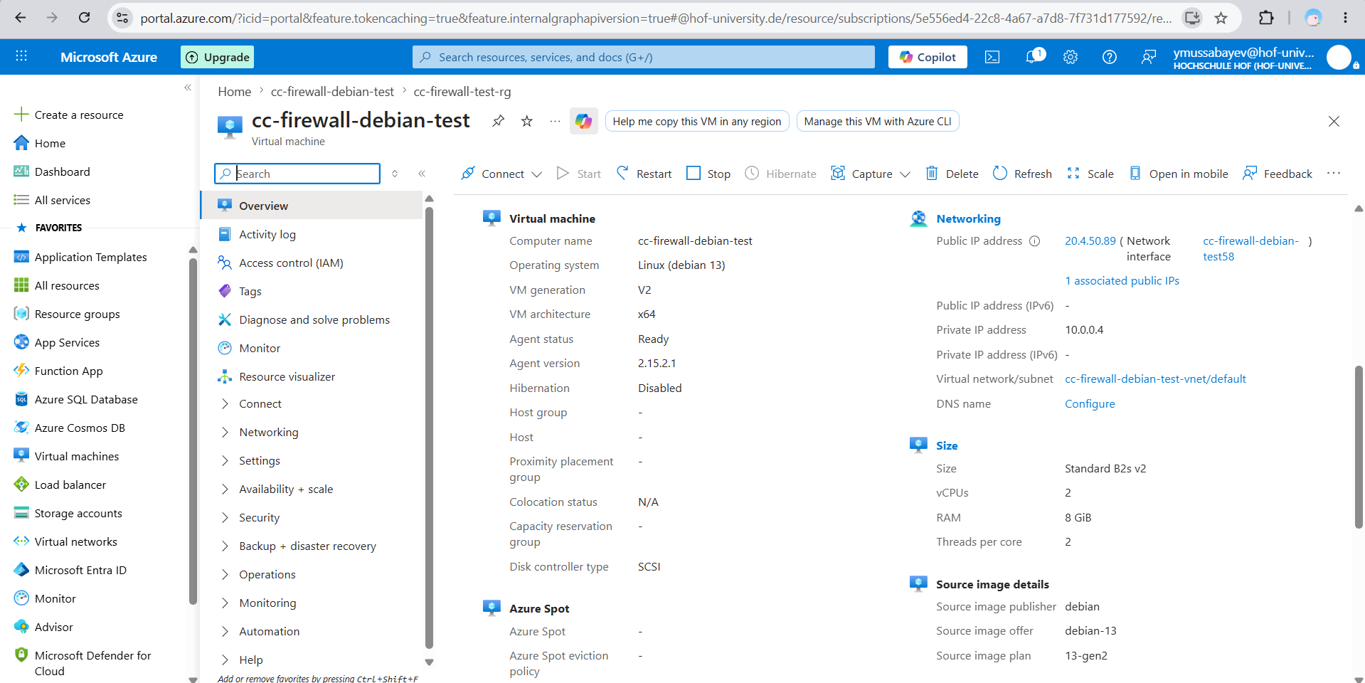

Figure 3. Azure image and security details. Confirms that the source image is the Debian publisher image with offer `debian-13` and plan `13-gen2`, and that the VM uses the standard security type rather than a special custom image.
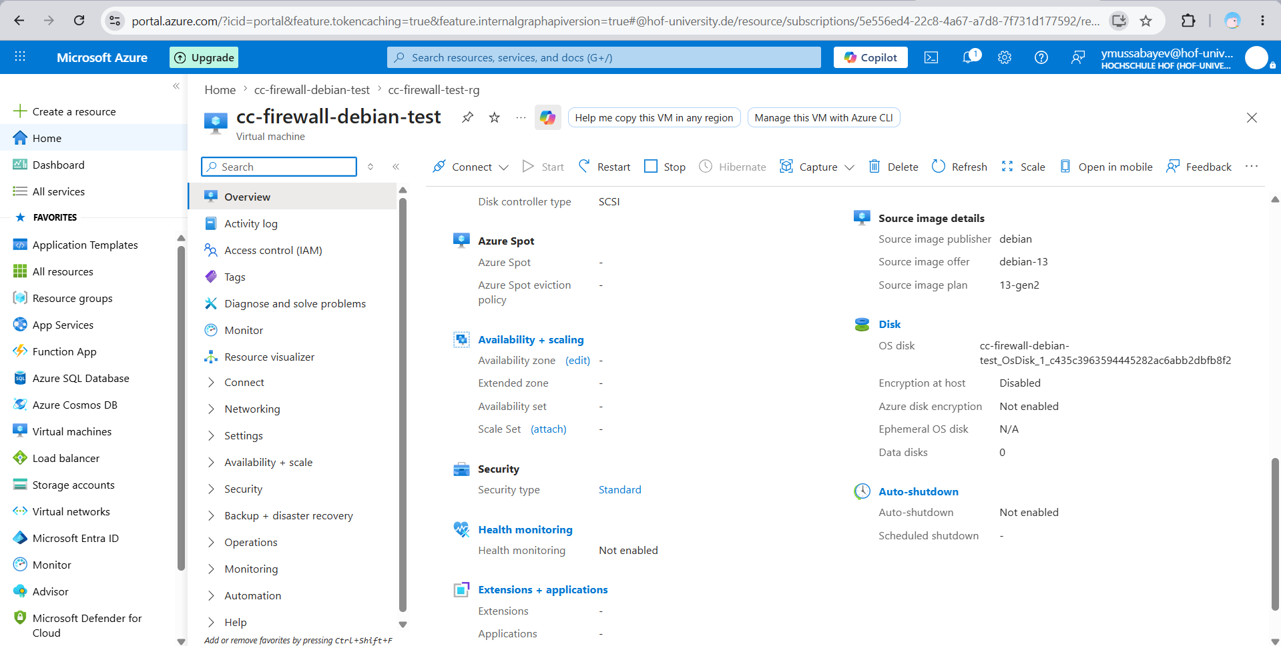

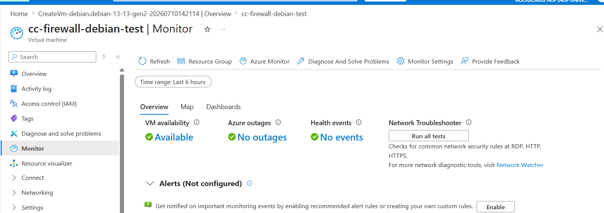
Figure 4. Azure Monitor availability. Shows that Azure reports the VM as available with no outage or health event during the verification window.

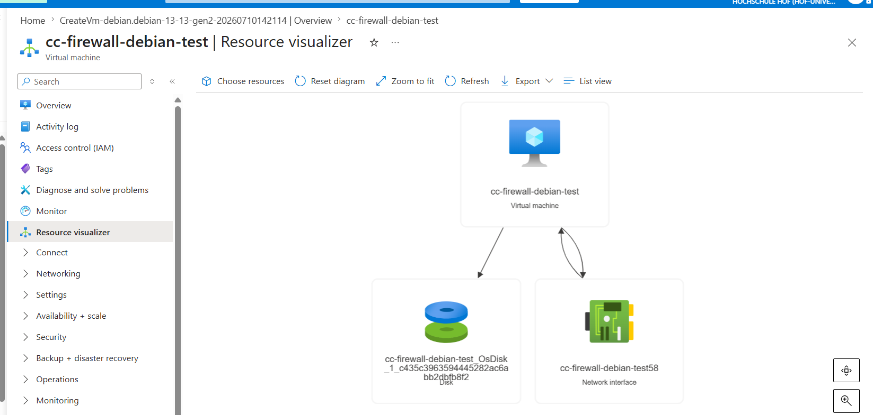
Figure 5. Azure resource visualizer. Shows the VM infrastructure resources created for the test run: the virtual machine, OS disk, and network interface inside the temporary resource group.

Figure 6. Debian, Docker, Docker Compose, and commit proof. The terminal verifies Debian GNU/Linux 13 (trixie), x86_64/amd64, Docker Engine 29.6.1, Docker Compose v5.3.1, and the tested project commit `e10265d`.
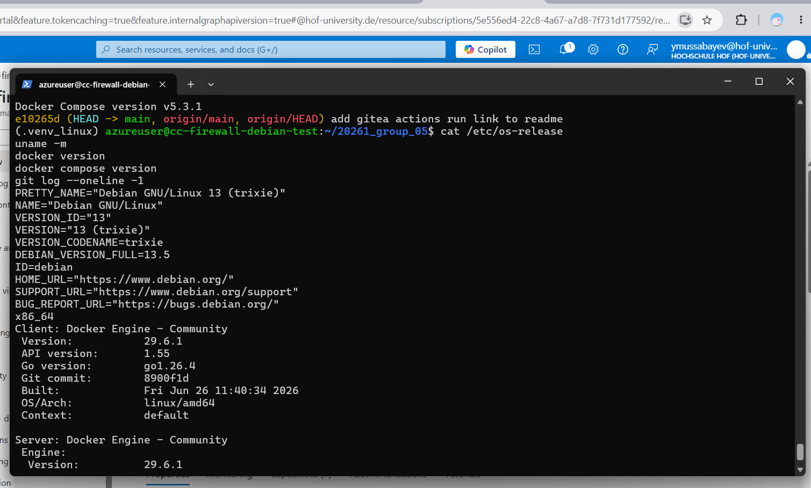

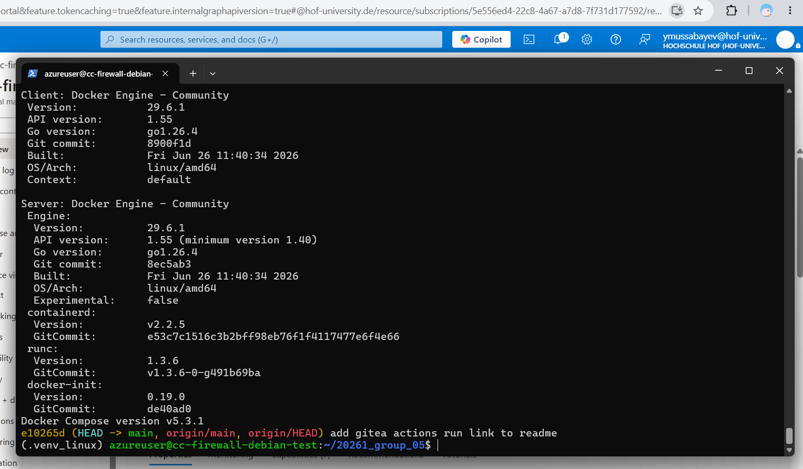
Figure 7. Docker Engine details. Shows the Docker client and server versions from the clean Debian VM, including Linux/amd64 architecture, containerd, runc, and Docker Compose v5.3.1.

Figure 8. Docker Compose runtime state. Shows that the complete lab stack was built and started: three firewall nodes, three clients, two backend servers, and the traffic generator, with firewall and backend containers reported healthy.
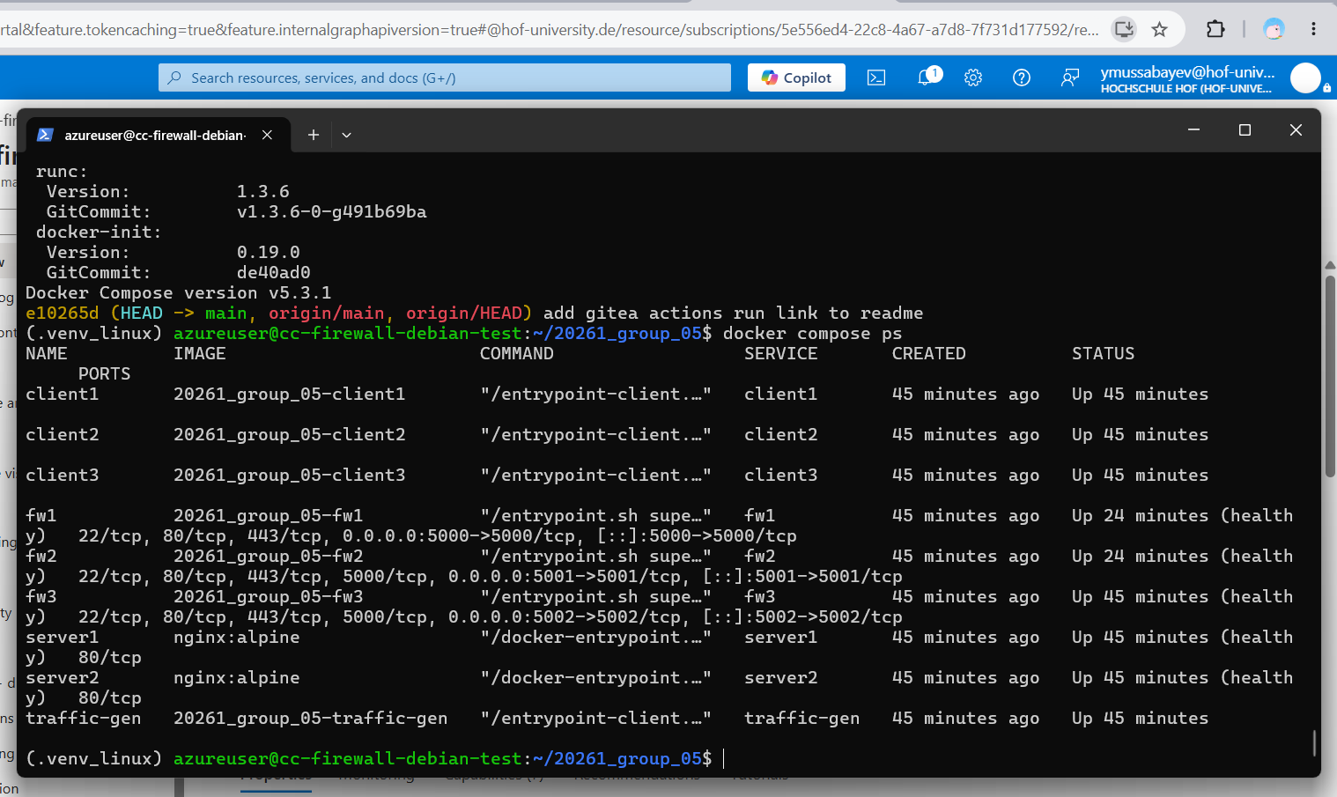

Figure 9. Ansible inventory, syntax check, and lint proof. Shows the generated inventory graph, the successful syntax check for `ansible/playbooks/site.yml`, and Ansible lint passing with 0 failures and 0 warnings.
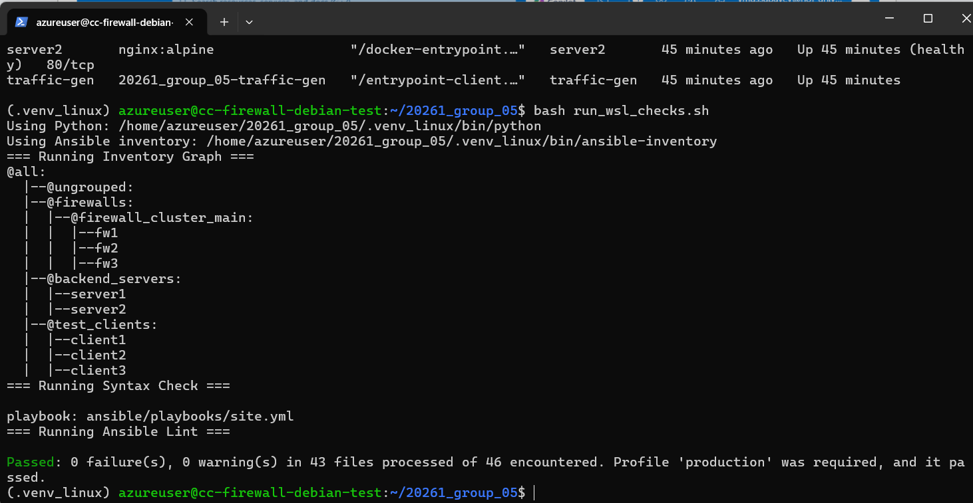

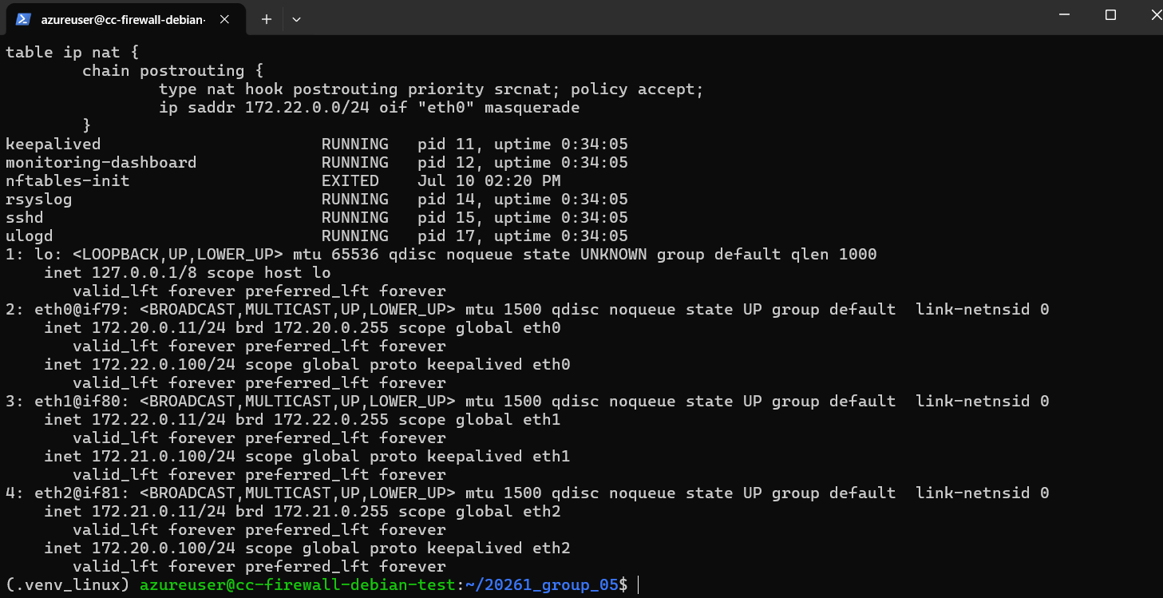
Figure 10. Loaded firewall rules and HA services. Shows the real nftables rules loaded inside `fw1`, Keepalived and related services running, and the cluster virtual IPs assigned on the firewall interfaces.

мм

Figure 11. Generated test report. Shows the final HTML report produced by the automated test playbook: 85 passed, 0 failed, 11 skipped, 96 total, with current VIP ownership and failover evidence.
