
VisionInspectAI
ISY5002-PRS-PM-PT Final Report

PT-GRP19
Group Members:

Name | Student ID
Loh Kian Chee | A0339775J
Sim Yee Fei | A0339751W

Table of Contents
1 Project overview and data 3
1.1 Problem and objectives 3
1.2 Dataset and scope 3
1.3 Separate data protocols for separate tasks 5
2 Tools and techniques used 6
2.1 Software tools 6
2.2 Learning techniques 6
2.3 Preprocessing and augmentation 7
3 System design and model architecture 8
3.1 Offline and online components 8
3.2 Category Classification 8
3.3 Standard PatchCore Anomaly Detector 8
3.4 Normal-only calibration 9
4 Inspection outputs and deployment choices 10
4.1 Routing and confidence 11
4.2 Localization and severity 11
4.3 Defect typing and multiple region segmentation 11
5 System performance and evaluation 13
5.1 Metric definitions 13
5.2 Standard calibrated PatchCore results 13
6 Category and defect classification results 15
6.1 Category classification 15
6.2 Matched defect-type architecture benchmark 15
6.3 Ensemble model comparisons and tracking 17
6.4 Final category-routed defect-type result 20
7 Comparative experiments and fusion 21
7.1 Supervised good/defective baseline 21
7.2 Per-category defect-type results using PCA with LDA on frozen ResNet18 embeddings 22
7.3 Reconstruction baseline and anomaly fusion 23
7.4 Classifier and PatchCore fusion 25
7.5 Classical RBF, GRNN and SOM comparison 26
8 Findings from model and localization studies 28
8.1 Detection is stronger than precise segmentation 28
8.2 Preprocessing must match the category 29
8.3 More model capacity does not ensure improvement 29
8.4 Crops must match inference conditions 29
8.5 PatchCore tuning, scoring and projection choices 29
9 Discussion and limitations 32
9.1 What the experiments establish 32
9.2 Limits to generalization 32
10 Conclusion 34
References 35

1 Project overview and data

1.1 Problem and objectives
Industrial inspection must identify defective products even when examples of each possible defect are scarce. We developed VisionInspectAI to answer four related questions: which product category is shown, whether it is defective, where the suspected defect lies, and which known defect type best describes it. The separation allows a detector trained only on normal products to identify unusual regions while supervised classifiers provide category and defect labels.

Manual inspection is inconsistent between inspectors, limited in throughput, prone to fatigue and costly to scale as production grows, which motivates a more consistent automated system. The project also compares supervised and unsupervised deep learning, classical models, data augmentation and ensembles, so that each component is chosen on evidence.
The application accepts an image and returns the detected category, a Normal or Defective verdict, an anomaly score, a heatmap overlay, an area-based severity indicator and, when a trained classifier is available, defect-type predictions. It supports all 15 MVTec AD categories.

The project covers all four aspects required by the practice module. Supervised learning is used for category classification and defect typing; unsupervised learning for the normal-only PatchCore detector, the convolutional autoencoder and the SOM comparison. Machine learning and deep learning techniques range from PCA with LDA, RBF, GRNN and SOM models to transfer-learned CNNs and transformers. Hybrid and ensemble approaches include the category-routed pipeline, the four-model soft vote for pill defects, and the classifier plus PatchCore and PatchCore plus autoencoder fusions. Intelligent sensing and sense-making are provided by the interface that turns an image into a category, verdict, heatmap, severity level and defect type.

1.2 Dataset and scope
MVTec Anomaly Detection (AD) contains normal training images, normal and defective test images, and pixel masks for defective examples. The dataset contains 5,354 images: 3,629 training and 1,725 test images. The five texture categories are carpet, grid, leather, tile and wood; the ten object categories are bottle, cable, capsule, hazelnut, metal nut, pill, screw, toothbrush, transistor and zipper. Toothbrush has a generic defective label but no fine-grained subtype task in this project.

A CSV manifest records image_path, mask_path, split, label and defect_type. The binary label is 0 for good and 1 for defective. Retaining the original split and mask association makes fitting, calibration and evaluation traceable.

The prototype takes a still image through a Streamlit interface and is validated only on MVTec AD images, which are captured under controlled conditions. Factory integration, live camera feeds, unfamiliar capture conditions and measured production latency are outside the validated scope.
Category | Train (normal) | Test, normal | Test, defective (with masks) | Test, total
Bottle | 209 | 20 | 63 | 83
Cable | 224 | 58 | 92 | 150
Capsule | 219 | 23 | 109 | 132
Carpet | 280 | 28 | 89 | 117
Grid | 264 | 21 | 57 | 78
Hazelnut | 391 | 40 | 70 | 110
Leather | 245 | 32 | 92 | 124
Metal nut | 220 | 22 | 93 | 115
Pill | 267 | 26 | 141 | 167
Screw | 320 | 41 | 119 | 160
Tile | 230 | 33 | 84 | 117
Toothbrush | 60 | 12 | 30 | 42
Transistor | 213 | 60 | 40 | 100
Wood | 247 | 19 | 60 | 79
Zipper | 240 | 32 | 119 | 151
Total | 3,629 | 467 | 1,258 | 1,725
Table 1. MVTec AD images per category in the project manifests. Every defective test image has a pixel mask.

The split is about 2:1, with 67.8% of images in train and 32.2% in test. Categories average 242 training and 115 test images, and the 1,258 defective test images have 83.9 masks per category (sample standard deviations at 30.9). Hazelnut has the most training images (391) and toothbrush the fewest (60).
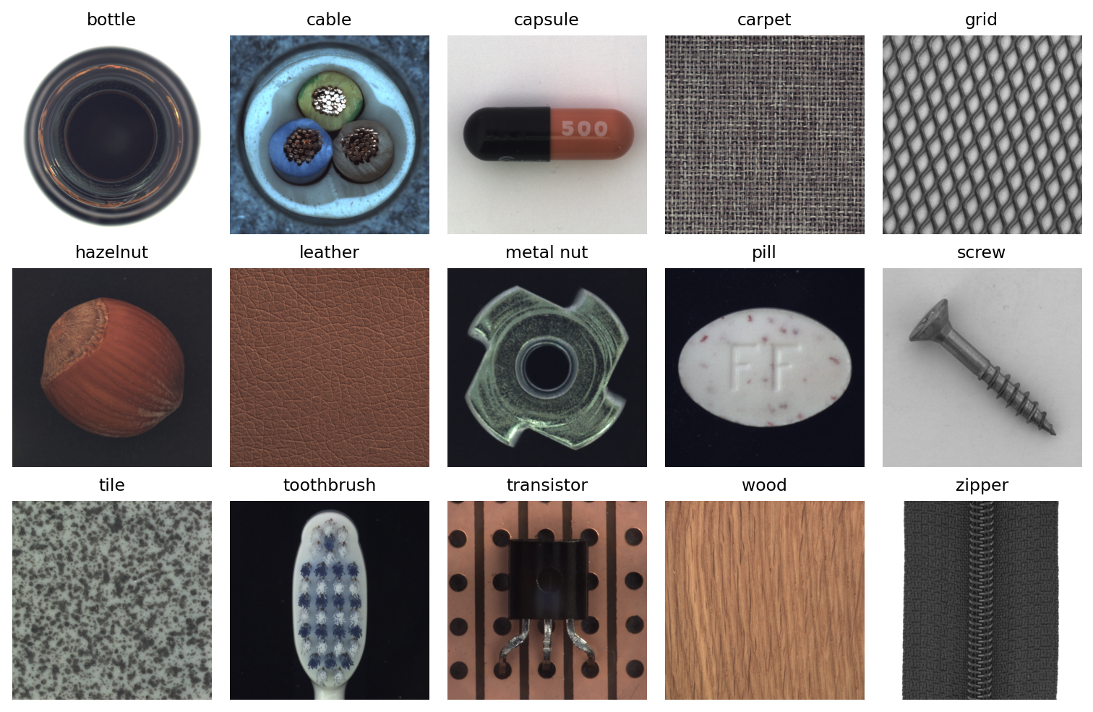
Figure 1. One normal test image from each of the 15 MVTec AD categories.

1.3 Separate data protocols for separate tasks
Task | Fitting and model selection | Evaluation
Category classification | 2,540 original training images; 1,089 validation images for early stopping | 1,725 original test images
Standard PatchCore | 80% of train/good for the bank; 20% for normal-only threshold calibration | All original test images per category
Supervised binary baseline | 70/30 development and validation split from labeled test rows | Validation subset only
Defect-type benchmark | 70/30 stratified split of defective test rows; seed 42 | 373 validation images across 14 categories
Table 2. Data used for fitting, model selection and evaluation, by task.

These scores are not interchangeable. Category classification preserves an original test holdout, whereas supervised defect training uses labeled images from MVTec’s test folders. The latter evaluates within-dataset discrimination and does not provide an independent production estimate.
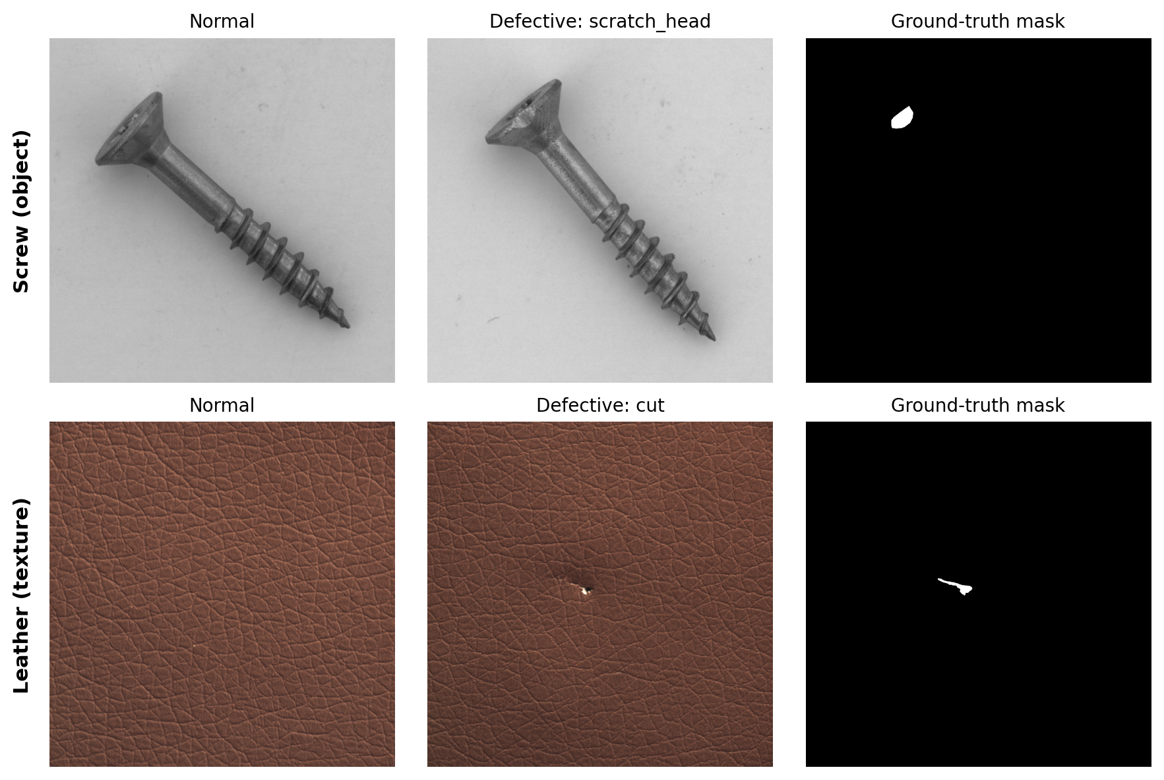
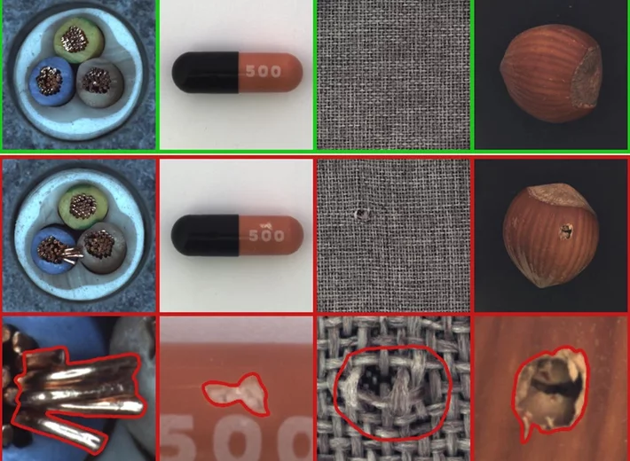
Figure 2. Representative MVTec AD examples. Top: normal image, defective image and ground-truth mask for an object category (screw, scratch_head defect) and a texture category (leather, cut defect). Bottom: normal images (green frames), defective images (red) and enlarged defect outlines for cable, capsule, carpet and hazelnut.

2 Tools and techniques used

2.1 Software tools
Tool | Used in the project
Python and PyTorch | Model fitting, tensor operations, automatic differentiation and inference
torchvision | ImageNet-pretrained backbones and image transforms
NumPy and pandas | Numerical processing, manifests and experiment summaries
scikit-learn | Stratified splitting, classical models and evaluation metrics
OpenCV and Pillow | Image loading, foreground masks, connected components and crops
Matplotlib | Confusion matrices, learning curves and heatmap figures
PyYAML and Streamlit | Per-category configuration and interactive inspection interface
pytest and GitHub | Automated checks, source versioning and model distribution scripts
Table 3. Software tools and their roles in the project.

The requirements file lists these dependencies without version pins. Configurations control image size, architecture, optimization settings, memory-bank construction and postprocessing. Checkpoints and metric JSON files preserve both weights and inference metadata.

2.2 Learning techniques
Transfer learning adapts ImageNet representations to category classification and defect typing. Supervised models minimize cross-entropy with Adam optimizer; validation loss controls early stopping and restoration of the best weights. The comparative models include ResNet18, EfficientNet-B0, DenseNet121, ConvNeXt-Tiny, ViT-B/16 and a small CNN trained from scratch. Each model answers a specified task rather than sharing one accuracy measure.

PatchCore combines frozen deep features with non-parametric nearest-neighbor matching. Greedy k-center coreset selection keeps representative normal patches, reducing storage and distance-computation cost. Random projection accelerates coreset selection; PCA projection is evaluated as an alternative. The stored memory vectors remain in the original feature space.

Classical comparisons use frozen CNN embeddings. PCA reduces dimensionality before linear discriminant analysis (LDA); radial basis function (RBF) and general regression neural network (GRNN) models use distance-based responses; self-organizing maps (SOMs) organize features into prototypes and can use quantization error for anomaly scoring. These are models for comparison, not the default application detector.

2.3 Preprocessing and augmentation
Standard CNN inputs are resized to 224 × 224 and ImageNet-normalized.

The defect-type benchmark augments training images with deterministic flips and quarter-turn rotations, while validation images remain unchanged. The full flip-and-quarter-turn is set for almost all labeled defect type categories except for transistor and toothbrush. Transistor only allows for horizontal flip as there is a defect type category that accounts for any misaligned rotation of transistors as misplaced. Hence the only data augmentation permitted to boost predictive performance for transistor is on defect type misplaced. Toothbrush is excluded because its manifest has only a generic defective label, not defect subtypes.

Categories | Variants per training image
screw, bottle, hazelnut, carpet, leather, wood, grid, tile, cable, capsule, metal nut, pill, zipper | original, horizontal flip, vertical flip, 90°, 180°, 270° rotation (6)
transistor, misplaced | original, horizontal flip, vertical flip, 180° rotation (4)
transistor, other defect types | original, horizontal flip (2)
Table 4. Categories and their data augmentation policies.

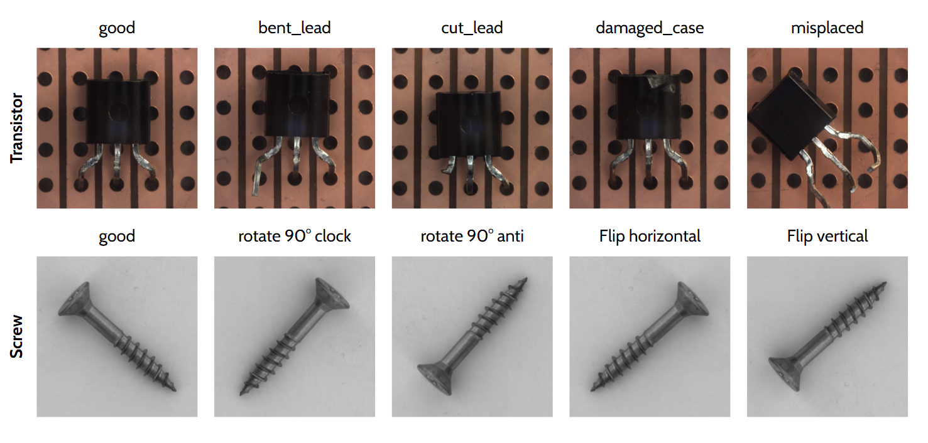
Figure 3. illustrating the differences between transistor and screw. A screw after deterministic flips and rotations will be fine. However, a defective transistor that is rotated will convolute with a misplaced defect type instead.

A combined horizontal+vertical flip is deliberately omitted because it is pixel-identical to a 180° rotation. The labeled-category training manifests use the same deterministic variants for all categories except the documented transistor-specific rule; Toothbrush is not included in defect-type training.

3 System design and model architecture

3.1 Offline and online components
Offline scripts create manifests, train classifiers, build one PatchCore memory bank per category and save calibration thresholds. Online inference loads the category model, selects the appropriate configuration, loads its detector and retrieves the matching metric metadata. The InspectionPipeline class separates inference from the Streamlit interface and caches loaded artifacts.
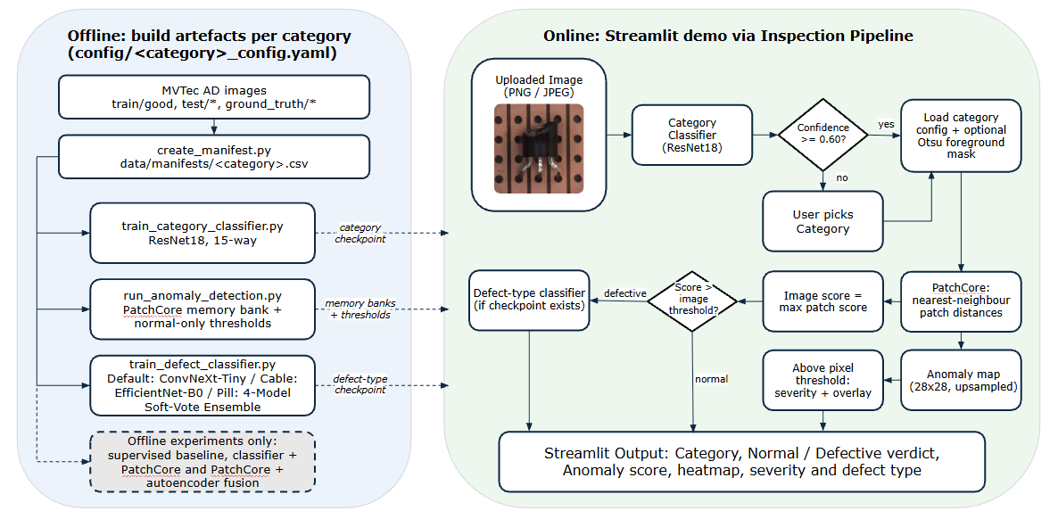
Figure 4. VisionInspectAI architecture.
Offline scripts build manifests, the category classifier, per-category PatchCore banks with normal-only thresholds and defect-type classifiers. Online, the InspectionPipeline routes an uploaded image (manual selection when confidence is below 0.60), scores it with PatchCore, produces a heatmap and severity, and runs the defect-type classifier on defective images. The supervised baseline and the classifier + PatchCore and PatchCore + autoencoder fusions are offline experiments only.

3.2 Category Classification
An ImageNet-pretrained ResNet18 uses a 15-output classification head. Training uses cross-entropy and Adam with a learning rate of 0.0001, batch size 16, up to eight epochs and patience of three epochs. The best validation-loss checkpoint is restored before the original test images are evaluated once. The saved ordered category list maps output indices to names.

3.3 Standard PatchCore Anomaly Detector
The normal-only detector freezes ResNet18 and extracts layer2 and layer3 features. For a 224 × 224 input these have spatial sizes 28 × 28 and 14 × 14, with 128 and 256 channels respectively. Local 3 × 3 average pooling adds neighborhood context; alignment and concatenation produce 384-dimensional patch descriptors on the finer grid. No defect labels or gradient training are required to fit the memory bank.

Greedy coreset selection repeatedly adds a patch far from those already selected. The standard configuration retains a fraction of the candidates, capped at 2,000 descriptors, and uses a 128-dimensional random projection for selection. At inference, each query patch is compared with the stored normal patches using Euclidean distance. The default uses one nearest neighbor and disables optional softmax reweighting.

For a query patch q and normal memory bank M, the patch score is a(q) = min over m in M of ||q − m||₂. The image score is the maximum patch score. A high score indicates that at least one region differs from the normal reference. The patch grid is upsampled into an image-sized anomaly map.

Foreground masking is an optional, per-category step applied at scoring time. For screw, hazelnut and pill, whose objects sit on a plain background, an Otsu foreground mask is computed on the resized input image. PatchCore still extracts features from the whole image and the memory bank is fitted without a mask; the mask is downsampled to the patch grid, and every patch outside the object is assigned the lowest object-patch score. The image score (the maximum patch score) and the heatmap are therefore taken from the object only, and the held-out calibration images are masked the same way, so the thresholds match. The other twelve categories score the full frame because they have no separable background or the mask would hide defects (Section 4.2).

3.4 Normal-only calibration
For each standard category run, 80% of train/good fits the bank and the remaining 20% sets thresholds. Image and pixel thresholds are independently set to the 95th percentiles of held-out normal image scores and pixel scores. The bank and thresholds are frozen before evaluation; calibration images are not added back to the bank. This avoids selecting the decision boundary from final-test labels.

Calibration also changes how results should be read. Under the earlier protocol the memory bank used all of train/good and the pixel threshold was chosen with Youden's J on the test labels. Bottle's mean IoU and Dice were 0.40 and 0.55 then, against 0.204 and 0.327 under normal-only calibration, so the earlier overlap figures were optimistic because the threshold was tuned on the images being scored. Normal-only calibration controls false alarms only approximately and cannot optimize recall or F1: for transistor, a 95th-percentile threshold from 43 normal images still gave an 18.3% false-alarm rate on the test set (Section 8.1). Labeled calibration, which reserves some defective images for threshold selection, is not implemented. The tuning experiments, the classifier-plus-PatchCore comparison and the kernel classifiers still use the earlier Youden-on-test thresholds, so their results are within-experiment comparisons only.
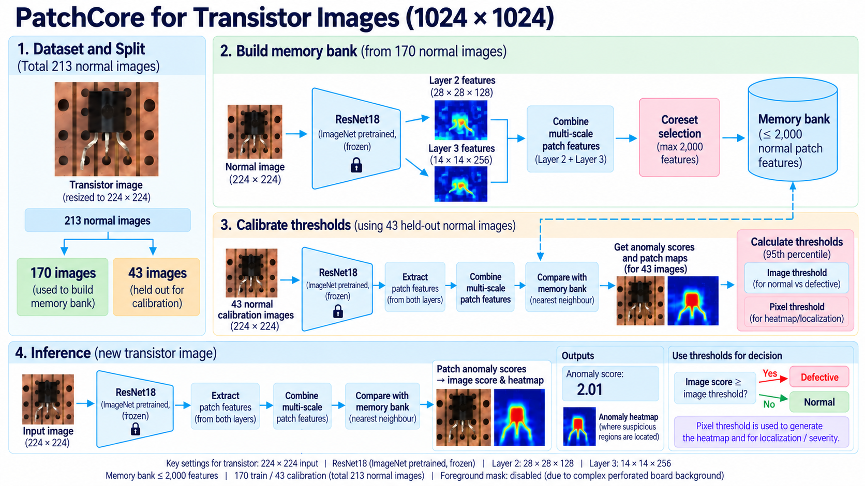
Figure 5. PatchCore for transistor.

A frozen ResNet18 supplies layer2 and layer3 features. 170 normal images build a memory bank of at most 2,000 patches, and 43 held-out normal images set the 95th-percentile image and pixel thresholds. A new image is scored against the bank and compared with the image threshold (2.01 in this example). Foreground masking is disabled for this transistor, because its perforated circuit board is not a plain background, so the full frame is scored (Section 3.3).

4 Inspection outputs and deployment choices

4.1 Routing and confidence
The application accepts PNG and JPEG images, converts them to RGB and composites transparent inputs onto gray. Automatic routing stops when category confidence is below 0.60; a manual category override allows the user to continue. Confidence below 0.70 also prompts a warning. These softmax scores are model outputs, not calibrated probabilities that an unfamiliar image belongs to the dataset.

4.2 Localization and severity
Optional Otsu foreground masking suppresses irrelevant background responses when its assumptions fit the category. It is disabled for full-frame textures and unsuitable object backgrounds. Transistor instead uses primary-region filtering with a peak fraction of 0.30 to reduce disconnected responses. This changes localization, severity and crops; the image verdict still uses the anomaly score and image threshold.

The mask setting is decided per category. It is on for screw, hazelnut and pill, which have a plain background and a hole-free object mask (pill's foreground fraction was 0.40 on every normal image checked). It is off for the full-frame textures and views (carpet, leather, wood, tile, grid, zipper and bottle), where no separable background exists; on bottle the mask made pixel AUROC fall to 0.374. It is also off where the mask itself would hide defects: metal nut (holes inside the shiny nut), toothbrush (holes at the bristle tufts, where defects occur), capsule (the black half is treated as background) and cable (a ragged mask drops dark insulation and wire strands). Transistor's perforated board breaks the plain-background assumption, so it uses primary-region filtering instead. For cable, capsule, metal nut, pill, toothbrush and zipper the choice came from inspecting masks of normal training images, without defect labels.

Severity is a heuristic based on the above-threshold area divided by the foreground area: Low below 5%, Medium from 5% to below 20%, and High at 20% or above. With masking disabled, the denominator is the full image. Severity therefore describes predicted spatial extent and has not been validated as an engineering measure of defect risk.

4.3 Defect typing and multiple region segmentation
A defective image is passed to a category-specific classifier. The selected policy uses augmented ConvNeXt-Tiny by default, EfficientNet-B0 for cable and equal soft voting over four architectures for pill. Toothbrush has no subtype classifier. Missing optional subtype artifacts do not prevent the anomaly verdict.

The region module thresholds the anomaly map, finds eight-connected components, removes regions smaller than 30 pixels and classifies padded crops. It reports distinct predicted types with confidence filtering. MVTec masks identify anomalous areas but do not label each component’s type, so this feature is a qualitative aid with no demonstrated multi-defect accuracy. Primary-region suppression can also discard secondary defects.
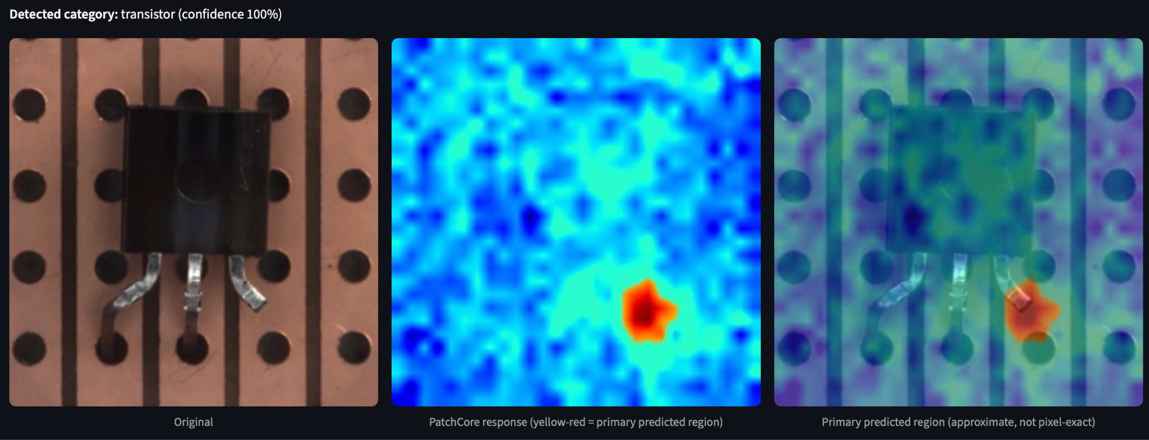
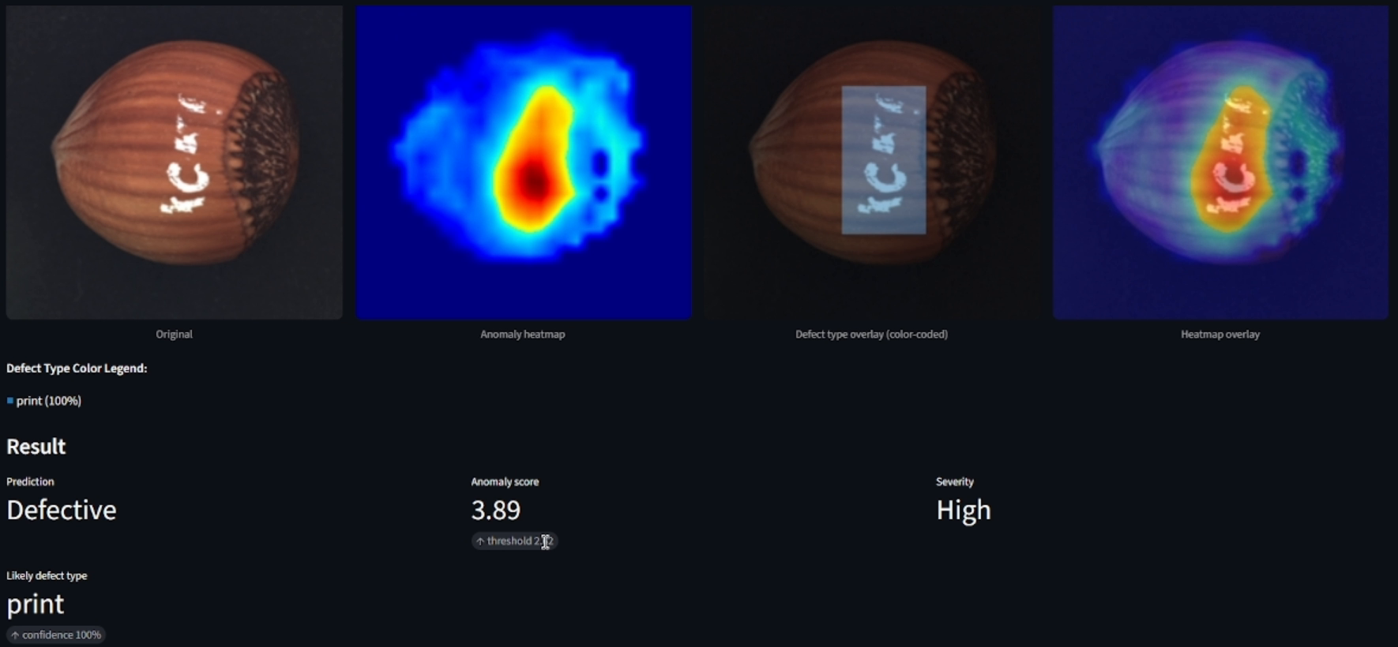
Figure 6. Streamlit inspection output for two MVTec AD test images.

Top: automatic category detection (transistor, confidence 100%) with the original image, the PatchCore response and the primary predicted region. Bottom: a hazelnut print defect with the original, anomaly heatmap, defect-type overlay and heatmap overlay, giving a Defective verdict, anomaly score 3.89, High severity and predicted type print (classifier confidence 100%). Single examples, not aggregate performance; the score is a distance measure, not a calibrated probability.

5 System performance and evaluation

5.1 Metric definitions
A positive prediction denotes a defect. Accuracy is (TP + TN) / N, precision is TP / (TP + FP), recall is TP / (TP + FN), and F1 is 2TP / (2TP + FP + FN). Recall measures missed-defect avoidance; precision reflects how often a flagged product is truly defective. Macro-F1 gives each class equal weight in multi-class tasks.

Image AUROC measures how well scores rank defective images above good images across thresholds. Pixel AUROC ranks defective pixels above normal pixels. IoU = intersection / union and Dice = 2 × intersection / (predicted area + true area) assess the thresholded mask. The reported overlap metrics average over defective images. Strong pixel ranking can coexist with poor mask overlap.

5.2 Standard calibrated PatchCore results
Table 5 presents the standard calibrated PatchCore results across all 15 categories. Each category uses its full original test split; test-set sizes differ by category. Means give each category equal weight. These are reported experiment results, not a new benchmark run.

Category | Accuracy | Recall | F1 | Image AUC | Pixel AUC
Screw | 0.769 | 0.723 | 0.823 | 0.899 | 0.886
Bottle | 0.952 | 1.000 | 0.969 | 1.000 | 0.981
Hazelnut | 0.991 | 0.986 | 0.993 | 1.000 | 0.858
Carpet | 0.932 | 0.955 | 0.955 | 0.973 | 0.987
Leather | 0.944 | 1.000 | 0.963 | 1.000 | 0.991
Wood | 0.911 | 1.000 | 0.945 | 0.996 | 0.931
Grid | 0.782 | 0.737 | 0.832 | 0.934 | 0.954
Tile | 0.974 | 0.988 | 0.982 | 0.998 | 0.939
Transistor | 0.890 | 1.000 | 0.879 | 0.990 | 0.967
Cable | 0.907 | 0.935 | 0.925 | 0.988 | 0.981
Capsule | 0.848 | 0.844 | 0.902 | 0.935 | 0.983
Metal nut | 0.965 | 0.978 | 0.978 | 0.991 | 0.979
Pill | 0.743 | 0.702 | 0.822 | 0.901 | 0.958
Toothbrush | 0.905 | 0.933 | 0.933 | 0.956 | 0.989
Zipper | 0.967 | 0.983 | 0.979 | 0.963 | 0.985
Mean (15 categories) | 0.899 | 0.918 | 0.925 | 0.968 | 0.958
Table 5. Standard normal-only calibrated PatchCore performance. Mean IoU and Dice across the 15 categories are 0.151 and 0.235, respectively. The standard screw benchmark differs from the current high-resolution demo route.

6 Category and defect classification results

6.1 Category classification
The 15-category ResNet18 achieves reported test accuracy of 1.000 on 1,725 held-out images, with precision, recall and F1 of 1.000 for every category. Its best epoch is eight and validation loss is 0.000134. These results indicate strong separation of the MVTec product categories; they do not demonstrate detection of subtle defects or classification of unknown categories.
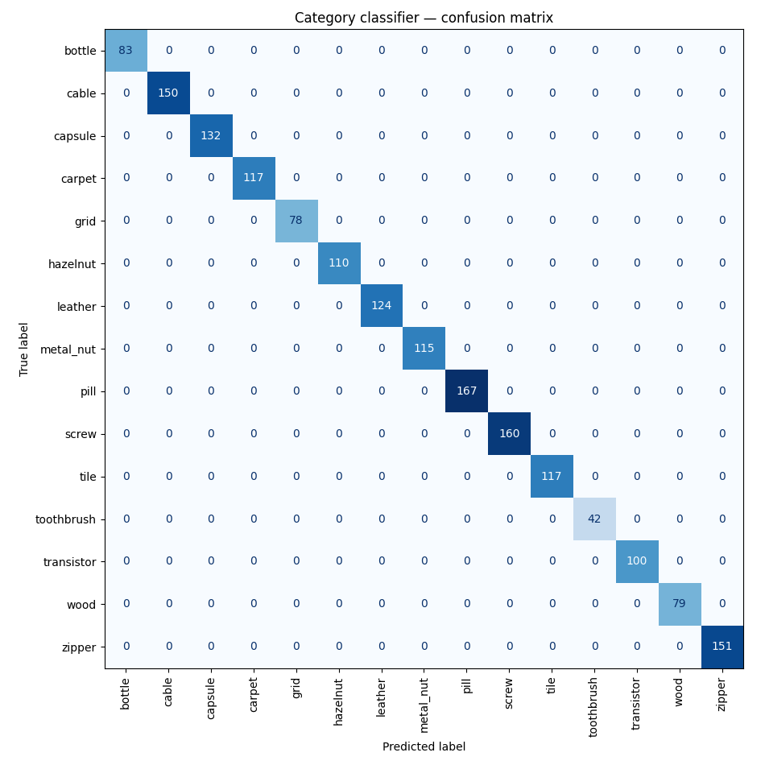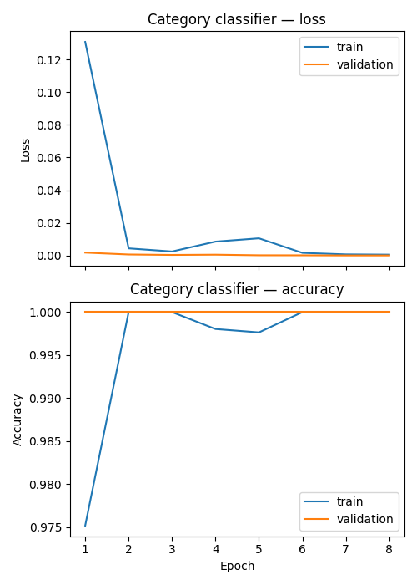
Figure 7. 15-category ResNet18 classifier on the 1,725 held-out MVTec AD test images: confusion matrix (left, no misclassifications) and training curves (right).

6.2 Matched defect-type architecture benchmark
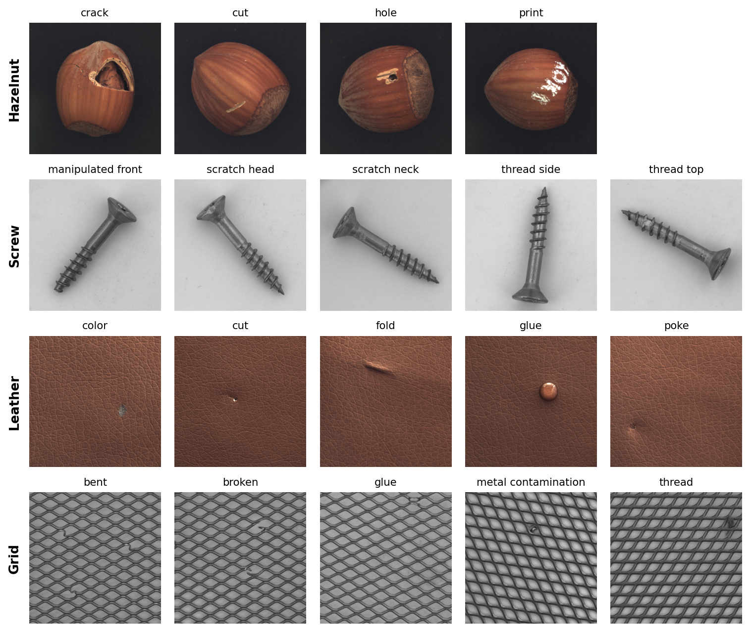
Figure 8. Defect-type examples for hazelnut, screw, leather and grid. Hazelnut and leather types are visually distinct, while screw and grid types are subtle and overlapping. ResNet18 without augmentation scored 0.905, 0.194, 0.929 and 0.222 on these categories; the final route scores 0.905, 0.944, 1.000 and 1.000. MVTec AD images.

The matched defect-type benchmark reuses a seed-42 stratified 70/30 split of defective test images. Fourteen categories have valid subtype labels; Toothbrush is excluded. Each cell below records validation accuracy / macro-F1 / final training loss. Accuracy and macro-F1 use the restored best-validation-loss checkpoint; final training loss is the loss from the last completed epoch.

Category | ResNet18, no augmentation | ResNet18, augmented | ConvNeXt-Tiny, augmented | EfficientNet-B0, augmented | DenseNet121, augmented
Screw | 0.194 / 0.160 / 0.1945 | 0.750 / 0.700 / 0.0928 | 0.944 / 0.943 / 0.0511 | 0.639 / 0.628 / 0.1025 | 0.917 / 0.914 / 0.0224
Bottle | 0.895 / 0.892 / 0.0053 | 0.895 / 0.885 / 0.0035 | 0.842 / 0.842 / 0.0051 | 0.842 / 0.842 / 0.0547 | 0.895 / 0.892 / 0.0192
Hazelnut | 0.905 / 0.909 / 0.0532 | 0.905 / 0.902 / 0.0068 | 0.905 / 0.902 / 0.0064 | 0.905 / 0.896 / 0.0281 | 0.905 / 0.896 / 0.0149
Carpet | 0.778 / 0.764 / 0.0087 | 0.889 / 0.883 / 0.0089 | 0.926 / 0.926 / 0.0117 | 0.815 / 0.818 / 0.0715 | 0.815 / 0.814 / 0.0428
Leather | 0.929 / 0.926 / 0.0072 | 1.000 / 1.000 / 0.0196 | 1.000 / 1.000 / 0.0019 | 1.000 / 1.000 / 0.0402 | 1.000 / 1.000 / 0.0183
Grid | 0.222 / 0.163 / 0.3959 | 0.278 / 0.210 / 0.1536 | 1.000 / 1.000 / 0.0052 | 0.444 / 0.420 / 0.4897 | 0.667 / 0.660 / 0.0475
Tile | 0.923 / 0.920 / 0.0131 | 0.962 / 0.960 / 0.0054 | 1.000 / 1.000 / 0.0008 | 1.000 / 1.000 / 0.0195 | 1.000 / 1.000 / 0.0115
Transistor | 0.667 / 0.667 / 0.0048 | 0.667 / 0.638 / 0.0255 | 0.917 / 0.914 / 0.0102 | 0.917 / 0.914 / 0.2461 | 0.750 / 0.731 / 0.0230
Wood | 0.667 / 0.646 / 0.0106 | 0.778 / 0.655 / 0.0171 | 0.889 / 0.867 / 0.0136 | 0.889 / 0.870 / 0.0917 | 0.889 / 0.867 / 0.0300
Cable | 0.714 / 0.656 / 0.0153 | 0.857 / 0.837 / 0.0091 | 0.821 / 0.780 / 0.0078 | 0.893 / 0.877 / 0.0477 | 0.893 / 0.874 / 0.0156
Capsule | 0.485 / 0.520 / 0.0069 | 0.485 / 0.505 / 0.0812 | 0.758 / 0.756 / 0.0434 | 0.636 / 0.643 / 0.1188 | 0.727 / 0.696 / 0.0271
Metal nut | 0.857 / 0.854 / 0.0370 | 0.893 / 0.892 / 0.0097 | 1.000 / 1.000 / 0.0009 | 1.000 / 1.000 / 0.0386 | 1.000 / 1.000 / 0.0185
Pill | 0.372 / 0.427 / 0.0684 | 0.605 / 0.621 / 0.0279 | 0.674 / 0.695 / 0.0135 | 0.628 / 0.642 / 0.0607 | 0.767 / 0.784 / 0.0333
Toothbrush | N/A | N/A | N/A | N/A | N/A
Zipper | 0.611 / 0.608 / 0.0481 | 0.750 / 0.754 / 0.0766 | 0.889 / 0.877 / 0.0192 | 0.806 / 0.804 / 0.1101 | 0.750 / 0.733 / 0.0823
Table 6. Per-category defect-type benchmark on the seed-42 70/30 split. Each entry is validation accuracy / macro-F1 / final training loss; Toothbrush is N/A because it has no fine-grained subtype labels.

ConvNeXt-Tiny is best or tied on most categories, reaching 1.000 accuracy on Grid, Tile, Leather and Metal nut, while Bottle, Cable and Pill remain difficult. EfficientNet-B0 is lightweight and competitive on selected categories, but its aggregate accuracy is lower and its mean final training loss is highest. DenseNet121 is a compact alternative and leads Pill in this single-split benchmark; later repeated-CV evidence changes the Cable decision. The final deployed route therefore requires the ensemble and repeated-CV evidence recorded in Section 6.3.

All augmented variants stay in the training partition. Mean ± Standard Deviation (SD) below refers to variation across categories, not uncertainty across training seeds.

Architecture and training | Mean accuracy ± SD | Mean macro-F1 ± SD | Mean final train loss | Parameters (ImageNet head)
ResNet18 without augmentation | 0.659 ± 0.245 | 0.651 ± 0.250 | 0.0621 | 11.7M
ResNet18 with augmentation | 0.765 ± 0.193 | 0.746 ± 0.204 | 0.0384 | 11.7M
ConvNeXt-Tiny with augmentation | 0.897 ± 0.094 | 0.893 ± 0.094 | 0.0136 | 28.6M
EfficientNet-B0 with augmentation | 0.815 ± 0.162 | 0.811 ± 0.164 | 0.1086 | 5.3M
DenseNet121 with augmentation | 0.855 ± 0.106 | 0.847 ± 0.110 | 0.0290 | 8.0M
Table 7. Matched defect-type benchmark on the seed-42 70/30 split (14 categories, 373 validation images); SD is across categories.

Table 7 shows that ConvNeXt-Tiny has the highest mean accuracy and macro-F1 (0.897 / 0.893), followed by DenseNet121 (0.855 / 0.847). ResNet18 augmentation raises mean accuracy from 0.659 to 0.765 and macro-F1 from 0.651 to 0.746, but this is not a fixed-update-budget experiment: augmented runs process 2-6 times more samples and optimizer updates per epoch. Accuracy improves in 10 of 14 scored categories and is unchanged for Bottle, Hazelnut, Transistor and Capsule; the largest gains are Screw (0.194 to 0.750) and Pill (0.372 to 0.605). These benchmark results inform architecture selection but are not independent deployment estimates.

6.3 Ensemble model comparisons and tracking
The ensemble study compares category-specific defect-type strategies rather than assuming that a global ensemble is optimal. It evaluates four-model hard voting, equal-weight soft voting, a ConvNeXt-heavy 70/10/10/10 soft vote, three-seed ConvNeXt bagging and a category-routed single model. Stacking and boosting were not evaluated. Members use the same seeded stratified split and deterministic category-specific augmentation; alternative weights are kept separate from active Streamlit checkpoints.

Category | ConvNeXt single | Hard vote (4) | Equal soft vote (4) | ConvNeXt-heavy soft (70/10/10/10) | ConvNeXt bagging (3) | Category-routed single
Screw | 0.944 / 0.943 | 0.917 / 0.914 | 0.917 / 0.914 | 0.944 / 0.943 | 0.917 / 0.914 | 0.944 / 0.943
Bottle | 0.842 / 0.842 | 0.842 / 0.842 | 0.842 / 0.842 | 0.842 / 0.842 | 0.895 / 0.892 | 0.895 / 0.892 (DenseNet121)
Hazelnut | 0.905 / 0.902 | 0.905 / 0.902 | 0.905 / 0.902 | 0.905 / 0.902 | 0.952 / 0.953 | 0.905 / 0.902
Carpet | 0.926 / 0.926 | 0.926 / 0.926 | 0.963 / 0.966 | 0.926 / 0.926 | 0.926 / 0.926 | 0.926 / 0.926
Leather | 1.000 / 1.000 | 1.000 / 1.000 | 1.000 / 1.000 | 1.000 / 1.000 | 1.000 / 1.000 | 1.000 / 1.000
Grid | 1.000 / 1.000 | 0.722 / 0.719 | 0.778 / 0.776 | 1.000 / 1.000 | 0.833 / 0.831 | 1.000 / 1.000
Tile | 1.000 / 1.000 | 1.000 / 1.000 | 1.000 / 1.000 | 1.000 / 1.000 | 1.000 / 1.000 | 1.000 / 1.000
Transistor | 0.917 / 0.914 | 0.833 / 0.833 | 0.833 / 0.833 | 0.917 / 0.914 | 0.833 / 0.833 | 0.917 / 0.914
Wood | 0.889 / 0.867 | 0.833 / 0.808 | 0.833 / 0.808 | 0.889 / 0.867 | 0.833 / 0.808 | 0.889 / 0.867
Cable | 0.821 / 0.780 | 0.857 / 0.798 | 0.857 / 0.798 | 0.821 / 0.780 | 0.857 / 0.798 | 0.893 / 0.874 (DenseNet121)
Capsule | 0.758 / 0.756 | 0.788 / 0.795 | 0.818 / 0.824 | 0.758 / 0.769 | 0.758 / 0.759 | 0.758 / 0.756
Metal nut | 1.000 / 1.000 | 1.000 / 1.000 | 1.000 / 1.000 | 1.000 / 1.000 | 0.964 / 0.964 | 1.000 / 1.000
Pill | 0.674 / 0.695 | 0.767 / 0.763 | 0.814 / 0.820 | 0.721 / 0.734 | 0.814 / 0.815 | 0.767 / 0.784 (DenseNet121)
Toothbrush | N/A | N/A | N/A | N/A | N/A | N/A
Zipper | 0.889 / 0.877 | 0.917 / 0.906 | 0.917 / 0.906 | 0.889 / 0.877 | 0.861 / 0.832 | 0.889 / 0.877
Table 8. Historical single-split ensemble comparison across all 15 categories. Values are validation accuracy / macro-F1; Toothbrush is N/A and aggregate statistics use the 14 scored categories (373 validation images).

The historical single-split comparison is retained as an experiment record, not an unbiased deployment estimate. Voting helps some categories - Carpet, Capsule and Pill for equal soft voting, and Hazelnut and Bottle for bagging but reduces performance on Grid, Transistor and Wood. The four-model heavy vote offers little aggregate benefit over a single ConvNeXt-Tiny model while adding checkpoint and inference cost. The earlier post-hoc route used DenseNet121 for Bottle, Cable and Pill and is superseded by the repeated-CV comparison.

Repeated stratified validation was then used for Bottle, Cable, Capsule and Pill. Three repeats of stratified 5-fold CV used seeds 42, 43 and 44, all four base architectures in each outer fold, and a separate stratified 15% inner split for early stopping. The same held-out predictions support hard voting, equal soft voting and the ConvNeXt-heavy vote. Each image appears in an outer validation fold once per repeat; training and augmentation use only that fold's training data, with a separate stratified 15% inner split for early stopping and best-epoch restoration.

Results report the mean and population SD of the three repeat-level out-of-fold scores. Correct totals count repeated predictions, not unique images: 63 Bottle, 92 Cable, 109 Capsule and 141 Pill images were each evaluated three times. The repeats reuse MVTec images, and the final policies were selected after comparing these same folds, so the results are exploratory rather than independent estimates or confidence intervals.

Category / strategy | Mean CV accuracy ± SD | Mean CV macro-F1 ± SD | Correct across 3 repeats
Bottle - ConvNeXt-Tiny single | 0.852 ± 0.007 | 0.854 ± 0.007 | 161 / 189
Bottle - ResNet18 single | 0.831 ± 0.007 | 0.832 ± 0.007 | 157 / 189
Bottle - EfficientNet-B0 single | 0.841 ± 0.022 | 0.845 ± 0.022 | 159 / 189
Bottle - DenseNet121 single | 0.783 ± 0.033 | 0.786 ± 0.032 | 148 / 189
Bottle - four-model hard vote | 0.857 ± 0.026 | 0.860 ± 0.025 | 162 / 189
Bottle - four-model equal soft vote | 0.868 ± 0.015 | 0.870 ± 0.015 | 164 / 189
Bottle - ConvNeXt-heavy soft vote (70/10/10/10) | 0.862 ± 0.007 | 0.864 ± 0.007 | 163 / 189
Cable - ConvNeXt-Tiny single | 0.815 ± 0.023 | 0.786 ± 0.026 | 225 / 276
Cable - ResNet18 single | 0.837 ± 0.032 | 0.809 ± 0.047 | 231 / 276
Cable - EfficientNet-B0 single | 0.880 ± 0.009 | 0.877 ± 0.009 | 243 / 276
Cable - DenseNet121 single (previous choice) | 0.830 ± 0.014 | 0.806 ± 0.026 | 229 / 276
Cable - four-model hard vote | 0.877 ± 0.027 | 0.854 ± 0.042 | 242 / 276
Cable - four-model equal soft vote | 0.884 ± 0.022 | 0.864 ± 0.032 | 244 / 276
Cable - ConvNeXt-heavy soft vote (70/10/10/10) | 0.844 ± 0.005 | 0.814 ± 0.016 | 233 / 276
Capsule - ConvNeXt-Tiny single | 0.771 ± 0.020 | 0.777 ± 0.021 | 252 / 327
Capsule - ResNet18 single | 0.584 ± 0.049 | 0.587 ± 0.046 | 191 / 327
Capsule - EfficientNet-B0 single | 0.572 ± 0.009 | 0.577 ± 0.008 | 187 / 327
Capsule - DenseNet121 single | 0.688 ± 0.054 | 0.693 ± 0.058 | 225 / 327
Capsule - four-model hard vote | 0.758 ± 0.004 | 0.763 ± 0.004 | 248 / 327
Capsule - four-model equal soft vote | 0.774 ± 0.016 | 0.779 ± 0.016 | 253 / 327
Capsule - ConvNeXt-heavy soft vote (70/10/10/10) | 0.780 ± 0.027 | 0.786 ± 0.028 | 255 / 327
Pill - ConvNeXt-Tiny single | 0.745 ± 0.021 | 0.751 ± 0.018 | 315 / 423
Pill - ResNet18 single | 0.605 ± 0.015 | 0.638 ± 0.013 | 256 / 423
Pill - EfficientNet-B0 single | 0.626 ± 0.017 | 0.662 ± 0.015 | 265 / 423
Pill - DenseNet121 single | 0.664 ± 0.012 | 0.687 ± 0.022 | 281 / 423
Pill - four-model hard vote | 0.761 ± 0.013 | 0.775 ± 0.013 | 322 / 423
Pill - four-model equal soft vote | 0.766 ± 0.015 | 0.778 ± 0.013 | 324 / 423
Pill - ConvNeXt-heavy soft vote (70/10/10/10) | 0.766 ± 0.021 | 0.774 ± 0.022 | 324 / 423
Table 9. Repeated stratified five-fold cross-validation (three repeats) of defect-type model choices; SD is across repeats.
Bottle keeps ConvNeXt-Tiny: its equal soft vote gains only 3 correct predictions of 189 and is inconsistent across repeats. Cable switches from DenseNet121 to EfficientNet-B0, which scores 0.880 / 0.877 and beats DenseNet121 by 14 correct predictions across all three repeats; the four-model equal soft vote adds only one correct prediction over EfficientNet-B0. Capsule keeps ConvNeXt-Tiny because the equal soft vote gains only 1 of 327 repeated predictions. Pill uses equal soft voting, which gains 9 of 423 over ConvNeXt-Tiny and has the highest mean macro-F1 (0.778), tying the heavy vote on mean accuracy (0.766).

Voting does not help everywhere. Equal soft voting raises Carpet to 0.963 (single model 0.926), Capsule to 0.818 (0.758) and Pill to 0.814 (0.674), while bagging raises Hazelnut to 0.952 (0.905) and Bottle to 0.895 (0.842). It lowers Grid from 1.000 to 0.778 under equal soft voting and to 0.722 under hard voting, and Transistor and Wood from 0.917 and 0.889 to 0.833. The ConvNeXt-heavy vote differs from the single model by only a few images in the aggregate. Four models per prediction add inference and checkpoint cost. Repeated CV now shows that the vote does not justify those costs for Bottle, Cable or Capsule; Pill is the only category where the four-model defect-type ensemble is deployed.

Decision summary: the Cable switch is supported by a consistent repeated-CV advantage at one-model inference cost; the Pill ensemble is retained for its strongest balanced fusion result; Bottle and Capsule remain single-model routes because their ensemble gains are small or inconsistent.

Strategy | Mean accuracy ± SD | Mean macro-F1 ± SD | Correct of 373
ConvNeXt-Tiny single model | 0.898 ± 0.094 | 0.893 ± 0.094 | 330
Four-model hard vote | 0.879 ± 0.085 | 0.872 ± 0.088 | 329
Four-model equal soft vote | 0.891 ± 0.074 | 0.885 ± 0.078 | 334
ConvNeXt-heavy soft vote (70/10/10/10) | 0.901 ± 0.087 | 0.897 ± 0.087 | 332
ConvNeXt bagging (3 seeds) | 0.889 ± 0.071 | 0.880 ± 0.077 | 331
Final category-routed, aug. (ConvNeXt-Tiny default + EfficientNet-B0 Cable + 4-model soft-vote Pill) | 0.916 ± 0.072 | 0.912 ± 0.073 | 339
Table 10. Defect-type strategies on the seed-42 70/30 split (14 scored categories, 373 validation images); SD is the population SD across categories.

Deployment status: the Streamlit defect-type route uses the selected category policy above. Classifier-plus-PatchCore and PatchCore-plus-autoencoder fusions remain offline experiments and are documented in Section 7. The category-routed score assumes the object category is known correctly; the category classifier achieved 1.000 accuracy on the 1,725-image test set.

Model-selection caveat: the final policy was selected after examining validation results, so the 0.916 / 0.912 single-split aggregate is optimistic. Repeated-CV totals reuse the same images across repeats and are not counts of unique production samples.

6.4 Final category-routed defect-type result
The final category-specific defect-type classification pipeline achieves mean accuracy 0.916 ± 0.072 and macro-F1 0.912 ± 0.073 on the same 373-image validation set, versus 0.659 and 0.651 for unaugmented ResNet18. Pooled correct predictions rise from 236/373 (63.3%) to 339/373 (90.9%). The 91.6% mean weights categories equally, whereas 90.9% weights images equally. This is 25.7 points above the baseline in mean accuracy and 103 more correct images, and the across-category SD falls from 0.245 to 0.072. The final route uses augmented ConvNeXt-Tiny by default, EfficientNet-B0 for Cable, and the four-model equal-soft-vote ensemble for Pill.

Model choices were informed by these data, so the final figure is optimistic. It assumes the product category is supplied correctly and is not an end-to-end defect-typing rate after detection failures and confidence rejection. Capsule and Pill remain relatively difficult on the single split, at 0.758 and 0.814 accuracy respectively; repeated-CV results are reported separately in Section 7.1.

7 Comparative experiments and fusion

7.1 Supervised good/defective baseline
The supervised baseline asks a narrower question than the deployed system: can a fine-tuned classifier separate good from defective images when it is given labeled defects? Six architectures were trained on screw, hazelnut, transistor, wood and tile, each with a 70/30 split of the labeled test rows, so every validation set is small (48 images for screw). Table 11 gives the mean across the five categories.
Architecture | Parameters | Mean validation accuracy | Mean validation F1
ResNet18 | 11.2M | 97.62% | 97.92%
ConvNeXt-Tiny | 27.8M | 97.44% | 96.75%
DenseNet121 | 8.0M | 96.22% | 95.23%
EfficientNet-B0 | 4.0M | 93.87% | 94.16%
ViT-B/16 | 85.8M | 89.78% | 78.50%
Small CNN from scratch | 0.25M | 60.38% | 37.63%
Table 11. Supervised good/defective baseline: mean validation accuracy and F1 across screw, hazelnut, transistor, wood and tile. Parameters are for the baseline classifiers.

ResNet18 and ConvNeXt-Tiny are effectively tied, and a 0.18-point gap is well inside the noise of validation sets of a few dozen images. Behavior differs by category. ResNet18 is the most consistent and the only model above 96% on transistor (96.7%, against 86.7% to 90.0% for DenseNet121, EfficientNet-B0 and ConvNeXt-Tiny). ViT-B/16 reaches 100% on hazelnut but only 60% on transistor, where it detects none of the defective images (recall 0). The small CNN is perfect on screw but falls to 36% on hazelnut and 25% on wood, so pretrained features carry most of the performance. These scores come from labeled MVTec test folders and were used to compare architectures; they are reference results, not independent estimates of production performance.

7.2 Per-category defect-type results using PCA with LDA on frozen ResNet18 embeddings

PCA with LDA on frozen ResNet18 embeddings (512 dimensions, standardized, up to 30 PCA components) was tried as a classical alternative on a seeded 70/30 split. The ResNet18 column below is each category's configured training run, which uses random horizontal flips, so it differs from the unaugmented baseline above (pill 0.558 against 0.372). Across the 13 categories with comparable splits ResNet18 is higher in 10 and PCA with LDA in 3 (screw, bottle and wood). Transistor is excluded from that count because its two scores use different validation sets (an eight-image holdout and a 12-image split). Variance retained is not class separation: grid keeps 0.976 of the variance yet reaches only 0.167 accuracy. These are single seeded runs on small, test-derived sets.
Category | ResNet18 accuracy | PCA with LDA accuracy | PCA dimensions (variance retained)
Screw | 0.444 | 0.528 | 30 (0.898)
Bottle | 0.789 | 0.842 | 30 (0.950)
Hazelnut | 0.857 | 0.714 | 30 (0.899)
Carpet | 0.815 | 0.593 | 30 (0.925)
Leather | 0.964 | 0.750 | 30 (0.923)
Wood | 0.667 | 0.833 | 30 (0.968)
Grid | 0.222 | 0.167 | 30 (0.976)
Tile | 0.923 | 0.885 | 30 (0.913)
Transistor | 0.750 (holdout) | 0.333 (12-image split) | 27 (1.000)
Cable | 0.714 | 0.607 | 30 (0.845)
Capsule | 0.576 | 0.394 | 30 (0.905)
Metal nut | 0.964 | 0.821 | 30 (0.876)
Pill | 0.558 | 0.395 | 30 (0.814)
Zipper | 0.472 | 0.333 | 30 (0.850)
Table 12. Defect-type accuracy of configured ResNet18 and PCA with LDA. Toothbrush has no defect subtypes and is excluded.

7.3 Reconstruction baseline and anomaly fusion
The transistor autoencoder is trained from scratch on normal images using a 128-dimensional bottleneck and approximately 6.7 million parameters. It minimizes either mean squared reconstruction error or 1 − SSIM for 200 epochs. Its anomaly map is reconstruction error, and the reported comparison uses mean error for the image score. All three detectors share the 170/43 fit/calibration split and the same 100-image test set.
Detector on transistor | Image AUC | Recall | F1
PatchCore | 0.9896 | 1.000 | 0.879
Autoencoder with L2 | 0.8313 | 0.525 | 0.627
Autoencoder with SSIM | 0.8317 | 0.475 | 0.603
PatchCore plus L2 autoencoder | 0.9933 | 1.000 | 0.909
PatchCore plus SSIM autoencoder | 0.9946 | 1.000 | 0.930
Table 13. Transistor detectors on the shared 170/43 fit/calibration split and 100-image test set.

The offline fusion uses equally weighted, z-score-normalized detector signals. With the SSIM autoencoder, false alarms fall from 11/60 to 6/60 while all 40 defects are detected. Whether this single-category generalizes is tested on all 15 categories below (Table 15). The demo continues to use PatchCore for the binary decision.
The per-defect-type results show where the autoencoder fails. It is perfect on the gross misplaced defect, which covers about 42% of the image, because a missing or rotated transistor is reconstructed as a blurry normal one. On the small defects (1.6% to 2.8% of the image) it flags only 20% to 50% of images. Its reconstructions are blurry, so thin high-contrast leads and case edges produce error even on good images and mask a bent or cut lead.

Defect type (mask area) | PatchCore | Autoencoder L2 | Autoencoder SSIM
bent_lead (1.6%) | 1.00 / 1.000 | 0.50 / 0.895 | 0.50 / 0.877
cut_lead (1.6%) | 1.00 / 0.985 | 0.30 / 0.780 | 0.20 / 0.745
damaged_case (2.8%) | 1.00 / 0.998 | 0.30 / 0.650 | 0.20 / 0.705
misplaced (41.9%) | 1.00 / 0.975 | 1.00 / 1.000 | 1.00 / 1.000
Table 14. Fraction of images flagged at the calibrated threshold / image AUROC of good versus each defect type, transistor.

Several variants did not change the picture. Image AUROC for the L2 autoencoder with latent sizes 32, 128 and 512 was 0.820, 0.831 and 0.829 (4.3M, 6.7M and 16.3M parameters), so the gap to PatchCore is not a bottleneck-size problem. Scoring by mean reconstruction error (0.831) beat the maximum (0.773). The autoencoder's lower false-alarm rate (10.0% and 6.7%, against 18.3%) reflects less separated scores, not a better detector, because recall falls to 0.53 and 0.48. In fusion, equal weights were fixed in advance; a post-hoc sweep of the PatchCore weight kept image AUROC between 0.989 and 0.996 for weights from 0.4 to 0.9, while F1 peaked near 0.4 to 0.5 (0.92 and 0.94 at 0.4) and returned to about 0.88 from 0.7. A paired bootstrap over the 100 test images gave image-AUROC gains of +0.0036 (95% interval -0.0067 to +0.0162) for L2 and +0.0047 (-0.0046 to +0.0179) for SSIM, so the intervals include zero. Primary-region filtering interacts with fusion: post-processed IoU and Dice fall from 0.315 and 0.455 (PatchCore) to 0.177 and 0.264 with the L2 autoencoder but rise to 0.385 and 0.526 with SSIM.

To test whether the transistor gain generalizes, the identical protocol was repeated on the other 14 categories: the same autoencoder settings, α = 0.5, normalizers and 95th-percentile thresholds fitted on held-out normal images only, and nothing tuned per category. Uncertainty is a stratified paired bootstrap over each category's test images (2,000 resamples, fused minus PatchCore).

Category | SSIM autoencoder alone (AUROC) | Image AUROC: PatchCore → fused | F1: PatchCore → fused | False alarms: PatchCore → fused
Transistor | 0.832 | 0.990 → 0.995 | 0.879 → 0.930 | 11 → 6 / 60
Toothbrush | 0.922 | 0.956 → 0.983 | 0.933 → 0.935 | 2 → 3 / 12
Zipper | 0.772 | 0.963 → 0.977 | 0.979 → 0.975 | 3 → 3 / 32
Pill | 0.773 | 0.901 → 0.907 | 0.822 → 0.802 | 1 → 1 / 26
Wood | 0.832 | 0.996 → 0.999 | 0.945 → 0.960 | 7 → 5 / 19
Bottle | 0.865 | 1.000 → 1.000 | 0.969 → 0.962 | 4 → 5 / 20
Leather | 0.264 | 1.000 → 1.000 | 0.963 → 0.852* | 7 → 32 / 32
Hazelnut | 0.735 | 1.000 → 0.999 | 0.993 → 0.986 | 0 → 0 / 40
Cable | 0.780 | 0.988 → 0.985 | 0.925 → 0.906 | 8 → 1 / 58
Metal nut | 0.524 | 0.991 → 0.974 | 0.978 → 0.958* | 2 → 6 / 22
Grid | 0.560 | 0.934 → 0.910 | 0.832 → 0.851 | 2 → 1 / 21
Screw | 0.586 | 0.899 → 0.863* | 0.823 → 0.745* | 4 → 4 / 41
Tile | 0.538 | 0.998 → 0.962* | 0.982 → 0.943* | 2 → 0 / 33
Capsule | 0.698 | 0.935 → 0.888* | 0.902 → 0.837* | 3 → 5 / 23
Carpet | 0.530 | 0.973 → 0.921* | 0.955 → 0.909* | 4 → 13 / 28
Mean / total | 0.681 | 0.968 → 0.958 | 0.925 → 0.903 | 60 → 85 / 467
Table 15. PatchCore plus SSIM autoencoder (α = 0.5) against PatchCore alone on all 15 categories, same frozen protocol, sorted by AUROC change. * marks a drop whose 95% paired-bootstrap interval excludes zero; no category improves with an interval that excludes zero. False alarms are good test images flagged as defective.

The transistor gain does not generalize. Across the 15 categories the fused detector lowers mean image AUROC from 0.968 to 0.958 and mean F1 from 0.925 to 0.903; F1 drops in 11 of 15 categories, recall falls from 0.92 to 0.89, and false alarms rise from 60 to 85 of 467 good images. The L2 autoencoder gives the same picture (AUROC 0.968 to 0.964, F1 0.925 to 0.903). The gain tracks the autoencoder's own strength (Spearman ρ = 0.65, p = 0.009, between its standalone AUROC and the fused AUROC gain): every category where it scores below 0.70 alone loses AUROC or ties at 1.000, because equal z-scored weighting lets a weak detector dilute PatchCore's ranking. Leather exposes a calibration risk: the fused detector flags all 32 good test images (PatchCore alone flags 7) although its AUROC stays 1.000, because every good test image has a higher reconstruction error than the autoencoder's own calibration threshold, a train-to-test shift that PatchCore's pretrained features largely ignore. The one consistent benefit is localization: IoU rises in 14 of 15 categories as the full-resolution reconstruction error sharpens PatchCore's coarse map. Transistor is therefore the best case rather than the typical one, and the demo keeps PatchCore alone for the Normal/Defective decision.

7.4 Classifier and PatchCore fusion
A second fusion combines the supervised classifier's softmax defective probability with PatchCore's min-max normalized image score by weighted averaging, using equal weights of 0.5. It is evaluated on each category's classifier validation subset, the only images the classifier did not train on. PatchCore's AUROC on these small subsets (48 images for screw) differs from Table 16 (screw 0.884 against 0.899). AUROC is threshold-free; accuracy uses thresholds chosen on the same subset and is therefore optimistic.

Category | Classifier AUROC / accuracy | PatchCore AUROC / accuracy | Fused AUROC / accuracy
Screw | 1.000 / 1.00 | 0.884 / 0.79 | 1.000 / 1.00
Bottle | 0.947 / 0.96 | 0.974 / 0.92 | 0.982 / 0.92
Hazelnut | 1.000 / 1.00 | 1.000 / 1.00 | 1.000 / 1.00
Carpet | 0.992 / 0.97 | 0.947 / 0.92 | 1.000 / 1.00
Leather | 1.000 / 1.00 | 1.000 / 1.00 | 1.000 / 1.00
Wood | 1.000 / 1.00 | 1.000 / 1.00 | 1.000 / 1.00
Grid | 0.870 / 0.83 | 0.880 / 0.88 | 0.954 / 0.96
Tile | 0.973 / 0.92 | 1.000 / 1.00 | 0.992 / 0.94
Transistor | 0.995 / 0.97 | 1.000 / 1.00 | 1.000 / 1.00
Table 16. Classifier, PatchCore and equal-weight fused ensemble on each classifier's held-out validation subset.

Fusion helps only where neither signal is already near its ceiling. For bottle, carpet and grid the fused AUROC exceeds both individual signals: bottle 0.947 and 0.974 rise to 0.982, carpet 0.992 and 0.947 rise to 1.000, and grid 0.870 and 0.880 rise to 0.954 (bottle's accuracy, 0.92, is below the classifier's 0.96). For screw, hazelnut, leather, wood and transistor one signal is already at AUROC 1.0, so fusion can only match it. Tile is the exception: PatchCore alone is perfect, and the weaker classifier (0.973) lowers the fused AUROC to 0.992. It remains an offline experiment on test-derived subsets; the demo uses PatchCore alone.

7.5 Classical RBF, GRNN and SOM comparison
RBF, GRNN and SOM models were fitted on fixed ResNet18 embeddings as classical comparisons, on the earlier eight-category manifests (screw, bottle, hazelnut, carpet, leather, grid, tile and wood; transistor was added later and is not included). On screw good/defective detection, RBF reached accuracy 0.833 and macro-F1 0.764 (ROC-AUC 0.824) and GRNN 0.708 and 0.681 (0.660), well below the fine-tuned ResNet18 and small CNN (both 1.000 on that split). SOM reached 0.708 accuracy but a ROC-AUC of 0.500. On eight-category classification RBF and SOM both scored 1.000 and GRNN 0.977, which again shows that whole categories separate easily in embedding space.

Category | RBF accuracy / F1 | GRNN accuracy / F1 | SOM accuracy / F1 | SOM anomaly AUROC | Earlier PatchCore AUROC
Screw | 0.556 / 0.524 | 0.361 / 0.356 | 0.194 / 0.188 | 0.514 | 0.909
Bottle | 0.842 / 0.842 | 0.579 / 0.463 | 0.789 / 0.775 | 0.983 | 1.000
Hazelnut | 0.714 / 0.706 | 0.286 / 0.183 | 0.571 / 0.576 | 0.911 | 0.998
Carpet | 0.704 / 0.698 | 0.333 / 0.283 | 0.481 / 0.471 | 0.795 | 0.971
Leather | 0.786 / 0.762 | 0.286 / 0.267 | 0.714 / 0.706 | 0.921 | 1.000
Grid | 0.333 / 0.311 | 0.167 / 0.197 | 0.278 / 0.209 | 0.476 | 1.000
Tile | 0.885 / 0.875 | 0.462 / 0.420 | 0.731 / 0.738 | 0.978 | 1.000
Wood | 0.889 / 0.863 | 0.444 / 0.392 | 0.556 / 0.496 | 0.885 | 1.000
Table 17. Defect-type accuracy and macro-F1 of RBF, GRNN and SOM on ResNet18 embeddings, SOM quantization-error anomaly AUROC, and the PatchCore image AUROC stored from the same earlier run (before normal-only calibration, so grid differs from Table 5).

RBF is the strongest shallow defect-type classifier and GRNN the weakest on these small splits. SOM beats GRNN on bottle, hazelnut, carpet, leather, tile and wood but not RBF, and it is poor on screw and grid, where similar defect types overlap in embedding space. As a novelty detector SOM is useful on bottle (0.983) and tile (0.978) but near random on screw (0.514) and grid (0.476). PatchCore is the more reliable detector and the only one of these models that produces pixel-level heatmaps, so these models serve as comparisons and as interpretable topology tools (the SOM U-matrix visualizes category separation), not as replacements.

8 Findings from model and localization studies

8.1 Detection is stronger than precise segmentation
The standard detector’s mean image AUROC of 0.968 and pixel AUROC of 0.958 show useful ranking performance, but mean IoU of 0.151 and Dice of 0.235 indicate imprecise thresholded localization. A coarse feature grid and upsampling spread responses beyond small defects. Heatmaps should therefore guide inspection, rather than serve as pixel-exact segmentation masks.

Transistor illustrates the distinction. From 213 normal training images, 170 fit the memory bank and 43 calibrate thresholds. At an image threshold of approximately 2.011, the test set yields TP = 40, FN = 0, TN = 49 and FP = 11: accuracy 0.890, precision 0.784, recall 1.000 and F1 0.879. The observed false-alarm rate is 18.3%, despite using a 95th-percentile normal calibration threshold.

Screw misses 33 of 119 defective images and pill misses 42 of 141 despite high precision. Transistor detects all 40 defective images but flags 11 of 60 good images. Leather and wood each produce seven false alarms, out of 32 and 19 good images respectively. Threshold choice therefore has category-specific consequences for inspection workload and missed defects; the mean score alone conceals these differences. Grid and capsule show the same pattern, with recall of 0.737 and 0.844 and image AUROC of 0.934 and 0.935 (Table 5).
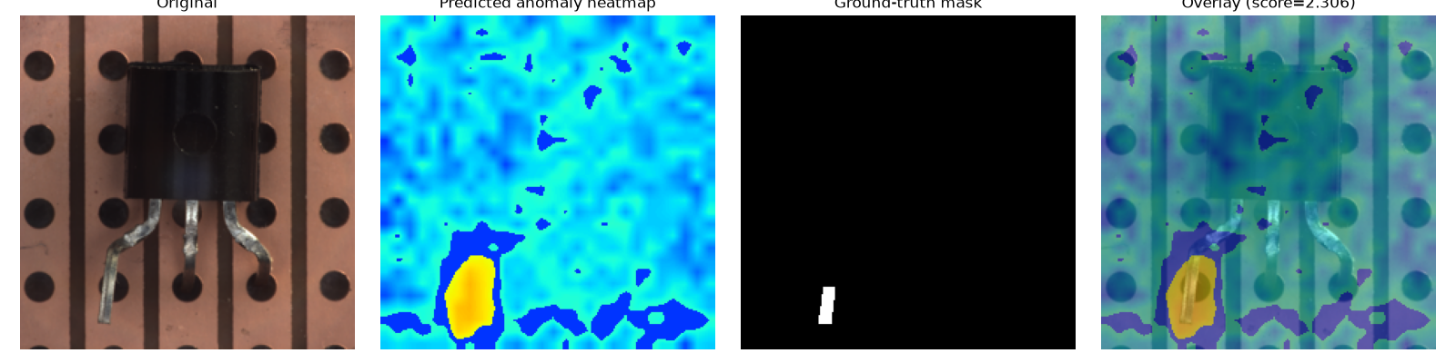
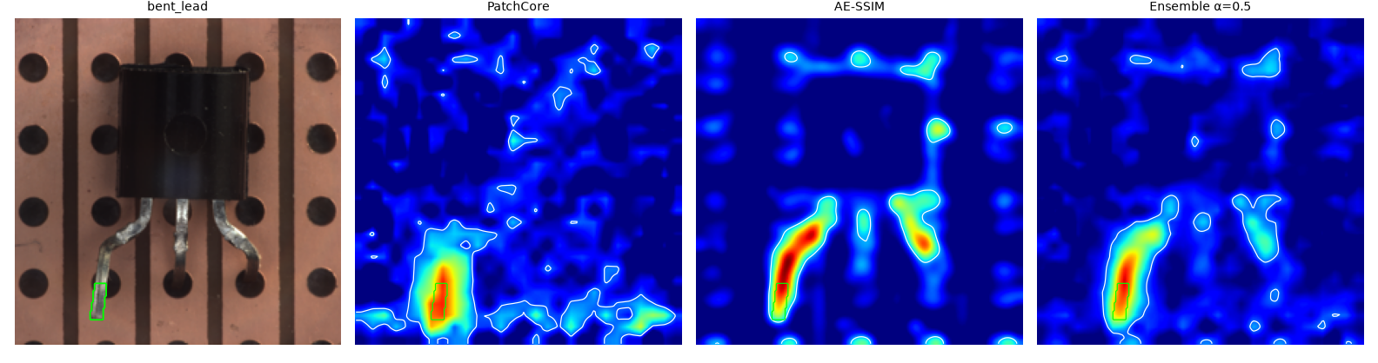
Figure 9. Transistor bent_lead example from the standard calibrated run. Top: original image, anomaly heatmap, ground-truth mask and overlay (image score 2.306 against an image threshold of 2.011 and a pixel threshold of 1.637; mean IoU 0.315 and Dice 0.455 over the transistor defective images). The response concentrates on the bent lead but spreads beyond the annotated region. Bottom: PatchCore, SSIM autoencoder and equal-weight ensemble anomaly maps for the same image, with the ground-truth box in green.
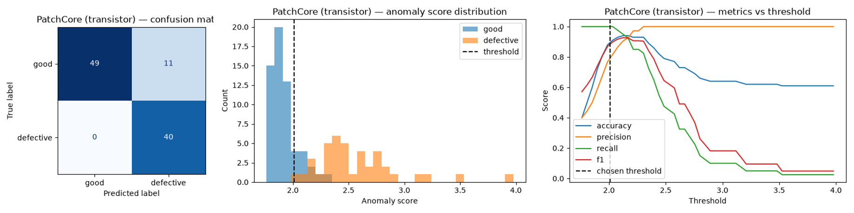
Figure 10. Transistor PatchCore on the 100-image test set at the calibrated image threshold: confusion matrix (49 true negatives, 11 false positives, 0 false negatives, 40 true positives), anomaly-score distribution and metrics versus threshold. Good scores cluster lower and overlap near the threshold, which explains the false alarms. The threshold was fixed from held-out normal images; the sweep is diagnostic only.

8.2 Preprocessing must match the category
The historical bottle experiment showed that applying a plain-background Otsu heuristic to a top-down bottle image could suppress actual defect pixels; pixel AUROC fell to 0.374 when the unsuitable foreground mask was applied. Full-frame textures and the transistor’s patterned board also violate simple foreground assumptions. Per-category configuration is therefore necessary, and a visually cleaner heatmap alone is insufficient evidence of improved localization.

8.3 More model capacity does not ensure improvement
In the matched calibrated screw comparison, replacing ResNet18 with WideResNet50-2 raises image AUROC from 0.899 to 0.917, but pixel AUROC falls from 0.886 to 0.883 and IoU from 0.036 to 0.034. The larger backbone improves image ranking modestly without solving localization. Legacy tuning experiments report other gains, but several fit on all normal images and select thresholds on the evaluation set; their overlap scores cannot be compared directly with the calibrated benchmark.

8.4 Crops must match inference conditions
In a separate screw ResNet18 ablation, ground-truth crops achieved 0.8611 validation accuracy, but the same model fell to 0.1944 when evaluated with predicted crops. Training and validating on PatchCore crops gave 0.6111, versus 0.4722 for a seeded full-image rerun. The improvement depends on matching training inputs to deployable localization. The crop study inherits a test-selected pixel threshold and remains exploratory. These numbers are distinct from the later ConvNeXt-Tiny benchmark.

8.5 PatchCore tuning, scoring and projection choices
Screw was used for a one-factor-at-a-time sweep of coreset size, projection dimension and feature layers. These runs predate normal-only calibration: the memory bank used all 320 normal images and thresholds came from Youden's J on the test labels. Their absolute values therefore differ from Table 5 and are comparable only with each other.
Configuration | Image AUROC | Pixel AUROC | Mean IoU | Mean Dice
Default: 2,000 patches, projection 128, layer2+3 | 0.9092 | 0.9761 | 0.0471 | 0.0884
Coreset 1,000 | 0.8664 | 0.9714 | 0.0345 | 0.0660
Coreset 4,000 | 0.9395 | 0.9794 | 0.0488 | 0.0916
Projection 64 | 0.9174 | 0.9770 | 0.0351 | 0.0671
Projection 256 | 0.9484 | 0.9765 | 0.0365 | 0.0697
layer2 only | 0.9436 | 0.9778 | 0.0491 | 0.0920
layer3 only | 0.8000 | 0.9709 | 0.0270 | 0.0520
layer1+2 | 0.9498 | 0.9704 | 0.0553 | 0.1031
320 px, layer1+2, 100k candidate cap | 0.9434 | 0.8830 | 0.0580 | 0.1076
Combined: 4,000, projection 256, layer2 (seeds 41-43) | 0.9696 ± 0.0061 | 0.9808 ± 0.0009 | 0.0677 ± 0.0030 | 0.1237 ± 0.0048
Table 18. Screw PatchCore one-factor sweep under the earlier protocol (memory bank on all normal images, threshold from test labels).

A smaller bank (1,000 patches) or the coarse layer3 features alone lost information, while a larger bank, a wider projection and layer2 features each helped. Combining 4,000 patches, projection 256 and layer2 gave image AUROC 0.9696 ± 0.0061 and mean IoU 0.0677 ± 0.0030 over three seeds, at about twice the storage and scoring cost. These values were tuned on screw and should not be copied to other categories without multi-seed validation.

Raising resolution trades ranking for overlap. At 320 px with layer1+2 features (an 80 × 80 grid) screw IoU rose from 0.0471 to 0.0580, Dice from 0.0884 to 0.1076 and image AUROC from 0.9092 to 0.9434, but pixel AUROC fell from 0.9761 to 0.8830; this is the model the demo uses for screw (its config has no normal-only calibration block, unlike the standard runs in Table 5). The idea failed on transistor, where the 224 px layer2+3 detector with primary-region filtering scored image AUROC 0.9975, pixel AUROC 0.9608 and IoU 0.3210, against 0.9763, 0.8759 and 0.1951 at 320 px layer2+3 and 0.9171, 0.7233 and 0.1608 at 320 px layer1+2. Shallow features respond to the perforated board's texture, so a finer grid helps only when its features stay selective for the defect.

k-nearest-neighbor scoring (k = 3) and softmax reweighting were also tested per category, again under the earlier protocol. The table lists image AUROC and mean IoU for k = 1 and k = 3, and image AUROC with softmax reweighting.

Category | Image AUROC, k = 1 to k = 3 | Mean IoU, k = 1 to k = 3 | Softmax image AUROC
Screw | 0.9092 to 0.9389 | 0.0471 to 0.0574 | 0.9043
Bottle | 1.0000 to 1.0000 | 0.3966 to 0.3952 | 1.0000
Hazelnut | 0.9982 to 0.9993 | 0.2093 to 0.2181 | 0.9979
Carpet | 0.9711 to 0.9767 | 0.2512 to 0.2465 | 0.9715
Leather | 1.0000 to 1.0000 | 0.1265 to 0.1357 | 1.0000
Grid | 0.7836 to 0.9181 | 0.0756 to 0.0966 | 0.8947
Tile | 0.9975 to 0.9996 | 0.3832 to 0.4004 | 1.0000
Wood | 0.9895 to 0.9895 | 0.1873 to 0.1877 | 0.9912
Transistor | 0.9975 to 0.9962 | 0.2482 to 0.2542 | 0.9958
Table 19. Effect of k-nearest-neighbor scoring and softmax reweighting on the default detector, earlier protocol.

k = 3 improved at least one ranking metric in eight of nine categories, most on grid and screw, but it slightly lowered transistor image AUROC even as pixel AUROC and IoU rose, and on the tuned screw detector it did not help (0.9659 ± 0.0031 against 0.9696 ± 0.0061 for k = 1 over three seeds). Softmax reweighting lifted grid to 0.8947 and tile to 1.0000 but lowered screw, hazelnut and transistor. Both are per-category options; k = 1 without reweighting stays the global default.

A PCA projection for coreset selection, in place of the random projection, was compared over seeds 41 to 43 on screw, bottle, hazelnut, carpet and leather. Screw image AUROC averaged 0.9212 ± 0.0144 against 0.9092 for the single random run but seed 43 (0.9067) fell below that baseline, and mean IoU and Dice were 0.0451 and 0.0851 against 0.0471 and 0.0884. Bottle and leather were already at an image AUROC of 1.000, and hazelnut and carpet gained only 0.0015 and 0.0009. The random projection therefore stays the default; the comparison also used one random seed, so it is not a matched multi-seed test.

9 Discussion and limitations

9.1 What the experiments establish
The project demonstrates a modular inspection workflow in which pretrained representations support both supervised classification and normal-only anomaly detection. Product classification is easier than fine-grained defect typing in this dataset. PatchCore is especially useful when labeled defects are scarce, while supervised models add names for known defect types. The two components address different requirements and should be evaluated separately.

The transistor autoencoder recognizes gross misplaced defects but struggles with small lead and case defects. Reconstruction error on normal thin structures can obscure subtle anomalies. SSIM improves pixel ranking relative to L2 in this experiment but leaves image AUROC almost unchanged. Primary-region postprocessing also affects the detectors differently: it helps PatchCore’s reported overlap but reduces autoencoder overlap. A postprocessing rule should therefore be validated for each detector, not transferred automatically.

Classical models provide useful reference points. RBF and SOM each reached 1.000 accuracy on the historical eight-category classification task, yet subtype accuracy varied widely. The nine-category matched PCA-plus-LDA comparison reported mean accuracy 0.627 versus 0.687 for unaugmented ResNet18 and 0.930 for augmented ConvNeXt-Tiny. These older subsets must not be mixed with the later 14-category benchmark. Retaining high PCA variance does not guarantee discrimination between defect classes.

The supervised good/defective baseline (Section 6.4) is a reference result. Its validation sets are carved from MVTec's labeled test folders and were used to compare architectures, so it is not an independent estimate, and the demo uses PatchCore for the Normal/Defective decision.

9.2 Limits to generalization
MVTec uses controlled capture conditions. A high anomaly score may reflect a new camera, background, lighting condition or product appearance rather than a defect. The category confidence gate does not establish reliable out-of-distribution rejection. Independent production-like images are needed before making deployment claims.

Defect-type datasets are small and derived from labeled test folders. One image can move a category’s accuracy by several percentage points. Repeated folds reuse images, and choosing architecture or voting policy using those folds makes the selected result exploratory. Reported standard deviations are not confidence intervals. No measured end-to-end accuracy is supplied for the combined category-routing, detection, rejection and subtype pipeline.

The severity labels are area heuristics, and the connected-component subtype feature lacks component-level ground truth. Neither has a validated reliability score. Normal-only percentile calibration also provides approximate false-alarm control; the number and diversity of calibration images constrain its stability.

10 Conclusion
VisionInspectAI integrates category classification, normal-only anomaly detection, visual localization and category-specific defect typing into an inspectable application. The standard calibrated benchmark reports mean image AUROC of 0.968 over 15 categories, while the selected defect-type route reports 339 correct predictions out of 373 validation images. These results support the approach within MVTec’s capture conditions, subject to the model-selection caveats described in this report.

The main remaining gaps are precise localization, stable category-specific operating thresholds, consistency between deployed configurations and benchmark claims, and generalization to independent images. The report therefore presents the application as an evaluated prototype with explicit experimental limits.
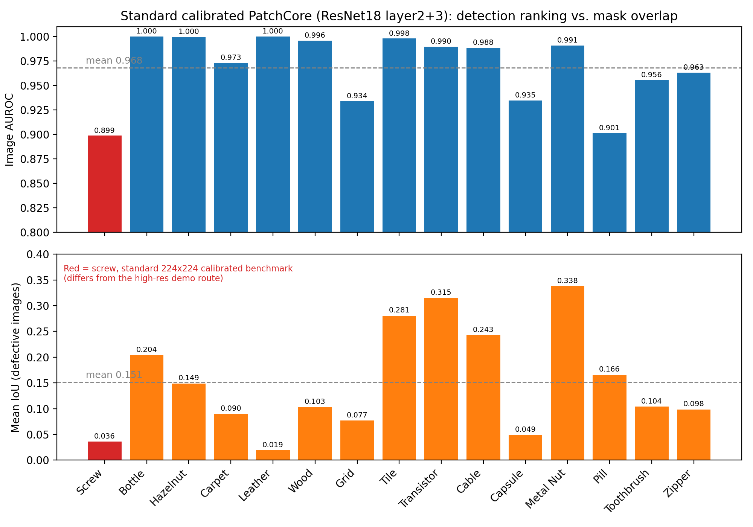
Figure 11. Standard calibrated PatchCore (ResNet18 layer2 + layer3) image AUROC (top) and mean IoU over defective images (bottom) per category, on separate scales. Means are 0.968 and 0.151. Screw (red) is the standard 224 × 224 calibrated configuration, not the high-resolution demo route.

References
● Roth, K. et al. (2022). Towards Total Recall in Industrial Anomaly Detection. CVPR. PatchCore method reference. arXiv:2106.08265.
● Bergmann, P. et al. (2019). MVTec AD — A Comprehensive Real-World Dataset for Unsupervised Anomaly Detection. CVPR. Dataset reference. https://www.mvtec.com/research-teaching/datasets/mvtec-ad
● He, K. et al. (2016). Deep Residual Learning for Image Recognition. CVPR. ResNet reference.
● Wang, Z. et al. (2004). Image Quality Assessment: From Error Visibility to Structural Similarity. IEEE Transactions on Image Processing, 13(4). SSIM reference.
● Liu, Z. et al. (2022). A ConvNet for the 2020s. CVPR. ConvNeXt reference.
● Huang, G., Liu, Z., van der Maaten, L. and Weinberger, K. Q. (2017). Densely Connected Convolutional Networks. CVPR. DenseNet reference.
● Tan, M. and Le, Q. V. (2019). EfficientNet: Rethinking Model Scaling for Convolutional Neural Networks. ICML. EfficientNet reference.
● Dosovitskiy, A. et al. (2021). An Image is Worth 16x16 Words: Transformers for Image Recognition at Scale. ICLR. ViT reference.
● Otsu, N. (1979). A Threshold Selection Method from Gray-Level Histograms. IEEE Transactions on Systems, Man, and Cybernetics, 9(1). Foreground thresholding reference.

