**FIT5003 Software Security**

**As1**

**1. Compile and run the program**

You can run this program in Unix system such as Ubuntu.

To run the program:

(1) Open the terminal

(2) Find the location of the file

(3) Compile it by “gcc –pthread –std=c99 as1.c”(make sure that your system has pthread library)

(4) Run it by “./a.out”(Or your execution file’s name).

(5) Type in a valid number for how many threads you want to create and press ENTER.

(6) Type in a valid number for the value of interval and press ENTER.

(7) Get your result

Example:

Compile:

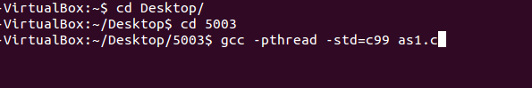

Run:



Enter values and get result:

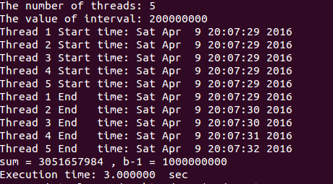

**2.Assumption and Justification**

There are two inputs in this program, threads number and interval value. So there are two steps of validation.

For threads number, It can’t be greater than 380 or smaller than 1. Also when the user wants to enter a value that is not number (e.g. abcd) The program will show an error message.

The threads number is picked by my own PC, It could be different on the other PC.

For the interval number, It can’t be greater than 2000000000 or smaller than 1. Type can only be integer. And Interval number * threads number can’t be greater than 10000000000. This values are based on the limit of my system.

The mutex function can lock the sum value and a value when one thread is executing and unlock these two values after the execution. So the next thread can do the same execution.

The calculation is adding the value from 0 to b-1 and the program separates the calculation into many parts (threads). The final output is the sum value and the last number b-1.

The timer is set up for each thread and for whole program. Users can see when the thread begins and ends and the time cost for whole process is also printed.