Item Class Test Strategy

Class:

Item

Fields:

itemName: String

itemId: int

itemCost: int

itemLvl: int

itemDiscount: int

Constructors:

Item()

Item(String, int, int, int, int)

Methods:

getName() String

getId() int

getCost() int

getLvl() int

getDiscount() int

setName(String)

setId(int)

setCost(int)

setLvl(int)

setDiscount(int)

**Test Plan**

1. Create an item object using default constructor.

2. Create an item object using constructor with valid parameters.

3. Create an item object using constructor with invalid parameters.

4. Test get methods.

5. Test set methods with valid parameters.

6. Test set methods with invalid parameters.

Test 1. Create an item object using default constructor.

Test data: no input

Expected result:

itemName = “null”

itemId = 1

itemCost = 1

itemLvl = 1

itemDiscount = 0

Actual result:

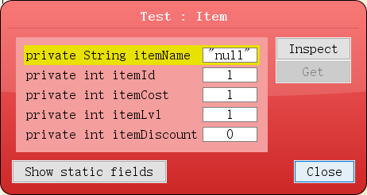

Test2. Create an item object using constructor with valid parameters.

Test data

itemName = “Coke”

itemId = 111

itemCost = 3

itemLvl = 50

itemDiscount = 20

Expected result:

itemName = “Coke”

itemId = 111

itemCost = 3

itemLvl = 50

itemDiscount = 20

Actual result:

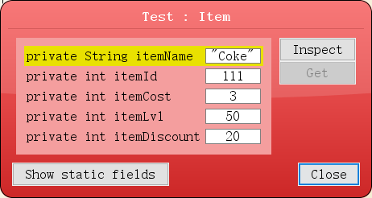

Test 3. Create an item object using constructor with invalid parameters.

Test data

itemName = “”

itemId = -1

itemCost = -1

itemLvl = -1

itemDiscount = 15

Expected result:

itemName = “null”

itemId = 1

itemCost = 1

itemLvl = 1

itemDiscount = 0

Actual result:

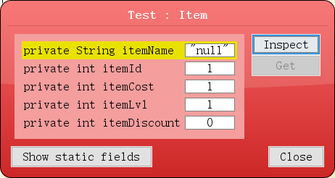

4. Test get methods.

Test data

itemName = “Coke”

itemId = 123

itemCost = 3

itemLvl = 50

itemDiscount = 20

getName()

Expected result:

itemName = “Coke”

Actual result:

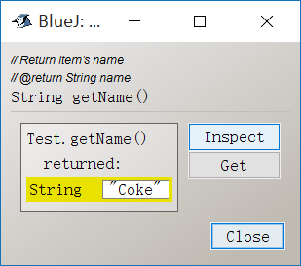

getId()

Expected result:

itemId = 123

Actual result:

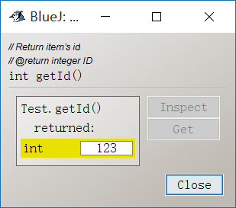

getCost()

Expected result:

itemCost = 3

Actual result:

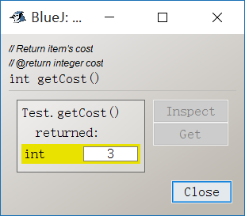

getLvl()

Expected result:

itemLvl = 50

Actual result:

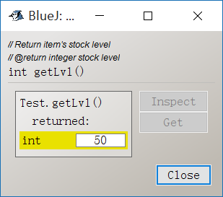

getDiscount()

Expected result:

itemDiscount = 20

Actual result:

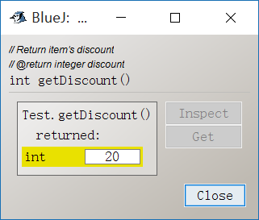

5. Test set methods with valid parameters.

Default data

itemName = “Coke”

itemId = 123

itemCost = 3

itemLvl = 50

itemDiscount = 20

setName()

Test data

ItemName = “Banana”

Expected result:

itemName = “Banana”

Actual result:

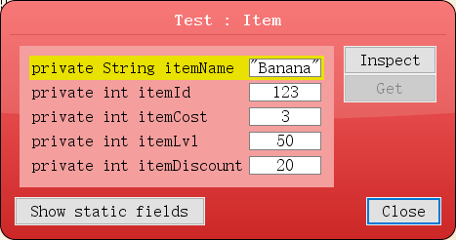

setId()

Test data

ItemId = 111

Expected result:

itemName = 111

Actual result:

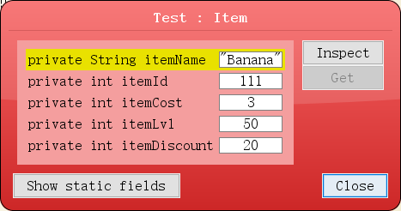

setCost()

Test data

ItemCost = 10

Expected result:

itemCost = 10

Actual result:

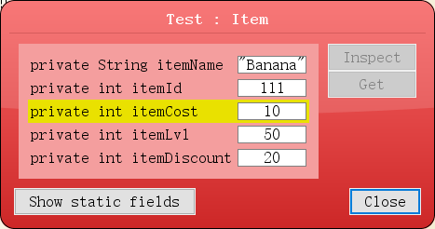

setLvl()

Test data

ItemLvl = 100

Expected result:

itemLvl = 100

Actual result:

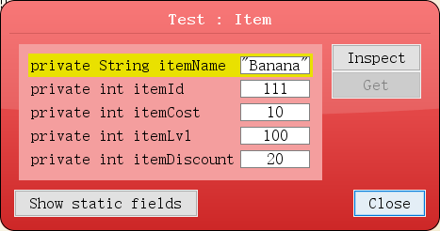

setDiscount()

Test data

ItemDiscount = 10

Expected result:

itemDiscount = 10

Actual result:

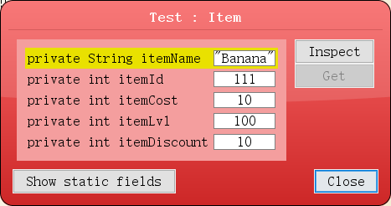

6. Test set methods with invalid parameters.

setName()

Test data

ItemName = “”

Expected result:

itemName = “Banana”

setId()

Test data

ItemId = -1

Expected result:

itemId = 111

setCost()

Test data

ItemCost = -1

Expected result:

itemCost = 10

setLvl()

Test data

ItemLvl = -1

Expected result:

itemLvl = 100

setDiscount()

Test data

ItemDiscount = 15

Expected result:

itemDiscount = 100

Actual result:

