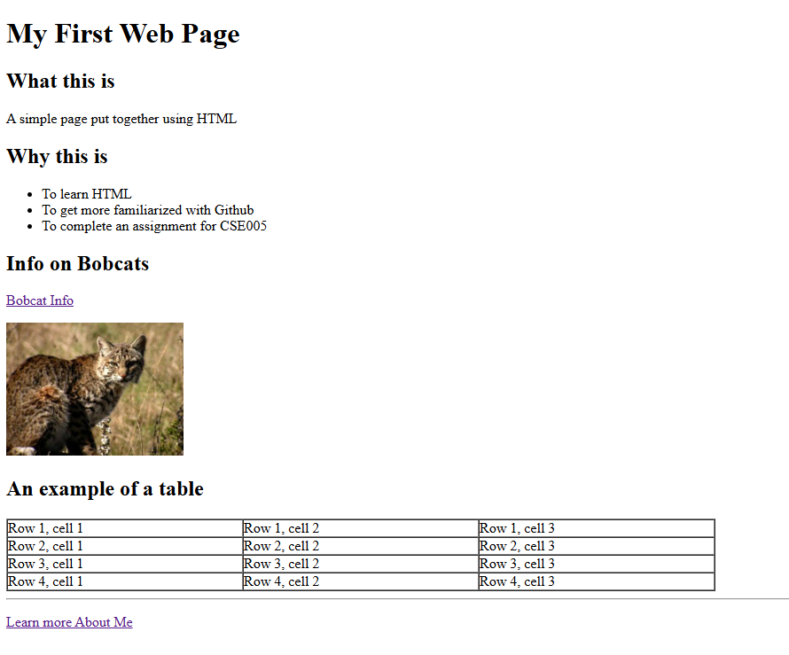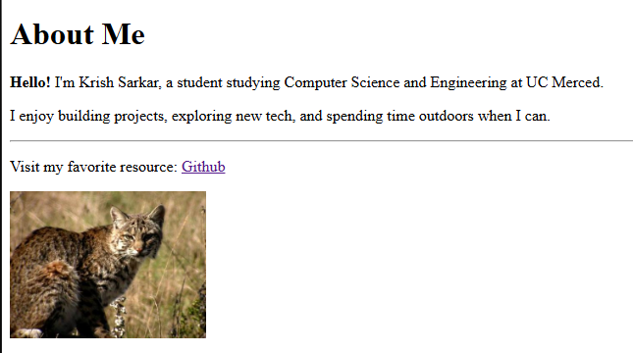

<https://yeehawcuzzin.github.io/CSE-005-Lab1-07/myfirstwebpage.html>

<https://yeehawcuzzin.github.io/CSE-005-Lab1-07/AboutMe.html>