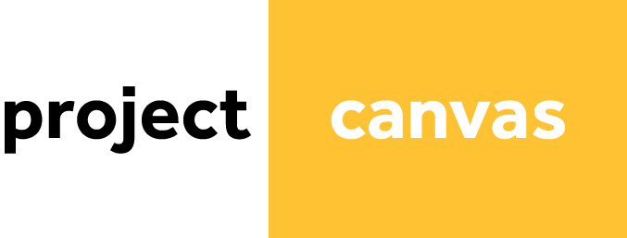

Project owner Nicky Heldoorn, Dries Vandewinkel, Johnatan

|  |  |  |  |
| --- | --- | --- | --- |
| Purpose    Wij vinden het belangrijk om je eigen energie op te kunnen wekken om een groenere wereld te krijgen. | Scope  What does this project contain?  Een nieuwe manier om energie op te wekken in je tuin  What does this project not contain?  We maken de windmolen zelf niet | Success Criteria  What do we need to achieve in order for the project to be successful?  How can the Success Criteria be measured? | |
| Milestones  When will we start the project and when is the final deadline ?  We zijn begin dit school jaar met dit project begonnen en we eindigen op 23 mei.  What are the key milestones and when will they occur?  De eerste opstelling op school is een belangrijke punt van dit project  How can the milestones be measured?  Met een | | |  |
|  | | |  |
|  | | |  |
| Actions  Which activities need to be executed in order to reach a certain milestone? | | |  |
|  | | |  |
|  | | |  |
|  | | | Outcome  What is the end result? |
|  | | | * A book * A website * An event |
| Team  Who are the team members? What are their roles in the project? | Stakeholders  Who has an interest in the success of the project? In what way are they involved in the project? | Users  Who will benefit from the outcome of the project? | |
| Resources  What resources do we need in the project?   * Physical (office, building, server) * Financial (money) * Human (time, knowledge) | Constraints  What are the known limitations of the project?   * Physical (office, building, server) * Financial (money) * Human (time, knowledge, politics) | Risks  Which risks may occur during the project? How do we treat these risks? | |

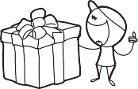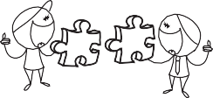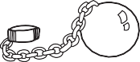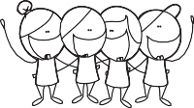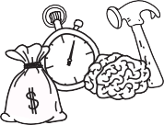Copyright © Project Canvas [www.projectcanvas.dk](http://www.projectcanvas.dk/)

