Deliverable 1

# Project Proposal:

The Fitness Tracker Application will help users set fitness goals, track their progress over time, and keep track of their workout routines. With its user-friendly layout, this application will benefit both casual and dedicated fitness lovers by offering tools to track activities, assess accomplishments, and visualize progress.

The application will be developed in Java and will support both English and French.

# Diagrams:

## Class Diagram:

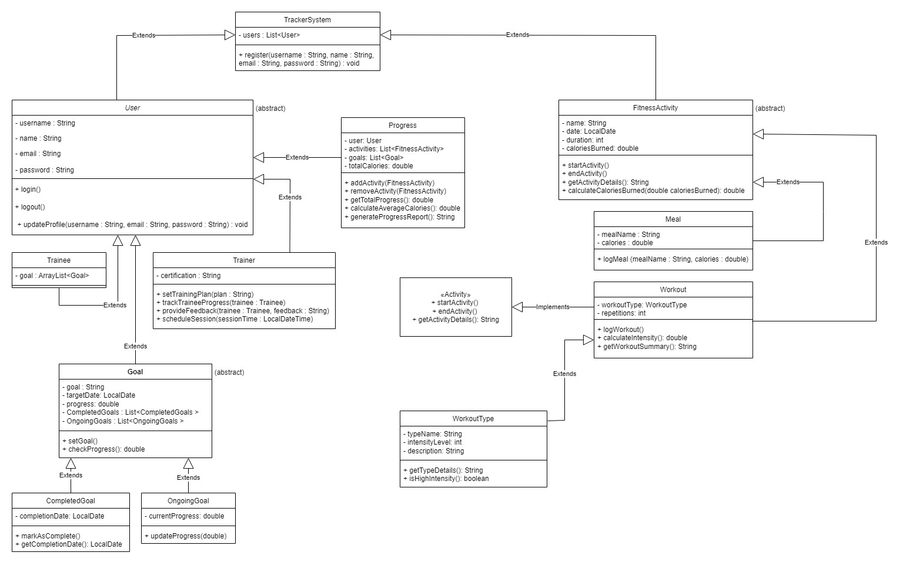

## Entity Relationship Diagram:

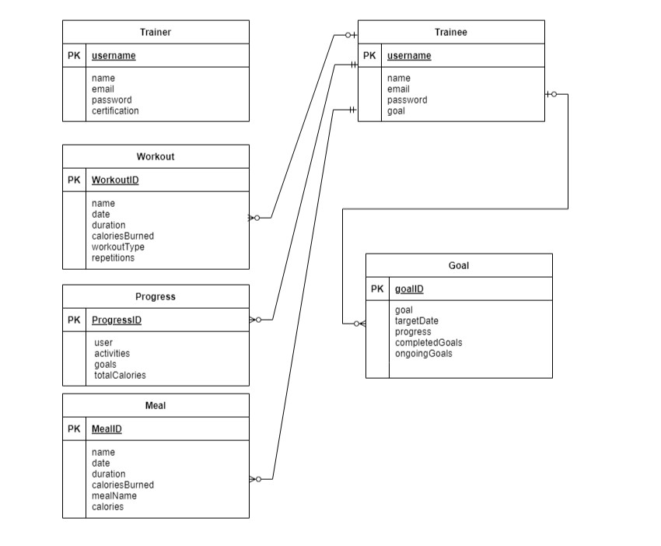

## Activity Diagram:

### Trainer:

### Trainee:

