Noah McCarthy
Module Assignment 5.2
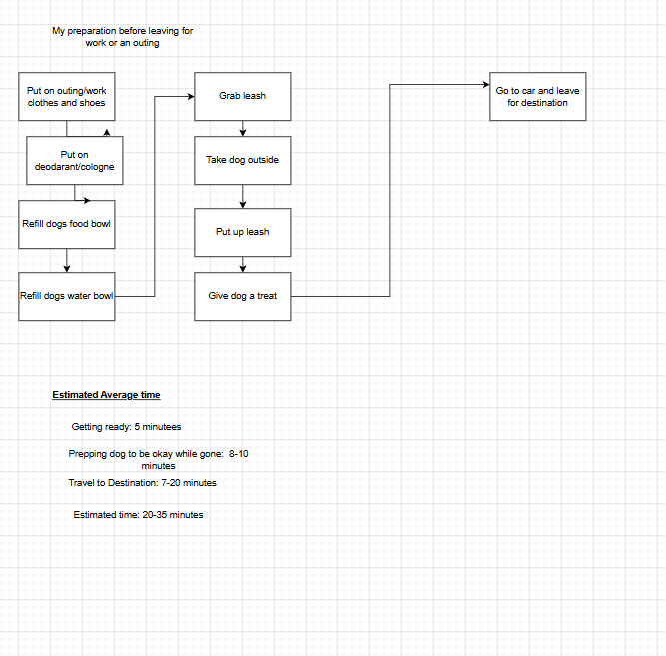
I went with my routine I go with before leaving the house to go do something. I couldn’t really think of anything else I could apply it to at the time.

Optimizations
- I’m not sure if I should do the optimizations or not, but I figured it couldn’t hurt
The optimizations for this are on the more minuscule end as it would be saving mostly seconds in most cases. For putting on clothes for the outing, I could just skip that and go with the house clothes I am wearing, and just put on some socks and slip on some shoes instead. Of course, that depends on the situation. I obviously don’t want to do that, going to a nice restaurant, but if I am just going to Sheetz or something like that, then it's not as big a deal. The same could be applied to putting on deodorant or cologne. Depending on where you are going, let's say going to just a convenience store, you are most likely not going to need to put on cologne or sweat enough to need deodorant in most cases. Then, as for filling up the food and water bowl, I can grab the leash while doing that, saving time there. Additionally, before taking my dog out, I can leave her a treat waiting on her dog bed before we go outside, saving me time having to go back and do that before leaving. Therefore, only needed to put up the leash before leaving to head to my destination. As for optimizing travel to the destination, the only legal way to improve that is to optimize the route you take.

