Noah McCarthy
Module 2.3 Assignment
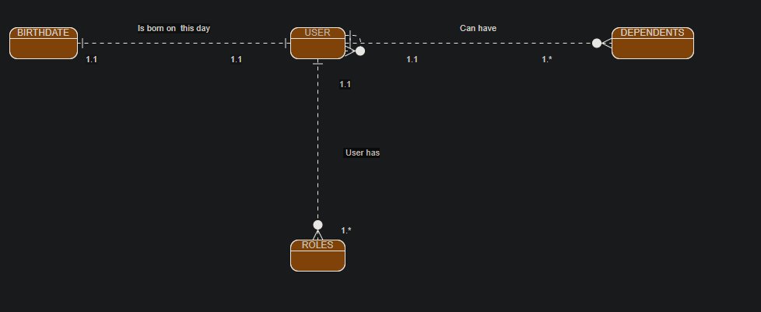NoSQL Data Structure:
{
“user”: “Noah”,
“birth_date”: “03/14/2001”,
“roles”: [
Service Manager,
Trainer
]
“Dependents”: [
None
]
}

