Noah McCarthy
Assignment 4.2
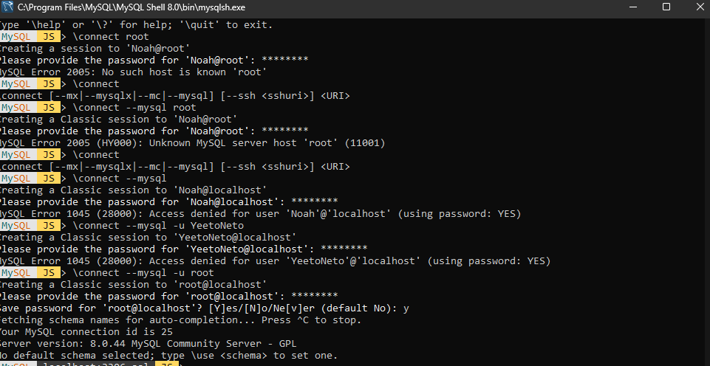
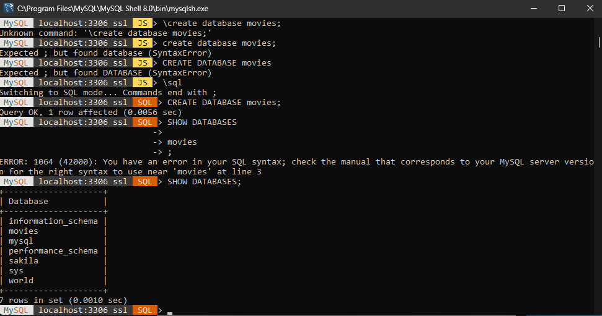
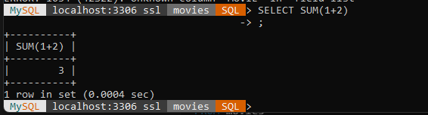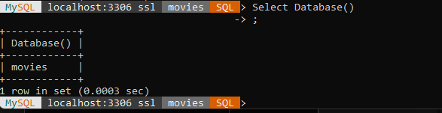
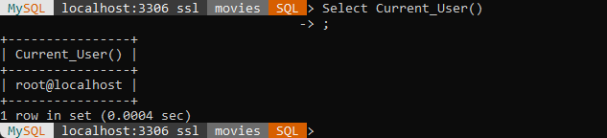
I went with the SUM, DATABASE, and CURRENT_USER commands. Sum is most likely to be used when you need to add numerical data together from a table. Like you have 5 pears here and 5 apples somewhere else, and you are counting the total amount of product. DATABASE is most likely to be used before you start editing a database to ensure you are working on the correct one and not adding to the incorrect database. The CURRENT_USER command can be used to make sure you are signed into the correct account if you are experiencing permission issues or otherwise.
