- Birth Weight in Relation to Morbidity and Mortality among Newborn Infants
The paper uses various methods and calculations to estimate the health outcomes of newborn infants. Some of the methods and calculations mentioned in the paper include:
1. Analyzing neonatal outcomes such as death, Apgar scores, umbilical-artery blood pH, and morbidity due to prematurity.
2. Creating a distribution of birth weights according to gestational age.
3. Using birth-weight percentiles to compare outcomes among different groups.
4. Conducting univariate analysis using chi-square statistics.
5. Adjusting for demographic factors such as mother's race and parity and infant's sex.
6. Deriving smoothed birth-weight curves for each percentile.
7. Analyzing data after stratification according to gestational-age groups.
8. Using the Cochran–Mantel–Haenszel method for adjustment.
9. Applying Bonferroni corrections for multiple testing.
These methods and calculations help the researchers in the study to assess the relationship between birth weight and various health outcomes in newborn infants.

- Health and the Political Agency of Women
By Sonia Bhalotra and Irma Clots-Figueras
“we find that a one standard deviation increase in women’s political representation in the birth
year (and similarly in the two years preceding birth) results in a 1.5 percentage
point (24 percent) reduction in neonatal mortality, which is a 0.06 standard devia-
tion change.”
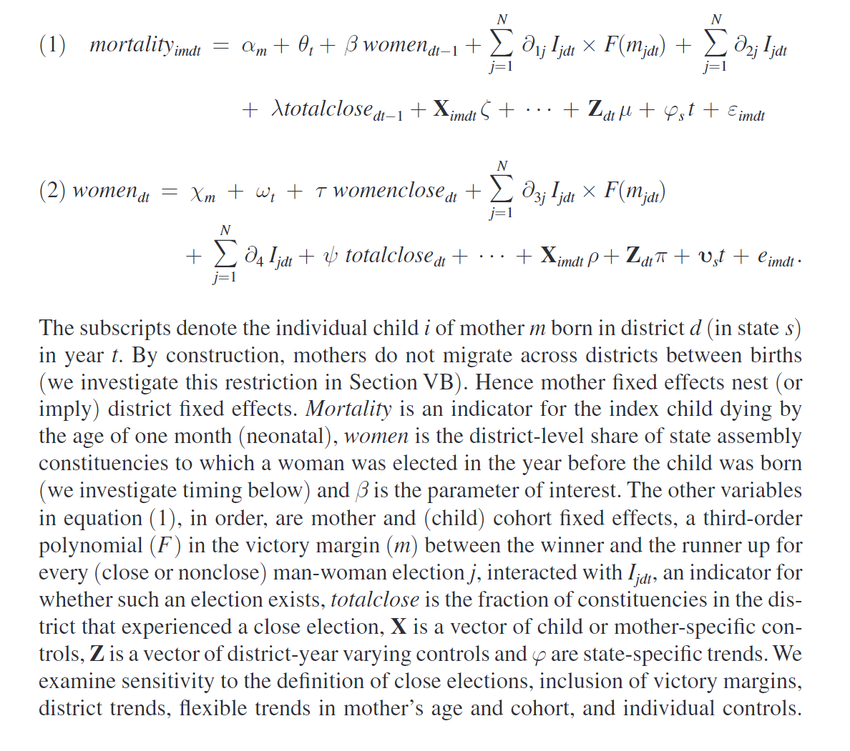

- The influence of economic development level, household wealth and maternal education on child health in the developing world
Michael H. Boylea, Yvonne Racine a , Katholiki Georgiades a , Dana Snelling a, Sungjin Hongb , Walter Omariba a, Patricia Hurley c , Purnima Rao-Melacini
Analysis:
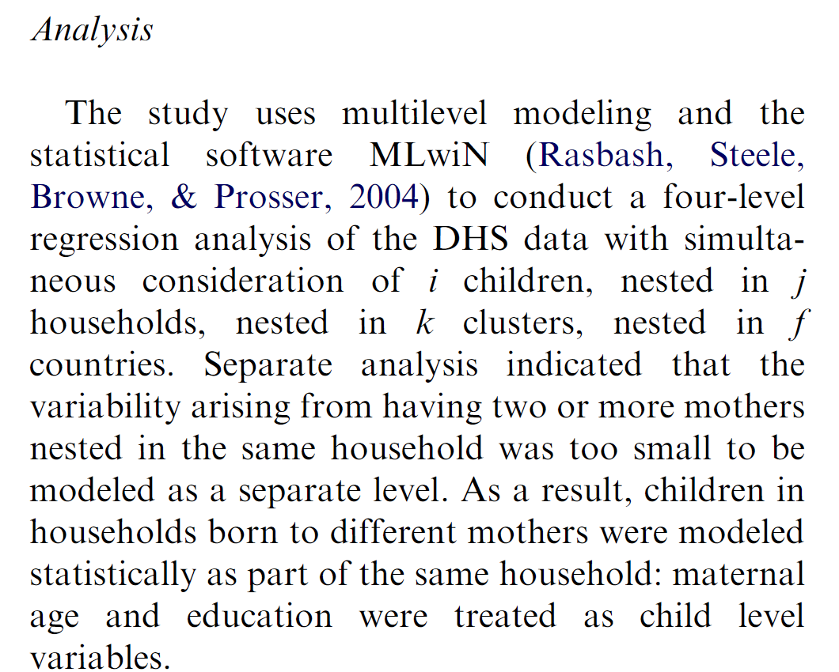

Does Critical Mass Matter? Women’s Political Representation and Child Health in Developing Countries
Liam Swiss, Kathleen M. Fallon, Giovani Burgos
总体而言，研究旨在通过分析女性立法者的增加对儿童健康的影响，特别是免疫接种率和婴儿死亡率
“尽管没有研究专门探讨女性立法代表增加与民主制度结合是否会导致积极的发展成果，但许多研究确实探讨了民主对健康的影响。研究结果不一。一些学者发现，民主制度会导致预期寿命和免疫接种率的增加，以及婴儿/儿童死亡率和孕产妇死亡率的下降（Alvarez-Dardet 和 Franco-Giraldo 2006；Baum 和 Lake 2001；Navia 和 Zweifel 2003；Paxson 等人 2004；Safaei 2006；Shandra 等人 2004）。另一些人则认为，民主对预期寿命、婴儿/儿童死亡率和孕产妇死亡率没有影响或有负面影响（Ross 2006；Wejnert 2008）。“
上面这个关于民主和死亡率的文献总结可以首位在自己的论文中提一下但是不易提很多， 和主题不是很密切的关联。
不同疫苗的接种率

Own paper:
Channel:
Gather new data on the increased number of female governors at various levels of government, including local, governorates, and central government. Mention family power dynamics as well.
Check nutrition. Examine the birthplace (hospital or home) and whether mothers received special care or adequate support before and after childbirth.
Identified the concept and dimensions of female autonomy (Mason, 1986; Samman and Santos, 2009):
The concept and dimensions of female autonomy include:
- Psychological Dimension: self-efficacy and self-esteem
- Social Dimension: social networks and support systems
- Economic Dimension: control over income and assets
- Legal Dimension: legal rights and protections
- Political Dimension: participation in decision-making and political processes
Female voter turnout
Proportion of women in the workforce (any type of work)

Dependent variable:
1. Under-five survival: Similar to infant survival, we use under-five survival rates, calculated as the percentage of children in a country estimated to survive past their fifth birthday.
2. Immunization rates
3. Measles immunization rate
4. Prenatal and postnatal care for women
5. Birth and mortality rates of girls, vaccination rates of girls, nutritional status of girls, etc.

Information from DHS:
Birth weight: m19(pounds) only 20% information available. Hw2 (kg measurement)
Tetanus: m1, m1a, m1b, m1c, m1d, m1e, s515b
Number of daughters: gidx daughter’s index to birth history
Miscarriage: s231
Health checking: s536, home health check within 2 months of birth
Has birth certification where vaccinations were written down: tab s605a only 20% information
Children death information: b6 b7 b13 s921d
Time space between births:

Four phases during Arab Spring:
