Mermaid codes for Diagrams

Code for Figure 1:

classDiagram
class User {
+Integer id
+String username
+String email
+String password
+String address
+String phoneNumber
+createAccount()
+updateProfile()
}

class Product {
+Integer id
+String name
+String category
+Decimal price
+String description
+Integer stockQuantity
+addProduct()
+updateProduct()
}

class Order {
+Integer id
+Integer userId
+DateTime orderDate
+String status
+createOrder()
+updateOrderStatus()
}

User "1" -- "0..*" Order : places
Order "1" -- "1..*" Product : contains
Product "0..*" -- "1" User : viewedBy
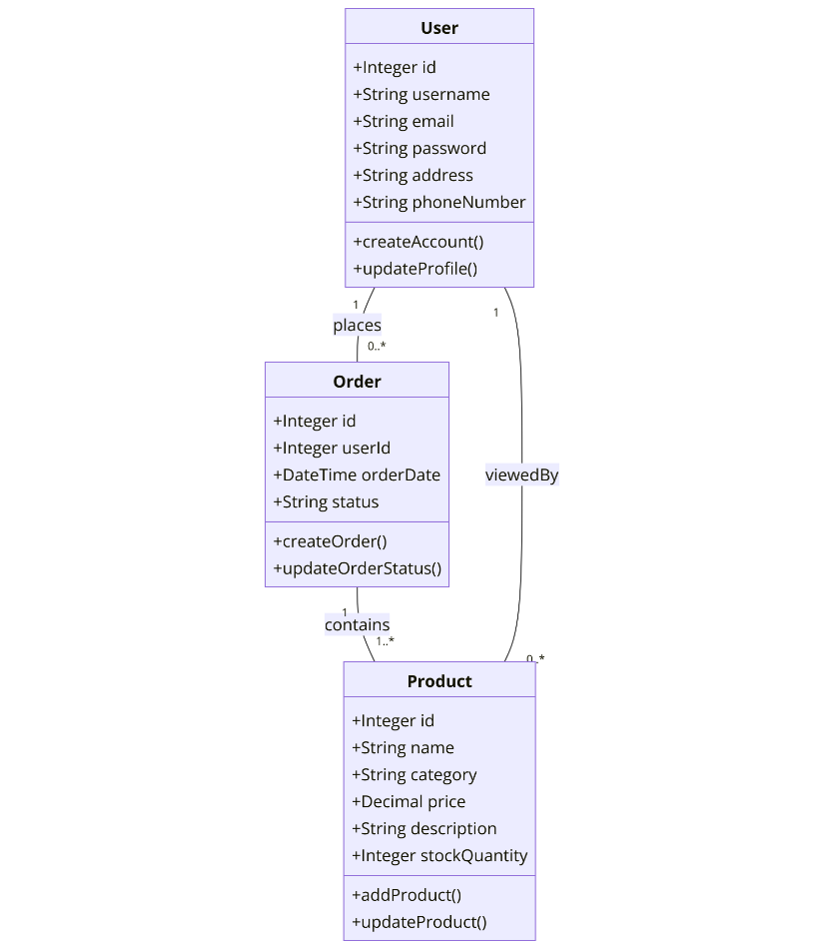

Figure 1: Class diagram illustrating the high-level architecture of the e-commerce platform

Figure 2 Code:

classDiagram
class Order {
+Integer id
+Integer userId
+DateTime orderDate
+String status
+createOrder()
+updateOrderStatus()
+cancelOrder()
+trackOrder()
}

classDiagram
class Product {
+Integer id
+String name
+String category
+Decimal price
+String description
+Integer stockQuantity
+addProduct()
+updateProduct()
+removeProduct()
+checkStock()
}

classDiagram
class User {
+Integer id
+String username
+String email
+String password
+String address
+String phoneNumber
+createAccount()
+updateProfile()
+login()
+logout()
+resetPassword()
}

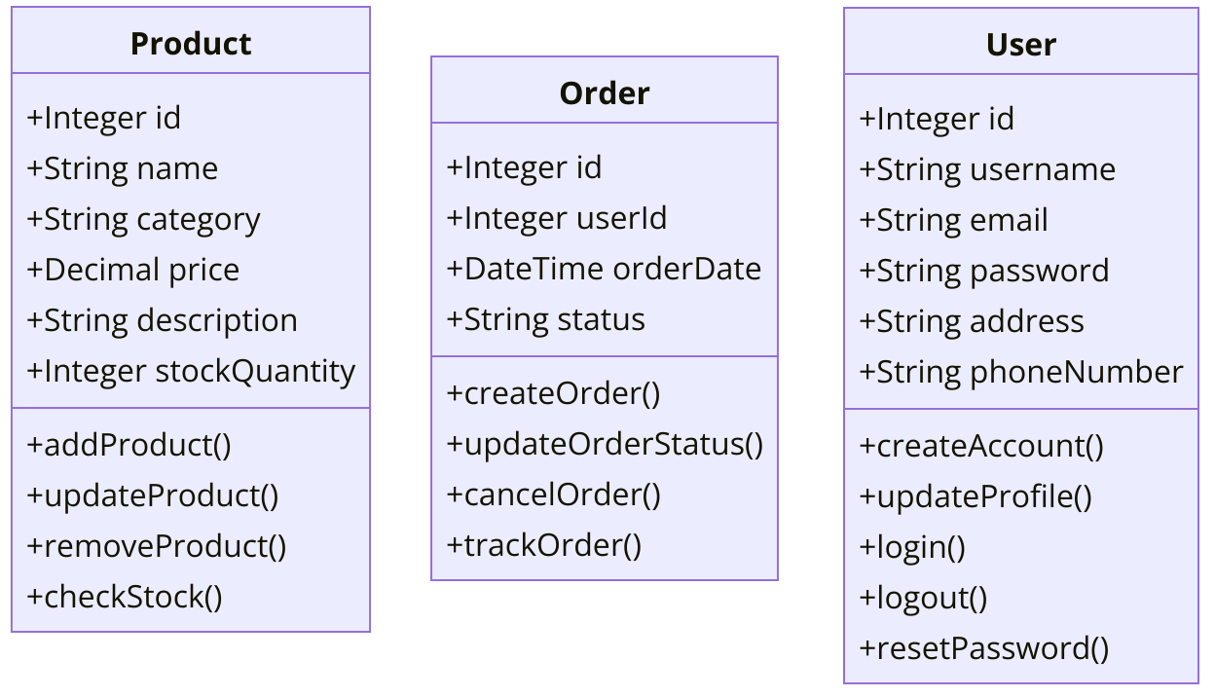

Figure 2: Class diagrams for 3 most important classes

Code for Figure 3:
sequenceDiagram
participant User
participant ECommercePlatform
participant PaymentGateway
participant ShippingService

User->>ECommercePlatform: Add item to cart
User->>ECommercePlatform: Proceed to checkout
ECommercePlatform->>PaymentGateway: Process payment
PaymentGateway-->>ECommercePlatform: Payment confirmation
ECommercePlatform->>ShippingService: Arrange shipment
ShippingService-->>ECommercePlatform: Shipment confirmation
ECommercePlatform-->>User: Order confirmation

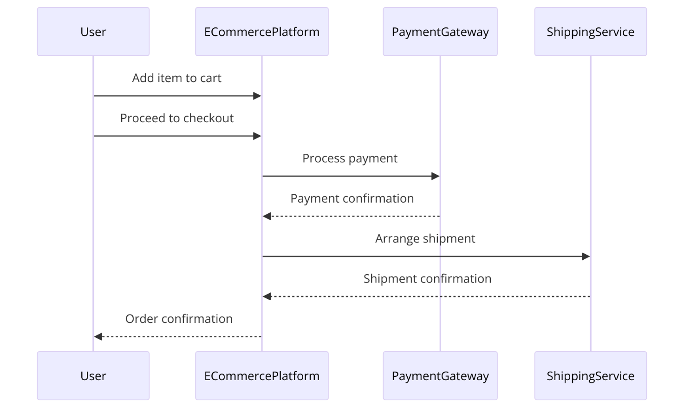

Figure 3: Sequence diagram illustrating the checkout process

