Student Name: Emily Yeh
Check one:
[ X ] I completed this assignment without assistance or external resources.
[ ] I completed this assignment with assistance from ___
and/or using these external resources: ___

PART 1
A. Strings containing only the symbol a whose length is a power of 2 (i.e. length 2^n). This is not a regular expression (and I know this with 100% certainty because I actually tried this in the pumping lemma game). Let’s assume that this language is regular. Let p be the pumping length, and let our input string be s = (aa)^{P}. This string is a member of our language and |s| is more than the p, so it can be split into three pieces, xyz, where for any i > 0, there is a string xy^{i}z that fits in the language. However, we can immediately see that this is not always true. If P is 0, then s is an empty string, and we can never get a (a string of length 2^0) as a result. Therefore, this expression cannot be regular.
B. All strings with an equal number of occurrences of the substrings 01 and 10. This is a regular expression. It can be expressed as 0Σ*0∪1Σ*1.

C. All strings (over {0,1}) consisting of a substring w followed by the reverse of the substring. Let’s assume that this language is regular, because I really don’t know. Let p be the pumping length, and let our input string be s = 0^{P}110^{P}. This string is a member of our language and |s| is more than the p, so it can be split into three pieces, xyz, where for any i > 0, there is a string xy^{i}z that fits in the language. From this string, we know that the length of any prefix of 0^{P}110^{P} of length < P must consist entirely of 0s. If a given prefix has length K, then we can assume that 0^{P+K}110^{P} must be part of the language. What if we try to decompose 0^{P+K}110^{P} into a string W followed by its reversal? If |W| < P + K, then W will contain no 1s. However, if |W| > P + K + 2, it will contain two 1s, but the string following it will contain none, meaning that it would be impossible for the following string to be the reversal of W. Either way, there is a contradiction, indicating that this language is not regular.

PART 2
1. The computer claims that the language
L={w∈Σ∗∣|w|a<|w|b}
over the alphabet Σ={a,b} is regular. It also claims it can build a finite automaton accepting L using 10 states.

It's your turn now. Please enter a word belonging to L that's at least 10 characters long.
aaaaaabbbbbbb
Now highlight a part of the string that's at least 10 characters long.
aaaaaabbbbbbb
This is the computer's pick:
aaaaaabbbbbbb
You can now change how often this pick appears in the string. Your job of course is to end up with a string that does not belong to the language.
aaaaaabbbbbb
The string doesn't belong to the language. You won!
2. The computer claims that the language
L={anbn∣n∈ℕ}
over the alphabet Σ={a,b} is regular. It also claims it can build a finite automaton accepting L using 19 states.
It's your turn now. Please enter a word belonging to L that's at least 19 characters long.
aaaaaaaaaabbbbbbbbbb
Now highlight a part of the string that's at least 19 characters long.
aaaaaaaaaabbbbbbbbbb
This is the computer's pick:
aaaaaaaaaabbbbbbbbbb
You can now change how often this pick appears in the string. Your job of course is to end up with a string that does not belong to the language.
aaaaaaaaabbbbbbbbbb
The string doesn't belong to the language. You won!

PART 3
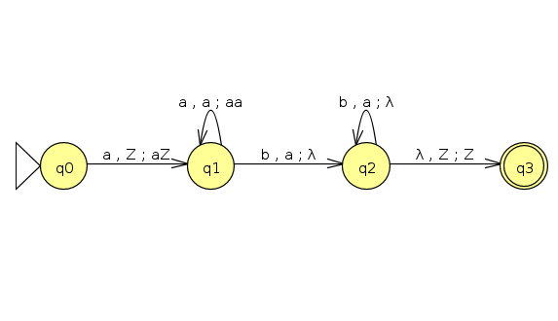
This is a PDA of Part 2, question 2.
I feel like I don’t understand PDAs or the pumping lemma very well yet… I hope we’ll do more examples in class.

