Student Name: Emily Yeh
Check one:
[X] I completed this assignment without assistance or external resources.
[ ] I completed this assignment with assistance from ___
and/or using these external resources: ___

2A: All strings (over {0,1}) consisting of a substring w followed by its reverse.
S = 0S0 | 1S1 | ε
Derivation for 010010:
S → 0S0 → 01S10 → 010S010 → 010ε010 → 010010

2B: All strings (over {a,b,c}) of the form a^{i}b^{i}c^{j}: an equal number of as and bs, followed by any number of cs.
S1 = aS1b | ε
S2 = S2c | ε
S = S1S2
(Example) Derivation of aabbcccc:
S → S1S2→ aS1bS2c → aaS1bbS2cc → aaεbbS2ccc → aabbS2cccc → aabbεcccc → aabbcccc

2C: All strings (over {a,b,c}) of the form a^{i}b^{j}c^{j}: any number of as, followed by an equal number of bs and cs.
S1 = aS1 | ε
S2 = bS2c | ε
S = S1S2
(Example) Derivation of aaaabbcc:
S → S1S2 → aS1bS2c → aaS1bbS2cc → aaaS1bbεcc → aaaaS1bbcc → aaaaεbbcc → aaaabbcc

2D: Give two distinct grammars that produce the strings described by the regular expression (ab)*
Grammar 1:
S = Sab | ε
Grammar 2:
S1 = S1a | aS1 | ε
S2 = S2b | bS2 | ε
S = S1S2

4A:
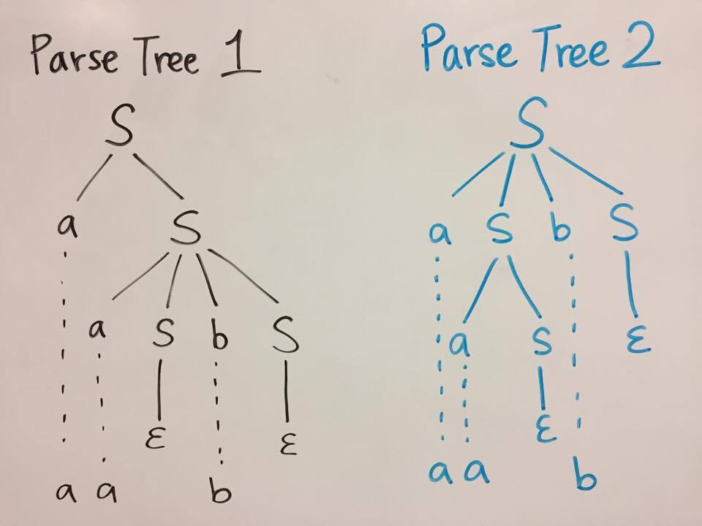
4B: Leftmost derivations:
Derivation 1:
S → aS → aaSbS → aaεbS → aabε → aab
Derivation 2:
S → aSbS → aaSbS → aaεbS → aabS → aabε → aab

4C: Rightmost derivations:
Derivation 1:
S → aSbS → aSbε → aaSb → aaεb → aab
Derivation 2:
S → aS → aaSbS → aaSbε → aaεb → aab

