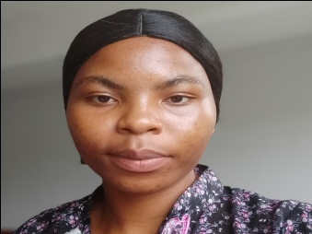

CURRICULUM VITAE
Name: YEH GREASHURES NAMAIN
Date of birth: 24/11/2005
Place of birth: BAMOUGOUM
Nationality: CAMEROONAIN
Marital status: SINGLE
Sex: FEMALE
E-mail: yehnamain@gmail.com
Telephone number: 673692749
Qualities: seriousness, devoted, hardworking, punctual
Values: truth, integrity, respect, love
ACADEMIC PROFILE
DATE | INSTITUTION | CERTIFICATE
2015 | GBPPS TYO VILLAGE | FIRST SCHOOL LEAVING CERTIFICATE(FSCL)
2022 | GBHS NGOUACHE | GCE ORDINARY LEVEL
2024 | GBHS NYALLA | GCE ADVANCE LEVEL
MANAGERIAL SKILL
- Have knowledge about computer proficiency such as word ,excel, PowerPoint and other software
- Good in cleaning
LANGUAGE
- Fluent in English (good)
- French (passable)

