CS1006 Project 2:
Game of Life – Group Submission by Christopher Taylor, Yehor Boiar and Anngeni Vincent

1. Requirements
For this project, our task was to create an implementation of Conway's Game of Life with a toroidal, 50x50 grid, complete with a user-friendly GUI and a save/load option. Our implementation not only meets all the standard requirements, but also includes features like zooming onto the grid, while also supporting the creation of larger grids and the use of different types of brushes. Furthermore, during the game the user has a range of options including start, stop, step, speed up, slow down and more, through either the use of the buttons, or hot-keys which are explained in the options menu.

2. System Overview
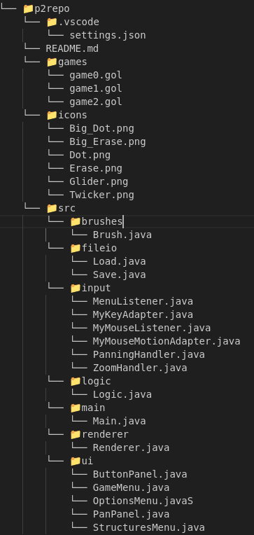Figure 1: File Structure
We established a clear file structure for our project. The 'games' folder stores saved games which the user can also load from, while 'src' houses all code related to game functionality. ‘icons’ contains the ‘.png’ files corresponding to the different brushes. Within 'src,' the ‘brushes’ folder contains the code used to set the different elements of each brush, 'fileio' manages file manipulations, 'input' handles input events, panning and zooming, 'logic' oversees the game's logic, 'main' contains the primary file to run the program, 'renderer' manages game rendering, and 'ui' deals with UI objects such as panels, buttons and menus. The file structure is shown in Figure 1.

3.0 Design

3.1 UI Design

During our first meeting as a group, we made an initial GUI design. Generally, we followed that initial design quite closely, with only a few additions being made.
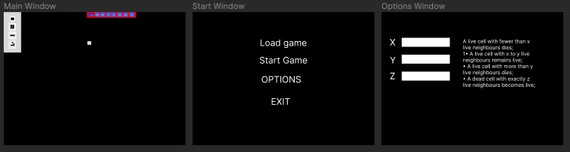Figure 2: Initial Design

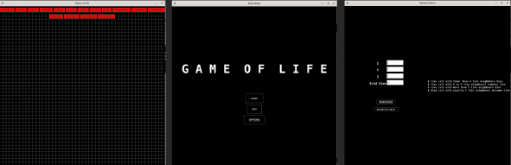Figure 3: Final GUI

Our main frame which is 1000x1000 pixels, includes a button panel with various functions. These include:
- Presets (different brushes)
- Start and stop
- Speed up and slow down
- Step
- Save and load game
- Exit
- Back to main menu
- Zoom in and zoom out
- Pan up, left, right and down

In the start menu, you can find start game, exit and options buttons. Clicking the ‘Options’ button opens a frame where the user can customise x, y and z values up to 8, and the grid size up to 1000 squares. We decided to set the maximum values for x, y and z to 8 because each cell has 8 neighbouring cells, and thus if it were set any higher then every cell would die. Furthermore, a pop-up explaining each hot-key is displayed by clicking the ‘Shortcut keys’ button in the options menu.

3.2 Hot-keys and buttons

During the design phase, we decided it was very important that the UI was as user-friendly as possible, and that the user should be able to do everything with the provided buttons or by using a combination of keys. This ensures that the player can enjoy the game and build their structures however is most comfortable.

Hot-keys:

- General Controls:
  - Space: Starts or stops the game.
  - Ctrl + M: Displays or hides buttons.
  - Ctrl + S: Saves the current state to a file.
  - Ctrl + O: Loads a saved game from a file.
  - Ctrl + Q: Exits the program.
  - Enter: Progresses the game by one step.
  - Escape: Sends the user back to the main menu.

- Panning Controls:
  - Up arrow: Pans up.
  - Left arrow: Pans left.
  - Right arrow: Pans right.
  - Down arrow: Pans down.

- Zooming Controls:
  - Equals: Zoom in
  - Minus: Zoom out

- Brush Selection:
  - 1: Dot
  - 2: Big dot (2x2 square)
  - 3: Dot eraser
  - 4: Big dot eraser
  - 5: Glider
  - 6: Twicker

3.3 Zooming and Panning:

Another design decision we made was to allow the user to pan and zoom throughout the grid. By doing so, our player has the capability to create massive grids while still being able to build meaningful structures. The user can zoom in and out using the mouse wheel or by using the provided hot-keys and buttons. Similarly, panning is possible through pressing the arrow keys, dragging the mouse with the right-mouse button down, or by clicking the pan buttons.

3.4 Cell building

An extra functionality we added was different types of brushes. These include an eraser brush, in both single square or 2x2 square form, which allows the user to delete any cells which were accidentally placed. We did this because it makes the improves the user experience by allowing the player to fix any errors without having to restart the game.

3.5 Design patterns

The Renderer class uses the Singleton pattern. Our reasoning for this was to ensure there is only one instance of the class, promoting global accessibility, centralised configuration, and resource management for the visual representation of the Game of Life grid. This pattern helps maintain consistency and avoids conflicts in managing graphical resources and user input.

4. Implementation

4.1 Implementation process
To streamline the implementation process, we documented our team workflow in the README.md found in the project repository. It outlines our approach to communication, including the use of branches, merging, pushing, and commits. This ensured that we could all effectively contribute to the project without causing too many compatibility and overlap issues.

For implementation, we split the workload into three rough categories – The game logic, the GUI and the extra functionality (save/load, presets etc.). We each took on one of these categories, which made sure that the workload was as equally split as possible. We worked well as a group, helping each other out if we had any struggles with our separate sections. There were no problems which we encountered which were particularly difficult, except for the bug we ran into during implementation specified in the next section.

4.2 Defect on border

When we create a grid, some of the bottom cells are covered from the user’s view point and can only be seen if the user zooms in very far and pans into the corner.
In Figure 4, on the next page, you can see a 50x50 grid. In the example. we clicked on the bottom right cell of the grid, and on the console output we can see that it’s actually cell number (50, 48).

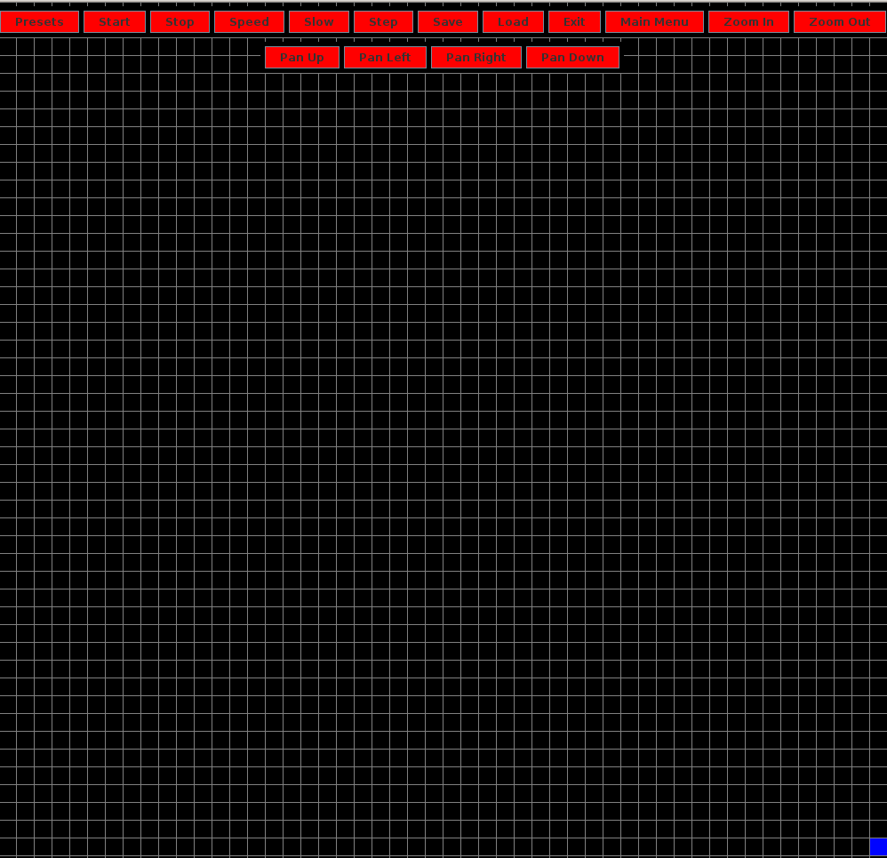Figure 4: Bottom right corner

5. Testing

Due to the complex nature of the program, manual testing was preferred over JUnit testing.
To test the logic of the program, a small pattern was drawn, and one cell was chosen as a point of reference (illustrated as an orange square below) to observe how the neighbouring cells’ statuses affect its status after one ‘step’.
All buttons, hot-keys and presets were also tested for expected functionality and all worked as expected. The testing of the saving, loading and drawing below were also replicated using hot-keys and yielded the same results as their graphical counterparts.
Temporary System.out.println() statements were also used extensively during development to check the functionality of new additions to the program and the control flow.

Testing... | Input(s) | Expected Output | Actual Output
1) Default x,y,z values  -No changes are made | X = 2  Y = 3  Z = 3  *DREW GLIDER in middle of grid* | Gilder moves along grid indefinitely under default values. Due to toroidal aspect, comes on opposite side of screen.  Println statement in Logic also will print x,y,z values | As expected;  In terminal:  2  3  3
2) Underpopulation with custom values  -Input X; so that neighbour number < X results in death | X = 4  Y= 5  Z= 5   | Orange cell (in this case all squares) will die | All cells die
3) Becomes alive  -Input Z; neighbour number = Z results in becoming alive | X=2  Y=3  Z=8   | Middle cell becomes  alive | As expected, Becomes alive  
4)Remains alive  -Between X and Y, cell should remain alive | X=2  Y=5  Z=3     | Orange cell remains alive | As expected, remains alive  
5) Overpopulation  -Input Y; neighbour number > Y, cell death | X = 2  Y = 4  Z = 3   | Orange cell dies | As expected, cell dies  
5) If condition to becoming alive was zero neighbours;  Z = 0 | X=2  Y=3  Z=0  *BLANK GRID* | All cells in grid become alive | Fully coloured grid
6) Underpopulation & Overpopulation  - X > Y | X = 4  Y = 2  Z = 2   | Orange cell will die | As expected, the cell dies  
7) Out of bounds input  -greater than 8 | X = 9  Y = 3  Z = 3 | Exception thrown, resulting in error message popup | As expected, a message pops up : “Enter an integer between 0-8"
8) Out of bounds input  -less than 0 | X = 2  Y = -1  Z = 3 | Same as above | As expected
9) Invalid input  -string input | X = 2  Y = 3  Z = foo | Same as above | As expected
10) Leaving text field blank ie invalid input | X = 2  Y =  Z = 3 | Exception thrown if enter key is pressed; otherwise once focus is lost, default value displayed in text field | As expected
11) Altering grid size | Grid Size = 100 | Grid of dimension 100 x 100 displayed when game started | Clicked the edge cells of the rendered grid to check the coords (MouseListener.mousePressed has println which prints out the coords) :  “Mouse Clicked: 0.0”  “Mouse Clicked: 99,95”
12) Invalid grid input | Grid Size = bar | Exception thrown, popup message | As expected, default grid size 50 still rendered:  Mouse Clicked: 0,0  Mouse Clicked: 49,47
13) Save pattern in default grid | 3x3 Square drawn in centre of grid orientated around 25,25 | New .gol file created of line length 50 | As expected, success statement printed to terminal:  “File created games/game3.gol.”
14) Save pattern of smaller grid | Grid Size = 10  Similar square drawn in centre | New .gol file created of line length 10 | “File created games/game4.gol.”
15) Save pattern of larger grid | Grid Size = 1000  W/ square drawn | New .gol file created of length 1000 | As expected + success statement printed
16) Load .gol file, previously saved | Grid Size = 50  Loaded game3.gol (size 50) | Previous pattern from test 13) displayed on grid in previous position | As expected, same coords
17) Load .gol file that has a different grid size | - Grid Size = 50  - Loaded game4.gol (Size 10)  -Loaded game5  (Size 1000) | -Pattern displayed in same coords (but will look smaller)  -pattern will not be displayed | As expected;  -smaller grid pattern displayed  -larger grid not displayed
18) Load non .gol file | Loaded text file  a.txt | Error message popup + print to stdout | As expected:  Printed “The file you've chosen is not .gol file.”
19) Speed up Button/ functionality | A glider was drawn and pressing speed up button numerous times until limit is hit. A println is added to Main.speedUp to observe the speed variable | Speed variable decreases by 10 each time button is pressed until reached limit message is printed. | In terminal:  90  80  70  60  50  40  30  20  10  You've reached the limit!  10
20) Slow down Button | Same as above but no limit enforced | ‘speed’ increments by 10 each time button is pressed | 110  120  130  140  150  Etc...

7. Critical Evaluation

In conclusion, our project meets all the functional requirements, being a working implementation of the Game of Life with a 50x50 toroidal grid and the ability to start, stop, slow down, speed up and move to the next step of the game. Furthermore, you can save a current game or load previous games and customise the settings of the game. We also have additional functionality including the ability to pan and zoom, while also featuring a user-friendly interface equipped with buttons and hot-keys.

The structured code enables easy scalability, providing confidence that the project can be expanded without anticipated issues. Furthermore, our program is relatively robust, as we are yet to encounter any game-breaking bugs, with the only one we were unable to solve is the defect border issue described in Section 7.1. Overall, we are very content with our submission.

Word count: 1990
Link to Git repository: /cs/group/cs1006-p2group15

8. Individual contribution report

I believe Yehor, Anngeni and I worked well as a group, communicating effectively throughout, and helping each other whenever it was necessary. Personally, I primarily contributed to the code by doing the majority of the GUI, including all of the button panels in the game, assigning the functionality for every button. I also wrote the code for the step functionality and hot-key, as well as the code for panning and zooming in and out with the keyboard. Finally, I put together the report for the submission, with the help of my group. Overall, I think we all contributed well to the project and we produced a project to be happy with.

