QMCO

Equity Research Update
  - Quantum Corporation (NASDAQ: QMCO) | Market-implied expectations, quality review and risks

Research date: October 12, 2026 | Price reference: October 9, 2026 close, $30.43
Fiscal year ends March 31. Q1 FY2027 = quarter ended June 30, 2026. Q2 FY2027 = quarter ended September 30, 2026.
Prepared for: ______________________ (private client / family office)
Prepared by: ______________________, Independent Advisor | Contact: ______________________
CONFIDENTIAL. For the named recipient only. Not for redistribution.

Rating: SELL, short-term HOLD possible | Price target: Under Review | Price: $30.43
Short-term holders: a HOLD is possible with a written exit rule, but in my view the risk is high compared with the reward. New money: not a buy at this price.
Scenario values per share: bear ~$5, base ~$10, bull ~$22, blue sky ~$45. Competitor multiples imply ~$10 to ~$25. These are reference points, not a price target.
Why: the price already assumes years of fast growth, with margins rising to competitor levels. In 16 months: eight senior leadership changes, heavy dilution, two restatements, weak controls and a pending lawsuit. Rivals are far larger. Even with the debt gone, I would sell.
The price target stays Under Review until the next two quarterly reports and updated company guidance.

Key facts
Item | Figure | Source
Share price / market cap | $30.43 / ~$1.20B (39.41M shares, up from 6.96M in Mar. 2025) | [2][23][33]
Enterprise value | ~$1.153B basic; ~$1.22B incl. in-the-money warrants | [23]; author calc.
52-week range / year to date | $4.19 - $35.65 / ~+372% | [24][42]
Q1 FY2027 revenue | $80.8M, +26% YoY (guided $75M ± $2M) | [1][6]
Q1 GAAP operating income / adj. EBITDA | $5.0M / $8.0M (adj. EBITDA guided $1.5M ± $1M) | [1][6]
Q1 operating cash flow / capex | $0.9M / $0.4M | [2]
Cash and restricted cash / debt (Jun. 30, 2026) | $54.6M / $0. No credit line since Aug. 2025 | [2]
Float / avg. daily volume | 31.66M shares reported (~25.3M excluding Dialectic’s 14.1M) / ~1.86M shares a day (20-day, Oct. 5) | [18][35]; author calc.
Short interest | ~3.12M shares (Sep. 30); ~9.9% of reported float, ~12% excluding Dialectic; ~1.7 days of average volume | [27][35]; author calc.
Q2 FY2027 guidance | Revenue $82M ± $2M; adj. EBITDA $6M ± $1M; non-GAAP EPS $0.12 ± $0.10. On Oct. 9 the company said it expects to meet or exceed. | [4][5]
Analyst price targets | $24 - $29 (two targets); average $26.50. All below the price. Lake Street ($24) was also a placement agent on the June share sale. | [8][24][25]

1. Investment summary
- The price is too high. Even if margins rise to the level of Quantum’s main competitors (median ~14%), the price needs fast growth for ten years: about 16% to 29% a year. Quantum has not shown that kind of growth in the history reviewed [6][7][35].
- Competitor multiples point lower too. At competitor median multiples, Quantum would be worth about $10 to $25 a share. It trades at about 57 times consensus forward earnings (63x to 75x on run-rate earnings), versus a competitor median of about 19 times [1][24][35].
- Results improved, but it is early. Q1 revenue rose 26% YoY and beat guidance. GAAP operating income was $5.0M versus a $12.6M loss. But growth starts from a weak base: the Q2 guide is only ~14% above two years ago [1][34].
- Shareholders paid for the repair. Debt went to zero, but the share count rose ~5.7x in 15 months, from 6.96M to 39.38M [2][33].
- Competition is much bigger. Dell, HPE, IBM and NetApp have 25 to 511 times Quantum’s revenue. IBM is also the main tape-drive supplier, and supply was flat for months as of August [3][5][35].
- Too many changes, and trust is not yet earned. Eight senior leadership changes in 16 months, including three in the finance chief role. Controls not effective in three straight reports. Two restatements. A pending securities class action [2][3][4].
- The team needs to prove it. The new management is promising. It should show several quarters of steady results, positive cash flow and fixed controls before the stock deserves this price.
- Why a short-term HOLD is possible. Much is changing at once. Q2 results (expected around Nov. 12), a permanent CFO and progress on controls will show more. Existing holders who accept high risk can wait for them with a written exit rule [4].
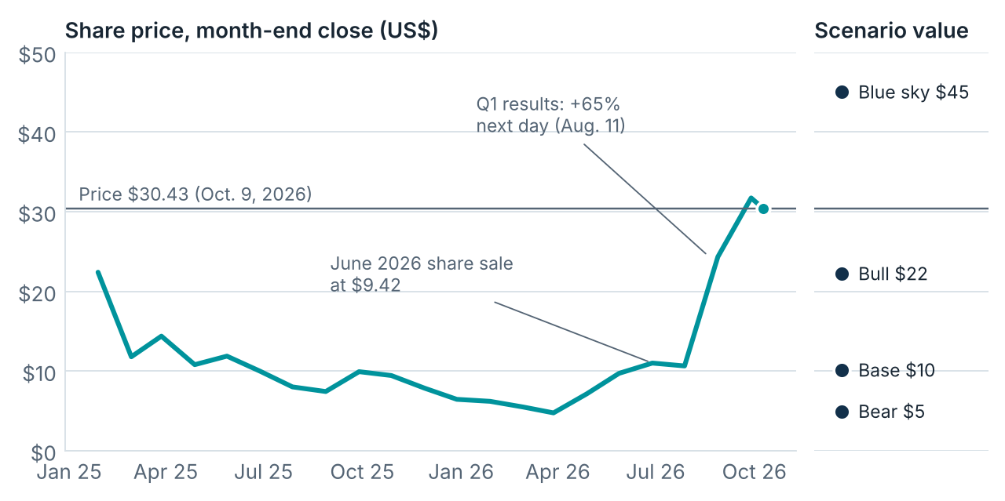
Figure 1. Share price (month-end close; the last point is the Oct. 9, 2026 close) and scenario values per share from section 3. Scenario values are not a price target. Sources: [42][43]; author’s model.

Pros and cons
Pros | Cons
Q1 revenue +26% YoY and above guidance ($75M ± $2M). Q2 guide ~+31% at midpoint; company expects to meet or exceed [1][4][5][6]. | Share count ~5.7x in 15 months (6.96M to 39.38M). Dialectic’s note converted at $5.194 per share; the June share sale priced at $9.42 [2][8][33].
Gross margin 39.3% vs. 35.3%. GAAP operating income $5.0M vs. -$12.6M [1]. | Key input (tape drives) comes from IBM, a competitor. Supply flat for months as of August [5][20].
Debt $0 at Jun. 30, vs. a $55.9M term loan plus a convertible note at Mar. 31. FY2026 interest expense of $21.6M largely removed [2][5][6]. | Controls not effective (Mar. 2025, Mar. 2026, Jun. 2026). Restatements in May 2024 and Aug. 2025 [2][3][14].
LTO capacity shipments +57% YoY in Q1 2026. Backlog at a record, per management (no dollar figure) [5][19]. | CFO terminated Oct. 9, no reason given. Three changes in the PFO role since Aug. 2025 [4][12][13].
Deferred revenue of $115.1M helps fund working capital [2]. | Q1 operating cash flow $0.9M vs. adj. EBITDA $8.0M. FY2026 operating cash outflow $37.9M [2][6].
LTO media royalties ($2.3M in Q1) rise with industry volume [2][3]. | Top five customers = 27% of FY2026 revenue; one customer >10% [3].
Experienced hires: COO ran Dell storage sales; PFO is a CPA with a controls background [4][10]. | No credit line since Aug. 2025; cash of $54.6M is the main buffer. Pending securities class action [2].

Why the stock rose, and why I would not buy yet
The stock is up about 372% this year. It jumped 65% in one day after the Q1 report, from $11.78 on Aug. 10 to $19.40 on Aug. 11 [43]. In my view it rose on good news and on fast growth in data storage. The table sets what buyers seem to expect next to what the evidence shows so far.
What buyers seem to expect | What the evidence shows so far
AI and data growth will lift tape demand for years. | LTO tape shipments rose 57% in Q1 2026. But they fell 9% in 2025, and grew only ~2% a year from 2021 to 2025 [19][40].
The turnaround is done. | One quarter of positive GAAP operating income ($5.0M). Q1 operating cash flow was only $0.9M. FY2026 operating cash outflow was $37.9M [1][2][6].
Debt-free means low risk. | Debt is gone. But the share count rose ~5.7x in 15 months, and there is no credit line [2][33].
Supply will open up and revenue will jump. | IBM drive supply was flat for months as of August. Management said it had not yet seen the turning point [5].
Big hyperscaler deals will keep coming. | One APAC deal was “well over eight figures.” The top five customers are 27% of revenue; one is over 10% [3][5].
New management will fix the company. | Promising hires. But the CFO was terminated about eight months after joining, and controls are still not effective [2][4][12].

2. Results, cash and the recapitalization
Metric | Q1 FY2027 | Q1 FY2026 | Change
Revenue | $80.8M | $64.3M | +26%
Gross margin | 39.3% | 35.3% | +3.9 pts
GAAP operating income (loss) | $5.0M | ($12.6M) | Turned positive
Adjusted EBITDA (non-GAAP) | $8.0M | ($6.5M) | Turned positive
GAAP net loss | ($155.3M) | ($17.2M) | Includes $157.7M noncash charges
Operating cash flow | $0.9M | ($16.9M) | Improved; thin vs. EBITDA

Sources: [1][2]. The GAAP loss includes a $129.7M loss on the convertible note’s fair value, a $16.3M warrant loss and an $11.7M debt-extinguishment loss [5].
Against guidance. In June the company guided Q1 revenue of $75M ± $2M and adjusted EBITDA of $1.5M ± $1M. It reported $80.8M and $8.0M. Both were above the top of the range [1][6].
Mix. Product revenue was $53.9M (66.7%), service and subscription $24.7M (30.5%) and royalties $2.3M (2.8%). Product drove ~99% of the YoY increase. Service and subscription fell ~1% YoY [2].
History. Revenue was $412.8M in FY2023 (as originally reported; FY2022-FY2023 were later restated), $274.1M in FY2025 and $279.6M in FY2026. The Q2 guide annualizes to ~$328M, still ~20% below FY2023 [3][6][7].
Weak base. Recent growth starts from a low point. Q2 FY2026 revenue was $62.7M, down from $71.8M a year earlier. So the Q2 FY2027 guide of $82M is ~31% above last year, but only ~14% above two years ago. Quarter to quarter, revenue went from $78.0M (Q4 FY2026) to $80.8M (Q1) to $82M guided (Q2). Management says drive supply limits shipments [1][5][6][34].
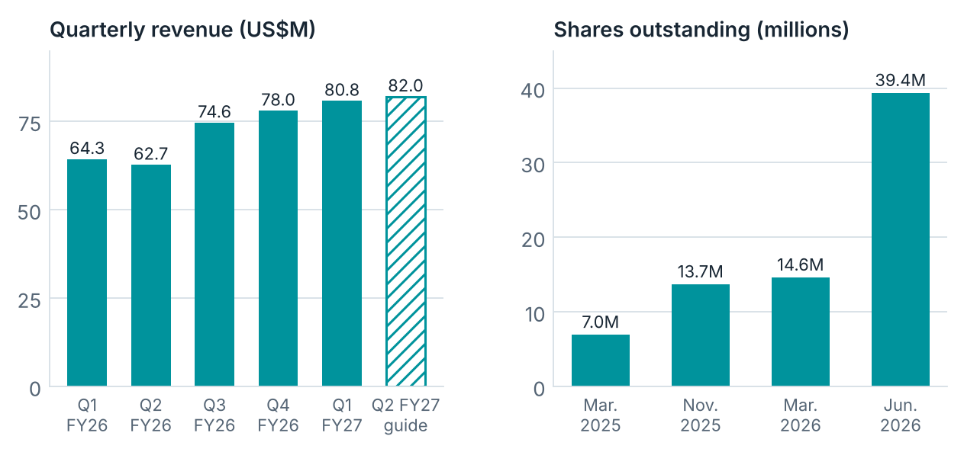
Figure 2. Quarterly revenue and shares outstanding. Q3 FY2026 revenue is derived from the FY2026 total; Q2 FY2027 is the guidance midpoint. Sources: [1][2][6][33][34].

Recapitalization (June 2026)
Item | Detail | Source
Debt at Mar. 31, 2026 | Term loan $55.9M principal ($54.8M carrying). Convertible note at $90.0M fair value; ~$52M of Dialectic’s term debt was exchanged into it (agreed Sep. 2025). Fair value includes the conversion right, so it is above the amount owed. | [2][6][36]
Private placement (PIPE) | 10.6M shares at $9.42; $100M gross, $94.6M net. Led by Two Seas and Oaktree | [2][8]
Note conversion (Dialectic) | ~14.1M shares at $5.194: 11.0M for ~$57.2M of principal and interest, plus 3.08M for future PIK and deferred interest. Issued Dec. 2025 at $10.00. By contract the price reset each quarter (floor $4.00; set by the lower of current price and 30-day average). $5.194 applied after Mar. 31, 2026. | [2][8][18]
Warrants (Dialectic) | ~2.76M shares at $5.194: a 2,653,308-share forbearance warrant (Sep. 2025, repriced Jun. 2026) plus a 105,911-share conversion warrant | [2][18]
Shares outstanding | 6.96M (Mar. 31, 2025); 14.64M (Mar. 31, 2026); 39.38M (Jun. 30, 2026); 39.41M at Aug. 6 | [2][33]
Equity line (SEPA) | Signed Jan. 2025: up to $200M over three years. ~7.5M shares sold (~$82.8M net) by Nov. 2025. Current status not confirmed | [33]
Credit line | PNC revolving line (up to $40M) terminated Aug. 13, 2025. None in place | [2]
Ownership | Dialectic 40.0% (16.86M shares incl. 2.76M warrants); its manager, John A. Fichthorn, is a director | [18]
Overhang | ~13.8M shares registered for resale. A six-month right of first refusal covers 25% of new equity (to Dec. 1, 2026 or the next financing) | [8][9]
Short interest | ~3.12M shares (Sep. 30, 2026); ~7.9% of shares outstanding; ~1.7 days of average volume | [27][35]

Read-through. The balance sheet is repaired, but shareholders paid for it. To match the EPS it would have earned on the March 2026 share count, Quantum now needs ~2.7x the earnings. Against March 2025 it needs ~5.7x. The $5.194 conversion price came from a contract reset in the note, not from the June talks [2]. Still, about $57M of Dialectic’s note (principal and interest) became 11.0M shares, and 3.1M more shares came as extra consideration. At $30.43 the 14.1M shares are worth about $429M. The warrants add about $70M of value. Dialectic’s manager, John A. Fichthorn, is a Quantum director, so these were related-party deals [2][18].
Liquidity. Cash was $54.6M at June 30. There is no credit line; the PNC line was terminated in August 2025. Non-cancelable purchase commitments were $142.6M. These are orders for inventory, not debt, but they will use cash as goods arrive. Deferred revenue of $115.1M (service paid in advance) helps [2].

3. Valuation: what the price implies
Method: market-implied expectations (Mauboussin and Rappaport). Step one, solve for the growth the price implies. Step two, find which value triggers (sales, costs, investments) are most likely to be revised. Step three, decide whether a revision is more likely up or down.
Margin assumption. I expect Quantum’s operating margin to rise as revenue grows. Q1 already showed this: non-GAAP operating costs fell 16% while revenue rose 26% [5]. Comparing with competitors, that expectation makes sense. So the model ties Quantum’s year-10 margin to what its main listed competitors earn today.
Company | Gross margin | Operating margin (last 12 months)
Quantum (last 12 months) | 37.8% | -0.4%
Quantum (Q1 FY2027) | 39.3% | 6.2%
HPE | 36.6% | 8.1%
Dell | 19.9% | 9.9%
IBM | 58.1% | 18.5%
NetApp | 70.6% | 26.0%
Median of the four competitors |  | ~14%

GAAP margins from StockAnalysis, checked Oct. 5-12, 2026 [1][35]. Seagate (34.7%) is left out because it makes hard drives and is not a direct rival. Quantum’s gross margin is close to HPE’s and far below IBM’s and NetApp’s.
Input | Assumption
Enterprise value | $1.153B [23]. About $1.22B if the 2.76M in-the-money warrants at $5.194 are included [2].
Starting revenue | $328M (Q2 guide midpoint x 4) [5]
Forecast period / discount rate | 10 years / 12% WACC (10% in the generous case)
EBIT margin | Rises evenly from 5% today to a competitor level in year 10. Main case: ~14%, the median of Dell, HPE, IBM and NetApp
Tax / reinvestment | 25% cash tax (0% in the generous case); sales-to-capital 2.0x
Free cash flow | FCFF(t) = Rev(t) x m(t) x (1 - tax) - [Rev(t) - Rev(t-1)] / 2.0, discounted at year end
Terminal value (year 10) | [Rev10 x (1+g) x m(T) x (1 - tax) - g x Rev10 / 2.0] / (WACC - g), with g = 3%

Result. Today’s enterprise value (~$1.15B) only makes sense if Quantum becomes a much larger company. With the margin rising to the competitor median (~14%), revenue must grow about 16% to 29% a year for ten years, depending on the inputs. That means year-10 revenue of roughly $1.4B to $4.1B, or about 5 to 14 times the ~$296M of the last 12 months.
Why so much growth? A company is worth its future cash profits, discounted back to today. Fast growth also uses cash first, for inventory and capacity. So most of the value has to come from the years after the company has grown. To support ~$1.15B today, Quantum must be much larger and profitable by year 10.
Including the in-the-money warrants, the growth needed rises slightly (about 30% a year with the report’s inputs). For context, Quantum’s revenue was $412.8M in FY2023 and $279.6M in FY2026 [6][7].
Author’s model, re-run for this report. It is simplified. Only verified warrants are counted; other stock awards would add more [2].

Stress tests: does the conclusion hold?
The table shows the yearly revenue growth needed for ten years to justify ~$1.15B at each competitor margin level. The report’s inputs use a 12% discount rate and 25% tax. The generous inputs use 10% and no tax, as if past tax losses cover all tax; ownership changes may limit their use [3].
Year-10 operating margin | Report inputs (12%, 25% tax) | Generous inputs (10%, no tax)
8% (HPE level) | ~59% | ~28%
14% (competitor median) | ~29% | ~16%
18.5% (IBM level) | ~22% | ~11%
26% (NetApp level) | ~15% | ~6%

Read the table this way. The higher the margin, the less growth Quantum needs. In my view, a margin between HPE’s and IBM’s is a fair expectation. In that range the price needs at least ~11% growth a year for ten years with the generous inputs, and 22% or more with the report’s inputs. Only a NetApp-level margin with the generous inputs works with modest growth. Starting from last-12-month revenue ($296M) instead of the Q2 guide x 4 would raise every figure. The conclusion holds: the price already includes a strong turnaround [1][6][7].

Which expectations could be revised?
Value trigger / factor | QMCO evidence | Likely revision
Sales: volume | LTO shipments +57% YoY in Q1 2026; record backlog; but IBM drive supply flat for months [5][19] | Up if supply ramps. Capped if not.
Sales: price and mix | Product 66.7% of revenue. CFO called Q2 margin guidance conservative because of large deals [2][5] | Mixed.
Costs: operating leverage | Non-GAAP opex $25.1M in Q1; guided to ~$27M in Q2 on R&D hiring and commissions [5] | Modestly up as revenue grows.
Costs: economies of scale | Buys drives from IBM, the last LTO drive maker; single contract manufacturer [3][20] | Limited.
Costs: cost efficiencies | Non-GAAP opex -16% YoY; interest expense removed [5] | Largely already realized.
Investments: efficiency | Capex <0.5% of revenue; deferred revenue $115.1M; purchase commitments $142.6M [2][5] | Mixed. Working capital rises in a ramp.

The sales-volume trigger (drive supply) has the largest revision potential. Even a full supply ramp must then be sustained for years to reach the implied path.

Scenario values per share
Scenario (yearly revenue growth / operating margin in year 10) | Year-10 revenue | Value per share (vs. $30.43) | Likelihood (qualitative)
Bear: 4% / 8% (supply tight; HPE-level margin) | $486M | ~$5 (-84%) | Plausible
Base: 10% / 14% (solid turnaround; competitor median) | $851M | ~$10 (-67%) | Most likely on current evidence
Bull: 18% / 18.5% (share gains; IBM-level margin) | $1.72B | ~$22 (-27%) | Possible; needs more proof
Blue sky: 22% / 26% (category leader; NetApp-level margin) | $2.40B | ~$45 (+48%) | Unlikely

Same model, 12% WACC and 25% tax for every scenario. Year-10 margins are tied to competitor levels [35]. Value per share = (enterprise value - $8.9M lease liabilities + $54.6M cash + $14.3M warrant proceeds) / 42.2M diluted shares; the bear case uses 39.41M basic shares because the warrants ($5.194) would not be used. Values are reference points, not a price target. Likelihoods are the author’s judgment, not probabilities [2].

Valuation against competitors
On sales, Quantum is priced close to its competitors. On earnings and cash profit, it is priced at two to three times their multiples, while its margins are lower [24][35].
Company | EV / Sales (12 mo.) | EV / EBITDA (12 mo.) | Forward P/E | Operating margin
Quantum (QMCO) | 3.9x | n.m. (~41x run-rate) | ~57x | -0.4% (Q1: 6.2%)
Dell (DELL) | 2.6x | 22.4x | 20.8x | 9.9%
HPE (HPE) | 2.7x | 16.2x | 15.8x | 8.1%
IBM (IBM) | 3.9x | 16.5x | 17.8x | 18.5%
NetApp (NTAP) | 6.0x | 21.2x | 23.9x | 26.0%
Median, four competitors | 3.3x | 18.8x | 19.3x | 14.2%
Seagate (STX), storage peer | 14.8x | 40.0x | 21.6x | 34.7%

StockAnalysis; prices at the Oct. 9, 2026 close; statistics checked Oct. 8-12 [24][35]. Quantum EV/Sales uses EV of ~$1.153B and revenue of $296.1M (author calc.). Quantum’s last-12-month GAAP EBITDA was $2.4M, so EV/EBITDA is not meaningful (n.m.). The run-rate uses adjusted EBITDA of Q1 ($8.0M) plus the Q2 guide ($6M), times two (~$28M) [1]. Competitor EBITDA is GAAP-based, so this comparison flatters Quantum. Seagate is not in the median.
P/E on different earnings bases. Quantum’s P/E depends heavily on which earnings you use. Over the last 12 months it lost money on both a GAAP and an adjusted basis, so a trailing P/E is not meaningful. On run-rate or forward earnings it is about 57x to 75x. Even the lowest of these is about three times the competitor median.
Earnings basis | Earnings used | EPS | P/E at $30.43
Last 12 months, GAAP | Net loss (incl. $157.7M of Q1 charges) | Loss | n.m.
Last 12 months, adjusted | Adjusted net loss of ~$11.2M | Loss | n.m.
Q1 FY2027 run-rate | $4.0M x 4 / 39.41M shares today | ~$0.41 | ~75x
Q2 FY2027 guide run-rate | $0.12 a quarter x 4 | ~$0.48 | ~63x
Consensus forward | Analyst estimates (StockAnalysis) | ~$0.54 | ~57x
Competitor median, forward | Dell, HPE, IBM, NetApp |  | ~19x

Adjusted net income (loss) by quarter: Q2 FY2026 -$7.1M, Q3 FY2026 -$4.9M, Q4 FY2026 -$3.1M, Q1 FY2027 +$4.0M [1][6][34][44]. Quantum reported Q1 adjusted EPS of $0.18 on 22.0M weighted shares, because most of the new shares were issued in June. On today’s 39.41M shares the same profit is ~$0.10 a share. The P/E-based value below uses the consensus figure, the most favorable to Quantum.
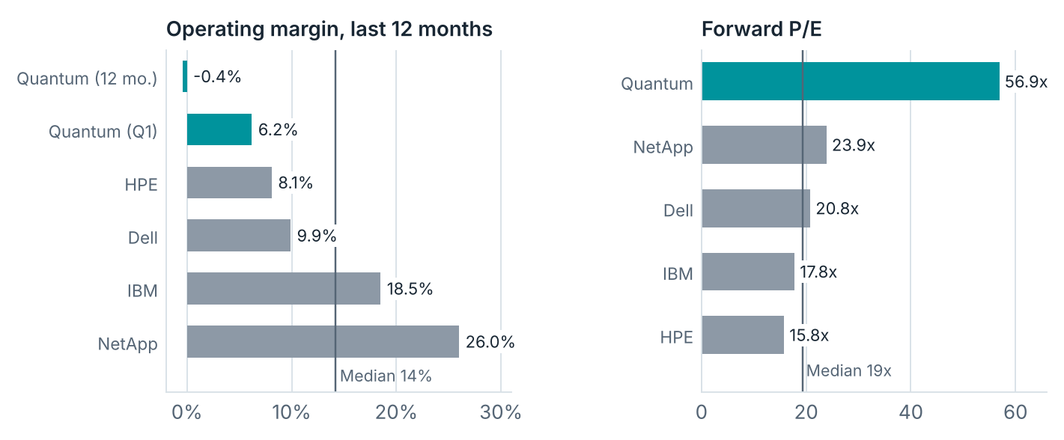
Figure 3. Operating margin (GAAP, last 12 months) and forward P/E: Quantum against its four main listed competitors. Sources: [1][24][35].
What competitor multiples would imply. If Quantum traded at the competitor medians, its shares would be worth about $10 to $25. Every method gives a value below today’s price.
Method | Competitor median | Quantum figure used | Value per share | vs. $30.43
EV / Sales | 3.3x | Revenue, last 12 months: $296.1M | ~$25 | -19%
EV / EBITDA | 18.8x | Run-rate adj. EBITDA: ~$28M | ~$14 | -54%
Forward P/E | 19.3x | Forward EPS implied by consensus: ~$0.54 | ~$10 | -66%

Cross-check only, not a price target. Enterprise values are converted to per-share values the same way as the scenarios. Forward EPS = $30.43 / 56.9x forward P/E [24][35].

4. Market size, competition and substitution

Market size
How big is the market? Estimates vary widely, because sources count different things (drives, media, libraries, services). Allied Market Research put the tape storage market at $4.31B in 2019, growing 7.8% a year to $9.42B by 2030. Research and Markets puts it at $7.6B in 2025, growing 10% a year to $17.9B by 2034. Both are paid industry reports, and their methods are not public. Allied’s own growth rate gives about $6.8B for 2025. So a working range for 2025 is about $6.8B to $7.6B, with forecasts of 8% to 10% growth a year (author calc.) [38][39].
How fast is volume growing? LTO tape capacity shipped rose from 105 EB in 2020 to 160.3 EB in 2025, about 9% a year. But most of that came in 2021 (+40%). From 2021 to 2025 the rate was only about 2% a year, including a 9% drop in 2025. An IDC analyst linked the 2023 growth mainly to denser cartridges, not to many new buyers. Q1 2026 was +57% YoY. One strong quarter is not yet a trend [19][40][41].
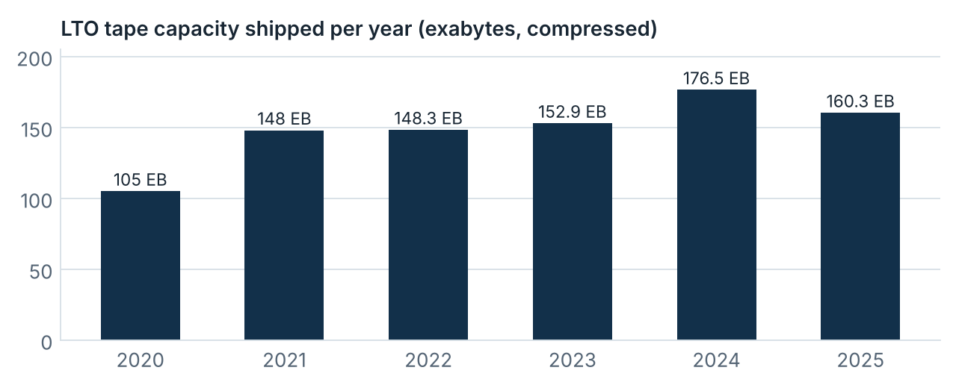
Figure 4. LTO tape capacity shipped per year (compressed). Q1 2026 was +57% YoY. Sources: [19][40][41].
Quantum’s share. Quantum does not report tape revenue on its own. In FY2026 its secondary storage revenue (Scalar tape, DXi backup and ActiveScale object storage) was about $101M, devices and media about $41M, and royalties $8.0M (author calc. from 10-K growth figures) [3]. Even if all ~$150M were tape-related, that is only about 2% of the market range above. Quantum is one of three LTO technology providers, with HPE and IBM, which earns it royalties on LTO media. IBM is reported to be the last maker of LTO drives [3][19][20].

Competition
Competition is much bigger. Quantum had about $296M of revenue in the last 12 months. NetApp’s revenue is about 25 times larger. HPE’s is about 141 times, IBM’s about 233 times and Dell’s about 511 times. These rivals have far more money for research, sales and pricing. IBM also makes the tape drives Quantum depends on. Even so, Quantum’s shares trade at about 57 times expected earnings, against about 16 to 24 times for the larger companies [3][24][35].
Company | Market cap | Revenue, last 12 months | Times Quantum’s revenue
Quantum (QMCO) | $1.20B | $296M | 1x
Dell (DELL) | $372.62B | $151.2B | ~511x
HPE (HPE) | $97.52B | $41.87B | ~141x
IBM (IBM) | $213.99B | $69.1B | ~233x
NetApp (NTAP) | $46.58B | $7.39B | ~25x
Seagate (STX) | $178.05B | $12.2B | ~41x

StockAnalysis data at the Oct. 9, 2026 close [23][35]. Quantum’s last-12-month revenue ($296.1M) matches the sum of its filed quarters: $62.7M + $74.6M + $78.0M + $80.8M for Q2 FY2026 to Q1 FY2027 [1][6][34]. Seagate makes hard drives; it is shown as a storage peer, not a direct rival.
IBM dependence. On the August call the CEO named IBM as the primary tape-drive supplier and said Quantum was “still not getting adequate supply” [5]. IBM is reported to be the last LTO drive manufacturer [20]. The 10-K lists IBM as a competitor in tape and in primary and object storage [3]. IBM also sells a tape library aimed at hyperscalers [21]. A rival’s output therefore sets part of Quantum’s revenue ceiling.
Segment | Main competitors | Quantum position
Tape libraries (Scalar) | IBM, Spectra Logic (private), HPE; BDT and others at entry/OEM level | Core franchise; installed at the largest hyperscalers [3]
Object storage (ActiveScale) | Dell, NetApp, IBM and other enterprise vendors | Small share; seven-digit enterprise deals growing [3][5]
Backup appliances (DXi) | Dell, HPE, Veritas | Legacy line [3]
File storage (StorNext, Myriad) | Dell, NetApp, IBM and others | Niche; strongest in media and entertainment [3]

Cloud substitution. The 10-K calls disk backup and cloud storage indirect alternatives to tape [3]. AWS lists S3 Glacier Deep Archive at $0.00099 per GB-month (~$12 per TB-year) in US East, with a 180-day minimum and 12-48 hour retrieval [22]. The 10-K describes hyperscalers as the largest users of hierarchical storage architectures [3]. So a move to cloud archive can shift tape demand from many enterprises to a few hyperscale buyers. That raises buyer concentration and pricing pressure (author’s analysis).
Customers. The top five customers were 27% of FY2026 revenue, up from 21% in FY2025. One customer exceeded 10% and is not named [3]. One APAC hyperscaler deal in Q1 was “well over eight figures” [5]. Management does not break out bookings by product or customer type [5].

5. Management, governance and controls
Too many changes. Since June 2025 Quantum has had eight senior leadership changes: a new CEO and Chair (Jun. 2025), three changes in the finance chief role (Aug. 2025, Feb. 2026, Oct. 2026), and a new chief accounting officer, CIO and COO (Sep. 2026). That is a lot of change in 16 months for a company of about 490 employees. New teams need time to show results [3][4][10][11][12][13][15].
Date | Event | Src.
Jan. 2025 | Equity line (SEPA) signed: up to $200M of stock over three years | [33]
Apr. 2025 | Dialectic buys Blue Torch’s $51M of term debt; John Fichthorn rejoins the board | [17]
Jun. 2, 2025 | Hugues Meyrath (director since 2022) succeeds CEO Jamie Lerner. Donald J. Jaworski becomes Chair | [15][16]
Aug. 2025 | Non-reliance on Q3 FY2025 statements (Aug. 8; revenue -$3.9M). PNC credit line terminated (Aug. 13). CFO Lewis W. Moorehead resigns (last day Aug. 18); CAO Laura A. Nash also named PFO | [2][13][14]
Sep. 29, 2025 | Debt restructuring agreed: ~$52M of Dialectic’s term debt to be exchanged into convertible notes; Dialectic receives a warrant for 2,653,308 shares | [36]
Dec. 18, 2025 | Convertible note issued to Dialectic; $10.00 initial conversion price with quarterly resets | [2][8]
Feb. 2, 2026 | William H. White appointed CFO | [12]
Jun. 1-4, 2026 | PIPE at $9.42; note converted at $5.194 (after contract resets); term debt repaid | [2][8]
Sep. 2026 | Hiral A. Patel named CAO (Sep. 1); ADM product launched (Sep. 8); Mike Heuer CIO (Sep. 14); director James C. Clancy becomes COO and leaves the board and Audit Committee (Sep. 28) | [4][10][11][37]
Oct. 9, 2026 | White terminated, no reason given; Patel becomes PFO. Audit Committee membership changed. 10-Q expected on time; Q2 expected to meet or exceed guidance | [4]

Person / role | Background (as disclosed)
Hugues Meyrath, CEO | Western Digital (1994-99); Quantum business development (2002-03); Brocade (2003-09); Juniper (2009-12); EMC/Dell (2012-17); ServiceChannel CPO (2017-22, sold to Fortive). Quantum director from Sep. 2022 [16]
James C. Clancy, COO | Dell President of Global Storage Sales; Dell EMC SVP Global Sales, Data Protection; Quantum director ~1 year [10]
Hiral A. Patel (38), CAO and PFO | CPA. EY 2011-20; VeriFone 2020-24; IKEA Retail VP Controller 2024-25; Pep Boys CAO Oct. 2025-Jun. 2026. About five weeks at Quantum when named PFO [4]
Mike Heuer, CIO | CIO at Legence (Blackstone portfolio); head of global IT at Blackhawk Network (ERP and CRM rollouts) [11]

Controls and litigation. Internal control over financial reporting was not effective at March 31, 2025, March 31, 2026 and June 30, 2026 [2][3]. In plain terms, the company’s own checks on its numbers have weaknesses serious enough that errors could slip through. The August 2025 restatement involved service and subscription revenue timing and standalone selling prices [14]. A securities class action (Lee v. Quantum, D. Colo.; filed Sep. 4, 2025; class period Nov. 15, 2024 - Aug. 18, 2025) is pending. The motion to dismiss was undecided at June 30. Derivative suits are stayed [2]. Allegations are not findings.
Insiders. The only insider trade found in 2026 was a sale of 260 shares at $10.51 on July 2 by Laura A. Nash, then CAO. No insider purchases in the past 12 months [28].

6. Risks
Downside risk | Evidence | What it would hit
Drive supply stays tight | Supply flat for months as of August [5] | Revenue and growth path
Much larger competitors | Dell, HPE, IBM and NetApp have 25-511x Quantum’s revenue; IBM also supplies drives [3][5][35] | Pricing, market share, margins
Customer concentration | Top five 27%; one >10% [3] | Quarterly revenue and margin
Reporting and controls | Three ineffective-control reports; new PFO [2][3][4] | Filing timeliness; credibility
Dilution | Share count ~5.7x in 15 months; equity line may still be available; right of first refusal on new equity [2][8][33] | Per-share value
No credit line | Revolver terminated Aug. 2025; cash $54.6M; purchase commitments $142.6M [2] | Liquidity if growth stalls
Share overhang | ~13.8M shares registered for resale; Dialectic may distribute to its LPs under lock-up terms [9][18] | Price pressure
Litigation | Class action pending; derivative suits stayed [2] | Cost; management time
Cloud substitution | Cloud archive is an indirect alternative [3][22] | Enterprise tape demand; pricing
Sentiment reversal | ~+372% YTD; above all published targets; forward P/E ~57x vs. ~16-24x for large peers [24][35] | Multiple

Upside risk (to a cautious view) | Evidence
IBM supply ramp | IBM signaled higher production in the second half; no inflection by August [5]
Takeover | A ~40% holder could support a sale [9][18]
Short squeeze | ~3.12M shares short, ~1.7 days of average volume; Dialectic holds ~36% of shares outstanding [18][27][35]
Tape cycle | LTO shipments +57% YoY in Q1 2026 [19]
ADM traction | Launched Sep. 2026; no revenue data yet

7. Decision and monitoring
- Rating: SELL. At about $30 the stock is overpriced. Even with the debt gone, I would sell.
- Price target: Under Review. I will set a target after the next two quarterly reports and updated company guidance give a clearer picture. The scenario values and competitor multiples in section 3 are reference points, not a target.
- Short-term HOLD is possible. A holder who accepts high risk can hold into the next report with a written exit rule, based on the negative signals in the table below. In my view the risk is high compared with the reward.
- New money: not a buy at this price.
- Watch, then decide. The new management is promising. I will follow the next several quarters. I would consider buying only after the positive signals below show up.
Checkpoint | Timing | Positive signal | Negative signal
Q2 FY2027 results and 10-Q | Likely mid-Nov. 2026 (est. Nov. 12; prior year Nov. 13, 2025) | Revenue at or above $84M; gross margin at or above 39%; operating cash flow above $5M; backlog quantified | Revenue at or below $82M; gross margin below 37%; late filing; new weakness; equity raise
Q3 FY2027 | Likely Feb. 2027 | Higher drive supply; revenue above $90M; second quarter of positive free cash flow | Supply flat; receivables and inventory outrunning cash
Controls | FY2027 10-K (~Jun. 2027) | Weaknesses remediated; permanent CFO | Still ineffective; another restatement
Litigation | Ongoing | Motion to dismiss granted | Motion denied
Capital | Any time | No new equity | Dilutive raise; insider or PIPE selling

Thresholds are the author’s, set relative to company guidance [5].
Holder | Suggested approach
Private client, gain held 12 months or less | Sell, or hold short term with a written exit rule. Compare the tax saved by waiting with the price risk.
Private client, gain held more than 12 months | Sell.
Private client, position >5% of liquid wealth | Sell the oversized part first, whatever the view.
Family office | No new investment. Sell existing holdings, or hold short term within the opportunistic-sleeve limit with a written exit rule. Record the rationale for the investment committee. Governance flags (controls, restatements, CFO exit) will fail many policy screens.

Turnaround cross-check (Peter Lynch). Lynch’s rule, paraphrased: sell a turnaround once it has turned around and everyone knows it. QMCO is up ~372% this year and trades above all published analyst targets [24][26]. Run-rate adjusted earnings give ~63x (Q2 guide) to ~75x (Q1 profit on today’s 39.41M shares) earnings, against ~26%-31% near-term revenue growth [1][5]. That is a growth-stock multiple on a company that has not yet proven sustained growth.
Bottom line
The business is improving, and the new team is promising. But the price already assumes a big, lasting turnaround that the company has not yet proven.
Too many changes, heavy dilution, weak controls, a pending lawsuit and much larger competitors make the risk too high for the reward. Scenario values and competitor multiples both point below today’s price. The stock is overpriced at about $30. Even without debt, I would sell. A short-term hold is possible only with a written exit rule.
Price target: Under Review until the next two quarterly reports and updated guidance. I would reconsider buying only after steady results and better trust.

Appendix A. Fisher’s 15 points
Point (paraphrased) | Verdict | Evidence
1. Market potential for sizable sales growth | Partial | LTO +57% in Q1 2026; record backlog. But 2025 LTO shipments -9%; Quantum revenue $412.8M (FY23) to $279.6M (FY26) [5][6][7][19]
2. Determination to develop new products | Partial | ADM launched Sep. 8, 2026; R&D hiring is the main opex increase. R&D cut 24.5% to $23.5M in FY2026. No ADM revenue data [3][5][37]
3. Effective R&D for its size | Fail | R&D ~8% of revenue vs. far larger rivals. Does not make the tape drive. 166 U.S. patents [3]
4. Above-average sales organization | Partial | Q1 beat; deals >$1M rose sharply; Avnet partner; Clancy hire. S&M $52.0M = 18.6% of FY26 revenue for +2% growth [5][6][10]
5. Worthwhile profit margin | Fail | Q1 GAAP operating margin 6.2% vs. 8%-26% for main competitors. FY2026 GAAP net loss $101.0M; operating cash outflow $37.9M [1][6][35]
6. Actions to keep or improve margins | Partial | Opex -16% YoY; interest removed. Q2 EBITDA guide steps down; IBM supplier power [5]
7. Labor and personnel relations | Unproven | ~490 employees in 18 countries after restructurings. No attrition data found [3]
8. Executive relations | Fail | New CEO (2025); PFO role changed three times since Aug. 2025; CAO replaced; new COO and CIO [4][12][13][15]
9. Depth of management | Fail | Most executives have weeks to ~16 months at Quantum. PFO ~5 weeks when named [4]
10. Cost analysis and accounting controls | Fail | Controls not effective in three straight reports; restatements in May 2024 and Aug. 2025 [2][3][14]
11. Industry-specific competitive clues | Partial | LTO royalties; hyperscaler installed base. IBM controls drive supply; sole-source parts; top five customers 27% [3][5]
12. Long-range view of profits | Partial | Accepts lower Q2 EBITDA to rebuild R&D. Recent history is survival financing [5]
13. Growth without heavy dilution | Fail | Shares 6.96M to 39.4M in 15 months, via an equity line, a share sale and a note conversion. Commitments $142.6M vs. cash $54.6M. A right of first refusal on new equity is in place [2][8][33]
14. Candor in bad times | Partial | No backlog dollars or bookings mix; no reason for CFO exit. Did disclose restatements and pre-announce Q2 [4][5]
15. Unquestioned integrity | Unproven | No finding of wrongdoing; Aug. 2025 8-K: no indication of fraud. Two restatements; pending class action; a director’s fund converted at $5.194 (contract reset) vs. the $9.42 PIPE [2][8][13]

Score: 0 pass, 7 partial, 6 fail, 2 unproven
Points 8, 9, 10 and 15 (executives, depth, controls, integrity) are central to Fisher’s method. QMCO fails or is unproven on all four. That argues for caution: sell, or hold only while watching whether management and controls improve. Scores use public information only; no customer, supplier or employee interviews were done.

Appendix B. Key terms in plain language
Term | Meaning
GAAP | The official US accounting rules. GAAP figures are the formal reported numbers.
Adjusted EBITDA | Profit before interest, taxes, depreciation and some one-off or noncash costs. A rough view of cash earnings. The company defines it, so it is not a GAAP figure.
Enterprise value (EV) | Market value of the shares, plus debt, minus cash. Roughly the price to buy the whole business.
EV / Sales, EV / EBITDA | Enterprise value divided by revenue or by EBITDA. Lower means cheaper for each dollar of sales or cash profit.
Market-implied expectations | Instead of guessing a value, ask what growth and profit the current price already assumes.
Discount rate (WACC) | The yearly return investors demand. A higher rate means future profits are worth less today.
Forward P/E | Share price divided by expected earnings per share for the next year.
Run-rate | A recent quarter’s figure multiplied by four to estimate a full year.
Price target: Under Review | No target is set for now. One will be set when key information arrives.
Dilution | When a company issues new shares, each existing share owns a smaller part of the company.
PIPE | A private sale of new shares to selected investors.
Convertible note | A loan the lender can swap for shares at a set price.
Equity line (SEPA) | An agreement that lets the company sell new shares to an investor over time.
Internal controls (ICFR) | The company’s own checks that keep its financial reports accurate. “Not effective” means weaknesses serious enough that errors could slip through.
Restatement | Correcting financial statements that were already published because they were wrong.
Exabyte (EB) | One billion gigabytes. Used to measure tape capacity shipped.
Short interest / float | Shares sold short by investors who expect a fall / shares available to trade freely.

Sources and disclosures
[1] Quantum Corporation, “Reports Fiscal First Quarter 2027 Financial Results”. Aug. 10, 2026. Link
[2] Quantum Corporation, Form 10-Q, quarter ended June 30, 2026. Link
[3] Quantum Corporation, Form 10-K, fiscal year ended March 31, 2026. Link
[4] Quantum Corporation, Form 8-K (CFO termination; PFO appointment; preliminary Q2 statement). Oct. 9, 2026. Link
[5] Quantum Corporation, Q1 FY2027 earnings call transcript (The Motley Fool). Aug. 2026. Link
[6] Quantum Corporation, fiscal Q4 and full-year 2026 results (8-K Ex. 99.1). Link
[7] Quantum Corporation, fourth-quarter and fiscal 2023 results. Jun. 2023. Link
[8] Quantum Corporation, “Announces Equity Financing to Strengthen Balance Sheet”. Jun. 2, 2026. Link
[9] Quantum Corporation, Rule 424(b)(3) resale prospectus. Jul. 2026. Link
[10] Quantum Corporation, Form 8-K (James C. Clancy appointed COO). Sep. 28, 2026. Link
[11] StorageNewsletter, “Quantum Appoints Mike Heuer as Chief Information Officer”. Sep. 2026. Link
[12] Quantum Corporation, CFO appointment of William H. White (8-K Ex. 99.1). Feb. 2, 2026. Link
[13] Quantum Corporation, Form 8-K (CFO Lewis W. Moorehead resignation). Aug. 2025. Link
[14] Quantum Corporation, Form 8-K (non-reliance on Q3 FY2025 statements). Aug. 8, 2025. Link
[15] Quantum Corporation, “Announces Leadership Changes” (8-K Ex. 99.1). Jun. 2, 2025. Link
[16] Blocks & Files, “Why did Hugues Meyrath come back to Quantum?” Oct. 10, 2025. Link
[17] Quantum Corporation, Dialectic purchase of $51M of term debt (Business Wire). Apr. 2025. Link
[18] Schedule 13D/A (Amendment No. 3), Dialectic Technology SPV LLC and John Fichthorn. Jun. 8, 2026. Link
[19] Blocks & Files, LTO capacity shipments. Sep. 4, 2026. Link
[20] heise online, IBM as the last manufacturer of LTO drives. Link
[21] Blocks & Files, IBM Diamondback tape library. Oct. 20, 2022. Link
[22] Spendark, S3 storage class pricing (AWS list prices). Aug. 8, 2026. Link
[23] StockAnalysis, QMCO market capitalization and enterprise value. Observed Oct. 9, 2026. Link
[24] StockAnalysis, QMCO overview (52-week range, forward P/E, analyst target). Observed Oct. 10, 2026. Link
[25] MarketBeat, “Quantum Leaps: Debt-Free as AI Storage Demand Accelerates”. Aug. 14, 2026. Link
[26] GuruFocus, QMCO expects to meet or exceed guidance (headline says Q3; this is fiscal Q2). Oct. 9, 2026. Link
[27] Equibles, QMCO short interest (FINRA), settlement Sep. 30, 2026. Link
[28] InsiderTrades, QMCO insider transactions. Observed Oct. 2026. Link
[29] Dell Technologies, Q2 FY2027 results and guidance. Sep. 1, 2026. Link
[30] IBM, Q2 2026 results and full-year expectations. Jul. 22, 2026. Link
[31] NetApp, Q1 FY2027 results and guidance. Sep. 2, 2026. Link
[32] Seagate Technology, FY2026 results and Q1 FY2027 outlook. Jul. 2026. Link
[33] Quantum Corporation, Form 10-Q, quarter ended Sep. 30, 2025 (share count, equity line). Link
[34] Quantum Corporation, “Reports Fiscal Second Quarter 2026 Financial Results”. Nov. 13, 2025. Link
[35] StockAnalysis, statistics for QMCO and peers: market cap, EV, revenue, margins, EV/Sales, EV/EBITDA, forward P/E, float, volume. Prices at Oct. 9, 2026 close; statistics checked Oct. 5-12, 2026. QMCO | HPE | DELL | IBM | NTAP | STX
[36] StorageNewsletter, “Quantum Enters into Definitive Agreement with Dialectic and Other Lenders to Restructure Term Debt”. Sep. 29, 2025. Link
[37] Quantum Corporation, “Introduces Autonomous Data Management”. Sep. 8, 2026. Link
[38] Allied Market Research, “Tape Storage Market” (press release; $4.31B in 2019, $9.42B by 2030, 7.8% CAGR). Link
[39] Research and Markets, “Tape Storage Market Outlook” ($7.6B in 2025, $17.9B by 2034, 10% CAGR). Oct. 2025. Link
[40] Business Wire, “LTO Tape Capacity Shipments Reach New Record In 2021” (105 EB in 2020; 148 EB in 2021). Apr. 19, 2022. Link
[41] TechTarget, “LTO tape shipments set another capacity record” (148.3 EB in 2022; 152.9 EB in 2023; IDC comment). Jun. 7, 2024. Link
[42] Digrin, QMCO monthly price history. Observed Oct. 2026. Link
[43] StockAnalysis, QMCO daily price history. Observed Oct. 2026. Link
[44] Quantum Corporation, “Reports Fiscal Third Quarter 2026 Financial Results” (8-K Ex. 99.1). Feb. 17, 2026. Link
Methods credited: market-implied expectations (Michael J. Mauboussin and Alfred Rappaport); 15-point quality review (Philip A. Fisher); turnaround cross-check (Peter Lynch). All paraphrased.

Important disclosures
Purpose. Prepared by [Name] for [Client / Family Office] for discussion. Confidential. Not to be shared without the author’s consent. Not an offer or solicitation to buy or sell any security.
Rating definitions. SELL: the author expects the stock to do worse than the broad market over the next 12 months; reduce or exit. Short-term HOLD possible: existing holders may wait for a named event, such as the next quarterly report, with a written exit rule; do not add. HOLD: in line with the market. BUY: better than the market. Price target Under Review: no target is set while key information is pending.
Analyst certification. [Confirm before use.] The views in this report accurately reflect the author’s personal views about the company and its securities. No part of the author’s pay is tied to the specific views in this report.
Advisory status. [Insert regulatory status and whether this report is provided under a written advisory agreement.] Otherwise this is general research, not a personalized recommendation.
Conflicts. [Disclose holdings in QMCO by the author, family or clients, and how the author is paid for this report.]
Information. Public information as of October 12, 2026, from sources believed reliable but not guaranteed. No material non-public information. No contact with management. Scenario values and competitor-multiple values are illustrations, not forecasts or price targets. Price target: Under Review. Not tax or legal advice.
Risk. QMCO is a volatile small-cap stock. Investors can lose some or all of their investment.

