Embedded Zero-Knowledge Authentication

Project submitted by:
Yosi Schlakman - 213661002
Yehoshua Gruenspecht – 332521103



Computer Science, JCT, Fall, 2021
Instructor: Prof. Arie Henel

Table of Contents
Contents
Table of Contents 2
Abstract 3
Introduction 4
Authentication 4
The Problem With Simple Authentication 4
Zero-Knowledge Authentication 5
Feige-Fiat-Shamir Identification Scheme 6
Implementation 8
Overall 8
Security 8
Future Improvements 8
Conclusion 9
Acknowledgments 9
Appendix 10

Abstract
As we all know, authentication is a key component in software security. The most common way to authenticate a person or machine is via password that only the one being authenticated should know. However, if there were to be an eavesdropper, this password can easily be heard and anyone can now be falsely authenticated. We wish to solve this problem by authenticating without revealing the password. This is called “Zero-knowledge authentication”. In the following project we researched to topic of Zero-knowledge authentication and created an embedded system that implements the Feige-Fiat-Shamir method for Zero-knowledge authentication. We will prove that our system works as an authentication system and that it fulfils the criteria for being Zero-knowledge.

Introduction

Authentication
In software security, authentication is when we ask the question: “Are you who you say you are?” to be sure we are communicating with the right person or machine. Peggy can authenticate herself in a number of ways.
- Something Peggy knows
This can for example be a password that only Peggy knows therefore if Peggy tells Victor the password, Victor will know for sure that he’s talking to Peggy. Of course it can’t be this simple as we will see later.

- Something Peggy has such as a physical key or magnetic chip.

- Something Peggy is. For example, biometrics, fingerprint, face ID and even handwriting.
Authentication can be man-to-machine or machine-to-machine. In our project we will be dealing with machine-to-machine authentication. We will connect a Tiva Launchpad to a PC via serial and run an authentication protocol where the Tiva Launchpad proves it is part of a group that can communicate with the PC by knowing something only a member of the group will know.

The Problem With Simple Authentication
As we already stated, Peggy can authenticate herself by proving she knows something only a member of the group with access would know. The simplest way to do so would be to simply tell said secret to Victor and Victor will know if it is correct or not.
This method is problematic because if Eve were to eavesdrop while Peggy revealed her secret to Victor, Eve now knows Peggy’s secret and will be able to convince Victor that she is Peggy and therefore has all of Peggy’s capability’s that Eve may not have otherwise.
One possible solution is to use a One Time Password. In the case of an OTP eavesdropping is useless because the password will change next time it needs to be used. The problem with OTP is it isn’t easy and cheap for the client. There are other solutions such as the many challenge-response authentication protocols however, in these protocols, the password stays the same every time and can be deciphered and therefore still vulnerable. Another disadvantage is that all of the encrypting and decrypting takes time.

Zero-Knowledge Authentication
In the following project, we will use Zero-knowledge proof to solve the problem with simple authentication stated above.
Zero-knowledge authentication is where Peggy authenticates herself by proving to Victor that she knows a secret only she should know without revealing the secret to Victor. This can be done by Victor asking Peggy a series of questions, that by answering correctly consistently, prove that Peggy knows the secret. For example, the Two Balls and Color Blind Friend: Imagine your friend is red-green colour-blind (while you are not) and you have two balls: one red and one green, but otherwise identical. To your friend they seem completely identical and he is sceptical that they are actually distinguishable. You want to prove to him they are in fact differently-coloured, but nothing else; in particular, you do not want to reveal which one is the red and which is the green ball.
Here is the proof system. You give the two balls to your friend and he puts them behind his back. Next, he takes one of the balls and brings it out from behind his back and displays it. He then places it behind his back again and then chooses to reveal just one of the two balls, picking one of the two at random with equal probability. He will ask you, "Did I switch the ball?" This whole procedure is then repeated as often as necessary.
A Zero-knowledge technique must satisfy three conditions:

- Completeness: If this statement is true, the honest verifier will always be convinced of this fact by an honest claimant.
- Soundness: If the statement provided by the claimant is false, no cheating claimant will be able to convince the honest verifier that it is actually true.
- Zero-knowledge: If the statement is true, no cheating verifier can learn anything other than this property. This is proved by showing that every cheating verifier has some simulator that can give a fake transcript of interaction between the claimant and the verifier when it has to prove about the relationship.

Let’s consider the Two Ball example.
Completeness: If the balls really are two different colors, the friend will be convinced when you tell him that he switched the balls (assuming you are honest).
Soundness: If someone who doesn’t actually know if the balls were switched or not would try to convince the color blind friend that he does know, he would have a 50% chance of guessing correctly. Now let’s assume that the process was repeated 10 times. That means that the cheater now has a $½^{10}=\frac{1}{1024}=0.09\%$ chance of tricking the friend. Since the probability of tricking the verifier is so low, it’s safe to say the no cheater will be able to convince the verifier that he is an honest prover.
Zero-knowledge: The friend is still color blind and since you never tell him which ball is which color, only that they are different colors, he still won’t know.

Feige-Fiat-Shamir Identification Scheme
For our project we decided to use the Feige-Fiat-Shamir identification scheme (FFS) to implement our Zero-knowledge authentication system. Here’s how it works:
- Peggy choses two prime numbers p and q.
- N = p*q
- S₁,S₂,…,S_{k} are co-prime to N and are Peggy’s secrets.
- V₁,V₂,…,V_{k} are sent to Victor while -> V_{i} = S_{i}² mod N.
- Peggy chooses random r ∈ R and s ∈ {1,-1} and calculates x $≡$ s*r² mod N
- Peggy sends x to Victor.
- Victor chooses a₁a₂…a_{k} | a_{i} ∈ {0,1} and sends to Peggy
- Peggy calculates $y≡r*\left({S1}^{a1}S2^{a2}…Sk^{ak}\right) mod N$ and sends y to Victor
- Victor verifies that y² $≡$ $±$ x(V₁^{a1}V₂^{a2}…V_{k}^{ak}) mod N
- Run multiple times until Victor is satisfied.
Now let’s check that FFS satisfies our 3 conditions for Zero-knowledge proof.
Completeness: If Peggy really knows the secrets, Victor will know after receiving both the x and the y values because $y^{2}≡r^{2}\left({\left(S1^{a1}\right)}^{2}{\left(S2^{a2}\right)}^{2}…{\left(Sk^{ak}\right)}^{2}\right)mod N=r^{2}\left(S1^{2a1}S2^{2a2}…Sk^{2ak}\right) mod N =r^{2}\left({\left(S1^{2}\right)}^{a1}{\left(S2^{2}\right)}^{a2}…{\left(Sk^{2}\right)}^{ak}\right)mod N =r^{2}\left(V1^{a1}V2^{a2}…Vk^{ak}\right) mod N =x\left(V1^{a1}V2^{a2}…Vk^{ak}\right)mod N$
Only if $∀i →Vi=Si^{2} mod N$ meaning, Peggy knows every S_{i} value. Therefore, Victor will be convinced by a true statement.
Soundness: Eve will be able to learn the V_{i} values by eavesdropping. However, this will not be enough to be authenticated. Eve will now still have to guess all of Victors a_{i} values and then pick a random y to calculate and then send x to Victor. Now when Victor sends a₁a₂…a_{k} Eve will simply return y and because of the x Eve sent Victor:
$y^{2}≡x v1^{a1} v2^{a2}…{vk}^{ak}mod N=y^{2} \left(v1^{-a1}v2^{-a2}…{vk}^{-ak} \right)mod N\left(v1^{a1}v2^{a2}…{vk}^{ak}\right)mod N≡y^{2}$
Victor will be falsely satisfied!
However, FFS is still sound because the probability of Eve guessing all a_{i} values correctly is $\frac{1}{2^{k}}$ and the probability of Eve guessing correctly for all t rounds of the protocol is $\frac{1}{2^{kt}}$. For example, if we choose k = 10 and t = 5 we will get $\frac{1}{2^{50}}=\frac{1}{1.125 *{10}^{12} }=88*{10}^{-14}= 0.88*{10}^{-14} \%=>0$
In other words, the probability of Eve identifying as Peggy is zero (extremely low).
Zero-knowledge: Even if Eve learns the V_{i} values, she still won’t be able to know the secrets because it’s extremely hard to determine a modular square root when the modulus' factorization is unknown (like the discrete log problem).

Implementation

Overall
To implement a Zero-knowledge authentication system we used an embedded device (Tiva Launchpad) as Peggy trying to authenticate itself to Victor our PC.
The order of events goes like this:
- Run the program.
- Connect the Tiva to the PC using the USB cable.
- The PC will now run a program to check which serial port the Tiva is connected to.
- Now that the initial connection has been made, we can run the FFS identification scheme to authenticate the Tiva while all of the communication is being done through serial.
- Run the process t more times. We decided on t = 4 because we decided it was enough to make the probability of an eavesdropper guessing extremely low but not to many times that the whole process feels long and tedious for the user.
We also created a GUI to show the user every step that is going on the software level and the progress being made.
Our program fulfils the criteria for Zero-knowledge proof for the same reasons that FFS does.

Security

Future Improvements

Conclusion
- We described an embedded Zero-knowledge authentication system using a Tiva Launchpad and the Feige-Fiat-Shamir identification scheme.
- It’s more secure than regular passwords.
- It’s easier to use than OTP.
- It’s quicker and more secure than a Challenge-response technique or an encrypted password.
- Just like everything else in software security, there is still room for improvement.

Acknowledgments
We would like to thank Prof. Arie Henel for his helpful remarks and for guiding us through this past semester and this project in particular.

Appendix
1.
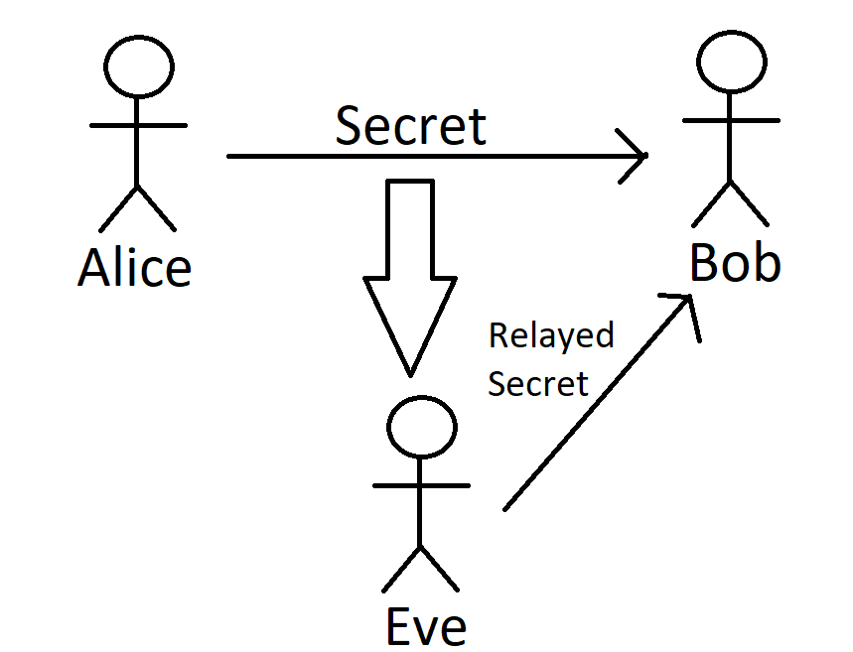
2.
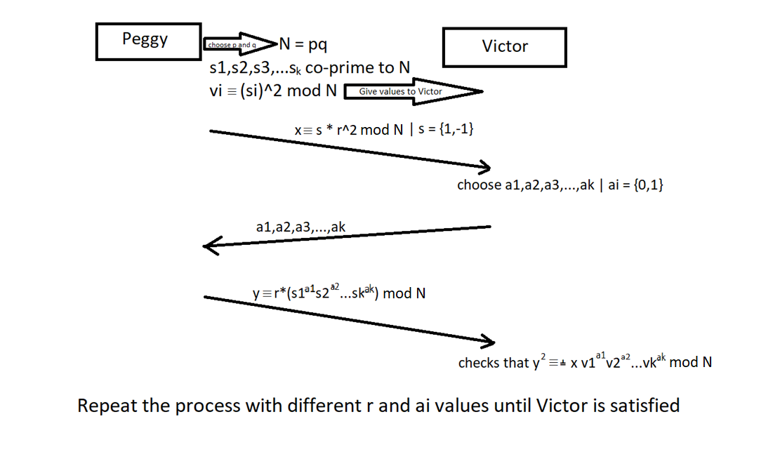

See appendix 1
Taken from Wikipedia ZK_Two_Balls
Taken from http://ethesis.nitrkl.ac.in/5755/1/110CS0371-2.pdf page 19
See appendix 2

