

University of Ghana

College of Basic and Applied Sciences

School of Engineering Sciences

1st Semester (2020/2021)

CPEN 207: Introduction to Software Engineering

Semester Project

ASHONG-KOTEI YEHOWASHIDAA - 10844395

TABLE OF CONTENTS

AMON’S RENTALS 1

1.0 Problem Statement 1

2.0 Requirements 1

2.1 User Requirements 1

2.2 Functional Requirements 2

2.3 Non-Functional Requirements 2

3.0 SOFTWARE PROCESS 2

4.0 SOFTWARE MODELING 3

4.1 USE-CASE DIAGRAM 3

4.2 FLOW DIAGRAM 4

4.3 ACTIVITY DIAGRAM 5

5.0 SYSTEM ARCHITECTURE 6

6.0 TESTING 6

7.0 CONCLUSION 6

8.0 REFERENCES 7

# AMON’S RENTALS

# 1.0 Problem Statement

Many car rental companies do not have any web or mobile application that can be used to advertise their services and effectively manage reservations. They mainly resort to the use of posters and flyers to carry out this task. Also many of these companies make use of phone call reservations which is quite limited in its effectiveness. This is because a customer might make a reservation for a car but might turn to not like the car upon pickup because the customer was not able to see any picture of the car. It may also be that the car he or she reserved did not meet their expectations. A web and mobile application has therefore been designed to effectively enhance the advertisement and successfully manage the reservations of a car rental company known as AMON’S RENTALS through the internet. This will help customers to see and adequately select any car of their choosing to use for a specific duration of time.

# 2.0 Requirements

## 2.1 User Requirements

1. The user must register and create an account to be able to login and use the application.
2. The user can visit the system at any given time.
3. The user can make a reservation for a car.
4. The user must make payment in order to make reservations.
5. The user must state the duration for which he or she will be using the service.

## 2.2 Functional Requirements

1. The system must allow users to register in order to get the user’s details.
2. The system must store the user’s information in a user-friendly and secure environment.
3. The system must allow users to make reservations and view available cars.
4. The system must display the various prices of the cars available for reservation.

## 2.3 Non-Functional Requirements

1. The system must store the user’s information in an SQL database.
2. The system must make sure that passwords are encrypted and that all passwords entered by a user should match.
3. The system must make sure that the user fills in all the required fields.
4. The system must make sure that no email or username can be duplicated.
5. The system should be responsive on all devices.
6. The system must have a very quick recovery time if anything was to malfunction.

# 3.0 SOFTWARE PROCESS

In designing this system, the agile process was used. This was because planning was done incrementally to allow changes to be easily made to the system. The Web page was created using a standard markup language known as Hyper Text Markup Language (HTML). It was assisted in its operation using Cascading Style Sheets (CSS). The Cascading Style Sheet (CSS) was what was used to style the HTML document and describe how the HTML documents should be displayed. The server scripting tool which was used to make the Web page interactive is known as PHP. It was also used in the creation of the database which was used to store the user’s information.

The Android App was created using an Integrated Development Environment known as Android Studio. The programming languages used were Kotlin and Java. The database for the app was created using a relational database management system known as SQLite.

# 4.0 SOFTWARE MODELING

## 4.1 USE-CASE DIAGRAM

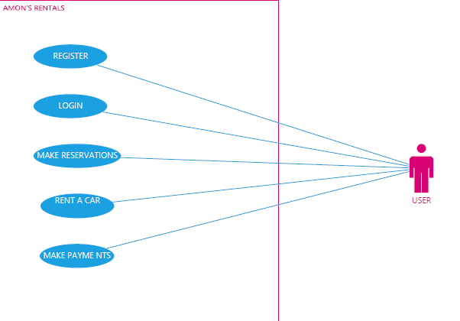

## 4.2 FLOW DIAGRAM

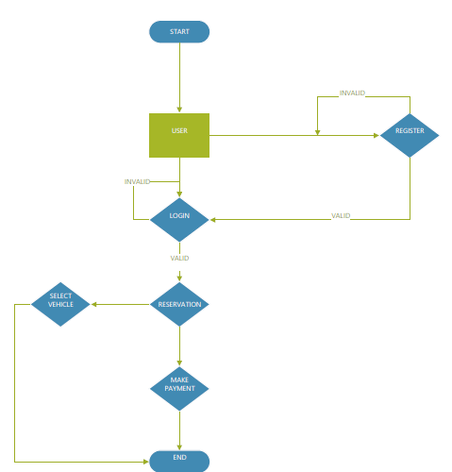

## 

## 4.3 ACTIVITY DIAGRAM

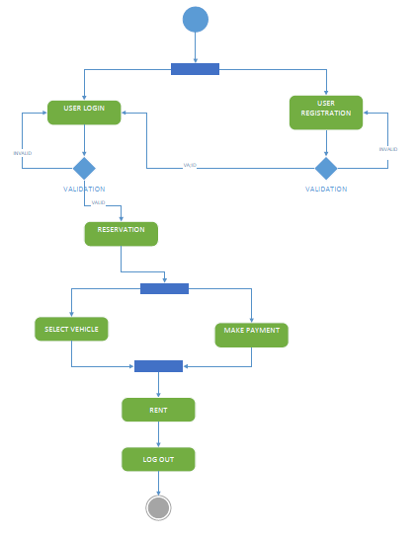

## 5.0 SYSTEM ARCHITECTURE

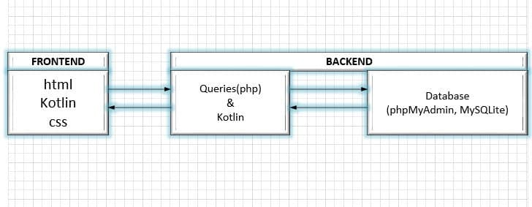

## 6.0 TESTING

Testing is carried out on the Web App and the Android App using artificial data. Any bug or error that occurs is looked at and fixed in order to ensure the smooth running of the both systems.

## 7.0 CONCLUSION

To conclude, these systems will serve as a web based application and an android application when testing is completed. The Company known as AMON’S RENTALS will be able to make use of these systems to advertise their services on a large scale and mange reservations effectively. It will also help customers to select their cars of choice and interact with the system.

# 8.0 REFERENCES

Santos, M. (2014). *DESIGN AND IMPLEMENTATION OF A CAR RENTAL SYSTEM.* Retrieved from projecttopics.org: https://www.projecttopics.org/design-and-implementation-of-a-car-rental-system.html[accessed on 20th May,2021]

Shamsil Arefin, D. S. (2015, June 10). Software Requirements Specification for Online CarRental System. p. 34.